Evaluation of Biodiversity Protected by Sea Change Tai Timu Tai Pari – Marine Protected Area Proposals

Prepared for Department of Conservation
August 2020

Prepared by:
Carolyn Lundquist
Jordi Tablada
Stephanie Watson

Contributors and Reviewers
Irene Pohl (Department of Conservation)
Shane Geange (Department of Conservation)
Karen Tunley (Fisheries New Zealand)
Martin Cryer (Fisheries New Zealand)
For any information regarding this report please contact:
Carolyn Lundquist
Principal Scientist
Marine Ecology
+64-7-859 1136
carolyn.lundquist@niwa.co.nz

National Institute of Water & Atmospheric Research Ltd
PO Box 11115
Hamilton 3251
Phone +64 7 856 7026
NIWA CLIENT REPORT No: 2020244HN
Report date: August 2020
NIWA Project: DOC20206

Quality Assurance Statement
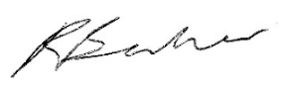 | Reviewed by: | Richard Bulmer
 | Formatting checked by: | Alison Bartley
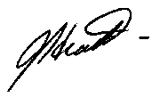 | Approved for release by: | Judi Hewitt

Contents
Executive summary 8
1 Introduction 10
1.1 Background of the Sea Change Tai Timu Tai Pari Hauraki Gulf Marine Spatial
Plan 10
1.2 Scope of the report 13
2 Available environmental, biodiversity and fisheries use datasets 15
2.1 Demersal fish species distribution models 19
2.2 Biogenic and physical habitat layers 20
2.3 Summary of layers used in biodiversity evaluation 23
2.4 Data pre-processing 24
3 Biodiversity values and fisheries activities in Sea Change MPA proposals 26
3.1 Methodology 26
3.2 Habitat and biodiversity features represented in proposed MPAs 27
3.3 Evaluation of overlap of proposed protected areas with fisheries 35
4 Analysis of Sea Change MPA proposals using the Zonation spatial prioritisation decision-support tool 38
4.1 Introduction to spatial conservation prioritisation using Zonation 38
4.2 Development of Zonation baseline for assessing marine reserve proposals 38
4.3 Marine reserves Baseline scenario – final selection 47
4.4 Evaluation of Proposed Marine Reserves 50
4.5 Optimised trade-off analysis of biodiversity protection and fisheries impacts 54
4.6 Development of Zonation baseline for assessing seabed protected areas
proposals 58
4.7 Seabed protected area baseline scenario – final selection 60
4.8 Optimised trade-off analysis of biodiversity protection and fisheries impacts 62
4.9 Evaluation of seabed protected areas 64
5 Conclusions and recommendations 69
5.1 Opportunity for stakeholder input into further Zonation scenarios 69
5.2 Scenario options and caveats of the approach 70
5.3 Summary of recommendations 71
6 Acknowledgements 72
7 References 73
Appendix A Demersal fish model evaluation 77
Appendix B Site-specific habitat and biodiversity features 87
Appendix C Fisheries data layers 119
Appendix D Detailed results of evaluation of proposed marine reserves with fisheries layers 122
Appendix E Seabed protected area baseline scoping – Gravel and rocky reef habitats 130
Appendix F Zonation output details for marine reserves scenarios 133

Tables
Table 1-1: Marine reserves proposed by the HGMSP. 11
Table 1-2: Existing marine reserves in the HGMP. 12
Table 1-3: Seabed protected areas proposed by the HGMSP. 12
Table 2-1: Datasets assessed for inclusion in the analysis of HGMSP MPA proposals. 16
Table 2-2: Summary of biodiversity, habitat and management layers selected for
input into Zonation spatial biodiversity prioritisation scenarios. 24
Table 3-1: Biodiversity feature protection (as percentage of the total distribution
within HGMP) within each MPA Scenario proposal. 29
Table 3-2: Physical habitat protection (as percentage of the total distribution within HGMP) within each Marine reserve and seabed protected area Scenario proposal. 30
Table 3-3: Comparison of biodiversity and habitat features (as percentage of the
total distribution within HGMP) within proposed sites having two marine reserve options. 33
Table 3-4: Comparison of biodiversity and habitat features (as percentage of the
total distribution within HGMP) within proposed sites having two seabed protected area options. 34
Table 3-5: Annual estimated displacement of fishing effort for Scenario 1 and
Scenario 2 marine reserves for each fishing method averaged for the
2016 to 2019 period. 36
Table 3-6: Annual estimated displacement of catch for Scenario 1 and Scenario 2
marine reserves for each fishing method averaged for the 2016 to 2019
period. 36
Table 3-7: Annual estimated displacement of fishing effort for Scenario 1 and
Scenario 2 seabed protected areas for each fishing method averaged
for the 2016 to 2019 period. 37
Table 3-8: Annual estimated displacement of catch for Scenario 1 and Scenario 2
seabed protected areas for each fishing method on average for the 2016
to 2019 period. 37
Table 4-1: Input layers for the two rocky reef scoping scenarios to compare equal
and three-fold increased weights for rocky reef habitat types. 44
Table 4-2: Average protection of biodiversity and habitat features in the final
baseline scenario vs Scenario 1 and Scenario 2 marine reserves. 49
Table 4-3: Average protection of biodiversity and habitat features comparing the
final baseline scenario with the Scenario 1 Proposed marine reserves
including fisheries layers. 56
Table 4-4: Average protection of biodiversity and habitat features comparing the
final baseline scenario with the Scenario 2 Proposed marine reserves
including fisheries layers. 58
Table 4-5: Relative protection of seafloor habitat features under the different
Baseline Scenario 1. 63
Table 4-6: Relative protection of seafloor habitat features under the different
Baseline scenario 2. 64
Table 4-7: Relative protection of seafloor habitat features under Scenario 1 seabed protected areas. 66
Table 4-8: Relative protection of seafloor habitat features under Scenario 2 seabed protected areas. The existing CPZs and scenario 1 seabed protected areas cover 17.71% of the analysed area. 67

Table A-1: Demersal fish species typically found at depths < 125 m, for which
predicted species occurrence models are available for the HGMP. 77
Table A-2: Demersal shelf fish species typically found at depths > 125 m, for which predicted species occurrence models are available for the HGMP. 82
Table B-1: Detailed intersect analysis between demersal fish and biogenic habitat
layers and Scenario 1 (SC1) and Scenario 2 (SC2) combined minimum
and maximum marine reserve options, and single option marine individual marine reserves. 87
Table B-2: Detailed intersect analysis between demersal fish and biogenic habitat
layers for alternative Scenario 1 (SC1) and Scenario 2 (SC2) individual
marine reserves. 92
Table B-3: Detailed intersect analysis between demersal fish and biogenic habitat
layers for alternative Scenario 1 (SC1) and Scenario 2 (SC2) individual
seabed protected areas. 95
Table B-4: Detailed intersect analysis between demersal fish and biogenic habitat
layers and Scenario 1 (SC1) and Scenario 2 (SC2) combined minimum and maximum options, and single option individual seabed protected areas. 100
Table B-5: Detailed intersect analysis between physical habitat layers and Scenario
1 and 2 combined minimum and maximum options, and single option
marine individual marine reserves. 105
Table B-6: Detailed intersect analysis between physical habitat layers and alternative Scenario 1 and Scenario 2 individual marine reserves. 108
Table B-7: Detailed intersect analysis between physical habitat layers and Scenario
1 and 2 combined minimum and maximum options, and single option
marine individual seabed protected areas. 111
Table B-8: Detailed intersect analysis between physical habitat layers and alternative Scenario 1 (SC1) and Scenario 2 (SC2) individual seabed protected areas. 114
Table B-9: Detailed intersect analysis between biogenic habitat point occurrence
records and proposed marine reserves and seabed protected areas. 117
Table C-1: Fisheries data layers provided by Fisheries New Zealand. 119
Table D-1: Detailed intersect analysis between all fisheries layers and Scenario 1
marine reserves. 122
Table D-2: Detailed intersect analysis between all fisheries layers and Scenario 2
marine reserves. 124
Table D-3: Detailed intersect analysis between all fisheries layers and Scenario 1
seabed protected areas. 126
Table D-4: Detailed intersect analysis between all fisheries layers and Scenario 2
seabed protected areas. 128
Table E-1: Habitat protection of gravel and rocky reef habitat types under Zonation scenario options for seabed protected areas. 130
Table E-2: Relative protection of seafloor habitat features (percent of total in
HGMP) under different Proposed seabed protected area scoping
scenarios. 132
Table F-1: Relative percentage protection of features under the Baseline scenario, Baseline including fisheries as negatively weighted layers, Scenario 1 and Scenario 2 of marine reserves. 133
Table F-2: Relative percentage protection of features under the Baseline scenario, Baseline including fisheries as negatively weighted layers, including
fisheries as negatively weighted layers and prioritised CPZs and Scenario
1 of seabed protected areas. 140
Table F-3: Relative percentage protection of features under the Baseline scenario, Baseline including fisheries as negatively weighted layers, including
fisheries as negatively weighted layers and prioritised CPZs and Scenario
2 of seabed protected areas. 143

Figures
Figure 1.1: Proposals for MPAs in Sea Change by type and Scenario. 13
Figure 2.1: Physical habitat types of the HGMP. 21
Figure 2.2: Mapped extent of six biogenic habitat types found in the Hauraki Gulf
Marine Park. 22
Figure 2.3: Modelled ecosystem service layer of predicted biogenic habitat
provisioning. 23
Figure 2.4: Hauraki Gulf Marine Park (HGMP) model area. 25
Figure 3.1: Annual intensity of trawl fishing from 2018/2019. Left: Full spatial
footprint. Right: Data extracted for proposed marine reserves under
Scenario 1. 27
Figure 4.1: Spatial prioritisation of the baseline scoping scenario with only physical
habitat layers as input. 40
Figure 4-2: Performance curves for each habitat layer in the Baseline Physical
Habitats exploratory scenario. 41
Figure 4.3: Spatial prioritisation of the baseline scoping scenario with only demersal
fish layers as input. 42
Figure 4.4: Average performance curves for endemic (red) and non-endemic (blue) demersal fish species. 43
Figure 4.5: Proportion of rocky reef habitats protected under the equal weighting
for rocky reefs scoping scenario. 44
Figure 4.6: Proportion of rocky reef habitats protected under the 3x weighting for
rocky reefs scoping scenario. 45
Figure 4.7: Spatial prioritisation of the two scoping scenarios to compare equal
(left) and three-fold (right) increased weights for rocky reef habitat types. 45
Figure 4-8: Performance curve for the biogenic ecosystem services layer. 46
Figure 4-9: Biogenic ecosystem services layer histogram. 47
Figure 4.10: Spatial prioritisation of the final baseline scenario with combined species
and habitat features, and higher weighting of biogenic habitats. 48
Figure 4.11: Performance curves for each group of features for the baseline scenario (without existing marine reserves). 49
Figure 4.12: Spatial prioritisation with Scenario 1 proposed marine reserves forced
as the highest priority for protection. 51
Figure 4.13: Performance curves for each group of features for the Scenario 1 proposed marine reserves forced as the highest priority for protection. 52
Figure 4.14: Performance curves for each group of features for the Scenario 2 proposed marine reserves forced as the highest priority for protection. 53
Figure 4.15: Spatial prioritisation with Scenario 2 proposed marine reserves forced
as the highest priority for protection. 54
Figure 4.16: Spatial prioritisation including proposed marine reserves under Scenario
1 and seven recreational and commercial fisheries layers. 55
Figure 4.17: Spatial prioritisation of the scenario with the Scenario 2 Proposed marine reserves including fisheries layers. 57
Figure 4-18: Analysed area for seabed protected areas Scenario 1 (left) and Scenario 2 marine reserve options (right). 59
Figure 4.19: Spatial prioritisation of the baseline scenarios for seabed protected areas. 61
Figure 4.20: Performance curves for each group of features for the Scenario 1 baseline scenario for seabed protected areas. 61
Figure 4-21: Performance curves for each group of features for the Scenario 2 baseline
of seabed protected areas scenario. 62
Figure 4.22: Spatial prioritisation of the scenario with the Scenario 1 proposed seabed protected areas and CPZs. 65
Figure 4.23: Spatial prioritisation of Scenario 2 Proposed seabed protected areas and
Cable Protection Zones. 67
Figure 5.1: Locations of dredging areas, shipping zones, military exclusion zones,
marine farms and sand extraction areas. 70

Executive summary
In response to the ongoing degradation documented in the Hauraki Gulf Marine Park (HGMP), a stakeholder working group (SWG), consisting of mana whenua and stakeholders worked together to develop the Sea Change Tai Timu Tai Pari Hauraki Gulf Marine Spatial Plan (hereafter HGMSP). One of the goals of the SWG was to identify suitable areas for additional biodiversity and seafloor protection. The SWG identified 15 locations to be considered for the establishment of new Marine Protected Areas (MPAs). At some locations, two options were proposed that varied in the spatial extent or type of protection (e.g., marine reserves and/or “seabed protected areas”).
Here we evaluate biodiversity and ecosystem benefits and the displacement of fishing activity associated with the HGMSP proposals, comparing different marine reserve and seabed protected area options within locations, as well as summarising differences between ‘maximum’ protection (combined Scenario 1 options) and ‘minimum’ protection proposals (combined Scenario 2 options). Marine reserve Scenario 1 and Scenario 2 proposals in combination covered a total of 4.5% and 3.2% of the HGMP, respectively; seabed protected area Scenario 1 and Scenario 2 proposals in combination covered a total of 14.4% and 10.3% of the HGMP. These scenarios were also compared to optimal solutions for both biodiversity protection and minimising impacts to the fisheries sector using the decision-support tool Zonation.
A central government working group assessed the reliability and relevance of available datasets for inclusion in the analysis, selecting four sets of layers that can either be used to calculate biodiversity or that underly biodiversity provision (90 demersal fish species, 47 physical habitats, six individual biogenic habitat maps, one biogenic ecosystem services layer), and eight sets of recreational and commercial (identified by gear type) fishing layers. These layers represent the best quality-assured data currently available; however, they do not provide a complete picture of biodiversity patterns within the HGMP, nor do they comprehensively represent potential impacts of MPA establishment on the environment or all existing users. Uncertainty in the accuracy of data layers was not incorporated into the analyses.
Proposals, if efficient, should protect larger proportions of biodiversity features than the relative proportion of area allocated to MPAs, and as a network, should cover the diversity of physical and biological features that drive key elements of biodiversity in the HGMP. Marine reserve and seabed protected area proposals varied individually in the relative protection given to these features. Biogenic habitats (dog cockles, rhodoliths, mangroves, seagrass, saltmarsh and green-lipped mussels) were inconsistently represented within MPA proposals. Only dog cockles and rhodoliths received above par protection within the Marine Reserve Scenarios 1 (4.5%) and 2 (3.2%) options, whereas green-lipped mussels, mangroves and saltmarsh each received above par in Seabed Protected Area Scenarios 1 (14.4%) and 2 (10.3%). Most other physical habitat types had poor representation in marine reserve Scenario 1 and 2 with only 19 and 16 habitats receiving above par protection, respectively, and biases of protection toward rarer gravel and rocky reef habitats. Seabed protected area scenarios showed higher protection, on average, of physical habitats, but illustrated similar biases toward high representation of rarer habitat types. On average, demersal fish received approximately ’on par’ protection within marine reserves. Scenario 1 (maximum) provided substantially larger benefits to biodiversity and seafloor habitats than Scenario 2 (minimum) due to typically large differences in the size of proposed marine reserves at the four sites with competing marine reserve options, whereas seabed protected area proposals were more similar in comparison between Scenario 1 and 2.
Estimates of proportional displacement for each gear type were similar between years and between metrics (catch (kg) or effort in number of trawls or events). Proportional displacement of catch (kg) was largest for rock lobster potting (9.7% and 6.7% for Scenario 1 and 2 respectively) and smallest for Danish seining (2.0% for Scenario 1 and 0.8% for Scenario 2). Displacement for Scenario 2 was comparable with that for Scenario 1, except for Danish seining, longlining and set net fishing, where impacts were approximately 50% less. Scenarios for seabed protected areas yielded larger estimated fisheries displacement of catch (kg), with set net fishing being the most affected fishery with 28.7% displacement for scenario 1 and 23.3% for Scenario 2.
A systematic conservation planning approach using the decision-support tool Zonation was used to estimate the ‘maximum’ protection of biodiversity features that could be provided for an equivalent area in protection to that in the HGMSP proposals. A Zonation baseline scenario was developed following input from DOC and FNZ, and the same layers (demersal fish, physical habitats, biogenic habitats, and biogenic ecosystem services) were used to drive biodiversity prioritisation in this scenario. The biogenic layers were upweighted relative to other biodiversity layers because they can support other types of biodiversity and disproportionately support ecosystem services. Because the ecological communities present in deeper water on the fringe of the HGMP differ from shallower waters throughout the rest of the HGMP, areas deeper than 200 m were excluded from the analysis. Existing marine reserves were also excluded from the analysis in order to focus on prioritising unprotected areas. Model iterations were performed to assess the influence of selected model options on the ‘maximum’ solution for biodiversity protection.
In the baseline scenario, most of the highly prioritised areas were concentrated around the coastline of the inner Hauraki Gulf, parts of the Coromandel Peninsula, Little Barrier Island/Hauturu and Great Barrier Island/Aotea. Some of the areas selected in Marine Reserve Scenarios 1 and 2 were also selected in the Zonation Baseline Scenario, for example, Cape Colville-Moehau, Tiritiri Matangi Scenario 1, and proportions of the Aldermen Islands/Te Ruamaahua. Other areas (e.g., Little Barrier Island - Hauturu) showed mismatches between the areas selected by the HGMSP and locations of highest priority based on biodiversity features included in the Baseline Scenario for Marine Reserves or Seabed Protected Areas. The Zonation Baseline Scenarios showed a positive bias toward protection of biogenic habitat layers (reflecting the higher weighting given to these layers) and physical habitat types such as estuarine areas and rocky reef and gravel habitats that cover small total areas. Demersal fish layers showed slightly lower representation in Baseline Scenarios.
The Zonation baseline and additional exploratory scenarios illustrate the opportunity for using this decision-support tool to inform refinement of the HGMSP marine reserves and/or seabed protected areas to better align with HGMSP objectives for conservation purposes as well as for minimising displacement of other existing uses of the HGMP. Although the baseline Zonation scenario was developed by a limited number of central government managers, policy makers and scientists, advised by independent scientists, Zonation has previously been used successfully in stakeholder processes, with direct participation in development and iteration of model scenarios. One example scenario is presented here for HGMP to illustrate how Zonation could incorporate fisheries layers to provide solutions that minimise displacement of commercial and recreational fishers, while maximising biodiversity protection. Other management uses (e.g., sand extraction, military zones) could be excluded in scenarios as some of these uses are incompatible with marine reserves and/or seabed protected areas. Datasets used in the analyses could be further explored to improve on their representation of biodiversity features, and of value/cost layers for different users to more accurately represent costs and benefits of different spatial management proposals.

Introduction

Background of the Sea Change Tai Timu Tai Pari Hauraki Gulf Marine Spatial Plan
In response to the ongoing degradation documented in the Hauraki Gulf, several stakeholder groups, mana whenua and government agencies worked together to design the Sea Change Tai Timu Tai Pari Hauraki Gulf Marine Spatial Plan (hereafter HGMSP) to help restore the natural state of the Hauraki Gulf Marine Park (HGMP). Two of the main goals of the plan are the recovery of fish stocks and the enhancement of marine biodiversity through a network of marine protected areas (MPAs) and the restoration of habitats via the phasing out of bottom trawling, Danish seining, and scallop dredging methods among other management tools. Current biodiversity protection in the Gulf is limited to six marine reserves that protect about 0.28% of the total area, and four Cable Protection Zones (CPZs) that limit seafloor disturbance in approximately 5% of the Gulf, supplemented by a range of fisheries regulations on commercial netting.
One of the goals of the HGMSP Stakeholder Working Group (SWG) was to identify suitable areas for additional biodiversity and seafloor protection through a series of options for spatial management designed to improve area-based marine protection in the HGMP and contribute towards a network of MPAs. The Plan identifies 15 areas within which new or additional marine protection measures are proposed (Figure 1.1, Table 1-1, Table 1-3) , with multiple options in terms of the spatial extent of protection or the type of protection proposed at some locations (Figure 1.1). The 15 areas include the extension of two existing marine reserves (Cape Rodney-Okakari Point and Te-Whanganui-A-Hei (Cathedral Cove)), six single-option marine reserves, in one case (Cape Colville-Moehau) buffered by a seabed protected area, six areas with several marine reserve options and adjacent seabed protected areas (or Special Management Areas), and one stand-alone seabed protected area in Craddock Channel (Figure 1.1). Marine Reserves are defined in the HGMSP as areas where all commercial and recreational fishing is restricted, whereas Seabed Protected Areas restrict all commercial and recreational fishing methods that impact on benthic habitat. The existing marine reserves cover approximately 0.28% of the total area of the HGMP (Table 1-2), and the four CPZs cover approximately 5% of the HGMP. The Plan does not propose any configuration of single-option and alternative MPAs as a network.
For the purpose of evaluating the MPAs as part of this project and in light of the many configurations of MPAs that could potentially be analysed, the decision was made by the central government working group to use a stepwise approach based on:
- Evaluating the likely performance of the proposed marine reserves first given that, in most cases, the seabed protected areas are proposed as buffers to the marine reserves.
- Evaluating the extremes in additional protection afforded by the proposals through two configurations of marine reserves: the combined set of proposed marine reserves affording the highest level of protection in term of area (Scenario 1); and the combined set of proposed marine reserves affording the lowest level of protection in term of area (Scenario 2).
- Evaluating the effectiveness of the seabed protected areas in light of the proposals to phase out mobile (towed) bottom-contacting methods.
- Exclude the area proposed under Ahu Moana due to a lack of detail of protection-specific objectives to analyse against.
- Treat Special Management Areas (SMAs) as seabed protected areas in the analysis of overlap between biodiversity and existing uses, but to omit them from the Zonation analyses.
Evaluating the minimum and maximum extremes in additional protection (as referred in B. above) required the development of two MPA scenarios and evaluating the overall contribution of the scenarios towards biodiversity representation and potential impacts on fisheries (Table 1-1, Table 1-3, Figure 1.1).
Table 1-1: Marine reserves proposed by the HGMSP.
Locations with different Scenario 1 and 2 options are in bold type.
Name | Area in Scenario 1 (km²) | Area in Scenario 2 (km²)
Alderman Islands, Te Ruamaahua | 164.5 | 164.5
Cape Colville, Moehau | 22.0 | 22.0
Cape Rodney-Okakari Point marine reserve extension | 15.2 | 15.2
Kawau Bay | 45.5 | 0.56
Little Barrier Island, Hauturu | 192.0 | 192.0
Mokohinau Islands | 118.3 | 1.3
Motukawao | 17.6 | 17.6
Rangitoto and Motutapu Islands | 10.6 | 7.6
Rotoroa Island | 8.8 | 8.8
Slipper Island, Whakahau | 4.2 | 4.2
The Noises | 4.7 | 4.7
Tiritiri Matangi | 22.4 | 1.7
Whanganui-A-Hei (Cathedral Cove) marine reserve extension | 10.2 | 10.2
Total area | 635.9 | 450.4
Percent of total HGMP (14,063 km²) | 4.52% | 3.20%

Table 1-2: Existing marine reserves in the HGMP.

Name | Area (km²)
Tawharanui | 3.9
Long Bay-Okura | 9.8
Motu Manawa-Pollen Island | 5.0
Te Matuku (Waiheke Island) | 6.9
Te Whanganui-A-Hei (Cathedral Cove) | 8.4
Cape Rodney-Okakari Point (Leigh) | 5.2
Total area | 39.2
Percent of total HGMP (14,063 km²) | 0.28%

Table 1-3: Seabed protected areas proposed by the HGMSP.
Special Management Areas (SMAs) are areas that do not allow commercial fishing and restrict recreational fishing.
Name | Area in Scenario 1 (km²) | Area in Scenario 2 (km²) (including SMAs) | Area in Scenario 2 (km²) (excluding SMAs)
Alderman Islands, Te Ruamaahua | 316.6 | 316.6 (*as SMA) | 0
Cape Colville, Moehau | 72.7 | 72.7 | 72.7
Craddock Channel | 142.3 | 142.3 | 142.3
Firth of Thames | 934.9 | 934.9 | 934.9
Kawau Bay | 164.4 | 208.9 | 208.9
Mercury Islands, Ahuahu Whakau | 4.6 | 4.6 | 4.6
Mokohinau Islands | 325.9 | 235.0 (*as SMA) | 0
Tiritiri Matangi | 59.9 | 80.8 | 80.8
Whangateau Harbour | 5.6 | 0 | 0
Total area | 2027.2 | 1996.2 | 1444.2
Percent of total HGMP (14,063 km²) | 14.41% | 14.19% | 10.26%

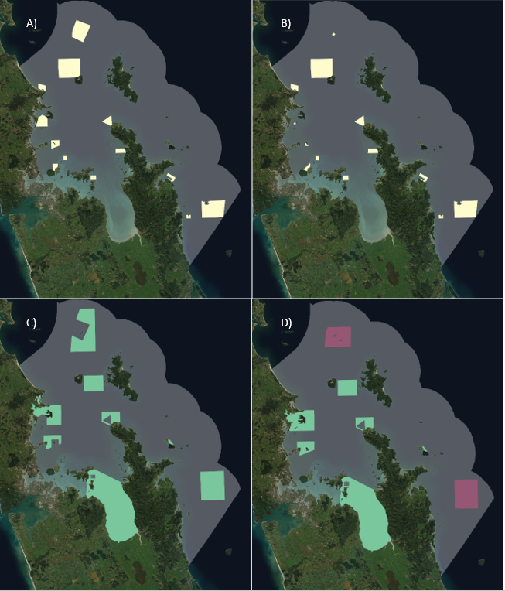
Figure 1.1: Proposals for MPAs in Sea Change by type and Scenario.
Marine reserve proposals are illustrated in white, seabed protected area proposals in green, and SMAs in maroon. A) marine reserves, Scenario 1, B) marine reserves, Scenario 2, C) seabed protected areas, Scenario 1 and D) seabed protected areas and SMAs, Scenario 2. The spatial extent of the HGMP is indicated with a grey polygon.

Scope of the report
Central government agencies are tasked with developing a Government Response Strategy to the Plan, detailing how agencies will implement Sea Change actions under their respective mandates. To that effect, agencies are required to assess how the Plan’s proposals align with the outcomes and vision in the Plan of a healthy and thriving Hauraki Gulf to assist the protection and restoration of at-risk, high value and representative habitats and ecosystems in the HGMP.
This report describes the analysis undertaken by the central government working group, including Department of Conservation (DOC) and Fisheries New Zealand (FNZ), to analyse the Plan’s spatial management proposals, with emphasis on management actions relevant to Marine Protected Area proposals (Chapter 6 – Biodiversity) within the Plan (Waikato Regional Council 2017). Specifically, individual marine reserve and seabed protected area proposals were evaluated for their contribution toward biodiversity representation and protection of benthic environments.
There are three suites of analyses presented in this report. The first analysis quantifies the proportion of different biodiversity layers that are protected by each of the proposed MPAs. This analysis should be viewed as providing information on how well the proposal protects a range of different biodiversity features, including biogenic habitats, biogenic ecosystem services, demersal reef fish and broadscale habitats. The second analysis quantifies the proportion of different fisheries layers that are displaced by the proposed MPAs. This analysis should be viewed as providing information on the extent to which fishing activities may be impacted, noting that displacement of fishing effort doesn’t necessarily equate to the loss of fishing effort. The third suite of analyses uses the decision-support tool Zonation to help determine how efficient the proposals are in meeting the Plan’s outcomes for the protection of biodiversity and benthic environments (with an emphasis on the protection of biogenic habitats) while simultaneously minimising impacts on existing recreational and commercial fishers. These analyses should be viewed as providing information that could be used to inform how the HGMSP proposals could be modified, if desired, to increase the performance of the MPAs in protecting biological diversity while concurrently minimising impacts on existing users.
The report covers:
- An evaluation of the contribution of proposed marine reserves and seabed protected areas in terms of their ability to protect a range of biodiversity attributes in the HGMP, including the assessment and selection of datasets to be included in the analysis.
- A stepwise discussion of decisions made by the central government working group in identifying priority areas for the protection of biodiversity and seabed habitats in the HGMP, using the spatial prioritisation software Zonation.
- Relative benefits of different Zonation model scenarios - for example, types of protection (marine reserves versus seabed protected areas) compared with scenarios where Zonation is allowed to prioritise areas for protection based on biodiversity and existing fisheries use layers, with no spatial constraints to placement of types of protection.

Available environmental, biodiversity and fisheries use datasets
Through the course of various workshops the central government working group undertook an assessment of all national and sub-national scale spatial biodiversity, management and fisheries datasets available to inform the analysis, resulting in the selection of: (1) 90 modelled layers of demersal fish species occurrences; (2) one modelled ecosystem service layer estimating biogenic ecosystem services; (3) six expert-derived maps of locations of biogenic habitat (mangrove, seagrass, saltmarsh, rhodoliths, dog cockles and green-lipped mussels); and (4) 47 physical habitats based on the MPA Policy inshore habitat classification (Table 2-1). Other datasets were considered to have incomplete spatial coverage, often consisting of limited point records. Some of these datasets were used in informal assessments of their overlap with proposed MPAs and summarised in the main report.
In addition to the above layers, the central government working group identified eight sets of recreational and commercial (identified by gear type) fishing layers to evaluate potential displacement of fishing activity, including: (1) recreational vessel density; (2) trawling; (3) Danish seining; (4) purse seining; (5) dredging; (5) long-lining; (7) set netting; and (8) potting. All fishing activity included layers for multiple years, and for commercial fisheries, catch and effort layers.
Criteria used to evaluate datasets and determine whether these should be used in the analysis included:
1) accuracy in representing biodiversity or existing fisheries use
2) suitability for inclusion in spatial biodiversity prioritisation analyses in Zonation to identify optimal locations for biodiversity protection
3) spatial coverage (ranging from comprehensive cover of a feature in the HGMP to datasets with limited cover or spatial biases in sampling area), and
4) scale of data (e.g., national datasets which had inappropriately coarse resolution or were assessed as having limited applicability for the HGMP).
Table 2-1: Datasets assessed for inclusion in the analysis of HGMSP MPA proposals.

Dataset name | Description | Source | Type of data | Decision
Biogenic ecosystem  services  (n = 1) | Modelled layer representing ecosystem services layer of potential biogenic habitat presence using Ecosystem Principles Approach | NIWA, Townsend and Thrush (2010); NIWA Client report to WRC | Raster grid (250 m²), with scores ranging from 0-11 at a resolution of 250 m² across the HGMP; an additional subset of this layer (using only high service values of 6-11) was used for evaluation | Include. Comprehensive, best available dataset, validated in Kawau Bay, with publication in peer-reviewed literature (Townsend and Lohrer 2019)
Biogenic  habitats  (n = 6) | Expert derived layers of seagrass, saltmarsh, rhodoliths, mangrove, green-lipped mussels, dog cockles | DOC Hauraki Gulf expert survey, used in national habitat classification developed under the MPA policy (Department of Conservation and Ministry of Fisheries 2011) | Shape files | Include based on best available information, anecdotal expert-derived layers, assume includes council derived vegetation mapping.
Estuarine vegetation | Collated from AC and WRC coastal vegetation layers, including mangroves, saltmarsh, seagrass, ‘undefined’ and ‘invasive’ | AC and WRC coastal vegetation layers collated for HGMSP | Shape files | Merge regional layers with national vegetation layers in biogenic habitats
Key biogenic habitats | Point record dataset of many biogenic habitats from horse mussels, kelp forests, dog cockles, rhodoliths, etc. | Ministry for the Environment report on national biogenic habitats (Anderson et al. 2019) | National point records, high spatial bias based on sampling effort | Include in evaluation of proposed areas. Do not include in Zonation analyses due to spatial bias, include only more comprehensive layers, and instead use these as validation of modelled biogenic layer and expert-derived biogenic habitat layers
Bryozoan species occurrence models | Modelled species distribution models of 11 bryozoan species | National layers prepared for PhD thesis, published in Wood et al. (2013) | National raster grid (1 km²) | Do not include; visual observation by local experts suggest not useful at HG scale
Physical habitats  (n = 47) | Physical habitats based on DOC Inshore Habitat Classification, adapted to suit available HGMP sediment layers | Habitat layers based on sediment, wave exposure, depth layers prepared using the national habitat classification developed under the MPA policy (Department of Conservation and Ministry of Fisheries 2011) | Shape files | Include. Based on best available information on underpinning environmental layers. Lack of differentiation of much of Gulf with ~70% in six moderate depth (30-200 m), soft sediment habitats.
Demersal  fish species occurrence models | 217 demersal fish layers, available at 1 km² grid scale nationally. Species occurrence models using gradient forest technique. | Updated species occurrence layers from Leathwick et al. (2006), layers associated with species turnover classification published in Stephenson et al. (2018a; 2020); revised layers plus associated uncertainty layers in preparation for DOC contract to NIWA on Key Ecological Areas (KEA) (Stephenson et al. 2018b; Lundquist et al. 2020). Note that predicted abundance or catch modelled layers were not available. | Raster grid, national layer 1 km², with nearest neighbour analysis to convert to 250 m² in the HGMP | Include. Best available demersal fish layers. Further assessed to determine which species have justifiable occurrence in HGMP to include in model (n = 90) (see Section 2.1 for detailed explanation on demersal fish species selection).
Reef fish modelled  layers (n = 59) | 59 reef fish species, model area restricted to out of date rocky reef layer that is biased against deep reefs. | Reef fish modelled layers from Smith et al. (2013) | Raster grid, national layer 1 km² | Do not include. Modelling in process in DOC KEA contract (Lundquist et al. 2020) to update layers to suit updated rocky reef layer. Some overlap with Demersal fish layers. Likelihood of bias toward rocky reef in Zonation models, with 59 species layers only found on reef areas resulting in high likelihood of all reef areas being selected. Reef areas already included as substrate, so reef fish layers superfluous to prioritise rocky reef.
Finfish spawning  layers | Polygons representing areas of finfish spawning for 39 species; summation layer of ‘hotspots’ of finfish spawning | NABIS, MPI | Polygon shape files based on expert derived spawning locations, national scale | Do not include. Coarse scale polygons, many of which include majority of HGMP. Key biogenic habitats and vegetation layers of important to finfish life history were assumed to serve as proxies for important nursery areas.
Invertebrate layers | Point records of invertebrates (includes also rare, endemic, threatened species as sub-layers) from national database extracts including OBIS, TRAWL, and SPECIFY (NIWA invertebrate collection) | See Lundquist et al. (2015) and Stephenson et al. (2018b) for descriptions of national databases and data extracts | Point records, national scale, dominated by observations at depths >200 m | Do not include, sampling bias toward deep depths based on higher sampling effort from research trawls.
Large brown seaweeds | Point record compilation from numerous historical macroalgal and rocky reef surveys | Wendy Nelson/Kate Neill for DOC Key ecological areas and DOC Marine Habitat Classification projects | Point records, to be modelled as species occurrences for DOC KEA contract (Lundquist et al. 2020) | Do not include, not available when analyses were undertaken for this contract.
Management layers | Suite of layers compiled for HGMSP including HGMP boundary, existing marine reserves and Type 2 MPAs, consented marine farms (2015), fisheries layers (see Table C-1 for additional detail), military zones designated for the handling or dumpling of explosives (2015), consented sand and mineral extraction zones (2015), dredging zones (2015), dedicated shipping zones | Land Information New Zealand; Auckland Council; Waikato Regional Council; NZ Defence Force; Navigation and Safety Bylaws, LINZ Hydrographic Office |  | Used to identify two spatial boundaries for Zonation model; full HGMP, and subset of HGMP where existing management areas are excluded form Zonation analysis of biodiversity prioritisation.
Fisheries  layers | Suite of layers indicating annual intensity (events, tows or pots), catch intensity, and annual intensity of undersized snapper for seven fishing methods; recreational vessel density; trawl footprint (2008-2018) (see Appendix C for detailed information on each layer) | Selected and provided by FNZ to represent the suite of different fisheries methods utilised within the HGMP (IN-CONFIDENCE) | Raster grid, 250 m x 250 m | Include.

Demersal fish species distribution models
Species distribution models were originally developed for demersal fish at a national scale based on >21,000 research trawls within the New Zealand Exclusive Economic Zone at 1 km² resolution (Leathwick et al. 2006; Leathwick et al. 2008). Details of the development of species distribution models of abundance of benthic, bentho-pelagic and pelagic species are presented elsewhere, including model validation (Leathwick et al. 2006). A total of 95 demersal fish layers were previously used in a spatial prioritisation of demersal fish in the Hauraki Gulf Marine Park (Jackson 2014, Jackson & Lundquist 2016). These layers have since been updated using additional data from research trawls, and more advanced statistical modelling techniques, allowing for models of the predicted spatial occurrence of 217 demersal fish species (Stephenson et al. 2018a, 2020). While models of predicted catch (abundance) of demersal fish were not available for this updated analysis, prior analyses showed good correlations between the predictions of likelihood of abundance and predicted catch (abundance) for a smaller number of demersal fish species using similar statistical methods (Leathwick et al. 2006), suggesting that models of species occurrence should be reasonable proxies for abundance of demersal fish species.
As a majority of the species are deepwater (>200 m depth), a selection process was used to identify which of the 217 species had significant distributions within the HGMP, with preference to avoid species predicted to be present in only a few cells within the Hauraki Gulf (analysis presented in Appendix A). If these ‘rare in the HGMP but abundant elsewhere’ cells were included, Zonation would treat them as rare species, and prioritise them in the model, whereas it is unlikely many of these species are actually found in the Hauraki Gulf.
Each modelled layer consisted of a predicted species occurrence for all 1 km² cells within the New Zealand EEZ. Species were first evaluated as to whether they had no non-zero values in the HGMP (removing a total of 28 species) or were a non-native species (salmon) (n = 1). A further visual analysis separated species into either those typically present at depths <125 m (n = 94) (Table A-1), and upper slope species typically found at depths of >125 m (n = 94) (Table A-2). The central government working group determined that the 94 upper slope species, which typically had low estimates of species occupancy, were a low priority for the Zonation prioritisation analysis and they were excluded from further analysis. A three-step process was then used to further evaluate which of the remaining 94 species found at depths < 125 m should be excluded from the analysis. First, for each species the total number of cells within the HGMP with greater than 50% probability of occurrence was calculated, and species with <5 total cells (n = 36) were identified for expert review to determine if they should be excluded from the analysis or not (Table A-1). Second, for each species the proportion of the number cells within the HGMP with a probability of occurrence >0.5 relative to the number cells within the EEZ with a probability of occurrence >0.5 was calculated to identify species for which the HGMP was not the primary region in the EEZ where they were found. Only 12 of the 94 species had >10% of their predicted distribution within the HGMP. Finally, an expert review process, including published research on fish species present in the Hauraki Gulf (Anderson et al. 1998, Clark et al. 1989, Hurst et al. 2000, Kendrick et al. 2002, Roberts et al. 2015, Zintzen et al. 2012), was then used to assess whether each of these 94 species was likely to be present in the Hauraki Gulf and whether it was endemic to New Zealand waters. Of the 94 species reviewed, 4 were identified for exclusion from the subsequent analyses (pale toadfish, silver dory, lookdown dory and hoki). The expert review process was supervised by marine scientists with extensive local knowledge from DOC and a curator from the Museum of New Zealand Te Papa Tongarewa, resulting in a final list of 90 demersal fish species to include in the analyses, of which 35 were assessed by these experts as endemic to New Zealand.

Biogenic and physical habitat layers
Physical habitats were based on habitat types defined in the DOC Inshore Habitat Classification (Ministry of Fisheries and Department of Conservation 2008; Department of Conservation and Ministry of Fisheries 2011), where habitat types were based on layers for sediment, wave exposure, and depth (Figure 2.1). Habitat types were adapted to suit available data resolution for fine (sand and mud) and coarse (gravel, cobbles and boulder substrates) sediments, and the wave and current exposure gradients found in the Hauraki Gulf. The classification defined a total of 47 habitat types in the HGMP, with a majority of the HGMP allocated to moderate exposure, deep (30-200 m) subtidal soft sediment habitats (Figure 2.1).

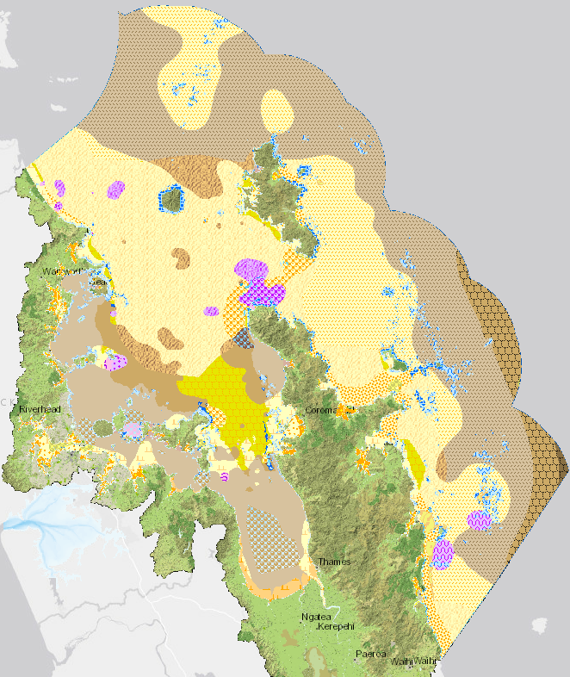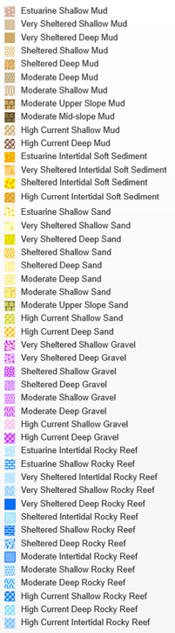
Figure 2.1: Physical habitat types of the HGMP.
Note this map includes the mid-upper slope habitats deeper than 200 m. Data based on Department of Conservation and Ministry of Fisheries (2011).
Several datasets indicating locations of biogenic habitat layers were available (Table 2-1). The first dataset included polygons representing presence of a subset of known biogenic habitats (dog cockles, green-lipped mussels, mangroves, rhodoliths, saltmarshes, seagrass) for which expert derived layers had been generated (Department of Conservation and Ministry of Fisheries 2011) (Figure 2.2). The national layers for mangroves, seagrass and saltmarsh were updated and merged with coastal vegetation layers provided by Auckland Council and Waikato Regional Council as part of the HGMSP initial data collation by partner agencies. Other biogenic habitats that have been identified in New Zealand include sponges, black corals, macroalgae, and bryozoans; however, expert derived spatial maps for these habitats were not available in the Hauraki Gulf. A further national dataset of biogenic habitats has been compiled, and included primarily point records for algal meadows, bivalve beds, bryozoans, kelp forests, mangroves, rhodoliths, seagrass, seapens and sponges (Anderson et al. 2019). Data records were extracted for the HGMP (Table B-9), noting that this dataset included only 54 locations (representing 1064 individual animals and plants) that overlapped proposed marine reserves and seabed protected areas. A further modelled layer of biogenic ecosystem services was available. This layer is based on the Ecosystem Principles Approach (Townsend and Thrush 2010) and ground-truthing using data from Great Barrier Island has shown it to be a good predictor of the locations of biogenic habitats (including primarily seafloor epifaunal communities) (Townsend and Lohrer 2019) (Figure 2.3). A subset of this layer reflecting only high values of biogenic ecosystem services (scores >6) was used for comparison between options.
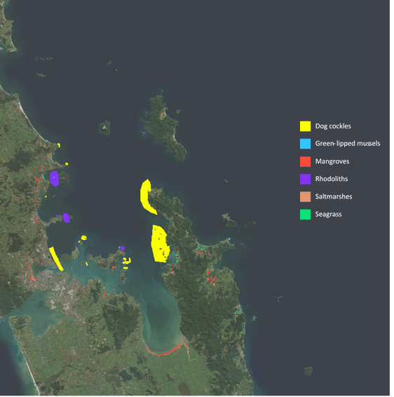
Figure 2.2: Mapped extent of six biogenic habitat types found in the Hauraki Gulf Marine Park.

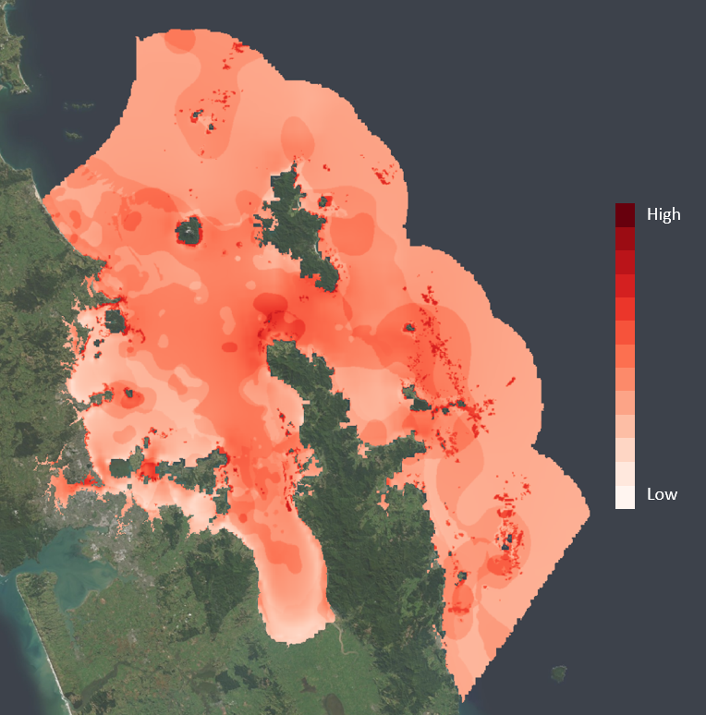
Figure 2.3: Modelled ecosystem service layer of predicted biogenic habitat provisioning.
Ranking shows relative importance for biogenic ecosystem services, from high (darkest shading) to low (lightest shading). Based on methods in Townsend and Thrush (2010).

Summary of layers used in biodiversity evaluation
Biodiversity and habitat datasets were used to determine their overlap with proposed marine reserves and seabed protected areas and to identify priority areas for protection using the Zonation software. For the Zonation analysis, an initial set of biodiversity data layers, comprising three types of habitat layers and demersal fish layers, was selected by the central government working group with advice from NIWA on how these could perform in a Zonation analysis (Table 2-2). Additionally, a set of fisheries layers (Table C-1) was provided by FNZ to inform an analysis of the likely displacement of existing commercial and recreational fisheries from proposed MPAs in the HGMP. Other datasets of existing management, including existing MPAs, marine farms, dredging areas, military zones, sand extraction zones and shipping zones were also compiled.
Table 2-2: Summary of biodiversity, habitat and management layers selected for input into Zonation spatial biodiversity prioritisation scenarios.

Data | Description | Source
Model input layers
Biogenic features | Dog cockles | DOC
 | Green lipped mussel | DOC
 | Mangroves | DOC
 | Rhodoliths | DOC
 | Saltmarsh | DOC
 | Seagrass | DOC
Modelled layers | Predicted biogenic ecosystem services | Townsend & Thrush, 2010
Physical habitats | 44 habitat types based on depth, sediment and exposure; 3 of the 47 available habitats were excluded as they were >200 m depth | DOC, adapted from Jackson & Lundquist 2016
Demersal fish | 90 of a total of 217 modelled species occurrence layers at a national scale | Stephenson et al. unpublished
Management layers | Existing marine reserves and Type 2 MPAs | DOC
 | Marine farms | Land Information New Zealand
 | Dredging areas | Land Information New Zealand
 | Military zones | Land Information New Zealand
 | Sand extraction zones | Land Information New Zealand
 | Shipping zones | Land Information New Zealand

Data pre-processing
All layers were re-projected to the NZ Albers Equal Area grid, and resampled at a grid scale of 250 m x 250 m. The Zonation model grid was defined as a grid of 761 by 1241 cells, which included the entire HGMP (Figure 2.4). The demersal fish dataset’s original resolution was 1 km² and includes part of New Zealand’s Territorial Seas (0 – 12 nautical miles offshore) and Exclusive Economic Zone (EEZ, 12 – 200 nautical miles offshore). To extrapolate the 1 km² demersal fish dataset to the boundary of the HGMP, these layers were extrapolated at a spatial resolution of 250 m x 250 m using a bilinear interpolation based on a weighted distance average of the four orthogonally adjacent cells.
Pilot analyses using Zonation (see Section 4) illustrated that a small portion of the southeast of the HGMP consistently received high priority due to the presence of continental slope habitat types and fauna that are atypical of HGMP habitats and deeper than 200 m. These slope habitats are not similar to the rest of the HGMP in terms of both habitat type and fauna due to their depth, though they are widespread and common habitats outside the HGMP. Following a discussion between scientists from

NIWA and central government, a decision was made to mask out the areas where these habitats are present to avoid skewing results in favour of habitat types that would more appropriately be analysed within the wider biogeographic region context, resulting in a modified boundary area to be used in the final analysis (Figure 2.4). Therefore, these three slope habitats were excluded from the rest of the Zonation analysis, resulting in a final list of 44 physical habitat layers (see Section 4).

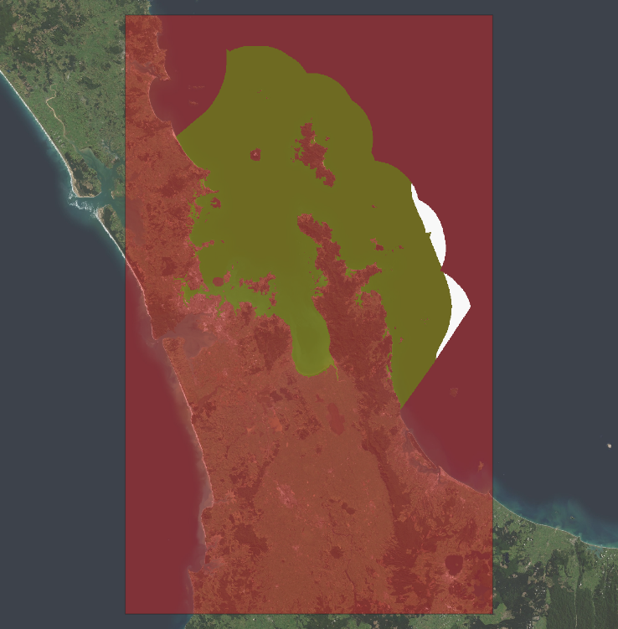
Figure 2.4: Hauraki Gulf Marine Park (HGMP) model area.
The red box is the grid of 761 x 1241 cells of size 250 m x 250 m, with the HGMP mask indicated by the dark green polygon. Areas of Moderate mid slope mud, Moderate upper slope mud and Moderate upper slope sand habitats that were excluded from analysis are indicated in white.

Biodiversity values and fisheries activities in Sea Change MPA proposals

Methodology
Combined proposal areas (Scenario 1 and Scenario 2 for marine reserves and seabed protected areas) as well as individual proposed marine reserves and seabed protected areas were evaluated against habitat and biodiversity layers, including biogenic habitats, biogenic ecosystem services, physical habitats, and demersal fish layers. To estimate the contribution of the proposed marine reserves toward biodiversity representation, we calculated the geospatial intersection between the marine reserve proposals and each of the biodiversity layers and fishing use layers. All pre-processing of data and intersect analysis was undertaken in ArcGIS (ArcMap v. 10.6). For each layer, we reported on the proportion of that layer occurring within combined or individual proposal boundaries. Shape files of each individual marine protected area (to the highest geospatial resolution available) and habitat and biodiversity features were used to delineate the position of marine protected area boundaries and the distribution of biodiversity layers. Files that were available only as rasters (i.e., demersal fish datasets, biogenic modelled layers) were converted from raster to shape files, and then intersect analyses were performed. For modelled layers (biogenic ecosystem services, demersal fish species occurrence models), intersect calculations represent the proportion of model values within the HGMP occurring within that proposal boundary, and are quantified by adding all values for a layer occurring within each proposed marine protected area polygon.
The overlap of spatial management proposals with fisheries data layers (Appendix C) are presented for proposed marine reserves and seabed protected areas in Scenarios 1 and 2 (Figure 3.1). The suite of fisheries layers included three years of annual fishing intensity (events or tows), catch intensity, and annual fishing and catch intensity of undersized snapper, for seven commercial fishing methods; recreational vessel density; and the ten year national average trawl footprint (2008-2018) (see Appendix C for detailed information on each layer). Annual average for commercial fishing effort and catch layers were provided for 2016/17, 2017/18, and 2018/19), with some spatial variability amongst years. A geospatial intersect analysis between the fisheries layers and combined proposal areas for Scenario 1 and Scenario 2 (Figure 1.1) was undertaken to estimate the potential displacement of fishing effort (including fishing intensity and catch intensity) and annual intensity of undersized snapper. The number of fisheries data layers used in the analysis of seabed protected areas was reduced as it only includes mobile bottom-contacting fishing methods, deemed to be incompatible with the maintenance and recovery of physical features and biogenic structures (Ministry of Fisheries and Department of Conservation 2008). Such methods are Danish seine, dredging, set netting and trawling. Note that catch and effort of trawl fishing data layers include both bottom and midwater trawling, and trawling and Danish seining are banned from the inner HGMP.

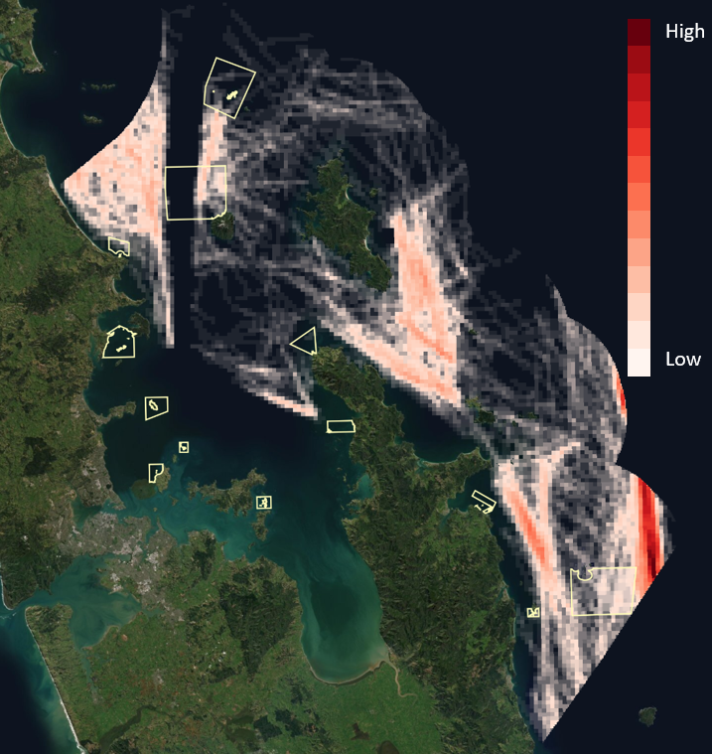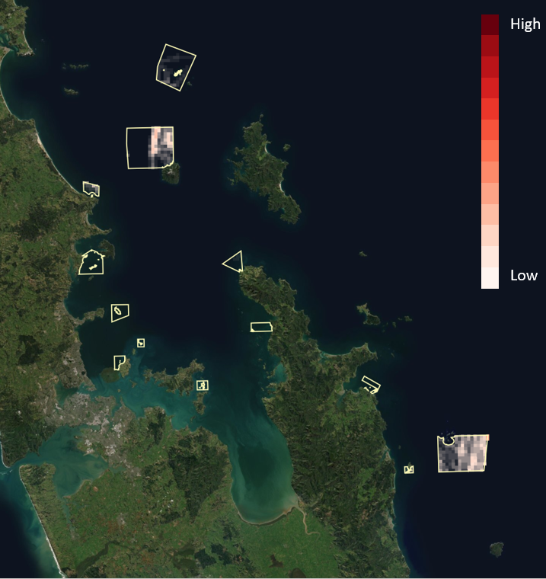
Figure 3.1: Annual intensity of trawl fishing from 2018/2019. Left: Full spatial footprint. Right: Data extracted for proposed marine reserves under Scenario 1.
Colours indicate the density of trawling, from white (low) to red (high). The polygon borders of each marine reserve under Scenario 1 are identified.
Fisheries data layers that were available for three years were averaged to provide an estimate of average effort over the period. For each fishery, fishery displacement was estimated by adding all values for a particular fishery metric occurring within each proposed marine reserve and seabed protected area polygon.
Annual fishing and catch intensity layers that represented fishing methods as events per statistical area (e.g., annual intensity of dredging or annual intensity of potting provided at the scale of relevant statistical reporting areas) were not included in the intersect analysis as these statistical areas are far larger than grid scales and individual proposed marine reserve polygons (maps are available from http://data-mpi.opendata.arcgis.com/).

Habitat and biodiversity features represented in proposed MPAs
The performance of proposed marine reserves can be evaluated as the relative proportion of each feature included within their boundaries compared to the relative area of the HGMP covered by the proposed area. A calculation would indicate ‘below par’, ‘on par’ and ‘above par’ efficiency if the proportion of a features’ range that is protected is less than, equal to or greater than the proportion a proposal covers of the total area of the HGMP, respectively (e.g., if feature A has 7% of its range protected within a MPA that covers 5% of the HGMP, this would be considered an ‘above par’ solution for feature A).
Marine reserves
Scenario 1 and Scenario 2 proposed marine reserves are poor at achieving above par protection (Table 3-1). Few biogenic habitat features were well represented in the proposed marine reserves, aside from strong coverage of dog cockles in Cape Colville, Motukawao, Rotoroa Island and the Noises, of rhodoliths in Kawau Bay (Scenario 1 only) and Tiritiri Matangi Island (Scenario 1 and 2), and of a subtidal seagrass feature in Slipper Island (Table B-1, Table B-2). The Scenario 1 and Scenario 2 marine reserve proposals both show above par protection of high value biogenic ecosystem services (modelled scores > 6), with 22.65% and 8.60%, respectively, of predicted biogenic ecosystem services within these marine reserve boundaries (Table 3-1). Most individual marine reserve proposals had above par protection, with the exception of the Cape Rodney Okakari Point Marine Reserve extension, Motukawao, both Kawau Bay scenario proposals, the Mokohinau Islands SC1 proposal and both Rangitoto and Motutapu scenario proposals (Table B-1, Table B-2).
On average, demersal fish receive below par protection from Scenario 1 marine reserves (Table 3-1). A subset of common recreational fish and rocky reef fish achieved on par or above par protection in Scenario 1 (Table 3-1), though soft sediment species (e.g., flounders) typically showed below par protection. In Scenario 1, 43 of the 90 evaluated demersal fish taxa received ‘on par’ or ‘greater than on par’ protection of their species occurrence (as a proxy of abundance) within an area of 4.52% of the HGMP (Table B-1). In Scenario 2, only 35 of the 90 evaluated demersal fish taxa received ‘on par’ or ‘greater than on par’ protection in the proposed marine reserves (Table 3-1). Detailed analyses of individual demersal fish species are presented in Table B-1 and Table B-2 in Appendix B.
On average, physical habitat types in the proposed marine reserves in Scenarios 1 and 2 achieved above par protection (Table 3-2). However, most habitat types were poorly represented within marine reserves, with only 19 and 16 of the 47 habitat types, respectively, receiving above par protection in Scenarios 1 and 2, and high protection typically only occurring in less extensive high current, rocky reef or gravel habitats. Some individual marine reserves performed well in terms of their individual contribution to the protection of these rarer habitats (see Table B-5, Table B-6). These include Cape Colville which included a number of high current habitats (deep gravel: 17.79%; deep rocky reef (10.69%); deep sand (4.68%); shallow gravel (4.76%) and shallow rocky reef (4.19%)), the Alderman Islands / Te Ruamaahua with high proportions of moderate deep gravel (32.90%) and moderate deep rocky reef (8.98%), and Little Barrier Island/ Hauturu with high proportions of sheltered deep habitats (mud: 5.83; rocky reef: 4.80%; sand (4.11%)). Gravel/coarse sediments and rocky reef habitats, which often covered only small areas (<1% of the HGMP) were more likely to have above par in the proposals. With the exception of estuarine rocky reefs and estuarine shallow mud in Rangitoto and Motutapu, and estuarine rocky reefs in Kawau Bay SC1, estuarine habitats were poorly protected in the marine reserve proposed areas in both Scenarios.
Seabed protected areas
Seabed protected areas in Scenarios 1 and 2 included higher proportions of biogenic habitats than the marine reserve scenarios (with the exception of dog cockles), primarily due to the larger proportion of the HGMP covered by the seabed protected area scenarios (Table 3-1). For the proportion of the HGMP protected in Scenarios 1 and 2, protection for dog cockles, saltmarsh, and seagrass was below par (Table 3-1). However, some individual seabed protected areas performed well in terms of their individual contribution to the protection of these taxa (Table B-3, Table B-4). In contrast, the protection of green lipped mussels, mangroves and rhodoliths was above par, with protection of rhodolith beds as high as 52.2% and 87.5% under Scenario 1 and 2, respectively (Table 3-1, Table B-3, Table B-4).
Biogenic ecosystem services received above par protection under all seabed protected area scenarios, with 2-3 times the relative area protected (Table 3-1). Demersal fish layers received, on average, just above par protection in seabed protected area Scenario 1 and 2 including SMAs (Table 3-1), with some species receiving particularly high protection (e.g., yellow eyed mullet and yellow-belly flounder, each receiving ~60% protection).

Table 3-1: Biodiversity feature protection (as percentage of the total distribution within HGMP) within each MPA Scenario proposal.
Analyses include the Slope habitats (>200 m) that were excluded from Zonation analyses in Section 4. Fish species include a subset of species analysed; the full analysis of all species is presented in Table B-1 and Table B-2 in Appendix B. Shaded cells with values in bold indicate greater performance than on par protection relative to the area of the HGMP covered by that proposed marine reserve.
Biodiversity feature | Species name | Scenario 1 Marine reserves | Scenario 2 Marine reserves | Scenario 1 Seabed protected areas | Scenario 2 Seabed protected areas (including SMAs) | Scenario 2 Seabed protected areas (excluding SMAs)
Total percentage of HGMP area |  | 4.52 | 3.20 | 14.41 | 14.19 | 10.26
Biogenic habitats
Dog cockles |  | 13.56 | 13.56 | 5.73 | 5.73 | 5.73
Green lipped mussels |  | 0.0 | 0.0 | 18.42 | 18.42 | 18.42
Mangrove |  | 0.0 | 0.0 | 23.00 | 22.27 | 22.27
Rhodolith |  | 38.52 | 1.15 | 52.17 | 87.50 | 87.50
Saltmarsh |  | 0.0 | 0.0 | 8.13 | 7.73 | 7.73
Seagrass |  | 0.8 | 0.8 | 11.28 | 7.52 | 7.52
Biogenic ecosystem services |  | 22.65 | 8.60 | 31.61 | 36.61 | 22.97
Demersal fish
Mean (all demersal fish) |  | 4.34 | 3.00 | 15.18 | 14.67 | 9.36
Mean (endemic demersal fish only) |  | 3.80 | 2.63 | 16.06 | 15.96 | 11.70
Number of demersal fish with greater than on par protection |  | 43 | 35 | 29 | 29 | 29
Yellow eyed mullet | Aldrichetta forsteri | 1.70 | 0.96 | 60.32 | 61.03 | 60.91
Kahawai | Arripis trutta | 3.54 | 2.34 | 36.58 | 37.27 | 34.58
Gurnard | Chelidonichthys kumu | 4.87 | 3.55 | 14.32 | 14.17 | 10.72
Snapper | Chrysophrys [Pagrus] auratus | 4.66 | 3.29 | 14.74 | 14.54 | 10.74
Parore | Girella tricuspidata | 5.36 | 0.58 | 28.71 | 33.32 | 33.19
Blue moki | Latridopsis ciliaris | 13.38 | 12.20 | 10.09 | 10.07 | 3.73
Leatherjacket | Meuschenia scaber | 5.83 | 4.63 | 8.84 | 8.61 | 4.70
Tarakihi | Nemadactylus macropterus | 6.19 | 4.44 | 9.57 | 8.42 | 0.61
Blue cod | Parapercis colias | 5.04 | 4.48 | 10.05 | 9.83 | 7.53
Hapuku | Polyprion oxygeneios | 4.15 | 3.17 | 8.76 | 6.50 | 0.63
Trevally | Pseudocaranx georgianus | 4.74 | 3.04 | 16.84 | 17.39 | 13.65
Yellow-belly flounder | Rhombosolea leporina | 2.09 | 1.31 | 58.50 | 59.15 | 59.09
Sand flounder | Rhombosolea plebeia | 2.92 | 1.89 | 23.35 | 24.19 | 22.91
Kingfish | Seriola lalandi | 5.46 | 3.60 | 13.82 | 13.83 | 7.28
Jack mackerel | Trachurus declivis | 4.96 | 3.17 | 9.91 | 9.03 | 0.92
Jack mackerel | Trachurus murphyi | 4.55 | 3.42 | 11.94 | 10.24 | 2.00

Seabed protected area scenarios show on average slightly above par protection of physical habitats, however there are large differences in representation between the typically smaller rocky reef and coarse sediment (i.e., gravel) habitat types and those in high current areas which typically comprise <1% of the HGMP, relative to the abundant deep mud and sand habitats that comprise a large proportion of the HGMP (Table 3-2). Over half of the HGMP is comprised of moderate and sheltered deep (30-200 m depth) sand and mud habitats; most other habitats comprise less than 1% of the total HGMP. Approximately 3.4% of the HGMP is >200 m slope habitats, and <2% of the HGMP is found in the five estuary habitat types.
Table 3-2: Physical habitat protection (as percentage of the total distribution within HGMP) within each Marine reserve and seabed protected area Scenario proposal.
Shaded cells with values in bold indicate greater performance than on par protection relative to the area of the HGMP covered by that proposed marine reserve.
Physical habitat | Scenario 1 Marine reserves | Scenario 2 Marine reserves | Scenario 1 Seabed protected areas | Scenario 2 Seabed protected areas (including SMAs) | Scenario 2 Seabed protected areas (excluding SMAs)
Total percentage of HGMP area | 4.52 | 3.20 | 14.41 | 14.19 | 10.26
Mean | 5.38 | 3.31 | 17.06 | 18.73 | 17.04
Number of physical habitats with  greater than on par protection | 19 | 16 | 18 | 18 | 20
Estuarine Intertidal Rocky Reef | 4.08 | 4.08 | 4.08 | 4.08 | 4.08
Estuarine Intertidal Soft Sediment | 0.09 | 0.00 | 5.79 | 3.01 | 3.01
Estuarine Shallow Mud | 0.75 | 0.25 | 8.79 | 9.04 | 9.04
Estuarine Shallow Rocky Reef | 0.98 | 0.00 | 13.73 | 16.67 | 16.67
Estuarine Shallow Sand | 0.00 | 0.00 | 1.10 | 0.73 | 0.73
High Current Deep Gravel | 17.79 | 17.79 | 50.16 | 50.16 | 50.16
High Current Deep Mud | 0.00 | 0.00 | 7.98 | 7.98 | 7.98
High Current Deep Rocky Reef | 10.69 | 10.69 | 67.92 | 67.92 | 67.92
High Current Deep Sand | 4.68 | 4.68 | 18.38 | 18.38 | 18.38
High Current Intertidal Rocky  Reef | 0.00 | 0.00 | 16.67 | 16.67 | 16.67
High Current Intertidal Soft  Sediment | 0.00 | 0.00 | 10.00 | 10.00 | 10.00
High Current Shallow Gravel | 4.76 | 4.76 | 6.80 | 6.80 | 6.80
High Current Shallow Mud | 0.00 | 0.00 | 79.64 | 79.64 | 79.64
High Current Shallow Rocky Reef | 6.98 | 6.98 | 45.11 | 45.11 | 45.11
High Current Shallow Sand | 4.92 | 4.92 | 12.29 | 12.29 | 12.29
Moderate Deep Gravel | 32.90 | 32.90 | 0.00 | 0.00 | 0.00
Moderate Deep Mud | 3.70 | 3.40 | 8.63 | 6.85 | 0.00
Moderate Deep Rocky Reef | 12.55 | 9.35 | 23.82 | 24.87 | 0.03
Moderate Deep Sand | 6.09 | 1.87 | 11.73 | 10.42 | 0.04
Moderate Intertidal Rocky Reef | 0.00 | 0.00 | 0.00 | 0.00 | 0.00
Moderate Mid slope Mud | 0.00 | 0.00 | 0.00 | 0.00 | 0.00
Moderate Shallow Gravel | 0.00 | 0.00 | 0.00 | 0.00 | 0.00
Moderate Shallow Mud | 0.00 | 0.00 | 0.00 | 0.00 | 0.00
Moderate Shallow Rocky Reef | 6.31 | 2.84 | 21.14 | 24.61 | 0.32
Moderate Shallow Sand | 1.57 | 1.00 | 4.27 | 5.12 | 0.14
Moderate Upper Slope Mud | 2.25 | 2.25 | 0.31 | 0.31 | 0.00
Moderate Upper Slope Sand | 0.00 | 0.00 | 0.00 | 0.00 | 0.00
Sheltered Deep Gravel | 1.30 | 1.30 | 0.55 | 0.41 | 0.41
Sheltered Deep Mud | 5.83 | 5.83 | 4.88 | 4.88 | 4.88
Sheltered Deep Rocky Reef | 5.34 | 5.16 | 17.79 | 17.97 | 16.55
Sheltered Deep Sand | 4.61 | 4.61 | 6.87 | 6.88 | 6.87
Sheltered Intertidal Rocky Reef | 0.79 | 0.79 | 6.34 | 7.93 | 3.96
Sheltered Intertidal Soft  Sediment | 0.00 | 0.00 | 0.00 | 0.00 | 0.00
Sheltered Shallow Gravel | 1.52 | 1.52 | 40.91 | 40.91 | 40.91
Sheltered Shallow Mud | 0.00 | 0.00 | 0.00 | 0.00 | 0.00
Sheltered Shallow Rocky Reef | 5.50 | 5.42 | 7.76 | 7.76 | 5.67
Sheltered Shallow Sand | 3.10 | 3.06 | 0.84 | 0.86 | 0.80
Very Sheltered Deep Gravel | 32.03 | 0.39 | 14.84 | 40.23 | 40.23
Very Sheltered Deep Mud | 1.14 | 0.22 | 14.78 | 15.78 | 15.78
Very Sheltered Deep Rocky Reef | 0.82 | 0.82 | 38.52 | 38.52 | 38.52
Very Sheltered Deep Sand | 0.57 | 0.42 | 12.44 | 12.65 | 12.65
Very Sheltered Intertidal Rocky  Reef | 6.15 | 2.05 | 10.52 | 13.34 | 13.34
Very Sheltered Intertidal Soft  Sediment | 0.12 | 0.12 | 74.07 | 74.32 | 74.32
Very Sheltered Shallow Gravel | 42.32 | 6.74 | 35.58 | 69.66 | 69.66
Very Sheltered Shallow Mud | 5.35 | 1.99 | 41.52 | 44.52 | 44.52
Very Sheltered Shallow Rocky  Reef | 12.49 | 5.67 | 25.03 | 32.11 | 32.06
Very Sheltered Shallow Sand | 2.73 | 1.89 | 30.63 | 31.29 | 31.29

Proposed MPAs were further evaluated to determine overlap with a national dataset of primarily point records of biogenic habitats (i.e., observed occurrences of a biogenic habitat type) (Anderson et al. 2019). This dataset includes a compilation of locations where these habitat types have been observed, but does not represent comprehensive sampling of presence and absence of these habitat types in the HGMP. Thus, these point records indicate locations where biogenic habitats have been found, but an absence of a point record in this dataset does not necessarily imply no biogenic habitats are found at that location (Anderson et al. 2019). A total of 10,528 individual records were recorded in the HGMP in this dataset; a number of records occurred at the same site, and for the same taxa. For example, two locations in Firth of Thames recorded >100 individual bivalves. Records from within the HGMP included 9 biogenic habitat categories (Algal meadows, Biogenic habitat, Bivalve, Bryozoan, Kelp, Mangrove, Rhodolith, Seagrass, and Sponge, but not Seapens). A total of 1,064 or approximately 10% of the records in the HGMP were within proposed marine reserves, seabed protected areas or special management areas (SMAs) (Table B-9). The number of biogenic habitat categories with records in each individual MPA ranged from 0 to 6, with 10 proposed MPA areas containing no biogenic habitat records. Marine reserves overlapped with a total of 15 biogenic habitat locations representing 85 records. Proposed seabed protected areas overlapped with a total of 37 biogenic habitat locations representing 976 records, 808 of which came from two locations in the Firth of Thames.

Comparison of Scenario 1 and Scenario 2
At the four locations where two alternative marine reserve options were proposed (Kawau Bay, Mokohinau Islands, Rangitoto & Motutapu, and Tiritiri Matangi Island), Scenario 1 provided substantially greater benefits to biodiversity and seafloor habitats than Scenario 2 (Table 3-3). This is to be expected considering that in the cases where two alternative marine reserves at the same location are proposed the Scenario 2 marine reserves are all considerably smaller. Results for all habitat types and all demersal fish species are presented in Appendix B.
Table 3-3: Comparison of biodiversity and habitat features (as percentage of the total distribution within HGMP) within proposed sites having two marine reserve options.
Shaded cells with values in bold indicate greater performance than on par protection relative to the area of the HGMP covered by that proposed marine reserve.
 | Kawau Bay |  | Mokohinau Islands |  | Rangitoto & Motutapu |  | Tiritiri Matangi Island
Biodiversity/habitat feature | SC1 | SC2 | SC1 | SC2 | SC1 | SC2 | SC1 | SC2
Total percentage of HGMP area | 0.32 | <0.01 | 0.84 | 0.01 | 0.08 | 0.05 | 0.16 | 0.01
Biogenic habitats
Dog cockles | 0.00 | 0.00 | 0.00 | 0.00 | 0.00 | 0.00 | 0.00 | 0.00
Green lipped mussels | 0.00 | 0.00 | 0.00 | 0.00 | 0.00 | 0.00 | 0.00 | 0.00
Mangrove | 0.00 | 0.00 | 0.00 | 0.00 | 0.00 | 0.00 | 0.00 | 0.00
Rhodoliths | 27.93 | 0.00 | 0.00 | 0.00 | 0.00 | 0.00 | 10.59 | 1.15
Saltmarsh | 0.00 | 0.00 | 0.00 | 0.00 | 0.00 | 0.00 | 0.00 | 0.00
Seagrass | 0.00 | 0.00 | 0.00 | 0.00 | 0.00 | 0.00 | 0.00 | 0.00
Biogenic ecosystem services | 0.30 | 0.00 | 0.42 | 0.01 | 0.01 | 0.01 | 0.98 | 0.12
Demersal fish
Demersal fish (average of all species) | 0.26 | 0.00 | 1.01 | 0.01 | 0.02 | 0.01 | 0.09 | 0.00
Demersal fish (average of endemic species) | 0.29 | 0.01 | 0.76 | 0.01 | 0.03 | 0.01 | 0.12 | 0.00
Number of demersal fish with greater than on par protection | 22 | 28 | 49 | 59 | 8 | 4 | 24 | 5
Physical habitats
Physical habitats (average of all habitat types) | 0.27 | 0.01 | 0.30 | 0.04 | 0.17 | 0.16 | 1.70 | 0.15
Number of physical habitats with greater than on par protection | 5 | 2 | 4 | 6 | 5 | 5 | 6 | 3
Physical habitats (average of 14 rocky reef habitat) | 0.59 | 0.02 | 0.52 | 0.06 | 0.46 | 0.47 | 0.26 | 0.03
Physical habitats (average of 8 gravel habitats) | 0.00 | 0.00 | 0.00 | 0.00 | 0.00 | 0.00 | 8.22 | 0.75
Physical habitats (average of 5 estuarine habitats) | 0.32 | 0.00 | 0.00 | 0.00 | 0.87 | 0.87 | 0.00 | 0.00

At the five locations where two different seabed protected area options were proposed, Scenario 1 options often provide lower protection of physical habitats than Scenario 2. For Tiritiri Matangi Island and for Kawau Bay, Scenario 2 includes a large area that is classified as a marine reserve in Scenario 1. In Scenario 2, the seabed protected areas of the Alderman Islands / Te Ruamaahua and the Mokohinau Islands are instead SMAs (Table 3-4). Results for all habitat types and all demersal fish species are presented in Appendix B.

Table 3-4: Comparison of biodiversity and habitat features (as percentage of the total distribution within HGMP) within proposed sites having two seabed protected area options.
Note the seabed protected areas for Tiritiri Matangi Island and for Kawau Bay in Scenario 2 are larger than the Scenario 1 alternatives due to the marine reserves nested within being smaller. For the Alderman Islands / Te Ruamaahua and the Mokohinau Islands, seabed protected areas are instead special management areas (SMAs) in Scenario 2. Shaded cells with values in bold indicate greater performance than on par protection relative to the area of the HGMP covered by that proposed marine reserve.
Biodiversity/habitat feature | Alderman Islands / Te Ruamaahua | Kawau Bay |  | Mokohinau Islands | Tiritiri Matangi Island |  | Whangateau Harbour
 | SC1 | SC1 | SC2 | SC1 | SC1 | SC2 | SC1
Total percentage of HGMP area | 2.25 | 1.17 | 1.49 | 2.32 | 0.43 | 0.57 | 0.04
Biogenic habitats
Dog cockles | 0.00 | 0.03 | 0.03 | 0.00 | 0.00 | 0.00 | 0.00
Green lipped mussel | 0.00 | 18.42 | 18.42 | 0.00 | 0.00 | 0.00 | 0.00
Mangrove | 0.00 | 0.87 | 1.16 | 0.00 | 0.00 | 0.00 | 1.02
Rhodoliths | 0.00 | 31.76 | 58.80 | 0.00 | 19.13 | 27.42 | 0.00
Saltmarsh | 0.00 | 0.00 | 0.41 | 0.00 | 0.00 | 0.00 | 0.81
Seagrass | 0.00 | 7.52 | 7.52 | 0.00 | 0.00 | 0.00 | 3.76
Biogenic ecosystem services | 2.37 | 2.20 | 2.53 | 0.94 | 0.39 | 1.21 | 0.00
Demersal fish
Demersal fish (average of all species) | 3.60 | 0.76 | 0.99 | 2.53 | 0.26 | 0.34 | *
Demersal fish (average of endemic species) | 2.86 | 0.93 | 1.20 | 1.87 | 0.38 | 0.48 | *
Number of demersal fish with greater than on par protection | 57 | 24 | 24 | 57 | 27 | 26 | *
Physical habitats
Physical habitats (average of all habitat types) | 1.09 | 2.70 | 2.96 | 0.51 | 0.55 | 1.95 | 0.08
Number of physical habitats with greater than on par protection | 5 | 17 | 16 | 4 | 10 | 10 | 4
Physical habitats (average of 14 rocky reef habitat) | 2.73 | 6.37 | 7.17 | 0.87 | 0.40 | 0.53 | 0.02
Physical habitats (average of 8 gravel habitats) | 0.0 | 0.98 | 0.67 | 0.0 | 1.06 | 8.79 | 0.0
Physical habitats (average of 5 estuarine habitats) | 0.0 | 5.59 | 6.29 | 0.0 | 0.0 | 0.0 | 0.69

Evaluation of overlap of proposed protected areas with fisheries
The detailed results of the evaluation of the overlap of fisheries data with the marine reserve and seabed protected area proposals in Scenarios 1 and 2 are provided in Appendix D (Table D-1, Table D-2, Table D-3, Table D-4).

Marine Reserves
As expected, the displacement of all types fishing activity and catch in Scenario 1 are consistently higher because Scenario 1 excludes fishing from a larger area (~635 km²) than Scenario 2 (~450 km²) (Table 1-1).
In Scenarios 1 and 2, the highest annual fishing effort displacement in terms of the absolute number of events or trawls was for long lining and trawling. Purse seining was the most affected in terms of percentage of effort displaced (7.4% and 7.2%, respectively, for Scenarios 1 and 2; Table 3-5).
Trawl fishing had 4.4% and 4.2% percentage of catch displaced in Scenarios 1 and 2, respectively, with an estimated displacement of over 1,000,000 kg in both scenarios (Table 3-5, Table 3-6). Displacement of catch was second highest in purse seine fisheries with an estimated 6.4% (>470,000 kg) of the catch displaced by proposed marine reserves under both scenarios (Table 3-5, Table 3-6).
The annual average displacement of effort for trawl fisheries for the 2016-2019 period in Scenario 1 (2,426 trawls) and 2 (2,302 trawls) was less than the displacement obtained using the national ten year time series 2008-2018, which was ~32,000 trawls for Scenario 1 and ~30,000 for Scenario 2 (~3,000 trawls per year) (Table D-2). This estimate suggests that trawl fishing intensity over the last four years in the areas proposed under Scenario 1 may be lower than the historical average, with observed values for these four years lower than 3000 trawls per year (Appendix D, Table D-1).
On average, rock lobster potting was the most displaced fishing method in terms of percentage of catch, with an estimated catch displacement of 9.7% and 6.7% under Scenario 1 and Scenario 2 respectively (Table 3-5, Table 3-6). However, caution is advised when interpreting the results. Because potting effort and catch are reported by statistical area, catch was interpolated across rocky reefs within the statistical area as an estimate of fine-scale catch intensity. The estimates of potting displacements are expected as many of the proposed marine reserves are located along the HGMP’s rocky coasts targeted by the lobster fishery.
Protection of undersized snapper was greater under Scenario 1 than Scenario 2, with an estimated annual average catch of 31,085 kg, mostly by trawl fishing (Appendix D, Table D-1, Table D-2). Long lining and Danish seining are estimated to catch ~700 kg of undersized snapper altogether within Scenario 1 marine reserves. Total catch of undersized snapper on average during 2016-2019 period within Scenario 1 marine reserves was over twice as high in 2016-2017, compared to overall trawling catch in 2017-2018 and 2018-2019. Average catch of undersized snapper for the 2016-2019 period within Scenario 2 marine reserves showed a similar pattern amongst years, with trawl fishing accounting for most of the catch (29,682 kg).
The annual rate of displacement of recreational fishing vessels varied between 6.4% and 7.7% for Scenario 1 marine reserves for the periods for which detailed aerial survey information was available (2004/2005, 2011/2012, 2017/2018) (Table D-1). Recreational fishing counts are by experienced observers of boats actively engaged in fishing at the time of overflight. The annual rate of displaced recreational vessels under Scenario 2 marine reserves was approximately half of that of Scenario 1, varying between 3.1 % and 3.4 % across the three survey periods (Table D-2). Recreational fishing surveys occur approximately every 5 years, and spatial changes in recreational fishing activity may not be detected at this coarse temporal survey scale.
Table 3-5: Annual estimated displacement of fishing effort for Scenario 1 and Scenario 2 marine reserves for each fishing method averaged for the 2016 to 2019 period.
Each fishing method refers to all species combined unless specifically stated otherwise. Displacement for each fishing method is given as the absolute number of trawls/events as well as in the percentage of trawls events within the HGMP.

Fishing method | Scenario 1 |  | Scenario 2
 | Displacement in # of fishing trawls or events | Displacement in % | Displacement # of fishing trawls or events | Displacement in %
Trawl fishing | 2,426 | 4.2 | 2,302 | 3.9
Danish seining | 1,391 | 2.0 | 626 | 0.9
Purse seining | 584 | 7.4 | 573 | 7.2
Long lining | 6,228 | 5.8 | 3,304 | 3.1
Set net fishing | 424 | 4.0 | 180 | 1.3

Table 3-6: Annual estimated displacement of catch for Scenario 1 and Scenario 2 marine reserves for each fishing method averaged for the 2016 to 2019 period.
Each fishing method refers to all species combined unless specifically stated. Displacement for each fishing method is given as the absolute number of trawls/events as well as in the percentage of trawls events within the HGMP.

Fishing method | Scenario 1 |  | Scenario 2
 | Displacement  (catch, kg) | Displacement  in % | Displacement  (catch, kg) | Displacement  in %
Trawl fishing | 1,127,933 | 4.4 | 1,080,905 | 4.2
Danish seining | 13,419 | 2.0 | 5,493 | 0.8
Purse seining | 475,196 | 6.4 | 473,029 | 6.4
Long lining | 80,733 | 6.4 | 41,574 | 3.3
Set net fishing | 2,822 | 4.0 | 1,115 | 1.4
Potting – rock lobster | 21,893 | 9.7 | 15,091 | 6.7

Seabed protected areas
The intersect analysis of seabed protected areas under Scenario 1 and Scenario 2 was performed against catch and intensity layers for Danish seining, trawling and set netting, the latter being sometimes banned in seafloor protected areas.
Given the differences in area (2,027 km² for Scenario 1 and 1,444 km² for Scenario 2), displacement was larger for Scenario 1, as expected, for both trawling and set netting, though slightly lower for Danish seining. Fishing effort and catch displacement of Danish seining yielded larger absolute values and higher percentages for Scenario 2 than for Scenario 1, with 6.2% and 7.1% for effort and catch, respectively (Table 3-7, Table 3-8). Displacement of set netting was higher under Scenario 1 than under Scenario 2, primarily associated the large seabed protected area around Tiritiri Matangi island.
Set netting displacement for catch and effort were significantly increased for both scenarios when compared to the estimated displacements under marine reserves scenarios (Table 3-6, Table 3-7, Table 3-8). Most of the set netting effort and catch tends were associated with the inner Gulf, including the southern Firth of Thames. Although the estimated annual displacement for set netting effort was 33.9% (Scenario 1) and 26.7% (Scenario 2) (Table 3-7) it reached percentages as high as 57.3% (Scenario 1) and 56.0% (Scenario 2) for the 2018-2019 period, making it the most affected fishery, in terms of effort, in the whole analysis (Appendix D, Table D-3, Table D-4).
Table 3-7: Annual estimated displacement of fishing effort for Scenario 1 and Scenario 2 seabed protected areas for each fishing method averaged for the 2016 to 2019 period.
Each fishing method refers to all species combined unless specifically stated otherwise. Displacement for each fishing method is given as the absolute number of trawls/events as well as in the percentage of trawls events within the HGMP.

Fishing method | Scenario 1 |  | Scenario 2
 | Displacement in # of fishing trawls or events | Displacement in % | Displacement # of fishing trawls or events | Displacement in %
Trawl fishing | 4,488 | 7.6 | 828 | 4.0
Danish seining | 4,175 | 5.9 | 4,385 | 6.2
Set net fishing | 5,155 | 33.9 | 4,517 | 26.7

Table 3-8: Annual estimated displacement of catch for Scenario 1 and Scenario 2 seabed protected areas for each fishing method on average for the 2016 to 2019 period.
Each fishing method refers to all species combined unless specifically stated. Displacement for each fishing method is given as the absolute number of trawls/events as well as in the percentage of trawls events within the HGMP.

Fishing method | Scenario 1 |  | Scenario 2
 | Displacement  (catch, kg) | Displacement  in % | Displacement  (catch, kg) | Displacement  in %
Trawl fishing | 1,986,869 | 7.6 | 544,874 | 2.0
Danish seining | 42,255 | 6.9 | 44,700 | 7.1
Set net fishing | 25,286 | 28.7 | 22,091 | 23.3

Areas of overlap of proposed seabed protected areas with catch of undersized snapper, averaged across the 2016-2019 period, was greatest for trawl fisheries, with ~68,000 kg and ~42,000 kg under Scenario 1 and Scenario 2 respectively (Appendix D, Table D-3, Table D-4). This represented an increase of more than 50% when compared to protection of undersized snapped provided by marine reserves under Scenario1 (~31,000 kg).

Analysis of Sea Change MPA proposals using the Zonation spatial prioritisation decision-support tool

Introduction to spatial conservation prioritisation using Zonation
The selection of potential sites and design of spatial management measures, including MPAs, is a complex process that needs to consider biodiversity and management goals alongside socio-economic outcomes (Margules & Pressey 2000). Conceptual frameworks assisted by decision-making software have arisen as an important tool to help managers and practitioners design effective plans to preserve and enhance ecosystems and the resources they provide (Knight et al. 2006; Pressey et al. 2007; Groves et al. 2009). One of the software tools commonly applied to the design of MPAs is Zonation (Moilanen 2004).
Zonation has been used both in New Zealand (Rowden et al. 2019; Geange et al. 2017; Jackson 2014; Jackson and Lundquist 2016; Leathwick et al. 2006) and overseas (Lehtomäki et al. 2019; Karimi & Hockings, 2018; Lehtomäki & Moilanen 2013; Liang et al. 2018; Stewart et al. 2018) to help to identify priorities for spatial management and conservation. Zonation selects high priority areas for conservation through an algorithm that progressively discards locations that make the smallest contribution to biodiversity representation until the entire evaluated area has been assessed. The algorithm uses a priority ranking that is primarily based on the consideration of species or habitats of importance. However, a range of other model options can be selected to tailor solutions to particular circumstances and objectives; these options include weighting of different biodiversity features, aggregation algorithms, representing network or individual species connectivity, cost or trade-off layers, and mask layers that force either the inclusion or exclusion of particular areas in priority solutions (Moilanen et al. 2005). The area being assessed can be understood as a grid or a matrix in which cells are ranked for their conservation value given the objectives, weightings, and constraining criteria. One output from Zonation is a set of performance curves that describes the level of protection for each biodiversity feature as the proportion of the model area in protected areas is progressively reduced. Zonation also provides a visual output for each scenario showing the priority value for each cell to assist in identifying areas of high value for biodiversity conservation.
Zonation scenarios were assessed to determine how well they compared with an achievement of ‘on par protection efficiency’, where at least the same proportion of each biodiversity feature is protected relative to the proportion a proposal covers of the total area of the HGMP (e.g., if feature A has 5% of its range protected within the top 5% priority areas this would be considered on par protection for feature A, whereas protection of >5% would be above par, and protection of <5% would be below par). Often, Zonation scenarios indicate spatial optimisations that deliver far larger efficiencies, i.e., 20% of a feature within 5% of the total model area.

Development of Zonation baseline for assessing marine reserve proposals
A baseline scenario was developed to provide an initial prioritisation analysis that includes solely biodiversity, habitats and ecosystem service features in the HGMP. This baseline scenario or ‘blank canvas’ (which excludes consideration of other spatial activities) can then be used as a reference to determine the efficiency of existing MPAs, the HGMSP marine reserve and seabed protected proposals in protecting a representative range of biodiversity, and to identify the impacts that the inclusion of commercial or recreational fisheries layers, or with other spatially defined activities such as marine farms have on achieving conservation outcomes.
The baseline scenario used the basic core-area Zonation (CAZ) algorithm. This approach selects cells based on prioritising representation of all biodiversity features, including those with restricted distributions (Moilanen et al. 2005; Moilanen 2007). The Additive Benefit Function (ABF) algorithm, which prioritises species richness, was also tested, though results were generally similar.
Multiple Zonation runs were performed in the process of developing the baseline scenario. Initially, no specific weightings were defined for different biodiversity features in the scoping exercise, which means that all layers were valued equally by the processing algorithm. An equal weight for scoping analyses allows for interpretation of which layers are the main drivers of the prioritisation results. In order to facilitate comparisons between results, the baseline scoping exercise investigated three types of scenarios: 1) physical habitat features only; 2) biodiversity (demersal fish) features only; and 3) the previous two scenarios combined plus biogenic features and six additional biogenic habitats. Further baseline analyses included assessment of including higher weights for rocky reef habitats, and potential implications of reducing the area for analysis to exclude existing spatial restrictions such as military zones.

Baseline scoping – Physical habitat features
The first scoping scenario explored used solely the 44 physical habitat layers (excluding three >200 m deep slope habitats), representing a local HGMP adaptation of the Inshore Marine Habitat Classification based on available environmental drivers (Figure 4.1). This scoping scenario identified areas with the highest priority for conservation as being located within the inner Hauraki Gulf, the east coast of the Coromandel Peninsula and the areas surrounding the outer islands. Physical habitats with limited distributions (i.e., only covering a small total area of the Hauraki Gulf) were preferentially selected while habitats covering large areas were less well represented in priority solutions. This result is expected as all habitats were equally weighted and the removal rule was set to the Core Area Zonation algorithm. Because no cell has more than one ‘habitat’ present, Zonation prioritises cells based on the relative proportion of a biodiversity feature present in each cell (thus biases toward restricted range features). For example, for a model area of 1000 cells, a habitat that is only present in 1% percent of the model area would be present in about 10 model cells and have a value of 1/10 (0.1) for each cell, whereas a common habitat present in 10% of the HGMP would be present in 100 cells and have a value of 1/100 (0.01) for each cell. Following prioritisation based on individual cell values for biodiversity features, Zonation further allocates priority to cells with identical cell values based on proximity to other neighbouring habitat types, typically resulting in priority areas being found at the boundary of two neighbouring habitat types.
While this physical habitat prioritisation is an unrealistic scenario, it allows visualisation of the effect of non-overlapping habitat layers, and how they drive the solution prior to additional layers being included in Zonation (Figure 4.1). Typically, habitat layers would be used in addition to other biodiversity features, and would be given lower weightings or the matrix connectivity algorithm used to try to weight habitat priorities based on similarity between habitats (e.g., estuarine sand would be more similar to estuarine mud than to estuarine rocky reef).
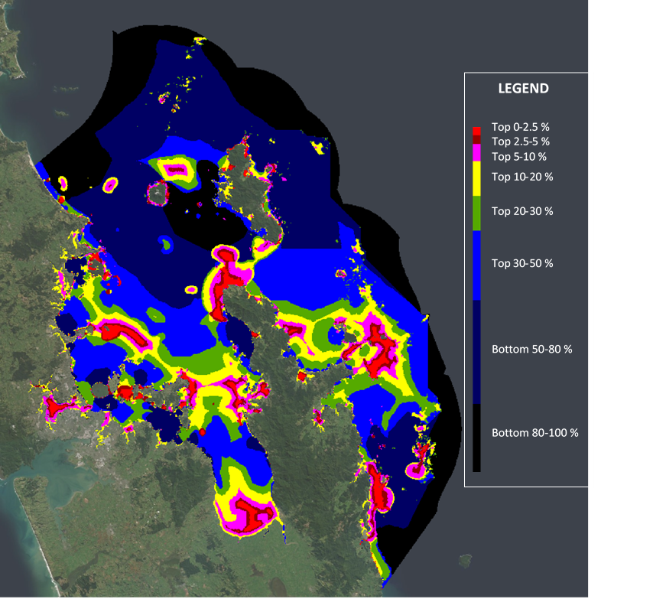
Figure 4.1: Spatial prioritisation of the baseline scoping scenario with only physical habitat layers as input.
Warm colours indicate higher priority areas for biodiversity representation, and colder colours indicate lower priority areas.
Zonation ‘performance curves’ illustrate how each biodiversity feature is prioritised within each scenario as lower value cells are removed from a scenario. These curves show that habitats with limited distributions (e.g., rocky reefs) receive highest priority selection as they are not selected until the final, or highest priority, stages of the iterative process (Figure 4-2). These rocky reef habitats and other cells containing rarer habitats such as Estuarine Shallow Rocky Reef are more likely to be prioritised compared with cells containing abundant habitats, such as Moderate Deep Mud, for which individual cells make a smaller overall contribution to the overall habitat distribution (Figure 4-2).

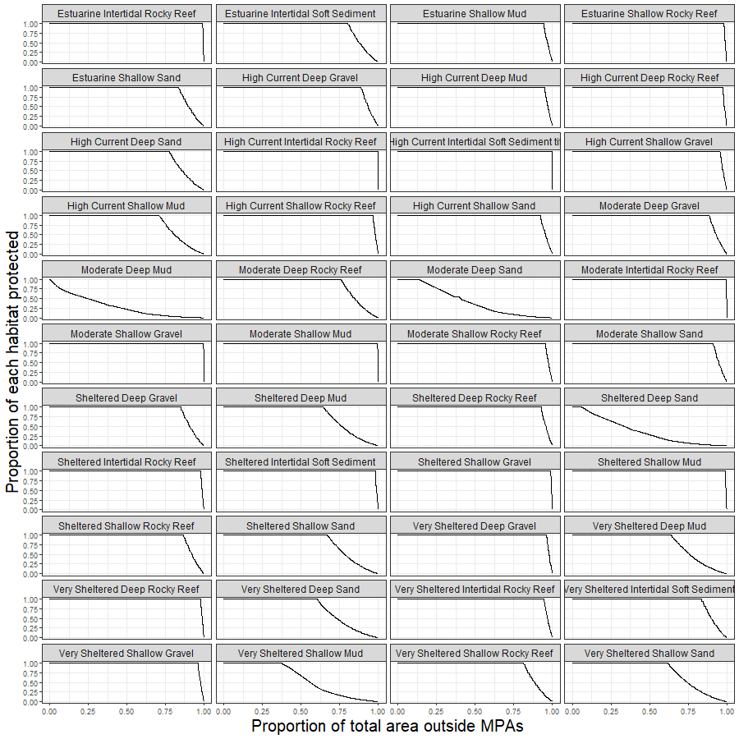
Figure 4-2: Performance curves for each habitat layer in the Baseline Physical Habitats exploratory scenario.

Marine reserves baseline scoping – Demersal fish biodiversity features
The second scoping scenario used solely the 90 demersal fish biodiversity features. This group of layers is better suited for Zonation analysis because the layers for different species are overlapping, such that multiple species can be found in each cell, and Zonation is able to prioritise areas based on trying to maximise representation of all biodiversity features (Figure 4.3). Here, priorities for biodiversity are situated across the HGMP except a gap in the south-west of Great Barrier Island. Some of the areas picked up by the Physical Habitat scenario are also included within the top 10% of this scoping scenario, for example the eastern coast of Great Barrier Island. Although no additional weighting was given for endemic species, the average performance curves showed that endemic species distributions received slightly higher protection within the top 10% of cells prioritised compared with non-endemic species (Figure 4.4). No aggregation and connectivity settings were used, resulting in a pixelated solution that is less suitable for designing practical and enforceable MPAs. Additional model complexity that creates more connected, or aggregated solutions, can be included once the primary biodiversity features driving the solution have been explored.
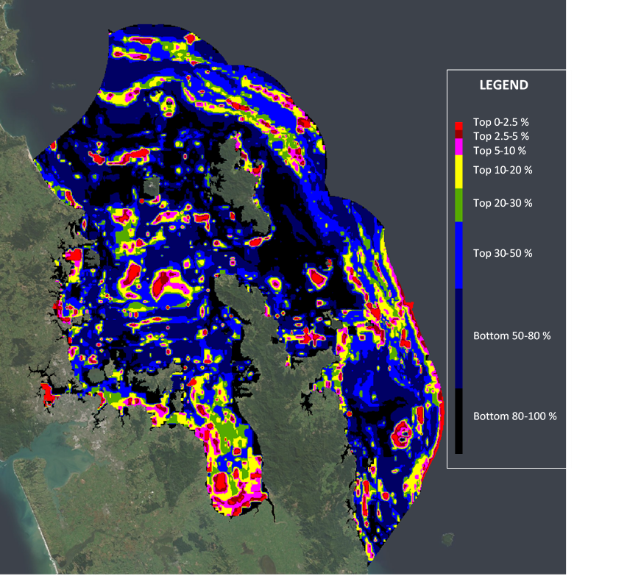
Figure 4.3: Spatial prioritisation of the baseline scoping scenario with only demersal fish layers as input.
Warm colours indicate higher priority areas for biodiversity, and colder colours indicate lower priority areas.
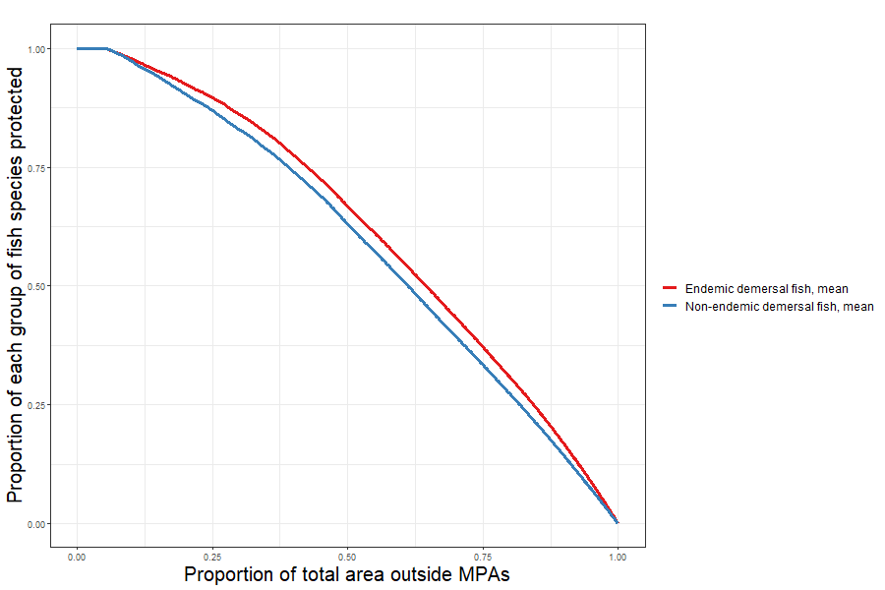
Figure 4.4: Average performance curves for endemic (red) and non-endemic (blue) demersal fish species.

Baseline scoping – Weights
Biogenic habitat layers including mangrove, saltmarsh, seagrass, rhodoliths, green-lipped mussel beds and dog cockles were identified by the central government working group as important data layers to be prioritised in the analysis, along with a predictive modelled layer of biogenic ecosystem services.
Rocky reef and gravel physical habitat types were also initially suggested for higher weighting in the Zonation baseline scenario. Given that rocky reefs include a variety of habitats that host a large array of organisms (including bivalves, polychaetes, arthropods and algae) and tend to host macroalgal forests with diverse red, brown and green algae, it would seem reasonable to increase the weights for such habitats. Zonation often is biased toward selection of features within limited distributions (such as the rocky reef and gravel habitats, as shown in the Physical Habitat scenario), so exploratory scenarios were undertaken to determine if additional weighting was required, or if these rarer habitat types were already adequately represented in priority solutions.
Two scenarios were performed: A) rocky reef and biogenic habitats weighted equally to all other biodiversity layers; and B) rocky reef and biogenic habitats weighted three times higher than other biodiversity layers (Table 4-1).
Table 4-1: Input layers for the two rocky reef scoping scenarios to compare equal and three-fold increased weights for rocky reef habitat types.

Layer | Rocky reef weighting  option 1 | Rocky reef weighting  option 2
Biogenic habitat layers (dog cockles, green-lipped mussel, rhodoliths, mangrove, seagrass and saltmarsh) | 1.0 | 3.0
Biogenic ecosystem services | 1.0 | 3.0
13 Rocky reef physical habitats | 1.0 | 3.0
31 Physical habitats (all habitat layers minus the rocky reef habitat layers) | 1.0 | 1.0
90 demersal fish species | 1.0 | 1.0

The results from these two scenarios suggest that prioritisation was not very sensitive to this weighting choice. Only 3 of the 13 rocky reef types were not fully protected within the top 10% of ranked cells (Figure 4.5, Figure 4.6). Moderate deep, sheltered shallow and very sheltered shallow rocky reefs are the only habitat types that experience an increase under the three times weighting scenario, which suggest that rocky reef and other limited distribution features are already being sufficiently prioritised under the equal weighting Zonation scenarios. Few differences in the spatial location of priority areas were apparent between the two rocky reef weighting scoping scenarios (Figure 4.7).
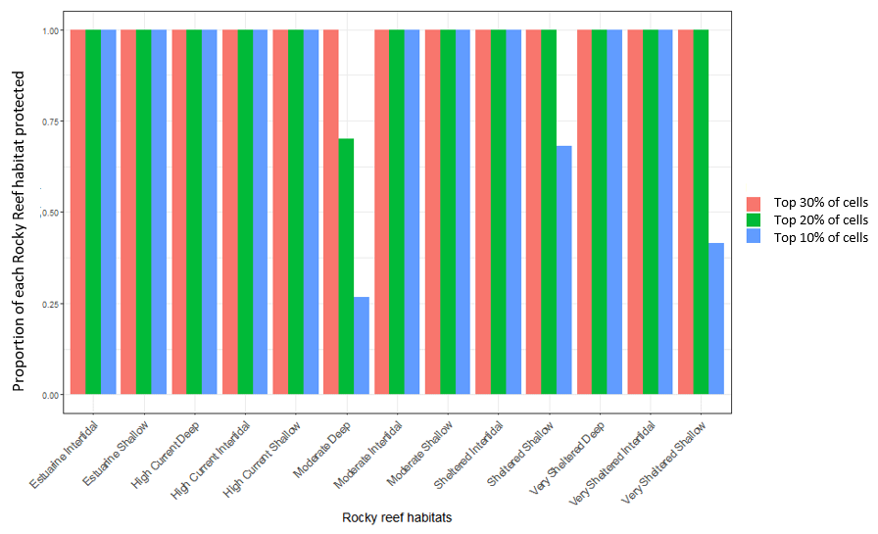

Figure 4.5: Proportion of rocky reef habitats protected under the equal weighting for rocky reefs scoping scenario.
Proportion of rocky reef habitats protected within the top 30% (pink), 20% (green) and 10% (blue) of ranked cells using equal weights for biogenic and rocky reef habitat layers.
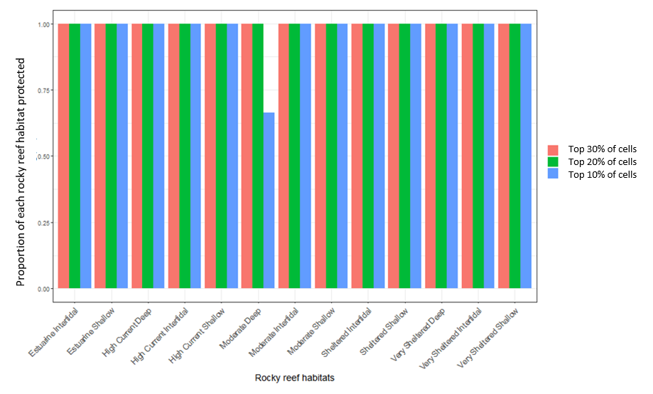
Figure 4.6: Proportion of rocky reef habitats protected under the 3x weighting for rocky reefs scoping scenario.
Proportion of rocky reef habitats protected within the top 30% (pink), 20% (green) and 10% (blue) of ranked cells using equal weights for biogenic and rocky reef habitat layers.

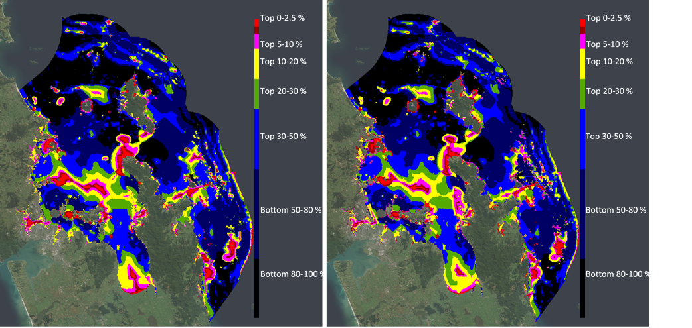
Figure 4.7: Spatial prioritisation of the two scoping scenarios to compare equal (left) and three-fold (right) increased weights for rocky reef habitat types.
Warm colours indicate higher priority areas for biodiversity representation, and colder colours indicate lower priority areas.

Baseline scoping - Biogenic ecosystem services
Initial evaluation of the performance of the biogenic ecosystem services layer at multiple thresholds appeared to be relatively low when compared to the biogenic habitat layers, and it was not clear whether the Zonation scenarios were optimising the areas with high predicted biogenic ecosystem services (Figure 2.3). A further scenario was defined to analyse the performance of the ecosystem services layer. The performance curve (Figure 4-8) shows a steady decrease (except from 0 to 0.02, X-axis) in the proportion of biogenic ecosystem services protected.
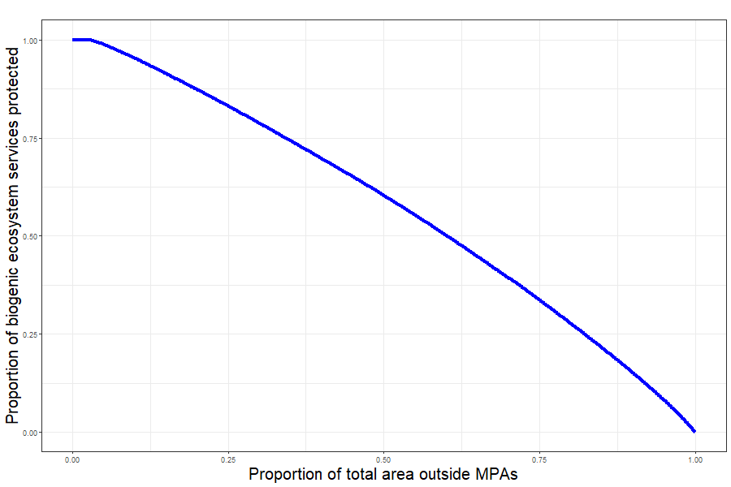
Figure 4-8: Performance curve for the biogenic ecosystem services layer.

As the ecosystem services layer covered the full extent of the area of analysis (the HGMP) and showed high spatial variability in the distribution of values across cells (Figure 4-9), the linear performance is expected. This is because few total cells occur with high predicted ecosystem services value, for example, the highest 33% of the value range (>7.2) account for only the 2.8% of the total number of cells with a non-zero value (>0). Due to this result, further evaluation of the level of protection given to biogenic ecosystem services under various scenarios used a subset of only cells with values of the top third of the distribution (biogenic ecosystem services model scores of higher than 6), which include cells with medium or high likelihood of the occurrence of biogenic habitats.
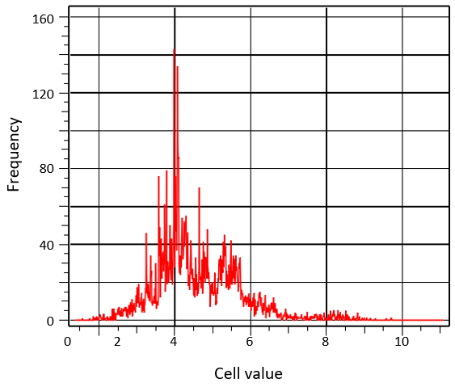
Figure 4-9: Biogenic ecosystem services layer histogram.
Range of values distributed across X-axis, frequency of appearance of each value across Y-axis

Marine reserves Baseline scenario – final selection
The final baseline scenario used a combination of biodiversity features, with 90 demersal fish layers, 44 physical habitat layers (excluding slope habitats at depths >200 m), 6 biogenic habitat layers, and one modelled layer representing potential biogenic ecosystem services. Biogenic habitat layers, including mangrove, saltmarsh, seagrass, rhodoliths, green-lipped mussel and dog cockles, were identified as important habitat types that support a diversity of species including fish, invertebrates, and algae, and potentially serve as proxies for fish nursery habitats (Table 2-1).
The biogenic habitat layers and biogenic ecosystem services layer were thus upweighted three times higher than physical habitats and demersal fish. The locations of the six existing marine reserves (comprising ~0.2% of the HGMP) were excluded from the analysis as they are already protected as marine reserves, and the objective of the analysis was to evaluate the newly proposed MPAs irrespective of existing protection.
Results from the baseline run show how most of the highly prioritised areas are concentrated around the coastline of the inner Hauraki Gulf, parts of the Coromandel Peninsula, Little Barrier Island/Hauturu and Great Barrier Island/Aotea (Figure 4.10). The effect of the increased weighting on biogenic habitats is obvious, particularly mangrove, saltmarsh and seagrass, since most of the estuarine areas across the HGMP are highly prioritised (e.g., occur within the top 10%). Rarer habitats located in offshore areas are also prioritised, as occurred in the Physical Habitats baseline scoping scenario (Figure 4.1), often in combination with areas where other more common habitats and demersal fish species also occur (e.g., Craddock Channel between Little Barrier Island/Hauturu and Great Barrier Island/Aotea).
Relatively large areas in the inner Hauraki Gulf and the inner Firth of Thames are also prioritised for biodiversity protection, likely due to an overlap of physical and biogenic habitats with multiple demersal fish distributions. Of note are dog cockle beds that have been prioritised off Coromandel Harbour and those that overlap with rarer gravel habitat types in Colville Channel. While no aggregation algorithms were used in this scenario, the lack of down-weighting of physical habitats (particularly those that are rarer) results in some aggregation on boundaries between adjacent physical habitat types.
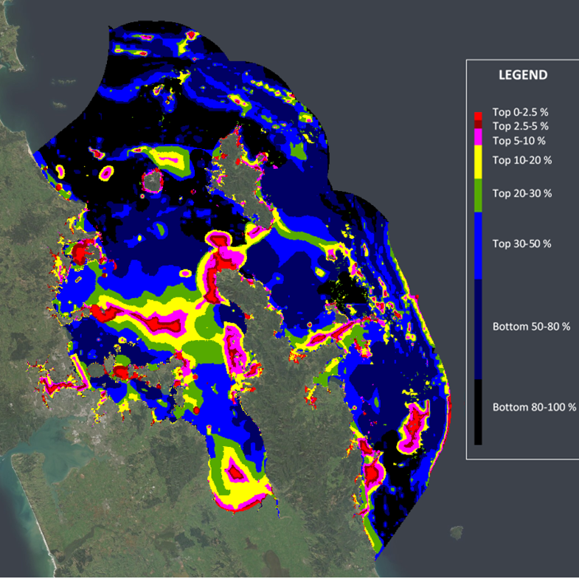
Figure 4.10: Spatial prioritisation of the final baseline scenario with combined species and habitat features, and higher weighting of biogenic habitats.
Warm colours indicate higher priority areas for biodiversity, and colder colours indicate lower priority areas.
Table 4-2: Average protection of biodiversity and habitat features in the final baseline scenario vs Scenario 1 and Scenario 2 marine reserves.
Values presented for the 4.70% (area within combined Scenario 1 marine reserves) and top 3.33% (area within combined Scenario 2 marine reserves) relative to the total model area (excluding upper slope habitats). Shaded cells with values in bold indicate greater performance than on par protection relative to the area of the HGMP covered by that proposed marine reserve.
 | Baseline Scenario (4.70%) | Scenario 1 (4.70%) |  | Baseline Scenario (3.33%) | Scenario 2 (3.33%)
All features | 22.9 | 9.0 |  | 19.8 | 11.1
Biogenic features (mean) | 85.3 | 28.7 |  | 75.7 | 29.2
Biogenic ecosystem services (percent of high value scores >6 only) | 14.8 | 9.1 |  | 10.8 | 7.6
Physical habitats (mean) | 54.1 | 15.2 |  | 47.7 | 17.3
Endemic demersal fish (mean) | 4.2 | 4.2 |  | 3.1 | 3.0
Non-endemic demersal fish (mean) | 3.3 | 5.0 |  | 2.4 | 3.3

Performance curves illustrate that biogenic features and physical habitats are preferentially selected for the priority solution, whereas endemic and non-endemic fish, and the biogenic ecosystem services layer show roughly on par protection of these features with increasing proportion of the total area in protected areas (Figure 4.11). The biogenic ecosystem service layer was also weighted higher in this solution, resulting in approximately double the on par protection for mid and high value biogenic ecosystem services (Table 4-2). High levels of protection were given to individual biogenic polygons, as these individual small polygons are more likely to be selected within the Zonation algorithm due to their small size. Further downweighting of these expert-based biogenic features could be used to put less priority on these features; however, they often overlap with other features that are associated with high ecological value.
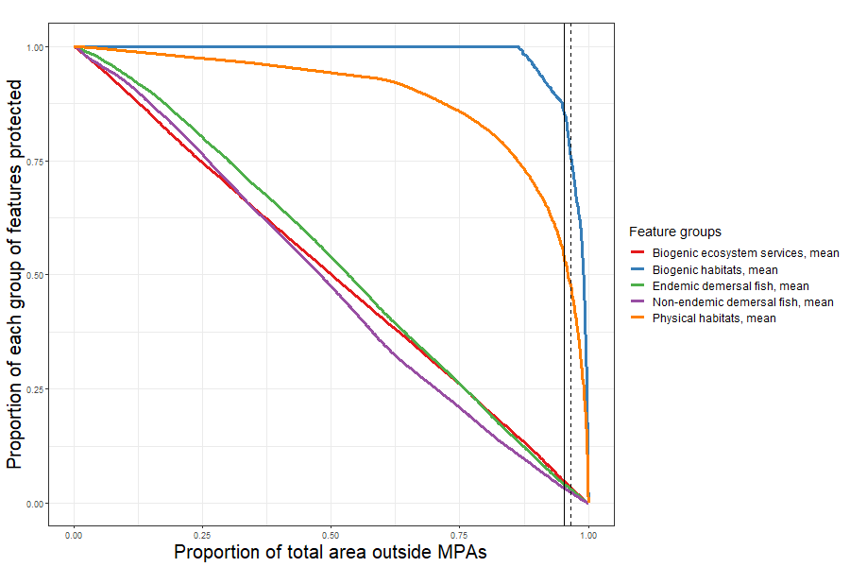
Figure 4.11: Performance curves for each group of features for the baseline scenario (without existing marine reserves).
Biogenic habitats (blue), biogenic ecosystem services (red), endemic demersal fish (green), non-endemic demersal fish (purple) and physical habitats (orange). Vertical lines for scenario 1 (4.70% of the analysed area, solid) and scenario 2 (3.33% of the analysed area, dashed).

Evaluation of Proposed Marine Reserves

Performance of Scenario 1 Marine Reserves against Baseline
The proposed marine reserves under Scenario 1 (maximum proposed option) were included as a mask layer, forcing Zonation to include these areas in the top priority solution (Figure 4.12). The spatial extent of the new reserves under Scenario 1 is approximately 4.70% of the analysed area (the HGMP excluding the mid- and upper-slope habitats and the existing marine reserves). The complete suite of results of analysing Scenario 1 is available in Appendix F (Table F-1).
The results for Scenario 1 suggest that the proposed marine reserves provide less than half the protection for biodiversity compared to the baseline scenario at the 4.70% threshold (Table 4-2). Comparing relative protection at 4.70% of the total area suggests high protection under the baseline scenario for biogenic and physical habitats (both well above 50%), which almost triples the amount of protection afforded by Scenario 1. Regardless, the Scenario 1 proposed marine reserves in total protect 28.7% of the biogenic features within 4.70% of the area, equating to over five times greater than on par protection. Relative to the baseline, endemic demersal fish species achieve higher levels of protection (on average) under the Scenario 1.
The spatial prioritisation with forced inclusion of Scenario 1 proposed marine reserves showcases the overlap or proximity of some of these proposed marine reserves to areas that are highly prioritised for their biodiversity values such as to the north of Little Barrier Island /Hauturu, Cape Colville, and Tiritiri Matangi Island (Figure 4.12).
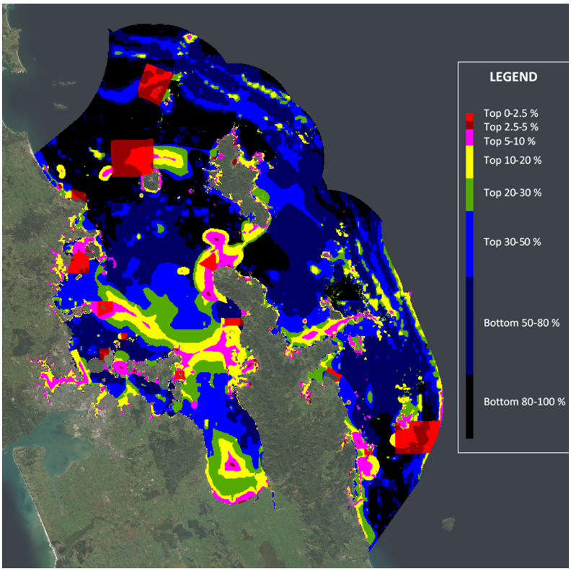
Figure 4.12: Spatial prioritisation with Scenario 1 proposed marine reserves forced as the highest priority for protection.
Warm colours indicate higher priority areas for biodiversity, and colder colours indicate lower priority areas.
Performance curves illustrate that biogenic features and physical habitats are still preferentially selected for the priority solution, though compared to the baseline scenario, a smaller proportion is protected at 4.70% within Scenario 1 marine reserves (Figure 4.11, Figure 4.13). Endemic and non-endemic fish and the biogenic ecosystem services layer show similar responses to increasing protection as the baseline scenario, with a roughly linear relationship with increasing protection (Figure 4.13).

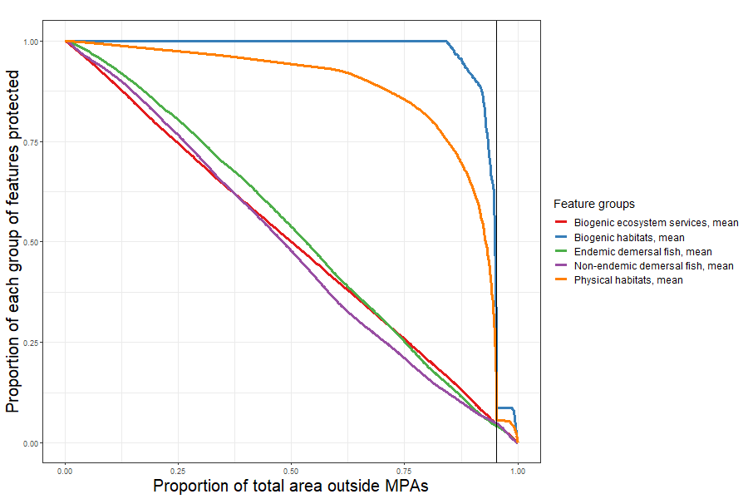
Figure 4.13: Performance curves for each group of features for the Scenario 1 proposed marine reserves forced as the highest priority for protection.
Biogenic habitats (blue), biogenic ecosystem services (red), endemic demersal fish (green), non-endemic demersal fish (purple) and physical habitats (orange). A vertical line (solid) indicates extent of scenario 1 (4.70% of the analysed area).

Performance of Scenario 2 Marine Reserves against Baseline
A further Zonation run was performed to analyse the Scenario 2 (minimum proposed option) for marine reserves, with the proposed marine reserves under Scenario 2 as a mask layer, forcing Zonation to include these areas in the top priority solution. The spatial extent of the existing marine reserves and the proposed marine reserves in Scenario 2 is approximately the 3.33% of the model area (the HGMP excluding the mid- and upper-slope habitats and the existing marine reserves). The complete suite of results of analysing Scenario 2 is available in Appendix F (Table F-1).
The inclusion of the proposed marine reserves in Scenario 2 suggests conservation outcomes are significantly lower than in the baseline case (Table 4-2). Comparing relative protection at 3.33% of the total area suggests higher protection under the baseline scenario for biogenic and physical habitats. Non-endemic demersal fish species achieve slightly higher levels of protection (on average) under Scenario 2 when compared to the baseline scenario. The gap in biogenic and physical habitats is particularly large, with protection dropping by approximately a half between the baseline and Scenario 2. Regardless, the Scenario 2 marine reserves, on average, do protect 29.2% of the biogenic habitats and 17.2% of the physical habitats within an area that is 3.33% of the HGMP, equates to above par protection. The protection of biogenic ecosystem services was 3.2% higher for the baseline (for the 3.33% highest priority locations identified by this unconstrained scenario) compared to the Scenario 2 which was forced to include proposed marine reserve options.
Performance curves illustrate that biogenic features and physical habitats are still preferentially selected for the priority solution, compared to the baseline scenario (Figure 4.11) a smaller proportion is protected at 3.33% reflecting that a smaller extent of these habitats is protected within Scenario 2 marine reserves (Figure 4.14). Endemic and non-endemic fish and the biogenic ecosystem services layer show similar responses to increasing protection with the baseline scenario, with approximately linear or minimum efficiency protection with increasing proportion of the total area in protected areas (Figure 4.14).
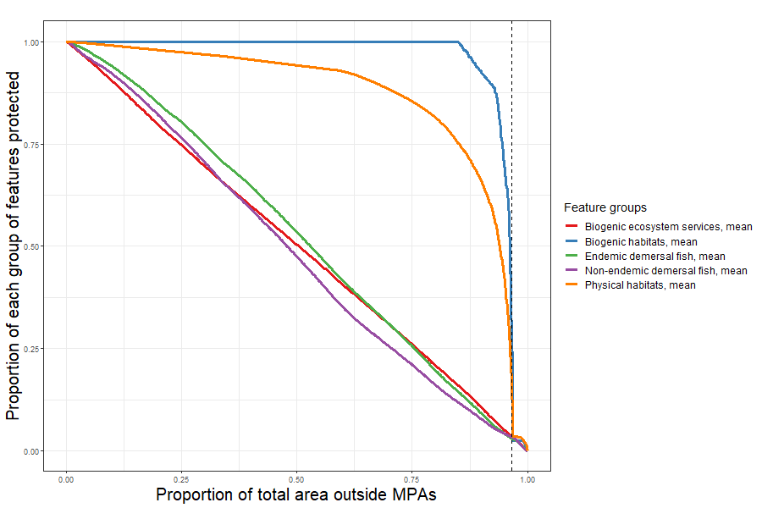
Figure 4.14: Performance curves for each group of features for the Scenario 2 proposed marine reserves forced as the highest priority for protection.
Biogenic habitats (blue), biogenic ecosystem services (red), endemic demersal fish (green), non-endemic demersal fish (purple) and physical habitats (orange). A vertical line (dashed) indicates extent of scenario 2 (3.33% of the analysed area).

The spatial prioritisation with Scenario 2 proposed marine reserves showcases the overlap or proximity of some of these proposed marine reserves to areas that are highly prioritised for their biodiversity values such as to the north of Little Barrier Island /Hauturu, Cape Colville, and Tiritiri Matangi Island (Figure 4.15).

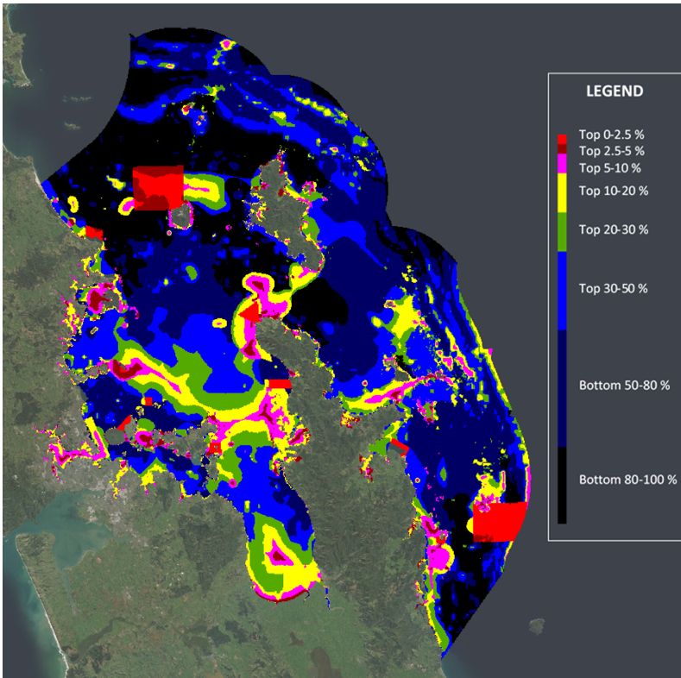
Figure 4.15: Spatial prioritisation with Scenario 2 proposed marine reserves forced as the highest priority for protection.
Warm colours indicate higher priority areas for biodiversity, and colder colours indicate lower priority areas.

Optimised trade-off analysis of biodiversity protection and fisheries impacts
Zonation facilitates inclusion of multiple objectives via inclusion of either ‘cost’ layers or by including other spatial uses as negatively weighted features. For this analysis, data layers reflecting fishery metrics as provided by FNZ were included as negatively weighted layers to estimate displacement of fishing activity or catch caused by proposed marine reserves under Scenario 1 and Scenario 2. Seven fishing catch intensity layers were used, with FNZ recommending use of the most recent year of fishery information rather than using the average of the last 3 years average, across which there was large spatial variability in fishing effort.
- Danish Seining catch intensity 2018/2019.
- Long lining catch intensity 2018/2019.
- Purse seine catch intensity 2018/2019.
- Set net catch intensity 2018/2019.
- Trawling catch intensity 2018/2019.
- Potting (rock lobster) catch intensity 2018/2019.
- Recreational vessel density 2017/2018.
The complete set of results including performance of fisheries layers can be found in Appendix F (Table F-1).

Performance of Scenario 1 Marine Reserves against optimised biodiversity and fisheries impacts outcomes
Whereas different scoping scenarios with varying biodiversity options were generally similar, the inclusion of fisheries layers as trade-offs for spatial allocation with protected areas resulted in clear differences in priority areas (Figure 4.16). The results differ in spatial areas prioritised to previous scenarios because Zonation is trying to avoid cells with high values of catch intensity and recreational vessel density.
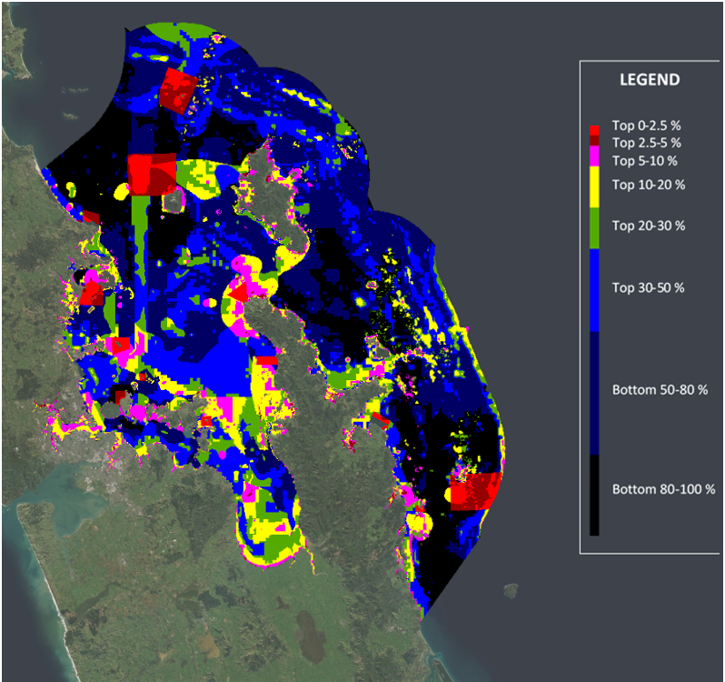
Figure 4.16: Spatial prioritisation including proposed marine reserves under Scenario 1 and seven recreational and commercial fisheries layers.
Fishing catch intensity (by gear type) and recreational vessel intensity (as a proxy for recreational fishing) for the most currently available year (18/19) were included as negatively weighted features. Warm colours indicate higher priority areas for biodiversity representation that minimize displacement of existing users, and colder colours indicate lower priority areas for biodiversity protection.
The inclusion of the fisheries layers reduces the biodiversity value of the top-ranked solution, with the exception of non-endemic demersal fish. Here, Zonation selects areas with lower value for biodiversity protection in order to minimise displacement of commercial and recreational fisheries (Table 4-3).
Table 4-3: Average protection of biodiversity and habitat features comparing the final baseline scenario with the Scenario 1 Proposed marine reserves including fisheries layers.
Values presented for 4.70% (the total relative area of Scenario 1 Proposed marine reserves, with the area of existing marine reserves excluded from the analysis). Shaded cells with values in bold indicate greater performance than on par protection relative to the area of the HGMP covered by that proposed marine reserve.
 | 4.70% of Protected landscape (%)
 | Baseline | Baseline with fisheries as negatively weighted layers | Scenario 1
All biodiversity features | 22.9 | 21.9 | 9.0
Biogenic features (mean) | 85.3 | 84.0 | 28.7
Biogenic ecosystem services (percent of high value scores >6 only) | 14.8 | 14.2 | 9.1
Physical habitats (mean) | 54.0 | 51.9 | 15.2
Demersal fish (mean) | 3.6 | 3.2 | 4.6
Endemic demersal fish (mean) | 4.2 | 3.7 | 4.2
Non-endemic demersal fish (mean) | 3.3 | 2.9 | 5.0
Fishery layers
Danish Seine | 7.8 | 0.8 | 1.8
Long lining | 3.7 | 2.2 | 6.1
Purse Seine | 3.0 | 0.4 | 7.1
Set Net | 10.3 | 6.5 | 3.7
Trawling | 2.5 | 0.6 | 3.4
Potting (crayfish) | 12.2 | 7.3 | 9.5
Recreational vessel density | 13.3 | 11.0 | 7.9

Comparison of fisheries displacement across gear types under the Scenario 1 marine reserves illustrated largest displacement for lobster potting fisheries, purse seine and long lining gear types (Table 4-3). The baseline scenario including fishing as negatively weighted layers yields smaller displacements than Scenario 1 except for recreational vessel density and set net gear types. Furthermore, relative to the baseline with fisheries as negatively weighted layers, the protection of the majority of biodiversity and habitat features (on average) in Scenario 1 was reduced slightly, with the exception of demersal fish, which achieved higher levels of protection.

Performance of Scenario 2 Marine Reserves against optimised biodiversity and fisheries impacts outcomes
Figure 4.17: Spatial prioritisation of the scenario with the Scenario 2 Proposed marine reserves including fisheries layers.
Fishing catch intensity and recreational vessel intensity were included as negatively weighted features. Warm colours indicate higher priority areas for biodiversity, and colder colours indicate lower priority areas.

Relative to analysis without negatively weighted fisheries layers, the inclusion of fisheries layers resulted in Zonation prioritizing areas for protection with lower value for biodiversity value in order to minimise impact on fisheries layers (Figure 4.15, Figure 4.17, Table 4-4).

Table 4-4: Average protection of biodiversity and habitat features comparing the final baseline scenario with the Scenario 2 Proposed marine reserves including fisheries layers.
Values presented for 3.33% (the total relative area of Scenario 2 Proposed marine reserves). Shaded cells with values in bold indicate greater performance than on par protection relative to the area of the HGMP covered by that proposed marine reserve.
 | 3.33% of Protected landscape (%)
 | Baseline | Baseline with fisheries as negatively  weighted layers | Scenario 2
All biodiversity features | 19.8 | 18.9 | 8.5
Biogenic features (mean) | 75.7 | 75.1 | 29.2
Biogenic ecosystem services (percent of high value scores >6 only) | 10.8 | 10.3 | 7.6
Physical habitats (mean) | 47.7 | 45.6 | 17.2
Demersal fish (mean) | 2.6 | 2.5 | 3.1
Endemic demersal fish (mean) | 3.1 | 2.5 | 3.0
Non-endemic demersal fish (mean) | 2.4 | 2.0 | 3.3
Fishery layers
Danish Seine | 5.3 | 0.4 | 0.6
Long lining | 2.5 | 1.4 | 3.2
Purse Seine | 1.8 | 0.2 | 7.0
Set Net | 7.5 | 3.8 | 2.4
Trawling | 1.9 | 0.3 | 3.1
Potting (crayfish) | 8.9 | 0.4 | 7.0
Recreational vessel density | 9.8 | 7.5 | 3.7

Scenario 2 shows largest displacement for lobster potting fisheries, purse seine and long lining (Table 4-4). Relative to the baseline scenario that included fisheries as negatively weighted layers, Scenario 1 resulted in a greater displacement of long-lining, purse seine, trawling and potting and less protection of biogenic features and physical habitats (Table 4-3). Despite the addition of fisheries layers as negatively weighted features, the baseline scenario yields a biodiversity average twice as large as the protection provided under Scenario 2, while minimising fisheries displacement (except for set netting catch intensity and recreational vessel density). In particular, biogenic features (on average) and the modelled biogenic ecosystem services layer showed only minimal declines between the baseline and baseline scenario with fishing, indicating that Zonation was still able to identify areas that delivered high habitat protection for these features, while minimising overlap with high value locations for fishery layers.

Development of Zonation baseline for assessing seabed protected areas proposals
The analysis for the proposed seabed protected areas involved a subset of the original habitat and biodiversity layers used in the marine reserve scenarios, selected for their likelihood of being protected if seafloor disturbance was excluded. These layers include:
- Physical habitats.
- Biogenic habitats (dog cockles, green-lipped mussel, rhodoliths, mangrove, seagrass and saltmarsh).
- Biogenic ecosystem services.

Baseline scoping – Spatial extent
The spatial extent of the benthic analysis was reduced further as the areas with existing and proposed marine reserves were masked out. Existing and proposed marine reserves were excluded from the analysis to allow exploration of areas currently not protected (or proposed for full no-take protection). Because the marine reserves proposed under both scenarios are different, the benthic analysis presents two baselines: 1) existing and Scenario 1 marine reserves being excluded and 2) existing and Scenario 2 marine reserves being excluded (Figure 4-18). This duplicated baseline allows comparison of results against the two proposed scenarios for seabed protected areas.
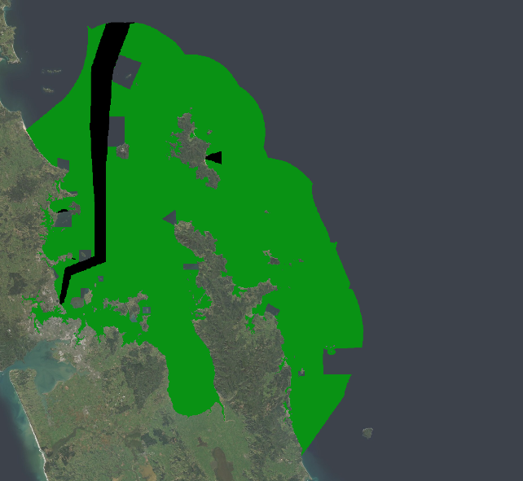
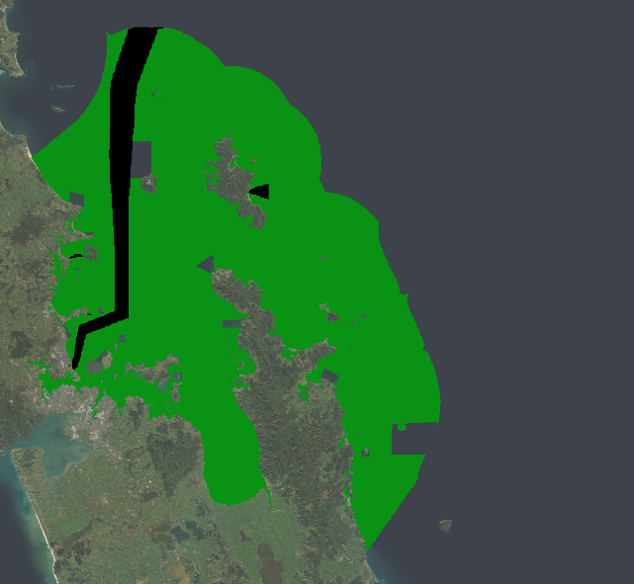
Ideally existing CPZs should have been excluded from the area of analysis since they act as `de-facto` seabed protected areas. However, some of the proposals overlap the CPZs (Hauturu/Little Barrier island), making the exclusion of the CPZs inconsistent with inclusion of the scenario proposals. Instead, a decision was made to perform multiples runs for each Zonation setup, with and without forcing CPZs to have the highest priority in the results. Prioritisation of existing CPZs allows to discern the value differences, in terms of theoretical protection, between the ideal cases (baseline) and each of the defined Scenario 1 and Scenario 2.
Figure 4-18: Analysed area for seabed protected areas Scenario 1 (left) and Scenario 2 marine reserve options (right).
Grey areas with the HGMP represent the marine reserves that correspond to each scenario and black polygons represent existing CPZs.

Baseline scoping – Weighting
Following a similar approach to the marine reserve scenarios, the scoping of the baseline seabed protected areas analysis involved three alternatives:
- Biogenic ecosystem services weighted by two-fold with the rest of layers equally weighted. This weight was reduced from three-fold (used in the marine reserves analysis) to two-fold upweighting due to the smaller number of layers used in this analysis.
- Biogenic habitats and biogenic ecosystem services weighted by two-fold, with physical habitats equally weighted.
- Biogenic habitats, biogenic ecosystem services, rocky reef habitats and gravel-bottom habitats weighted by two-fold with the rest of physical habitats equally weighted. Rocky reef and gravel habitats are the only habitats allocated weights of two as their distribution is scarce and they are known to host a diverse array of biodiversity. Although using Zonation’s CAZ removal rule prioritises rare habitats, extra weighting pushes the prioritisation algorithm to further increase the likelihood of including these highly weighted habitats in highest priority areas.
Scenario outputs of the three cases were similar, although increasing the weights for rocky reef and gravel-based habitats slightly increased the average inclusion of physical habitats (by the order of 0.2-1.7%) but decreased the inclusion of biogenic ecosystem services and biogenic features (by the order of ~0.1-1%) (Table E-2). Biogenic features benefit from increased weighting but were already highly prioritised as these are features with limited spatial distributions that are preferentially selected by Zonation.
Certain physical habitats such as moderate deep, sheltered shallow, very sheltered shallow rocky reef and sheltered deep gravel habitats benefit from the extra weighting under alternative 3 (Table E-1). As the spatial extent of the existing and proposed seabed protected areas (both scenarios) is ~20% of the HGMP, it does not seem necessary to increase the weights for these habitats as the remaining distributions under the three alternatives is the same except for Moderate deep rocky reef, which drops to 80.7% under alternative 1 when setting aside 20% of the total landscape. Biogenic habitat features also show similar percentages of their distributions being included in the top 20% of the results. The only continuous data layer used in the seabed protected areas analysis is the biogenic ecosystem services layer, with the rest of the layers showing little or no overlap among them. Thus, weighting of layers in the final baseline scenario was selected as equal weights for all physical habitats and biogenic habitats and a two-fold weighting for the biogenic ecosystem services.

Seabed protected area baseline scenario – final selection
The spatial prioritisation shows highest priority areas for seabed protection scattered across the coastline of the Hauraki Gulf, including the inner and outer islands (Figure 4.19). The prioritised areas overlap with the distribution of biogenic features and low-occurrence habitats such as rocky reef as well as the high-end of the biogenic modelled habitat layer. All the proposed seabed protected areas overlap to some degree with areas being included in the top 10% of the results, although the percentage varies for each proposal. As the spatial extent of the excluded marine reserves differ between Scenario 1 and Scenario 2, variations occur in the spatial prioritisations. For example, the Mokohinau Islands, Kawau Bay and Tiritiri Matangi Island are top priority areas, at least partially, in the Scenario 2 baseline while they remain excluded from high priority areas in Scenario 1.

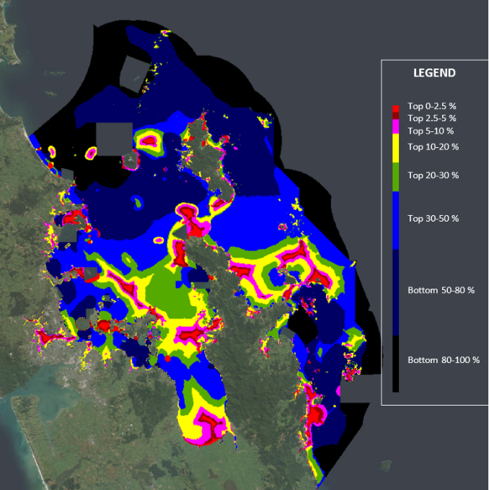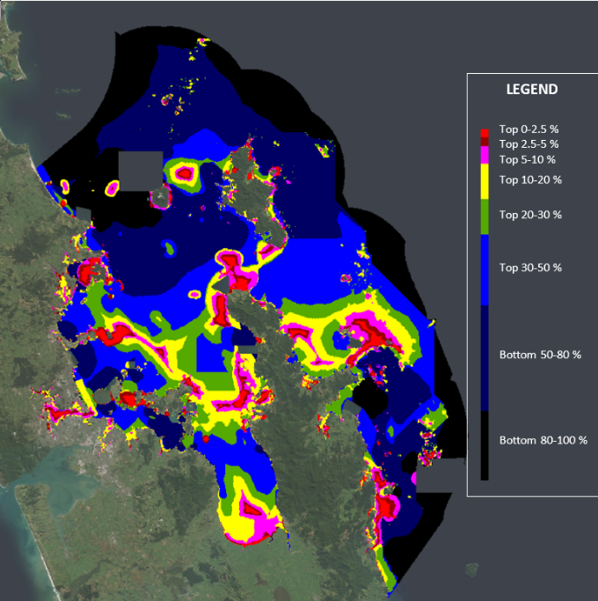
Figure 4.19: Spatial prioritisation of the baseline scenarios for seabed protected areas.
Left: baseline with marine reserves from Scenario 1 masked out. Right: baseline with marine reserves from Scenario 2 masked out. Warm colours indicate higher priority areas for biodiversity representation, and colder colours indicate lower priority areas.
Performance curves illustrate that biogenic features and physical habitats are still preferentially selected for the priority solution in the baseline scenario for proposed seabed protected areas (Figure 4.20, Figure 4-21). Although the performance curves under both scenarios are similar, it is important to note that the total extent of the analysed area is slightly different as the spatial extent of the excluded areas (marine reserves) for the two scenarios is different. Thus, a direct comparison between both baseline cases is not applicable.
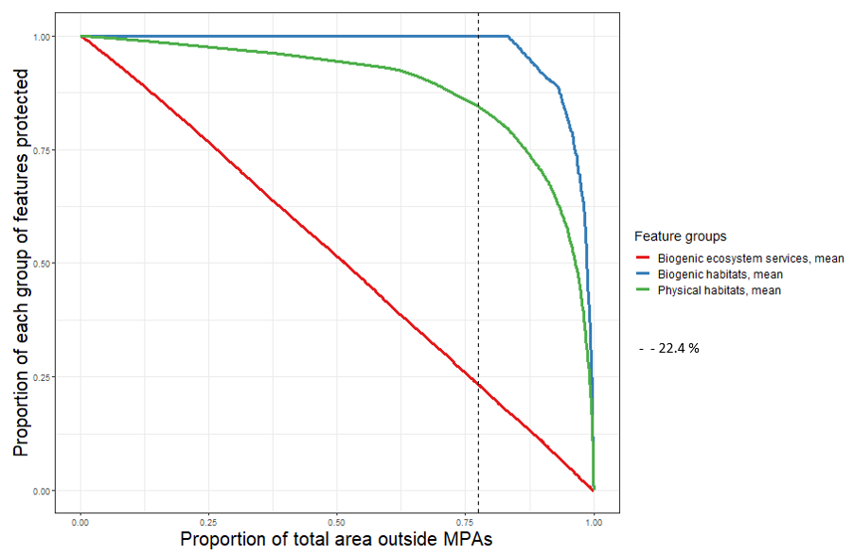
Figure 4.20: Performance curves for each group of features for the Scenario 1 baseline scenario for seabed protected areas.
Biogenic habitats (blue), biogenic ecosystem services (red) and physical habitats (green). The dashed line indicates the spatial extent of the seabed protected areas under Scenario 1 (22.48% of the analysed area).
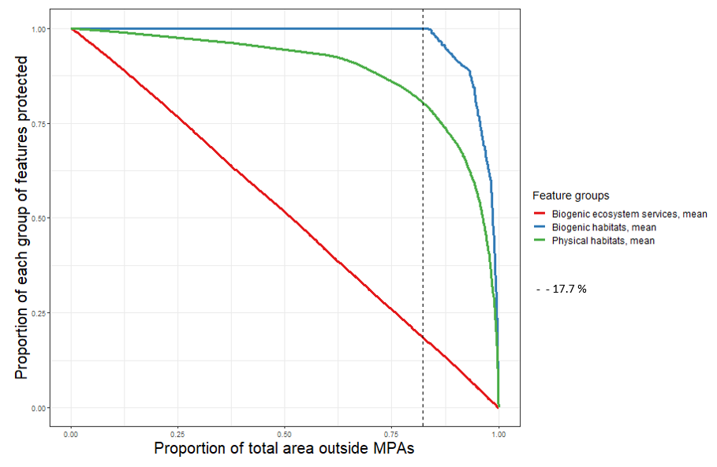
Figure 4-21: Performance curves for each group of features for the Scenario 2 baseline of seabed protected areas scenario.
Biogenic habitats (blue), biogenic ecosystem services (red) and physical habitats (green). The dashed line indicates the spatial extent of the seabed protected areas under Scenario 2 (17.7% of the analysed area).

Optimised trade-off analysis of biodiversity protection and fisheries impacts

Two extra Zonation runs were performed for each baseline case:
- Adding fisheries layers as negatively weighted layers.
- Forcing the existing CPZs in the top part of the results while adding fisheries layers as negatively weighted layers.
Because of the existing spatial overlap between the existing CPZs and some of the proposed seabed protected areas (Hauturu/Little Barrier island), a decision of forcing Zonation to include CPZs within the top part of the solution under both Scenario 1 and Scenario 2 was made. The inclusion of the CPZs in both baseline scenarios facilitates comparisons against the proposed Scenario 1 and Scenario 2 as shown in Section 4.9.
For this analysis, data layers reflecting fishery metrics as provided by FNZ were included as negatively weighted layers to estimate displacement of fishing activity or catch caused by proposed seabed protected areas. Unlike the marine reserve’s analysis, only two fishing catch intensity layers were used, reflecting the most recent year of fishery information as opposed to the last 3 years average, which in some cases showed large spatial variability
- Danish Seining catch intensity 2018/2019.
- Trawling catch intensity 2018/2019.
In addition, fisheries layers were included in the baseline cases as silent layers, having no effect in the results but being reported on in order to obtain estimated displacements. The complete set of results including performance of fisheries layers can be found in Appendix F (Table F-2).

Baseline scenario 1 including impacts on fisheries and prioritising existing CPZs
The inclusion of fisheries layers and negatively weighted features resulted in minor reduction in percentage of protection (<1%) for most biodiversity layers, with the exception of an approximately 7% reduction for the biogenic ecosystem services layer. However, this scenario reduced fisheries displacement by ~4x in the case of Danish Seine and by ~2x in the case of trawling (Table 4-5). Averaged levels of protection yielded by biodiversity features decreased by a further 1-4% when forcing CPZs to be in the top part of the solution. However, this CPZ scenario only resulted in a minor change in fisheries displacement by ~1.3% (trawling) and ~0.1% (Danish Seine), as no trawling and no Danish seine takes place within the CPZs.
Table 4-5: Relative protection of seafloor habitat features under the different Baseline Scenario 1.
The existing CPZs and Scenario 1 seabed protected areas cover 22.48% of the analysed area. Performance of the baseline scenario with and without forcing of existing CPZs in the top solution is provided to facilitate comparisons. Shaded cells with values in bold indicate greater performance than on par protection relative to the area of the HGMP covered by that proposed marine reserve.

 | Baseline | Baseline with negatively weighted fisheries | Baseline with existing CPZs and negatively weighted fisheries
Protected landscape (%) | 22.48% | 22.48% | 22.48%
All features | 85.1 | 84.5 | 83.1
Biogenic features (mean) | 100.0 | 99.7 | 98.1
Biogenic ecosystem services (percent of high value scores >6 only) | 50.2 | 43.4 | 39.4
Physical habitats (mean) | 84.5 | 83.9 | 82.4
Danish Seine | 28.1 | 7.1 | 5.8
Trawling catch intensity | 11.8 | 5.6 | 5.5

Baseline Scenario 2 including fisheries and existing CPZs
The inclusion of fisheries layers and negatively weighted features resulted in reduced percentage of protection for all biodiversity layers but reduced fisheries displacement by approximately ~4x in the case of Danish Seine and by ~2x in the case of trawling (Table 4-6). Average levels of protection achieved by biodiversity features showed a decrease that ranged from 1.2% to 6.1% when forcing CPZs to be selected in the highest priority solution. The addition of the masked CPZs showed only a minor decrease in fisheries displacement by 0.1% (trawling) and 0.2% (Danish seine), as no trawling and no Danish seine takes place within the CPZs.
Table 4-6: Relative protection of seafloor habitat features under the different Baseline scenario 2.
The existing CPZs and Scenario 2 seabed protected areas cover 17.71% of the analysed area. Performance of the baseline scenario with and without forcing of existing CPZs in the top solution is provided to facilitate comparisons. Shaded cells with values in bold indicate greater performance than on par protection relative to the area of the HGMP covered by that proposed marine reserve.

 | Baseline | Baseline with negatively weighted fisheries | Baseline with existing CPZs and negatively weighted fisheries
Protected landscape (%) | 17.71% | 17.71% | 17.71%
All features | 81.6 | 80.7 | 77.7
Biogenic features (mean) | 100.0 | 97.9 | 96.7
Biogenic ecosystem services (percent of high value scores >6 only) | 45.3 | 39.1 | 33.0
Physical habitats (mean) | 80.5 | 79.8 | 76.5
Danish Seine | 22.8 | 4.9 | 4.8
Trawling intensity | 7.9 | 4.2 | 4.0

Evaluation of seabed protected areas

Performance of Scenario 1 seabed protected areas against Baseline
This case examined protection when the model was forced to include both the proposed seabed protected areas under Scenario 1 and the existing CPZs as highest priority (Figure 4.22). Because of the existing spatial overlap between existing CPZs and some of the proposed seabed protected areas, decision of forcing Zonation to include CPZs within the top part of the solution under both Scenario 1 and Scenario 2 was made. Combined, these areas (CPZs and proposed seabed protected areas) cover approximately 22.48% of the model area and deliver more than twice ’on par’ protection for biogenic features and physical habitats (Table 4-7). The complete suite of results of analysing Scenario 1 is available in Appendix F (Table F-2).

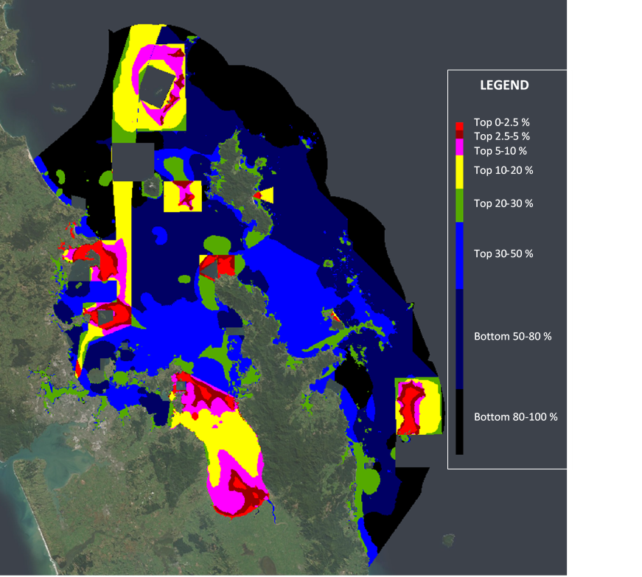
Figure 4.22: Spatial prioritisation of the scenario with the Scenario 1 proposed seabed protected areas and CPZs.
Warm colours indicate higher priority areas for biodiversity representation, and colder colours indicate lower priority areas. Existing and proposed marine reserves are masked out and excluded from the analysis. Grey polygons indicate locations of Scenario 1 marine reserves.

Table 4-7: Relative protection of seafloor habitat features under Scenario 1 seabed protected areas.
The existing CPZs and Scenario 1 seabed protected areas cover 22.48% of the analysed area. Performance of the baseline scenario with and without forcing of existing CPZs in the top solution is provided to facilitate comparisons. Shaded cells with values in bold indicate greater performance than on par protection relative to the area of the HGMP covered by that proposed marine reserve.

 | Baseline | Baseline with negatively weighted fisheries | Baseline with existing CPZs  and negatively weighted  fisheries | Scenario 1
Protected landscape (%) | 22.48% | 22.48% | 22.48% | 22.48%
All features | 85.1 | 84.5 | 83.1 | 54.6
Biogenic features (mean) | 100.0 | 99.7 | 98.1 | 64.4
Biogenic ecosystem services (percent of high value scores >6 only) | 50.2 | 43.4 | 39.4 | 16.2
Physical habitats (mean) | 84.5 | 83.9 | 82.4 | 54.0
Danish Seine | 28.1 | 7.1 | 5.8 | 12.1
Trawling catch intensity | 11.8 | 5.6 | 5.5 | 9.5

Fisheries layers were included both as silent and negatively weighted layers in the baseline scenarios, and as silent layers in the Scenario 1 for seabed protected areas. The estimated displacement of Danish seine fisheries was greater (almost 3x) under the baseline scenario than under Scenario 1, when looking at protecting approximately 22.48% of the analysed area, which is the spatial extent of the SC1 proposal plus the CPZs protection zones (Table 4-7).
The inclusion of fishing layers as negatively weighted layers in the baseline scenario yielded smaller displacement than Scenario 1 while at the same time achieving higher percentages of all biodiversity and habitat features. Scenario 1 resulted in approximately double the fishery displacement for Danish seines and trawling catch intensity, compared to the baseline scenarios including fisheries, with small differences in displacement between the fisheries scenarios with and without inclusion of CPZs. All biodiversity features showed large decreases under Scenario 1 when compared to the three baseline scenarios (with and without fisheries/CPZs).

Performance of Scenario 2 Seabed Protected Areas against Baseline
This analysis examined protection when the model was forced to include both the proposed seabed protected areas under Scenario 2 and the existing CPZs as highest priority. The complete suite of results of analysing Scenario 2 is available in Appendix F (Table F-3).
Similar outputs were observed for the Scenario 2 seabed protected areas (Figure 4.23). In this scenario, the existing CPZs and the proposed seabed protected areas approximately cover 17.71% of the model area. All biodiversity features showed large decreases under Scenario 2 when compared to the three baseline scenarios (with and without fisheries/CPZs) (Table 4-8).
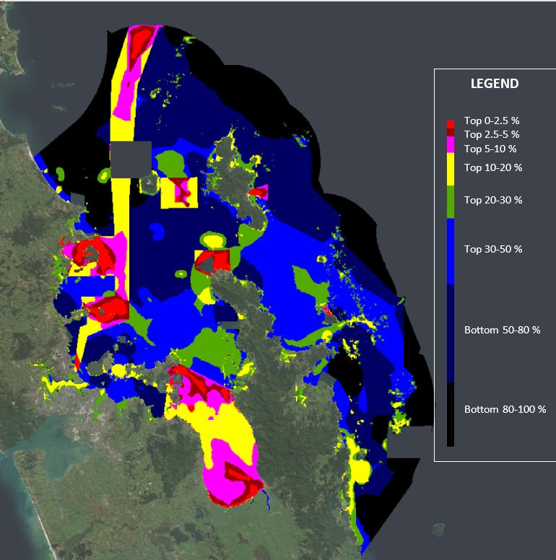
Figure 4.23: Spatial prioritisation of Scenario 2 Proposed seabed protected areas and Cable Protection Zones.
Warm colours indicate higher priority areas for biodiversity, and colder colours indicate lower priority areas. Grey boxes within the HGMP indicate locations of Scenario 2 proposed marine reserves.
Table 4-8: Relative protection of seafloor habitat features under Scenario 2 seabed protected areas. The existing CPZs and scenario 1 seabed protected areas cover 17.71% of the analysed area.
Performance of the baseline scenario with and without forcing of existing CPZs in the top solution is provided to facilitate comparisons. Shaded cells with values in bold indicate greater performance than on par protection relative to the area of the HGMP covered by that proposed marine reserve.
 | Baseline | Baseline with negatively weighted fisheries | Baseline with existing CPZs and negatively weighted fisheries | Scenario  2
Protected landscape (%) | 17.71% | 17.71% | 17.71% | 17.71%
All features | 81.6 | 80.7 | 77.7 | 50.8
Biogenic features (mean) | 100.0 | 97.9 | 96.7 | 57.13
Biogenic ecosystem services (percent of high value scores >6 only) | 45.3 | 39.1 | 33.0 | 14.5
Physical habitats (mean) | 80.5 | 79.8 | 76.5 | 50.7
Danish Seine | 22.8 | 4.9 | 4.8 | 12.3
Trawling intensity | 7.9 | 4.2 | 4.0 | 3.1
Including fisheries as negatively weighted layers in the baseline scenario caused reductions in displaced Danish seine and trawling fishing catch intensity, by ~4x and ~2x respectively (Table 4-8). Despite this decrease in estimated fisheries displacement, reductions in the protection of biodiversity and habitat features were on average minimal and still higher than for Scenario 1 for seabed protected areas. Scenario 2 showed fisheries displacements approximately half the magnitude of those yielded by the baseline scenario but displacement by trawl fishing was still more than 2x when compared to the baseline that forced CPZs into the top part of the results.

Conclusions and recommendations
The analyses presented in this report suggest that the HGMSP MPA proposals developed would deliver some benefits for biodiversity conservation within the HGMP. However, the analyses also suggest both shortfalls in biodiversity conservation for some species and habitats (including a number of biogenic habitats) compared with what might be achieved using decision support software and all available data, and a bias toward a subset of features that receive higher priority than others. The analysis of the MPA proposals with respect to fisheries effort and catch suggest disproportionate displacement of certain fisheries, particularly lobster potting and recreational fishing, based on priority selection of rocky reef habitats where these fisheries are often located.
Spatial decision support tools have been designed for the purpose of assisting in finding spatial management solutions that are supported by stakeholders, but also maximise the protection of selected features and minimise displacement of existing uses, and could be used to further develop these proposed spatial management areas for further benefits to biodiversity and minimisation of displacement of fisheries. Key areas for further scenario development include finding a balance between scenarios that prioritise spatially restricted (e.g., rocky reef, gravel habitats) or upweighted biogenic habitats and those that prioritise biodiversity more generally across the HGMP. Differences in datasets also can be discussed to determine whether one should put more weighting on expert-derived layers such as biogenic habitats, or predictive modelled layers such as the demersal fish and biogenic ecosystem services layer, when using them as drivers of spatial management priorities.
Further, inclusion or exclusion of existing protection (including Cable Protection Zones) and HGMSP proposals can potentially bias solutions through forcing of pre-selected areas. For example, models that forced inclusion of the seabed protected areas and CPZs include about 20% of the HGMP, such that many anecdotal or modelled high ecological value areas that aren’t included within these areas are potentially excluded from top 20% high priority solutions. Rather, baseline solutions should be used in an iterative fashion, considering overall biodiversity protection in a holistic fashion, and iterating sequentially through a process that first identifies priorities for new marine reserves, then seabed protected areas, and then modifications for fisheries displacement and other resource users that can deliver similar biodiversity benefits.

Opportunity for stakeholder input into further Zonation scenarios
The Zonation baseline and additional exploratory scenarios illustrates the opportunity for using this decision-support tool to inform refinement of the HGMSP marine reserve and seabed protected area proposals to better align with HGMSP objectives for conservation purposes as well as for minimising displacement of other existing uses of the HGMP. Although the baseline Zonation scenarios reported here were developed by a limited number of central government participants and advised by expert scientists, Zonation has been used successfully in stakeholder processes in New Zealand, where stakeholders participate directly in development and iteration of model scenarios, and participate in all decisions with respect to datasets, model boundaries, other options within the Zonation framework. A recent stakeholder process led by FNZ resulted in the successful acceptance by an international fisheries management organisation (SPRFMO) of revised spatial management measures for the South Pacific high seas, where NZ Inc is highly invested in orange roughy fisheries. The new spatial measures delivered substantially better protection for biodiversity than the previous measures at slightly lower cost to the fishing industry in terms of displacement (Cryer et al. 2018).

Scenario options and caveats of the approach
Many different scenarios could be analysed within the Zonation decision support tool, to assist stakeholders and central and regional government in identifying potential options for biodiversity protection in the HGMP, while also considering other uses. One example scenario illustrated how Zonation could incorporate fisheries layers to provide solutions that minimise displacement (by 2-3 times) of commercial and recreational fishers, while maximising biodiversity protection. Other management uses (e.g., sand extraction, fishery management areas, military zones) (Figure 5.1) could be included in scenarios as some of these uses are incompatible with MPAs. Stakeholders can also make informed decisions on the inclusion of, and weighting of, different datasets to ensure that scenarios match their perceptions of which biodiversity features are most important to protect. One obstacle however is that biodiversity information is incomplete, especially for vulnerable and sensitive habitats and species. Where this is the case, Zonation may not provide an optimal solution for the habitats and species that are not represented within the analysis, in which case, the input of expert opinion and local knowledge during the stakeholder participatory process becomes increasingly important. Regardless, understanding of how different types of layers, for example, layers with restricted distributions such as rocky reef habitat types, influence priority solutions within the internal algorithms of these tools is part of the learning process that occurs within stakeholder processes using Zonation, and can be used to further guide upweighting (or downweighting) of features that are perceived to be either not being selected, or are having too much influence on the priority solutions.
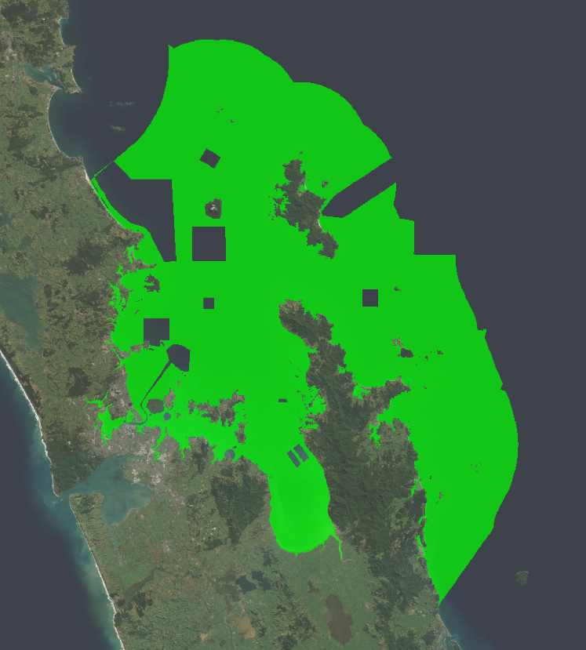
Figure 5.1: Locations of dredging areas, shipping zones, military exclusion zones, marine farms and sand extraction areas.
Represented by dark areas within the green outline of the HGMP.

Other considerations for improving the Zonation analyses include addressing the gaps in biodiversity datasets to more comprehensively represent biodiversity. A key limitation for the model scenarios in the analysis was the recognition that few robust and spatially comprehensive marine biodiversity datasets were available within the HGMP, though certainly some information exists for many biodiversity features. For example, biodiversity data exists for some taxonomic groups (e.g., seabirds, shorebirds, and marine mammals) that could be further refined to form more comprehensive layers to be used within a Zonation analysis. A number of datasets will become available in approximately September 2020, funded by the DOC and overseen by the MSAG (Marine Protected Areas Special Advisory Group), including a revised national habitat classification, and revised species richness and individual species distribution models for demersal fish, rocky reef fish, macroalgae and seafloor invertebrates. These layers could further inform this approach if taken forward with the Sea Change Ministerial Committee.
Further non-trivial issues occur in using these decision support tools when translating the Zonation scenarios, which may include highly pixelated maps in their identification of optimal solutions, into practical management areas suitable for easy identification of boundaries by resource users, and for ease of enforcement. Previous stakeholder processes suggest this process is not always straightforward, particularly when optimal, pixelated, but ‘impractical’ spatial management scenario outputs are far too optimistic and potentially misleading relative to practical iterations of these optimal scenarios. Decision-makers need to understand the limitations of model generated solutions, and their theoretical performance, and the need to further iterate models to estimate the performance of practical options.

Summary of recommendations
Here, we summarise recommendations for further iteration of Sea Change spatial management scenarios, and for understanding the assumptions and caveats of the various biodiversity datasets that were modelled using the Zonation approach.
- Participation of stakeholders (industry, recreational fishers, environmental organisations, community groups, iwi and central government operational managers, etc.,) in an iterative process to refine the original HGMSP Scenario proposals.
- Use of Zonation within this iterative process to assist in maximising the performance against HGMSP objectives of these marine reserves and seabed protected areas MPAs.
- Inclusion of additional biodiversity datasets and revised weighting placed on each dataset.
- Discussion of exclusion/inclusion of areas with existing use such as sand extraction and military zones.
- Fishers to determine which fishery layers (commercial and recreational) best match their interests and represent the diversity of industry layers.
- Incorporation of Ahu Moana Mana Whenua/community co-management areas within the analysis, if desired by the Ministerial Committee and/or stakeholder group.
- Understanding of caveats of using primarily maps of individual habitats within Zonation and how this biases results.
- Assessment of the likely performance of suites of MPAs that are practical to implement (i.e., have relatively few but relatively large individual MPAs with simple boundaries).
- Further consideration of displacement of existing uses, including more complex analyses of costs and benefits of different protected areas.

Acknowledgements
We thank the Department of Conservation and Fisheries New Zealand working group members that advised on datasets and exploratory scenarios at a number of workshops. We particularly thank Clinton Duffy and colleagues and Te Papa and the Auckland Museum for assistance with fish groups, and Mathilde Richer de Forges for early input into the working group. We thank Dr Fabrice Stephenson for sharing R code to assist with data conversions, and Dr Stephenson and MSAG for permission to use updated demersal fish layers currently being developed for NIWA Project DOC19207 (Spatial biodiversity optimisation). We thank Irene Pohl, Shane Geange, Karen Tunley, and Martin Cryer for comments on the report.

References
Anderson, O.F., Bagley, N.W., Hurst, R.J., Francis, M.P., Clark, M.R., McMillan, P.J. (1998) Atlas of New Zealand fish and squid distributions from research bottom trawls. NIWA Technical Report 42: 303.
Anderson, T.J., Morrison, M., MacDiarmid, A., Clark, M., D’Archino, R., Nelson, W., Tracey, D., Gordon, D., Read, G., Kettles, H., Morrisey, D., Wood, A., Anderson, O., Smith, A.M., Page, M., Paul-Burke, K., Schnabel, K., Wadhwa, S. (2019) Review of New Zealand’s Key Biogenic Habitats. NIWA Client Report No. 2018139WN, prepared for the Ministry for the Environment: 184. https://www.mfe.govt.nz/sites/default/files/media/Marine/NZ-biogenic-habitat-review.pdf
Clark, M.R., King, K.J. (1989) Deepwater fish resources off the North Island, New Zealand: results of a trawl survey, May 1985 to June 1986. N.Z. Fisheries Technical Report, No. 11: 56.
Cryer, M., Geange, S.W., Bock, T.D. (2018) Methods for designing spatial management areas using outputs from Zonation software and other spatial data. Paper DW-11 for the 6th Meeting of the SPRFMO Scientific Committee, Puerto Varas, Chile, 9-14 September 2018: 14. Available at: http://www.sprfmo.int/assets/2018-SC6/Meeting-Documents/SC6-DW11-Process-for-drawing-mgmt-areas.pdf.
Department of Conservation & Ministry of Fisheries (2011) Broad scale gap analysis of coastal marine habitats and marine protected areas in the New Zealand Territorial Sea. Wellington, New Zealand: 50 plus App.
Geange, S.W., Leathwick, J., Linwood, M., Curtis, H., Duffy, C., Funnell, G., & Cooper, S. (2017) Integrating conservation and economic objectives in MPA network planning: A case study from New Zealand. Biological Conservation, 210: 136-144.
Groves, C.R., Jensen, D.B., Valutis, L.L., Redford, K.H., Shaffer, M.L., Scott, J.M., Anderson, M.G. (2002) Planning for Biodiversity Conservation: Putting Conservation Science into Practice: A seven-step framework for developing regional plans to conserve biological diversity, based upon principles of conservation biology and ecology, is being used extensively by the nature conservancy to identify priority areas for conservation. BioScience, 52(6): 499-512.
Hodgson, J.A., Thomas, C.D., Wintle, B.A., Moilanen, A. (2009) Climate change, connectivity and conservation decision making: back to basics. Journal of Applied Ecology, 46(5): 964-969.
Hurst, R.J., Stevenson, M.L., Bagley, N.W., Griggs, L.H., Morrison, M.A., Francis, M.P. (2000) Areas of importance for spawning, pupping or egg-laying, and juveniles of New Zealand coastal fishes. Report for Ministry of Fisheries Research Project, ENV1999/03 Objective 1. (Unpublished report held by Ministry for Primary Industries, Wellington).
Jackson, S. (2014) Prioritisation of Areas in the Hauraki Gulf Marine Park for Biodiversity Conservation (MSc thesis, ResearchSpace@ Auckland).
Jackson, S.E., Lundquist, C.J. (2016) Limitations of biophysical habitats as biodiversity surrogates in the Hauraki Gulf Marine Park. Pacific Conservation Biology, 22(2): 159-172. http://dx.doi.org/10.1071/PC15050
Karimi, A., Hockings, M. (2018) A social-ecological approach to land-use conflict to inform regional and conservation planning and management. Landscape Ecology, 33(5): 691-710.
Kendrick, T.H., Francis, M.P. (2002) Fish assemblages in the Hauraki Gulf, New Zealand. New Zealand Journal of Marine and Freshwater Research, 36: 699–717.
Knight, A.T., Driver, A., Cowling, R.M., Maze, K., Desmet, P.G., Lombard, A.T., Goodman, P. S. (2006) Designing systematic conservation assessments that promote effective implementation: best practice from South Africa. Conservation Biology, 20(3): 739-750.
Leathwick, J., Moilanen, A., Francis, M., Elith, J., Taylor, P., Julian, K., Hastie, T., Duffy, C. (2008) Novel methods for the design and evaluation of marine protected areas in offshore waters. Conservation Letters, 1: 91-102.
Leathwick, J.R., Elith, J., Francis, M.P., Hastie, T., Taylor, P. (2006) Variation in demersal fish species richness in the oceans surrounding New Zealand: an analysis using boosted regression trees. Marine Ecology Progress Series, 321: 267-281.
Lehtomäki, J., Moilanen, A. (2013) Methods and workflow for spatial conservation prioritization using Zonation. Environmental Modelling & Software, 47: 128-137.
Lehtomäki, J., Kusumoto, B., Shiono, T., Tanaka, T., Kubota, Y., Moilanen, A. (2019) Spatial conservation prioritization for the East Asian islands: A balanced representation of multitaxon biogeography in a protected area network. Diversity and Distributions, 25(3): 414-429.
Liang, J., He, X., Zeng, G., Zhong, M., Gao, X., Li, X., Li, X., Wu, H., Feng, C., Xing, W., Fang, Y., Mo, D. (2018) Integrating priority areas and ecological corridors into national network for conservation planning in China. Science of the Total Environment, 626: 22-29.
Lundquist, C.J., Julian, K.A., Costello, M., Gordon, D.P., Mackay, K., Neill, K., Mills, S., Nelson, W.A., Thompson, D. (2015) Development of a Tier 1 National Reporting Statistic for New Zealand's Marine Biodiversity. New Zealand Aquatic Environment and Biodiversity Report, No. 147. Ministry for Primary Industries, Wellington, New Zealand.
Lundquist, C., Stephenson, F., McCartain, L., Watson, S., Brough, T., Nelson, W., Neill, K., Anderson, T., Anderson, O., Bulmer, R., Gee, E., Pinkerton, M., Rowden, A., Thompson, D. (2020) Evaluating Key Ecological Areas datasets for the New Zealand marine environment. NIWA Client Report No. 2020109HN, prepared for Department of Conservation Project No.DOC19206, Hamilton, New Zealand: 120.
Margules, C.R., Pressey, R.L. (2000) Systematic conservation planning. Nature, 405(6783): 243.

Ministry of Fisheries and Department of Conservation (2008) Marine protected areas: Classification, protection standard and implementation guidelines. Wellington, New Zealand, Ministry of Fisheries.
Moilanen, A. (2004) Zonation. Conservation Biology Informatics Group.
Moilanen, A. (2007) Landscape zonation, benefit functions and target-based planning: unifying reserve selection strategies. Biological Conservation, 134(4): 571-579.
Moilanen, A., Franco, A.M.A., Early, R.I., Fox, R., Wintle, B., Thomas, C.D. (2005) Prioritizing multiple-use landscapes for conservation: Methods for large multi-species planning problems. Proceedings of the Royal Society B: Biological Sciences, 272 (1575): 1885-1891.
Pressey, R.L., Cabeza, M., Watts, M.E., Cowling, R.M., Wilson, K.A. (2007) Conservation planning in a changing world. Trends in Ecology & Evolution, 22 (11): 583-592.
Roberts, C.D., Stewart, A.L., Struthers, C.D. (eds.) (2015) The Fishes of New Zealand. Te Papa Press, Wellington.
Rowden, A.A., Stephenson, F., Clark, M.R., Anderson, O.F., Guinotte, J.M., Baird, S.J., Roux, M.-J., Wadhwa, S., Cryer, M., Lundquist, C.J. (2019) Examining the utility of a decision-support tool to develop spatial management options for the protection of vulnerable marine ecosystems on the high seas around New Zealand. Ocean & Coastal Management, 170: 1–16.
Smith, A.N., Duffy, C.A.J., Leathwick, J.R. (2013) Predicting the distribution and relative abundance of fishes on shallow subtidal reefs around New Zealand. Publishing Team, Department of Conservation.
Stephenson, F., Leathwick, J.R., Francis, M.P., Lundquist, C.J. (2020) A New Zealand demersal fish classification using Gradient Forest models. New Zealand Journal of Marine and Freshwater Research, 54(1): 60-85. 10.1080/00288330.2019.1660384.
Stephenson, F., Leathwick, J.R., Geange, S.W., Bulmer, R.H., Hewitt, J.E., Anderson, O.F., Rowden, A.A., Lundquist, C.J. (2018a) Using Gradient Forests to summarize patterns in species turnover across large spatial scales and inform conservation planning. Diversity and Distributions, 24(11): 1641-1656. doi:10.1111/ddi.12787
Stephenson, F., Rowden, A., Anderson, T., Hewitt, J., Costello, M., Pinkerton, M., Morrison, M., Clark, M., Wadhwa, S., Mouton, T., Lundquist, C. (2018b) Mapping Key Ecological Areas in the New Zealand Marine Environment: Data collation. NIWA Client Report 2018332HN, prepared for the Department of Conservation.
Stewart, D.R., Underwood, Z.E., Rahel, F.J., Walters, A.W. (2018) The effectiveness of surrogate taxa to conserve freshwater biodiversity. Conservation Biology, 32(1): 183-194. 10.1111/cobi.12967
TNC, WWF, CI & WCS (2008) Marine protected area networks in the Coral Triangle: development and lessons. The Nature Conservancy, World Wildlife Fund, Conservation International, Wildlife Conservation Society and the United States Agency for International Development, Cebu City, Philippines: 106.
Townsend, M., Thrush, S. (2010) Ecosystem functioning, goods and services in the coastal environment. Prepared by NIWA. Auckland Regional Council Technical Report, 2010/033. Auckland Regional Council, Auckland, New Zealand: 53.
Townsend, M., Lohrer, A.M. (2019) Empirical validation of an ecosystem service map developed from ecological principles and biophysical parameters. Frontiers in Marine Science, 6(21). 10.3389/fmars.2019.00021
Waikato Regional Council (2017) Sea change - Tai timu tai pari: Hauraki Gulf Marine Spatial Plan Hamilton, New Zealand: Waikato Regional Council.
Wood, A.C., Rowden, A.A., Compton, T.J., Gordon, D.P., Probert, P.K. (2013) Habitat-forming bryozoans in New Zealand: their known and predicted distribution in relation to broad-scale environmental variables and fishing effort. PLoS One, 8: e75160.
Zintzen, V., Anderson, M.J., Roberts, C.D., Harvey, E.S., Stewart, A.L., Struthers, C.D. (2012) Diversity and composition of demersal fishes along a depth gradient assessed by baited remote underwater stereo-video. PLoS One, 7(10): e48522. doi:10.1371/journal.pone.0048522.

Demersal fish model evaluation
Table A-1: Demersal fish species typically found at depths < 125 m, for which predicted species occurrence models are available for the HGMP.
E indicates species assessed as endemic. * indicates species excluded from analysis due to expert assessment of being unlikely to occur in the HGMP.

Code | Common name | Species Name | EEZ > 0.5 probability occurrence | HG > 0.5 probability occurrence | Sum of >0.5 threshold in EEZ | Sum of >0.5 threshold in HG | Proportion of probability occurrence of species in HG relative to EEZ (column 2, divided by column 1)
YEM | Yellow-eyed mullet | Aldrichetta forsteri | 591 | 341 | 40052 | 32034 | 0.58
POP | Porcupine fish | Allomycterus jaculiferus | 6176 | 448 | 62788 | 21430 | 0.07
TOP | Pale toadfish | Ambophthalmos angustus* | 24310 | 11 | 66949 | 1375 | <0.01
SSI | Silverside (E) | Argentina elongata | 297596 | 764 | 95816 | 31143 | <0.01
WIT | Witch (E) | Arnoglossus scapha | 50950 | 137 | 92777 | 9697 | <0.01
KAH | Kahawai | Arripis trutta | 108529 | 665 | 78811 | 48897 | 0.01
PCO | Ahuru (E) | Auchenoceros punctatus | 95327 | 21 | 54008 | 2591 | <0.01
BPE | Butterfly perch | Caesioperca lepidoptera | 359 | 0 | 28271 | 0 | <0.01
ELE | Elephant fish | Callorhinchus milii | 18852 | 0 | 95816 | 0 | <0.01
CDO | Capro dory (E) | Capromimus abbreviatus | 44609 | 591 | 87289 | 46859 | 0.01
CAR | Carpet Shark (E) | Cephaloscyllium isabellum | 67851 | 821 | 92527 | 28248 | 0.01
GUR | Gurnard | Chelidonichthys kumu | 216044 | 9790 | 95816 | 94798 | 0.05
CUC | Cucumber fish | Chlorophthalmus (Paraulopus) nigripinnis | 41427 | 1386 | 80014 | 42699 | 0.03
RAT | Rattail (E) | Coelorinchus aspercephalus | 148750 | 0 | 82415 | 0 | <0.01
RAT | Rattail (E) | Coelorinchus biclinozonalis | 6266 | 0 | 72770 | 0 | <0.01
CBO | Bollons Rattail (E) | Coelorinchus bollonsi | 189173 | 0 | 89520 | 0 | <0.01
BRI | Brill (E) | Colistium guntheri | 1019 | 0 | 62339 | 0 | <0.01
TUR | Turbot (E) | Colistium nudipinnis | 87629 | 0 | 20135 | 0 | <0.01
SAZ | Sand stargazer (E) | Crapatalus novaezelandiae | 303 | 0 | 29214 | 0 | <0.01
SDO | Silver dory | Cyttus novaezealandiae* | 24304 | 12 | 86813 | 1195 | <0.01
LDO | Lookdown dory | Cyttus traversi* | 354664 | 79 | 95816 | 13637 | <0.01
BSH | Seal shark | Dalatias licha | 21924 | 0 | 69352 | 0 | <0.01
BRA | Short-tailed black ray | Dasyatis brevicaudata | 230 | 67 | 15562 | 6774 | 0.29
WRA | Long-tailed stingray | Dasyatis thetidis | 85256 | 96 | 27626 | 11452 | <0.01
SSK | Smooth Skate (E) | Dipturus innominatus | 3655 | 14 | 35105 | 1608 | <0.01
RBT | Redbait | Emmelichthys nitidus | 6607 | 3 | 57434 | 400 | <0.01
ANC | Anchovy | Engraulis australis | 735 | 27 | 34764 | 2876 | 0.04
SCH | School shark | Galeorhinus galeus | 201383 | 73 | 94290 | 7083 | <0.01
SPZ | Spotted stargazer (E) | Genyagnus monopterygius | 1866 | 577 | 58996 | 41903 | 0.31
LIN | Ling | Genypterus blacodes | 588351 | 238 | 95816 | 25172 | <0.01
PAR | Parore | Girella tricuspidata | 18 | 18 | 2442 | 2442 | 1.00
HEP | Sharpnose sevengill shark | Heptranchias perlo | 20 | 0 | 2197 | 0 | <0.01
FHD | Deepsea flathead (E) | Hoplichthys haswelli (undescribed species) | 73662 | 127 | 85572 | 14483 | <0.01
SRH | Silver roughy | Hoplostethus mediterraneus | 137520 | 235 | 95816 | 30642 | <0.01
GSP | Pale ghost shark (E) | Hydrolagus bemisi | 608640 | 0 | 95816 | 0 | <0.01
GSH | Ghost shark (E) | Hydrolagus novaezealandiae | 96389 | 71 | 94037 | 7003 | <0.01
BNS | Bluenose | Hyperoglyphe antarctica | 10595 | 0 | 41109 | 0 | <0.01
STA | Giant stargazer (E) | Kathetostoma giganteum | 100770 | 2 | 92019 | 265 | <0.01
MOK | Blue moki | Latridopsis ciliaris | 1626 | 0 | 54803 | 0 | <0.01
TRU | Trumpeter | Latris lineata | 234 | 0 | 22201 | 0 | <0.01
OPE | Orange perch (E) | Lepidoperca aurantia | 11281 | 14 | 79088 | 1258 | <0.01
FRO | Frostfish | Lepidopus caudatus | 64206 | 533 | 86797 | 23120 | 0.01
JAV | Javelinfish | Lepidorhynchus denticulatus | 657989 | 253 | 95816 | 34881 | <0.01
SCG | Scaly gurnard (E) | Lepidotrigla brachyoptera | 52838 | 4317 | 89269 | 61730 | 0.08
 | Crested flounder (E) | Lophonectes mongonuiensis [gallus] | 174 | 165 | 16844 | 16321 | 0.95
SNI | Snipefish | Macroramphosus scolopax | 1108 | 574 | 33189 | 29339 | 0.52
HOK | Hoki | Macruronus novaezelandiae* | 743239 | 233 | 95816 | 30861 | <0.01
HAK | Hake | Merluccius australis | 246795 | 0 | 94544 | 0 | <0.01
LEA | Leatherjacket | Meuschenia scaber | 36117 | 6131 | 94544 | 93532 | 0.17
SPO | Rig (E) | Mustelus lenticulatus | 168826 | 1087 | 93288 | 56341 | 0.01
EGR | Eagle ray | Myliobatis tenuicaudatus | 5376 | 1057 | 84344 | 52879 | 0.20
POR | Porae | Nemadactylus douglasii | 165 | 0 | 15640 | 0 | <0.01
TAR | Tarakihi | Nemadactylus macropterus | 168666 | 3307 | 95307 | 57910 | 0.02
TOD | Dark toadfish (E) | Neophrynichthys latus | 801 | 0 | 29154 | 0 | <0.01
STY | Spotty (E) | Notolabrus celidotus | 3767 | 703 | 92819 | 56421 | 0.19
CBE | Crested Bellowfish | Notopogon lilliei | 3904 | 0 | 68309 | 0 | <0.01
SNA | Snapper | Pagrus [Chrysophrus] auratus | 152199 | 12375 | 95816 | 94377 | 0.08
BCO | Blue cod (E) | Parapercis colias | 14933 | 182 | 94571 | 21925 | 0.01
RHY | Common roughy (E) | Paratrachichthys trailli | 3965 | 0 | 57051 | 0 | <0.01
BOA | Sowfish | Paristiopterus labiosus | 152 | 1 | 13069 | 136 | 0.01
LSO | Lemon sole (E) | Pelotretis flavilatus | 30719 | 338 | 93027 | 25104 | 0.01
SOL | Speckled sole (E) | Peltorhamphus latus | 298 | 2 | 29529 | 296 | 0.01
ESO | N.Z. Sole (E) | Peltorhamphus novaezeelandiae | 101356 | 21 | 95054 | 2772 | <0.01
SLS | Slender sole (E) | Peltorhamphus tenuis | 173 | 0 | 19070 | 0 | <0.01
RBY | Rubyfish | Plagiogeneion rubiginosum | 322 | 0 | 19984 | 0 | <0.01
HAP | Hapuku | Polyprion oxygeneios | 73356 | 0 | 95307 | 0 | <0.01
TRE | Trevally | Pseudocaranx georgianus | 104462 | 608 | 93028 | 38999 | 0.01
SPF | Scarlet wrasse (E) | Pseudolabrus miles | 596 | 0 | 37393 | 0 | <0.01
RCO | Red cod | Pseudophycis bachus | 99357 | 255 | 95307 | 29183 | <0.01
JGU | Japanese gurnard | Pterygotrigla picta | 33722 | 1700 | 68626 | 41778 | 0.05
SKI | Gemfish | Rexea solandri | 81594 | 484 | 93531 | 37039 | 0.01
YBF | Yellow-belly flounder (E) | Rhombosolea leporina | 1691 | 381 | 85851 | 39833 | 0.23
SFL | Sand flounder (E) | Rhombosolea plebeia | 115943 | 1862 | 95816 | 71362 | 0.02
PIL | Pilchard | Sardinops sagax | 598 | 112 | 38726 | 12667 | 0.19
EMA | Blue mackerel | Scomber australasicus | 97628 | 324 | 37477 | 24064 | <0.01
KIN | Kingfish | Seriola lalandi | 1304 | 9 | 43945 | 965 | 0.01
WAR | Common warehou | Seriolella brama | 19202 | 4 | 95052 | 575 | <0.01
WWA | White warehou | Seriolella caerulea | 81203 | 0 | 92777 | 0 | <0.01
SWA | Silver warehou | Seriolella punctata | 123481 | 1 | 90020 | 133 | <0.01
SDR | Spiny seadragon | Solegnathus spinosissimus | 130 | 0 | 12508 | 0 | <0.01
HHS | Hammerhead shark | Sphyrna zygaena | 98 | 5 | 9548 | 712 | 0.05
SPR | New Zealand Sprat (E) | Sprattus muelleri | 37 | 0 | 4051 | 0 | <0.01
SPD | Spiny dogfish | Squalus acanthias | 273448 | 0 | 95816 | 0 | <0.01
NSD | Northern spiny dogfish (E) | Squalus griffini | 63996 | 321 | 76959 | 25370 | 0.01
BAR | Barracouta | Thyrsites atun | 207003 | 1580 | 95816 | 37842 | 0.01
JMA | Jack mackerel | Trachurus declivis | 55894 | 1116 | 87783 | 28812 | 0.02
JMA | Jack mackerel | Trachurus murphyi | 11988 | 2 | 65855 | 264 | <0.01
JMA | Jack mackerel (Golden mackerel) | Trachurus novaezealandiae | 145811 | 7425 | 93784 | 93536 | 0.05
RMU | Red mullet/Goatfish (E) | Upeneichthys porosus [lineatus] | 531 | 481 | 41851 | 39817 | 0.91
BRZ | Brown stargazer | Xenocephalus armatus | 823 | 62 | 27545 | 6368 | 0.08
LFB | Long-finned boarfish | Zanclistius elevatus | 96 | 0 | 9473 | 0 | <0.01
RSK | Rough skate (E) | Zearaja nasuta | 4998 | 1 | 93352 | 140 | <0.01
MDO | Mirror dory | Zenopsis nebulosa | 3274 | 376 | 53797 | 32287 | 0.11
JDO | John dory | Zeus faber | 91861 | 11825 | 95561 | 95561 | 0.13

Table A-2: Demersal shelf fish species typically found at depths > 125 m, for which predicted species occurrence models are available for the HGMP.
These deeper water species were excluded from analysis as models suggested low probability of occurrence in the HGMP, or because species were primarily found in waters > 200 m that were excluded from Zonation analyses.

Code | Common name | Species Name | EEZ > 0.5 probability occurrence | HG > 0.5 probability occurrence | Sum of >0.5 threshold in EEZ | Sum of >0.5 threshold in HG | Proportion of probability occurrence of species in HG relative to EEZ (column 2, divided by column 1)
AGR | Ribbonfish | Agrostichthys parkeri | 0 | 0 | 0 | 0 | <0.01
API | Alert Pigfish | Alertichthys blacki | 5093 | 0 | 59030 | 0 | <0.01
 | Common fangtooth | Anoplogaster cornuta | 80 | 0 | 8128 | 0 | <0.01
VCO | Violet cod | Antimora rostrata | 65563 | 0 | 74405 | 0 | <0.01
 | Half-naked hatchetfish | Argyropelecus hemigymnus | 1 | 0 | 138 | 0 | <0.01
LSK | Long-tailed skate | Arhynchobatis asperrimus | 48 | 0 | 4704 | 0 | <0.01
SDF | Spotted flounder | Azygopus pinnifasciatus | 77 | 14 | 7972 | 2038 | 0.18
SCO | Swallenhead conger | Bassanago bulbiceps | 160411 | 45 | 73500 | 6369 | <0.01
HCO | Hairy conger | Bassanago hirsutus | 67307 | 1 | 67949 | 128 | <0.01
BYX | Long-finned beryx | Beryx decadactylus | 5 | 0 | 677 | 0 | <0.01
BYX | Alfonsino | Beryx splendens | 32556 | 0 | 82655 | 0 | <0.01
BCR | Blue cusk eel | Brotulotaenia crassa | 2 | 0 | 266 | 0 | <0.01
BBE | Banded Bellowsfish | Centriscops humerosus | 136165 | 68 | 95307 | 12528 | <0.01
RUD | Rudderfish | Centrolophus niger | 12125 | 0 | 58728 | 0 | <0.01
CSQ | Leafscale gulper shark | Centrophorus squamosus | 11160 | 0 | 64747 | 0 | <0.01
CYL | Portuguese dogfish | Centroscymnus coelolepis | 4971 | 0 | 50533 | 0 | <0.01
CYP | Longnose velvet dogfish | Centroscymnus crepidater | 135847 | 0 | 93278 | 0 | <0.01
CYO | Smooth skin dogfish | Centroscymnus owstoni | 153825 | 0 | 88033 | 0 | <0.01
PLS | Plunket's shark | Centroscymnus plunketi | 6080 | 0 | 50533 | 0 | <0.01
 | Warming's lantern fish | Ceratoscopelus warmingii | 531 | 0 | 23425 | 0 | <0.01
RAT | Rattail | Cetonurus crassiceps | 13 | 0 | 1484 | 0 | <0.01
CHA | Viper Fish | Chauliodus sloani | 3893 | 0 | 33454 | 0 | <0.01
CHX | Pink frogmouth | Chaunax pictus | 658 | 0 | 22370 | 0 | <0.01
FRS | Frill shark | Chlamydoselachus anguineus | 37 | 0 | 3376 | 0 | <0.01
RAT | Rattail | Coelorinchus celaenostomus | 1712 | 0 | 31604 | 0 | <0.01
RAT | Rattail | Coelorinchus cookianus | 768 | 0 | 24080 | 0 | <0.01
CFA | Banded rattail | Coelorinchus fasciatus | 281270 | 0 | 88780 | 0 | <0.01
RAT | Rattail | Coelorinchus innotabilis | 90131 | 0 | 94037 | 0 | <0.01
CMA | Mahia rattail | Coelorinchus matamua | 48695 | 0 | 88279 | 0 | <0.01
RAT | Rattail | Coelorinchus maurofasciatus | 4606 | 0 | 55291 | 0 | <0.01
RAT | Rattail | Coelorinchus mycterismus | 14 | 0 | 1750 | 0 | <0.01
COL | Olivers rattail | Coelorinchus oliverianus | 213141 | 0 | 91016 | 0 | <0.01
RAT | Rattail | Coelorinchus parvifasciatus | 4267 | 0 | 54417 | 0 | <0.01
RAT | Rattail | Coelorinchus supernasutus | 1 | 0 | 138 | 0 | <0.01
RAT | Rattail | Coelorinchus trachycarus | 0 | 0 | 0 | 0 | <0.01
 | Humpback whiptail | Coryphaenoides dossenus | 2774 | 0 | 33745 | 0 | <0.01
CSE | Serrulate whiptail | Coryphaenoides serrulatus | 272112 | 0 | 95816 | 0 | <0.01
 | Longrayed whiptail | Coryphaenoides subserrulatus | 167592 | 0 | 95307 | 0 | <0.01
COT | Bonyskull toadfish | Cottunculus nudus | 11 | 0 | 1522 | 0 | <0.01
 | Triplewart seadevil | Cryptopsaras couesii | 9 | 0 | 1059 | 0 | <0.01
SND | Shovelnosed dogfish | Deania calcea | 186059 | 0 | 95052 | 0 | <0.01
DIS | Discfish | Diretmus argenteus | 55 | 0 | 6142 | 0 | <0.01
 | Messmate | Echiodon cryomargarites | 538 | 0 | 14988 | 0 | <0.01
EPD | Cardinal fish, white | Epigonus denticulatus | 28 | 0 | 3127 | 0 | <0.01
EPL | Cardinal fish, bigeye | Epigonus lenimen | 1308 | 0 | 58131 | 0 | <0.01
EPR | Cardinal fish, robust | Epigonus robustus | 45 | 0 | 4307 | 0 | <0.01
CDL | Cardinal fish | Epigonus telescopus | 33854 | 0 | 37257 | 0 | <0.01
ETB | Baxter's lantern dogfish | Etmopterus baxteri | 320292 | 0 | 95816 | 0 | <0.01
ETL | Lucifer dogfish | Etmopterus lucifer | 181344 | 62 | 92774 | 10018 | <0.01
ETP | Smooth lanternshark | Etmopterus pusillus | 4 | 0 | 398 | 0 | <0.01
EUC | Eucla cod | Euclichthys polynemus | 29265 | 1 | 84352 | 172 | <0.01
SSH | Slender smooth-hound | Gollum attenuatus | 25509 | 30 | 89518 | 4292 | <0.01
 | Elongated bristlemouth fish | Gonostoma elongatum | 8 | 0 | 1076 | 0 | <0.01
DCS | Dawson's cat shark | Halaelurus dawsoni | 1637 | 0 | 29341 | 0 | <0.01
HJO | Johnson's cod | Halargyreus johnsonii | 186926 | 0 | 95816 | 0 | <0.01
 | Australian halosaur | Halosaurus pectoralis | 1047 | 0 | 32961 | 0 | <0.01
LCH | long-nosed chimaera | Harriotta raleighana | 273587 | 0 | 94291 | 0 | <0.01
HYP | Pointynose blue ghost shark | Hydrolagus trolli | 3312 | 0 | 22251 | 0 | <0.01
RAG | Ragfish | Icichthys australis | 341 | 0 | 19059 | 0 | <0.01
 | Pineapple rattail | Idiolophorhynchus andriashevi | 172 | 0 | 11318 | 0 | <0.01
RAT | Bulbos rattail | Kuronezumia bubonis | 11 | 0 | 1497 | 0 | <0.01
 | Snubnose whiptail | Kuronezumia leonis | 19 | 0 | 2556 | 0 | <0.01
LAN | Hector's lanternfish | Lampanyctodes hectoris | 68 | 0 | 7712 | 0 | <0.01
SMC | Small-headed cod | Lepidion microcephalus | 13757 | 0 | 84175 | 0 | <0.01
 | Blackspotted grenadier | Lucigadus nigromaculatus | 8810 | 0 | 52184 | 0 | <0.01
MCA | Ridge scaled rattail | Macrourus carinatus | 202853 | 0 | 95561 | 0 | <0.01
BCA | Barracudina | Magnisudis prionosa | 17 | 0 | 2052 | 0 | <0.01
 | Pennant pearlside | Maurolicus australis | 178 | 0 | 17343 | 0 | <0.01
 | Arrowtail | Melanonus zugmayeri | 0 | 0 | 0 | 0 | <0.01
 | Limp eelpout | Melanostigma gelatinosum | 131 | 0 | 17436 | 0 | <0.01
SBW | Southern blue whiting | Micromesistius australis | 173739 | 0 | 95816 | 0 | <0.01
RIB | Ribaldo | Mora moro | 326054 | 38 | 94798 | 6689 | <0.01
SOR | Spiky oreo | Neocyttus rhomboidalis | 129242 | 0 | 93784 | 0 | <0.01
RAT | Rattails (squashed face rattail) | Nezumia namatahi | 1856 | 0 | 35332 | 0 | <0.01
SBK | Spineback | Notacanthus sexspinis | 192528 | 0 | 87789 | 0 | <0.01
GPF | Girdled wrasse | Notolabrus cinctus | 53 | 0 | 6797 | 0 | <0.01
 | Dwarf codling | Notophycis marginata | 1725 | 0 | 31004 | 0 | <0.01
 | Smallscaled cod | Notothenia microlepidota | 2488 | 0 | 80053 | 0 | <0.01
PDG | Prickly dogfish | Oxynotus bruniensis | 730 | 0 | 25031 | 0 | <0.01
 | Yellow weaver | Parapercis gilliesii | 327 | 0 | 22298 | 0 | <0.01
YBO | Yellow boarfish | Pentaceros decacanthus | 24318 | 129 | 87783 | 13608 | 0.01
PER | Persparsia kopua | Persparsia kopua | 2 | 0 | 273 | 0 | <0.01
 | Silver lightfish | Phosichthys argenteus | 15072 | 0 | 42558 | 0 | <0.01
BAS | Bass | Polyprion americanus | 3 | 0 | 265 | 0 | <0.01
SSO | Smooth oreo | Pseudocyttus maculatus | 624287 | 0 | 95816 | 0 | <0.01
PSY | Blobfish | Psychrolutes microporos | 1253 | 0 | 35852 | 0 | <0.01
 | Stout cardinalfish | Rosenblattia robusta | 4 | 0 | 557 | 0 | <0.01
 | New Zealand ruffe | Schedophilus huttoni | 1 | 0 | 129 | 0 | <0.01
RAT | Rattail | Trachyrincus aphyodes | 45869 | 0 | 95052 | 0 | <0.01
 | Cape rockfish | Trachyscorpia eschmeyeri | 19020 | 0 | 66178 | 0 | <0.01
GRC | Grenadier cod | Tripterophycis gilchristi | 159 | 0 | 17523 | 0 | <0.01
TUB | Tubbia tasmanica | Tubbia tasmanica | 50 | 0 | 5422 | 0 | <0.01
 | Bluntsnout smooth-head | Xenodermichthys copei | 91618 | 0 | 90022 | 0 | <0.01
 | Elongate dory | Zenion leptolepis | 81 | 2 | 7207 | 259 | 0.02

Site-specific habitat and biodiversity features
Table B-1: Detailed intersect analysis between demersal fish and biogenic habitat layers and Scenario 1 (SC1) and Scenario 2 (SC2) combined minimum and maximum marine reserve options, and single option marine individual marine reserves.
Individual proposed marine reserves as per Table 1-1. Shaded cells with values in bold indicate greater performance than on par protection relative to the area of the HGMP covered by that proposed marine reserve.
Layer name | Maximum Proposed Option (Scenario 1) | Minimum Proposed Option (Scenario 2) | Alderman Islands / Te Ruamaahua | Cape Colville | Pakiri – Leigh (Cape Rodney Okakari Point Marine Reserve extension) | Little Barrier Island / Hauturu | Motukawao | Rotoroa Island | Slipper Island Whakahau | The Noises | Hahei (Whanganui A Hei Cathedral Cove Marine Reserve extension)
Total percentage of HGMP | 4.5 | 3.2 | 1.17 | 0.16 | 0.11 | 1.37 | 0.13 | 0.06 | 0.03 | 0.03 | 0.07
Biogenic habitats
Dog cockles | 13.56 | 13.56 | 0.00 | 7.68 | 0.05 | 0.00 | 3.27 | 1.36 | 0.00 | 1.20 | 0.00
Green lipped mussel | 0.00 | 0.00 | 0.00 | 0.00 | 0.00 | 0.00 | 0.00 | 0.00 | 0.00 | 0.00 | 0.00
Mangrove | 0.00 | 0.00 | 0.00 | 0.00 | 0.00 | 0.00 | 0.00 | 0.00 | 0.00 | 0.00 | 0.00
Rhodoliths | 38.52 | 1.15 | 0.00 | 0.00 | 0.00 | 0.00 | 0.00 | 0.00 | 0.00 | 0.00 | 0.00
Saltmarsh | 0.00 | 0.00 | 0.00 | 0.00 | 0.00 | 0.00 | 0.00 | 0.00 | 0.00 | 0.00 | 0.00
Seagrass | 0.75 | 0.75 | 0.00 | 0.00 | 0.00 | 0.00 | 0.00 | 0.00 | 0.75 | 0.00 | 0.00
Biogenic ecosystem services (high value scores >6 only) | 22.65 | 8.60 | 2.20 | 1.34 | 0.00 | 3.34 | 0.05 | 0.12 | 0.11 | 0.11 | 0.10
Demersal fish
Mean (all demersal fish) | 4.34 | 3.00 | 1.80 | 0.12 | 0.07 | 0.78 | 0.06 | 0.05 | 0.01 | 0.02 | 0.06
Mean (endemic demersal fish only) | 3.80 | 2.63 | 1.46 | 0.15 | 0.10 | 0.63 | 0.08 | 0.07 | 0.01 | 0.02 | 0.08
Number of demersal fish with greater than on par protection | 43 | 35 | 59 | 28 | 26 | 19 | 13 | 31 | 4 | 25 | 28
Aldrichetta forsteri | 1.70 | 0.96 | 0.09 | 0.09 | 0.02 | 0.03 | 0.29 | 0.30 | 0.01 | 0.04 | 0.05
Allomycterus jaculiferus | 5.30 | 3.91 | 2.03 | 0.12 | 0.06 | 1.53 | 0.00 | 0.00 | 0.01 | 0.00 | 0.14
Ambophthalmos angustus | 1.94 | 1.75 | 1.69 | 0.00 | 0.00 | 0.06 | 0.00 | 0.00 | 0.00 | 0.00 | 0.00
Argentina elongata | 4.25 | 2.91 | 2.46 | 0.00 | 0.00 | 0.44 | 0.00 | 0.00 | 0.00 | 0.00 | 0.00
Arripis trutta | 3.54 | 2.34 | 0.90 | 0.15 | 0.08 | 0.36 | 0.48 | 0.15 | 0.01 | 0.04 | 0.12
Auchenoceros punctatus | 2.35 | 1.45 | 0.21 | 0.62 | 0.05 | 0.22 | 0.04 | 0.13 | 0.01 | 0.05 | 0.07
Caesioperca lepidoptera | 4.21 | 2.59 | 1.96 | 0.08 | 0.03 | 0.35 | 0.00 | 0.01 | 0.02 | 0.01 | 0.09
Callorhinchus milii | 5.60 | 2.75 | 1.63 | 0.19 | 0.04 | 0.66 | 0.02 | 0.03 | 0.02 | 0.00 | 0.14
Capromimus abbreviatus | 3.27 | 2.41 | 2.38 | 0.00 | 0.00 | 0.03 | 0.00 | 0.00 | 0.00 | 0.00 | 0.00
Cephaloscyllium isabellum | 4.44 | 3.05 | 2.18 | 0.06 | 0.01 | 0.78 | 0.00 | 0.00 | 0.00 | 0.00 | 0.01
Chelidonichthys kumu | 4.87 | 3.55 | 0.95 | 0.20 | 0.17 | 1.87 | 0.12 | 0.08 | 0.01 | 0.03 | 0.09
Chlorophthalmus nigripinnis | 4.50 | 3.27 | 3.14 | 0.00 | 0.00 | 0.12 | 0.00 | 0.00 | 0.00 | 0.00 | 0.00
Chrysophrys [Pagrus] auratus | 4.66 | 3.29 | 1.00 | 0.18 | 0.13 | 1.62 | 0.13 | 0.08 | 0.01 | 0.03 | 0.08
Coelorinchus aspercephalus | 1.70 | 1.13 | 1.05 | 0.00 | 0.00 | 0.06 | 0.00 | 0.01 | 0.00 | 0.00 | 0.00
Coelorinchus biclinozonalis | 2.53 | 1.91 | 1.78 | 0.01 | 0.00 | 0.09 | 0.01 | 0.00 | 0.00 | 0.00 | 0.02
Coelorinchus bollonsi | 2.39 | 1.72 | 1.68 | 0.00 | 0.00 | 0.03 | 0.00 | 0.00 | 0.00 | 0.00 | 0.00
Colistium guntheri | 6.02 | 3.80 | 0.99 | 0.37 | 0.81 | 1.08 | 0.15 | 0.09 | 0.01 | 0.04 | 0.12
Colistium nudipinnis | 5.09 | 3.28 | 1.04 | 0.58 | 0.16 | 0.57 | 0.14 | 0.08 | 0.03 | 0.06 | 0.46
Crapatalus novaezelandiae | 3.54 | 1.91 | 0.79 | 0.03 | 0.09 | 0.19 | 0.06 | 0.44 | 0.02 | 0.03 | 0.18
Dalatias licha | 4.22 | 1.83 | 1.65 | 0.06 | 0.00 | 0.10 | 0.00 | 0.00 | 0.00 | 0.00 | 0.00
Dasyatis brevicaudata | 3.39 | 2.11 | 1.40 | 0.11 | 0.06 | 0.24 | 0.01 | 0.09 | 0.01 | 0.02 | 0.12
Dasyatis thetidis | 4.02 | 2.43 | 1.36 | 0.11 | 0.03 | 0.73 | 0.01 | 0.09 | 0.00 | 0.03 | 0.03
Dipturus innominatus | 5.57 | 4.52 | 2.51 | 0.18 | 0.08 | 1.69 | 0.00 | 0.01 | 0.00 | 0.00 | 0.03
Emmelichthys nitidus | 5.35 | 3.82 | 3.38 | 0.00 | 0.00 | 0.42 | 0.00 | 0.00 | 0.00 | 0.00 | 0.00
Engraulis australis | 3.02 | 2.22 | 0.37 | 0.50 | 0.14 | 0.93 | 0.08 | 0.05 | 0.00 | 0.05 | 0.07
Galeorhinus galeus | 5.03 | 3.28 | 1.68 | 0.33 | 0.06 | 1.12 | 0.01 | 0.03 | 0.00 | 0.01 | 0.02
Genyagnus monopterygius | 3.76 | 2.71 | 0.48 | 0.25 | 0.43 | 0.64 | 0.42 | 0.24 | 0.01 | 0.07 | 0.10
Genypterus blacodes | 4.78 | 3.67 | 3.32 | 0.01 | 0.00 | 0.32 | 0.00 | 0.00 | 0.00 | 0.00 | 0.01
Girella tricuspidata | 5.36 | 0.58 | 0.05 | 0.02 | 0.01 | 0.01 | 0.01 | 0.29 | 0.01 | 0.05 | 0.04
Heptranchias perlo | 3.93 | 2.52 | 2.49 | 0.01 | 0.00 | 0.01 | 0.00 | 0.00 | 0.00 | 0.00 | 0.00
Hoplichthys haswelli | 3.55 | 3.36 | 3.34 | 0.00 | 0.00 | 0.01 | 0.00 | 0.00 | 0.00 | 0.00 | 0.00
Hoplostethus mediterraneus | 2.99 | 2.64 | 2.62 | 0.00 | 0.00 | 0.01 | 0.00 | 0.00 | 0.00 | 0.00 | 0.00
Hydrolagus bemisi | 2.48 | 1.99 | 1.97 | 0.00 | 0.00 | 0.01 | 0.00 | 0.00 | 0.00 | 0.00 | 0.00
Hydrolagus novaezealandiae | 4.38 | 3.00 | 2.88 | 0.02 | 0.00 | 0.10 | 0.00 | 0.00 | 0.00 | 0.00 | 0.00
Hyperoglyphe antarctica | 2.82 | 2.09 | 2.05 | 0.00 | 0.00 | 0.03 | 0.00 | 0.00 | 0.00 | 0.00 | 0.00
Kathetostoma giganteum | 4.61 | 3.43 | 2.66 | 0.08 | 0.02 | 0.43 | 0.01 | 0.04 | 0.01 | 0.01 | 0.15
Latridopsis ciliaris | 13.38 | 12.20 | 2.74 | 0.12 | 0.05 | 8.79 | 0.01 | 0.08 | 0.05 | 0.02 | 0.31
Latris lineata | 5.33 | 3.18 | 3.10 | 0.00 | 0.00 | 0.07 | 0.00 | 0.00 | 0.00 | 0.00 | 0.00
Lepidoperca aurantia | 2.95 | 1.99 | 1.97 | 0.00 | 0.00 | 0.01 | 0.00 | 0.00 | 0.00 | 0.00 | 0.00
Lepidopus caudatus | 6.04 | 4.50 | 2.41 | 0.03 | 0.08 | 1.95 | 0.00 | 0.00 | 0.00 | 0.00 | 0.01
Lepidorhynchus denticulatus | 2.72 | 2.01 | 1.98 | 0.01 | 0.00 | 0.01 | 0.00 | 0.00 | 0.00 | 0.00 | 0.00
Lepidotrigla brachyoptera | 5.76 | 4.17 | 2.00 | 0.07 | 0.06 | 2.02 | 0.00 | 0.00 | 0.00 | 0.00 | 0.01
Lophonectes gallus | 4.24 | 3.51 | 0.63 | 0.40 | 0.28 | 2.10 | 0.01 | 0.01 | 0.01 | 0.01 | 0.06
Macroramphosus scolopax | 4.10 | 2.74 | 2.59 | 0.01 | 0.00 | 0.13 | 0.00 | 0.00 | 0.00 | 0.00 | 0.01
Merluccius australis | 3.24 | 1.64 | 1.53 | 0.02 | 0.01 | 0.04 | 0.01 | 0.00 | 0.00 | 0.00 | 0.01
Meuschenia scaber | 5.83 | 4.63 | 1.08 | 0.21 | 0.24 | 2.90 | 0.01 | 0.02 | 0.01 | 0.01 | 0.14
Mustelus lenticulatus | 3.63 | 2.52 | 1.12 | 0.32 | 0.09 | 0.42 | 0.28 | 0.16 | 0.00 | 0.05 | 0.05
Myliobatis tenuicaudatus | 3.41 | 2.16 | 0.43 | 0.32 | 0.15 | 0.62 | 0.15 | 0.17 | 0.02 | 0.04 | 0.18
Nemadactylus douglasii | 5.93 | 3.93 | 1.92 | 0.19 | 0.03 | 1.39 | 0.00 | 0.03 | 0.04 | 0.01 | 0.24
Nemadactylus macropterus | 6.19 | 4.44 | 2.06 | 0.04 | 0.02 | 2.28 | 0.00 | 0.00 | 0.00 | 0.00 | 0.03
Neophrynichthys latus | 2.34 | 1.89 | 1.84 | 0.00 | 0.00 | 0.03 | 0.00 | 0.00 | 0.00 | 0.00 | 0.01
Notolabrus celidotus | 3.31 | 1.90 | 0.27 | 0.21 | 0.11 | 0.04 | 0.74 | 0.32 | 0.00 | 0.10 | 0.02
Notopogon lilliei | 5.57 | 2.38 | 2.35 | 0.01 | 0.00 | 0.01 | 0.00 | 0.00 | 0.00 | 0.00 | 0.00
Parapercis colias | 5.04 | 4.48 | 0.71 | 0.63 | 0.30 | 2.73 | 0.01 | 0.05 | 0.01 | 0.01 | 0.04
Paratrachichthys trailli | 3.10 | 2.20 | 2.13 | 0.01 | 0.00 | 0.05 | 0.00 | 0.00 | 0.00 | 0.00 | 0.00
Paristiopterus labiosus | 4.93 | 4.04 | 2.33 | 0.17 | 0.17 | 1.08 | 0.01 | 0.03 | 0.06 | 0.00 | 0.18
Pelotretis flavilatus | 4.87 | 3.94 | 0.81 | 0.26 | 0.31 | 2.19 | 0.08 | 0.14 | 0.01 | 0.04 | 0.07
Peltorhamphus latus | 2.45 | 1.33 | 0.74 | 0.07 | 0.03 | 0.21 | 0.03 | 0.08 | 0.01 | 0.08 | 0.04
Peltorhamphus novaezeelandiae | 3.15 | 2.27 | 0.71 | 0.29 | 0.12 | 0.79 | 0.05 | 0.07 | 0.01 | 0.02 | 0.17
Peltorhamphus tenuis | 4.76 | 3.03 | 0.89 | 0.15 | 0.13 | 0.80 | 0.05 | 0.00 | 0.01 | 0.04 | 0.90
Plagiogeneion rubiginosum | 3.45 | 2.57 | 2.41 | 0.04 | 0.01 | 0.10 | 0.00 | 0.00 | 0.00 | 0.00 | 0.00
Polyprion oxygeneios | 4.15 | 3.17 | 2.07 | 0.01 | 0.01 | 1.06 | 0.00 | 0.00 | 0.00 | 0.00 | 0.01
Pseudocaranx georgianus | 4.74 | 3.04 | 1.43 | 0.18 | 0.15 | 0.55 | 0.38 | 0.08 | 0.02 | 0.04 | 0.14
Pseudolabrus miles | 6.46 | 2.21 | 1.95 | 0.06 | 0.01 | 0.06 | 0.01 | 0.08 | 0.01 | 0.01 | 0.01
Pseudophycis bachus | 4.18 | 2.89 | 2.34 | 0.07 | 0.04 | 0.40 | 0.00 | 0.01 | 0.00 | 0.01 | 0.02
Pterygotrigla picta | 5.79 | 3.59 | 3.24 | 0.01 | 0.01 | 0.31 | 0.00 | 0.00 | 0.00 | 0.00 | 0.01
Rexea solandri | 4.65 | 3.05 | 2.95 | 0.00 | 0.00 | 0.09 | 0.00 | 0.00 | 0.00 | 0.00 | 0.00
Rhombosolea leporina | 2.09 | 1.31 | 0.03 | 0.02 | 0.04 | 0.11 | 0.54 | 0.40 | 0.00 | 0.06 | 0.02
Rhombosolea plebeia | 2.92 | 1.89 | 0.42 | 0.25 | 0.25 | 0.27 | 0.32 | 0.19 | 0.01 | 0.06 | 0.09
Sardinops sagax | 2.98 | 1.94 | 0.45 | 0.16 | 0.11 | 1.00 | 0.03 | 0.08 | 0.01 | 0.03 | 0.04
Scomber australasicus | 5.40 | 3.90 | 0.88 | 0.20 | 0.16 | 2.47 | 0.06 | 0.05 | 0.01 | 0.03 | 0.03
Seriola lalandi | 5.46 | 3.60 | 2.51 | 0.30 | 0.15 | 0.42 | 0.01 | 0.05 | 0.02 | 0.01 | 0.10
Seriolella brama | 4.37 | 2.84 | 2.01 | 0.05 | 0.03 | 0.58 | 0.01 | 0.09 | 0.01 | 0.02 | 0.02
Seriolella caerulea | 2.25 | 1.66 | 1.62 | 0.01 | 0.00 | 0.02 | 0.00 | 0.00 | 0.00 | 0.00 | 0.00
Seriolella punctata | 4.40 | 3.42 | 2.37 | 0.02 | 0.05 | 0.94 | 0.01 | 0.00 | 0.00 | 0.00 | 0.01
Solegnathus spinosissimus | 4.82 | 3.18 | 2.87 | 0.01 | 0.00 | 0.29 | 0.00 | 0.00 | 0.00 | 0.00 | 0.00
Sphyrna zygaena | 2.47 | 1.84 | 0.39 | 0.46 | 0.12 | 0.64 | 0.02 | 0.12 | 0.01 | 0.02 | 0.04
Sprattus muelleri | 4.91 | 3.35 | 1.06 | 0.12 | 0.17 | 1.68 | 0.04 | 0.09 | 0.02 | 0.02 | 0.09
Squalus acanthias | 5.19 | 4.04 | 2.92 | 0.05 | 0.01 | 1.03 | 0.00 | 0.01 | 0.00 | 0.00 | 0.01
Squalus griffini | 4.71 | 2.82 | 2.50 | 0.01 | 0.00 | 0.29 | 0.00 | 0.00 | 0.00 | 0.00 | 0.00
Thyrsites atun | 4.81 | 3.56 | 1.97 | 0.15 | 0.14 | 1.14 | 0.03 | 0.04 | 0.00 | 0.02 | 0.05
Trachurus declivis | 4.96 | 3.17 | 1.77 | 0.07 | 0.04 | 1.25 | 0.00 | 0.01 | 0.00 | 0.00 | 0.01
Trachurus murphyi | 4.55 | 3.42 | 3.25 | 0.01 | 0.00 | 0.13 | 0.00 | 0.02 | 0.00 | 0.00 | 0.00
Trachurus novaezelandiae | 4.26 | 2.98 | 0.78 | 0.16 | 0.15 | 1.58 | 0.13 | 0.07 | 0.00 | 0.03 | 0.05
Upeneichthys lineatus | 3.75 | 2.81 | 0.38 | 0.30 | 0.18 | 1.75 | 0.01 | 0.05 | 0.01 | 0.02 | 0.09
Xenocephalus armatus | 5.18 | 4.00 | 3.86 | 0.02 | 0.01 | 0.11 | 0.00 | 0.00 | 0.00 | 0.00 | 0.01
Zanclistius elevatus | 8.05 | 6.70 | 5.07 | 0.04 | 0.06 | 1.46 | 0.00 | 0.00 | 0.01 | 0.00 | 0.05
Zearaja nasuta | 6.58 | 4.66 | 3.91 | 0.06 | 0.02 | 0.62 | 0.00 | 0.00 | 0.01 | 0.00 | 0.03
Zenopsis nebulosa | 4.88 | 3.45 | 3.33 | 0.00 | 0.00 | 0.11 | 0.00 | 0.00 | 0.00 | 0.00 | 0.00
Zeus faber | 4.96 | 3.57 | 1.09 | 0.17 | 0.13 | 1.84 | 0.11 | 0.08 | 0.01 | 0.03 | 0.08

Table B-2: Detailed intersect analysis between demersal fish and biogenic habitat layers for alternative Scenario 1 (SC1) and Scenario 2 (SC2) individual marine reserves.
Shaded cells with values in bold indicate greater performance than on par protection relative to the area of the HGMP covered by that proposed marine reserve.
Layer name | Kawau Bay SC1 | Kawau Bay SC2 | Mokohinau Islands SC1 | Mokohinau Islands SC2 | Rangitoto & Motutapu SC1 | Rangitoto & Motutapu SC2 | Tiritiri Matangi Island SC1 | Tiritiri Matangi Island SC2
Total percentage of HGMP | 0.32 | <0.01 | 0.84 | 0.01 | 0.08 | 0.05 | 0.16 | 0.01
Biogenic habitats
Dog cockles | 0.00 | 0.00 | 0.00 | 0.00 | 0.00 | 0.00 | 0.00 | 0.00
Green lipped mussel | 0.00 | 0.00 | 0.00 | 0.00 | 0.00 | 0.00 | 0.00 | 0.00
Mangrove | 0.00 | 0.00 | 0.00 | 0.00 | 0.00 | 0.00 | 0.00 | 0.00
Rhodoliths | 27.93 | 0.00 | 0.00 | 0.00 | 0.00 | 0.00 | 10.59 | 1.15
Saltmarsh | 0.00 | 0.00 | 0.00 | 0.00 | 0.00 | 0.00 | 0.00 | 0.00
Seagrass | 0.00 | 0.00 | 0.00 | 0.00 | 0.00 | 0.00 | 0.00 | 0.00
Biogenic ecosystem services (high value scores >6 only) | 0.30 | 0.00 | 0.42 | 0.01 | 0.01 | 0.01 | 0.98 | 0.12
Demersal fish
Mean (all demersal fish) | 0.26 | 0.00 | 1.01 | 0.01 | 0.02 | 0.01 | 0.09 | 0.00
Mean (endemic demersal fish only) | 0.29 | 0.01 | 0.76 | 0.01 | 0.03 | 0.01 | 0.12 | 0.00
Number of demersal fish with greater than on par protection | 22 | 28 | 49 | 59 | 8 | 4 | 24 | 5
Aldrichetta forsteri | 0.63 | 0.01 | 0.02 | 0.00 | 0.03 | 0.01 | 0.11 | 0.00
Allomycterus jaculiferus | 0.01 | 0.00 | 1.38 | 0.01 | 0.00 | 0.00 | 0.00 | 0.00
Ambophthalmos angustus | 0.00 | 0.00 | 0.19 | 0.00 | 0.00 | 0.00 | 0.00 | 0.00
Argentina elongata | 0.00 | 0.00 | 1.34 | 0.00 | 0.00 | 0.00 | 0.00 | 0.00
Arripis trutta | 0.49 | 0.01 | 0.52 | 0.02 | 0.06 | 0.04 | 0.19 | 0.00
Auchenoceros punctatus | 0.48 | 0.01 | 0.16 | 0.01 | 0.03 | 0.02 | 0.28 | 0.00
Caesioperca lepidoptera | 0.08 | 0.00 | 1.54 | 0.03 | 0.00 | 0.00 | 0.03 | 0.00
Callorhinchus milii | 0.17 | 0.00 | 2.63 | 0.01 | 0.00 | 0.00 | 0.07 | 0.00
Capromimus abbreviatus | 0.00 | 0.00 | 0.86 | 0.00 | 0.00 | 0.00 | 0.00 | 0.00
Cephaloscyllium isabellum | 0.01 | 0.00 | 1.38 | 0.00 | 0.00 | 0.00 | 0.00 | 0.00
Chelidonichthys kumu | 0.30 | 0.01 | 0.82 | 0.01 | 0.05 | 0.02 | 0.18 | 0.00
Chlorophthalmus nigripinnis | 0.00 | 0.00 | 1.23 | 0.00 | 0.00 | 0.00 | 0.00 | 0.00
Chrysophrys [Pagrus] auratus | 0.31 | 0.01 | 0.87 | 0.01 | 0.05 | 0.02 | 0.17 | 0.00
Coelorinchus aspercephalus | 0.04 | 0.00 | 0.54 | 0.00 | 0.00 | 0.00 | 0.00 | 0.00
Coelorinchus biclinozonalis | 0.05 | 0.00 | 0.56 | 0.00 | 0.00 | 0.00 | 0.02 | 0.00
Coelorinchus bollonsi | 0.00 | 0.00 | 0.67 | 0.00 | 0.00 | 0.00 | 0.00 | 0.00
Colistium guntheri | 1.34 | 0.02 | 0.64 | 0.05 | 0.08 | 0.06 | 0.31 | 0.01
Colistium nudipinnis | 1.26 | 0.02 | 0.41 | 0.05 | 0.12 | 0.09 | 0.19 | 0.00
Crapatalus novaezelandiae | 0.98 | 0.03 | 0.35 | 0.01 | 0.03 | 0.02 | 0.34 | 0.02
Dalatias licha | 0.03 | 0.00 | 2.34 | 0.00 | 0.00 | 0.00 | 0.02 | 0.00
Dasyatis brevicaudata | 0.35 | 0.01 | 0.88 | 0.02 | 0.05 | 0.02 | 0.05 | 0.00
Dasyatis thetidis | 0.29 | 0.01 | 1.21 | 0.02 | 0.02 | 0.01 | 0.09 | 0.00
Dipturus innominatus | 0.00 | 0.00 | 1.04 | 0.01 | 0.00 | 0.00 | 0.02 | 0.00
Emmelichthys nitidus | 0.00 | 0.00 | 1.54 | 0.01 | 0.00 | 0.00 | 0.00 | 0.00
Engraulis australis | 0.22 | 0.00 | 0.15 | 0.01 | 0.02 | 0.01 | 0.42 | 0.00
Galeorhinus galeus | 0.21 | 0.00 | 1.50 | 0.01 | 0.02 | 0.01 | 0.06 | 0.00
Genyagnus monopterygius | 0.43 | 0.01 | 0.23 | 0.01 | 0.10 | 0.04 | 0.35 | 0.00
Genypterus blacodes | 0.02 | 0.00 | 1.10 | 0.01 | 0.00 | 0.00 | 0.01 | 0.00
Girella tricuspidata | 4.65 | 0.06 | 0.02 | 0.01 | 0.03 | 0.02 | 0.17 | 0.01
Heptranchias perlo | 0.00 | 0.00 | 1.41 | 0.00 | 0.00 | 0.00 | 0.00 | 0.00
Hoplichthys haswelli | 0.00 | 0.00 | 0.19 | 0.01 | 0.00 | 0.00 | 0.00 | 0.00
Hoplostethus mediterraneus | 0.01 | 0.00 | 0.35 | 0.01 | 0.00 | 0.00 | 0.00 | 0.00
Hydrolagus bemisi | 0.01 | 0.00 | 0.49 | 0.01 | 0.00 | 0.00 | 0.00 | 0.00
Hydrolagus novaezealandiae | 0.00 | 0.00 | 1.38 | 0.00 | 0.00 | 0.00 | 0.00 | 0.00
Hyperoglyphe antarctica | 0.00 | 0.00 | 0.73 | 0.00 | 0.00 | 0.00 | 0.00 | 0.00
Kathetostoma giganteum | 0.10 | 0.00 | 1.05 | 0.01 | 0.00 | 0.00 | 0.04 | 0.00
Latridopsis ciliaris | 0.31 | 0.00 | 0.83 | 0.03 | 0.01 | 0.00 | 0.08 | 0.00
Latris lineata | 0.00 | 0.00 | 2.14 | 0.00 | 0.00 | 0.00 | 0.00 | 0.00
Lepidoperca aurantia | 0.01 | 0.00 | 0.96 | 0.00 | 0.00 | 0.00 | 0.00 | 0.00
Lepidopus caudatus | 0.00 | 0.00 | 1.53 | 0.01 | 0.00 | 0.00 | 0.00 | 0.00
Lepidorhynchus denticulatus | 0.01 | 0.00 | 0.69 | 0.00 | 0.00 | 0.00 | 0.00 | 0.00
Lepidotrigla brachyoptera | 0.00 | 0.00 | 1.59 | 0.00 | 0.00 | 0.00 | 0.00 | 0.00
Lophonectes gallus | 0.10 | 0.00 | 0.59 | 0.01 | 0.00 | 0.00 | 0.05 | 0.00
Macroramphosus scolopax | 0.00 | 0.00 | 1.36 | 0.00 | 0.00 | 0.00 | 0.00 | 0.00
Merluccius australis | 0.20 | 0.01 | 1.36 | 0.00 | 0.00 | 0.00 | 0.04 | 0.00
Meuschenia scaber | 0.27 | 0.00 | 0.89 | 0.01 | 0.00 | 0.00 | 0.06 | 0.00
Mustelus lenticulatus | 0.41 | 0.01 | 0.49 | 0.01 | 0.05 | 0.03 | 0.20 | 0.00
Myliobatis tenuicaudatus | 0.64 | 0.01 | 0.41 | 0.02 | 0.08 | 0.03 | 0.19 | 0.00
Nemadactylus douglasii | 0.22 | 0.00 | 1.80 | 0.07 | 0.00 | 0.00 | 0.06 | 0.00
Nemadactylus macropterus | 0.01 | 0.00 | 1.74 | 0.01 | 0.00 | 0.00 | 0.00 | 0.00
Neophrynichthys latus | 0.01 | 0.00 | 0.44 | 0.00 | 0.00 | 0.00 | 0.00 | 0.00
Notolabrus celidotus | 0.83 | 0.02 | 0.15 | 0.00 | 0.12 | 0.05 | 0.39 | 0.01
Notopogon lilliei | 0.00 | 0.00 | 3.19 | 0.00 | 0.00 | 0.00 | 0.00 | 0.00
Parapercis colias | 0.06 | 0.00 | 0.47 | 0.01 | 0.00 | 0.00 | 0.05 | 0.00
Paratrachichthys trailli | 0.00 | 0.00 | 0.89 | 0.00 | 0.00 | 0.00 | 0.00 | 0.00
Paristiopterus labiosus | 0.05 | 0.00 | 0.82 | 0.02 | 0.00 | 0.00 | 0.03 | 0.00
Pelotretis flavilatus | 0.30 | 0.01 | 0.43 | 0.01 | 0.05 | 0.02 | 0.18 | 0.00
Peltorhamphus latus | 0.55 | 0.01 | 0.09 | 0.00 | 0.11 | 0.03 | 0.41 | 0.00
Peltorhamphus novaezeelandiae | 0.32 | 0.01 | 0.39 | 0.01 | 0.03 | 0.02 | 0.17 | 0.00
Peltorhamphus tenuis | 0.66 | 0.01 | 0.66 | 0.02 | 0.03 | 0.03 | 0.44 | 0.01
Plagiogeneion rubiginosum | 0.04 | 0.00 | 0.83 | 0.01 | 0.00 | 0.00 | 0.02 | 0.00
Polyprion oxygeneios | 0.01 | 0.00 | 0.97 | 0.00 | 0.00 | 0.00 | 0.00 | 0.00
Pseudocaranx georgianus | 0.76 | 0.01 | 0.78 | 0.02 | 0.06 | 0.04 | 0.17 | 0.00
Pseudolabrus miles | 0.07 | 0.00 | 4.15 | 0.01 | 0.00 | 0.00 | 0.05 | 0.00
Pseudophycis bachus | 0.05 | 0.00 | 1.19 | 0.01 | 0.00 | 0.00 | 0.05 | 0.00
Pterygotrigla picta | 0.00 | 0.00 | 2.21 | 0.01 | 0.00 | 0.00 | 0.00 | 0.00
Rexea solandri | 0.00 | 0.00 | 1.60 | 0.00 | 0.00 | 0.00 | 0.00 | 0.00
Rhombosolea leporina | 0.52 | 0.01 | 0.01 | 0.00 | 0.16 | 0.06 | 0.16 | 0.00
Rhombosolea plebeia | 0.56 | 0.01 | 0.12 | 0.01 | 0.10 | 0.03 | 0.30 | 0.00
Sardinops sagax | 0.16 | 0.00 | 0.72 | 0.01 | 0.02 | 0.01 | 0.15 | 0.00
Scomber australasicus | 0.37 | 0.01 | 0.98 | 0.01 | 0.04 | 0.01 | 0.14 | 0.00
Seriola lalandi | 0.48 | 0.01 | 1.36 | 0.02 | 0.01 | 0.01 | 0.05 | 0.00
Seriolella brama | 0.28 | 0.01 | 1.20 | 0.01 | 0.01 | 0.01 | 0.06 | 0.00
Seriolella caerulea | 0.00 | 0.00 | 0.59 | 0.00 | 0.00 | 0.00 | 0.00 | 0.00
Seriolella punctata | 0.07 | 0.00 | 0.88 | 0.01 | 0.00 | 0.00 | 0.04 | 0.00
Solegnathus spinosissimus | 0.00 | 0.00 | 1.65 | 0.01 | 0.00 | 0.00 | 0.00 | 0.00
Sphyrna zygaena | 0.13 | 0.00 | 0.28 | 0.01 | 0.01 | 0.00 | 0.22 | 0.00
Sprattus muelleri | 0.97 | 0.01 | 0.37 | 0.02 | 0.05 | 0.02 | 0.23 | 0.00
Squalus acanthias | 0.07 | 0.00 | 1.07 | 0.01 | 0.00 | 0.00 | 0.02 | 0.00
Squalus griffini | 0.00 | 0.00 | 1.89 | 0.01 | 0.00 | 0.00 | 0.00 | 0.00
Thyrsites atun | 0.09 | 0.00 | 1.09 | 0.01 | 0.03 | 0.01 | 0.06 | 0.00
Trachurus declivis | 0.03 | 0.00 | 1.76 | 0.01 | 0.00 | 0.00 | 0.01 | 0.00
Trachurus murphyi | 0.02 | 0.00 | 1.11 | 0.00 | 0.00 | 0.00 | 0.01 | 0.00
Trachurus novaezelandiae | 0.28 | 0.00 | 0.81 | 0.01 | 0.06 | 0.02 | 0.17 | 0.00
Upeneichthys lineatus | 0.45 | 0.01 | 0.37 | 0.01 | 0.02 | 0.01 | 0.13 | 0.00
Xenocephalus armatus | 0.00 | 0.00 | 1.17 | 0.00 | 0.00 | 0.00 | 0.00 | 0.00
Zanclistius elevatus | 0.01 | 0.00 | 1.35 | 0.01 | 0.00 | 0.00 | 0.00 | 0.00
Zearaja nasuta | 0.03 | 0.00 | 1.89 | 0.01 | 0.00 | 0.00 | 0.02 | 0.00
Zenopsis nebulosa | 0.00 | 0.00 | 1.44 | 0.00 | 0.00 | 0.00 | 0.00 | 0.00
Zeus faber | 0.28 | 0.00 | 0.94 | 0.01 | 0.04 | 0.02 | 0.16 | 0.00

Table B-3: Detailed intersect analysis between demersal fish and biogenic habitat layers for alternative Scenario 1 (SC1) and Scenario 2 (SC2) individual seabed protected areas.
Shaded cells with values in bold indicate greater performance than on par protection relative to the area of the HGMP covered by that proposed seabed protected area.
Layer name | Maximum Proposed Option (Scenario 1) | Minimum Proposed Option (Scenario 2), including SMAs | Minimum Proposed Option (Scenario 2), excluding SMAs | Cape Colville | Craddock Channel | Firth of Thames | Mercury Islands Ahuahu / Whakau
Total percentage of HGMP | 14.41 | 14.19 | 10.26 | 0.52 | 1.01 | 6.65 | 0.03
Biogenic habitats
Dog cockles | 5.73 | 5.73 | 5.73 | 2.77 | 0.00 | 2.93 | 0.00
Green lipped mussel | 18.42 | 18.42 | 18.42 | 0.00 | 0.00 | 0.00 | 0.00
Mangrove | 23.00 | 22.27 | 22.27 | 0.00 | 0.00 | 21.11 | 0.00
Rhodoliths | 52.17 | 87.50 | 87.50 | 0.00 | 0.00 | 1.28 | 0.00
Saltmarsh | 8.13 | 7.73 | 7.73 | 0.00 | 0.00 | 7.32 | 0.00
Seagrass | 11.28 | 7.52 | 7.52 | 0.00 | 0.00 | 0.00 | 0.00
Biogenic ecosystem services (high value scores >6 only) | 31.61 | 36.61 | 22.97 | 4.51 | 0.24 | 3.18 | 0.08
Demersal fish
Mean (all demersal fish) | 15.18 | 14.67 | 9.36 | 0.41 | 0.56 | 7.01 | 0.05
Mean (endemic demersal fish only) | 16.06 | 15.96 | 11.70 | 0.54 | 0.60 | 8.87 | 0.03
Number of demersal fish with greater than on par protection | 29 | 29 | 29 | 28 | 20 | 27 | 35
Aldrichetta forsteri | 60.32 | 61.03 | 60.91 | 0.12 | 0.21 | 58.48 | 0.02
Allomycterus jaculiferus | 10.03 | 8.29 | 1.80 | 0.36 | 0.91 | 0.30 | 0.05
Ambophthalmos angustus | 7.13 | 4.01 | 0.11 | 0.00 | 0.00 | 0.10 | 0.00
Argentina elongata | 9.61 | 7.46 | 0.07 | 0.01 | 0.03 | 0.02 | 0.00
Arripis trutta | 36.58 | 37.27 | 34.58 | 0.32 | 0.18 | 31.56 | 0.04
Auchenoceros punctatus | 46.91 | 47.69 | 46.95 | 1.13 | 0.21 | 42.79 | 0.03
Caesioperca lepidoptera | 10.81 | 10.04 | 2.68 | 0.30 | 1.47 | 0.39 | 0.04
Callorhinchus milii | 12.51 | 13.89 | 5.24 | 0.52 | 0.35 | 3.18 | 0.13
Capromimus abbreviatus | 6.95 | 5.79 | 0.04 | 0.02 | 0.00 | 0.01 | 0.00
Cephaloscyllium isabellum | 9.08 | 7.70 | 0.63 | 0.33 | 0.14 | 0.07 | 0.01
Chelidonichthys kumu | 14.32 | 14.17 | 10.72 | 0.66 | 1.42 | 6.42 | 0.03
Chlorophthalmus nigripinnis | 10.68 | 8.22 | 0.04 | 0.01 | 0.01 | 0.01 | 0.00
Chrysophrys [Pagrus] auratus | 14.74 | 14.54 | 10.74 | 0.60 | 1.20 | 6.79 | 0.03
Coelorinchus aspercephalus | 7.56 | 4.09 | 0.38 | 0.01 | 0.02 | 0.29 | 0.00
Coelorinchus biclinozonalis | 8.08 | 6.46 | 1.34 | 0.02 | 0.05 | 1.06 | 0.01
Coelorinchus bollonsi | 8.07 | 5.04 | 0.16 | 0.00 | 0.00 | 0.15 | 0.00
Colistium guntheri | 20.46 | 22.32 | 19.26 | 0.85 | 1.26 | 13.03 | 0.06
Colistium nudipinnis | 11.12 | 12.63 | 10.73 | 1.19 | 0.34 | 5.60 | 0.08
Crapatalus novaezelandiae | 38.70 | 40.31 | 38.86 | 0.06 | 0.11 | 34.21 | 0.00
Dalatias licha | 7.75 | 8.58 | 0.53 | 0.20 | 0.07 | 0.12 | 0.00
Dasyatis brevicaudata | 29.27 | 28.48 | 24.51 | 0.39 | 0.62 | 22.17 | 0.04
Dasyatis thetidis | 21.73 | 20.76 | 15.48 | 0.32 | 0.56 | 13.34 | 0.02
Dipturus innominatus | 8.83 | 8.13 | 2.50 | 0.85 | 0.80 | 0.47 | 0.05
Emmelichthys nitidus | 11.53 | 10.16 | 0.23 | 0.01 | 0.02 | 0.17 | 0.00
Engraulis australis | 19.37 | 19.98 | 19.13 | 1.81 | 0.43 | 12.50 | 0.02
Galeorhinus galeus | 17.18 | 16.64 | 10.61 | 1.04 | 0.70 | 7.70 | 0.02
Genyagnus monopterygius | 16.83 | 17.54 | 16.24 | 0.64 | 0.87 | 10.57 | 0.04
Genypterus blacodes | 7.87 | 7.42 | 0.45 | 0.04 | 0.06 | 0.26 | 0.01
Girella tricuspidata | 28.71 | 33.32 | 33.19 | 0.05 | 0.00 | 20.42 | 0.01
Heptranchias perlo | 10.41 | 8.72 | 0.11 | 0.01 | 0.01 | 0.08 | 0.00
Hoplichthys haswelli | 3.44 | 3.13 | 0.07 | 0.00 | 0.01 | 0.05 | 0.00
Hoplostethus mediterraneus | 3.66 | 2.77 | 0.11 | 0.00 | 0.00 | 0.08 | 0.00
Hydrolagus bemisi | 9.13 | 5.91 | 0.41 | 0.01 | 0.00 | 0.38 | 0.00
Hydrolagus novaezealandiae | 9.07 | 8.02 | 0.17 | 0.04 | 0.03 | 0.05 | 0.01
Hyperoglyphe antarctica | 8.15 | 2.28 | 2.27 | 0.01 | 0.08 | 0.01 | 2.17
Kathetostoma giganteum | 12.18 | 11.41 | 3.61 | 0.25 | 0.30 | 2.58 | 0.04
Latridopsis ciliaris | 10.09 | 10.07 | 3.73 | 0.40 | 0.38 | 1.69 | 0.09
Latris lineata | 12.74 | 12.91 | 0.14 | 0.01 | 0.03 | 0.07 | 0.00
Lepidoperca aurantia | 8.74 | 6.38 | 0.05 | 0.00 | 0.01 | 0.03 | 0.00
Lepidopus caudatus | 9.20 | 8.38 | 0.61 | 0.09 | 0.34 | 0.04 | 0.02
Lepidorhynchus denticulatus | 5.23 | 4.52 | 0.17 | 0.03 | 0.03 | 0.07 | 0.00
Lepidotrigla brachyoptera | 10.29 | 8.74 | 1.42 | 0.27 | 0.70 | 0.07 | 0.01
Lophonectes gallus | 9.88 | 9.45 | 6.49 | 1.17 | 3.06 | 0.45 | 0.04
Macroramphosus scolopax | 12.76 | 9.13 | 0.07 | 0.03 | 0.01 | 0.02 | 0.00
Merluccius australis | 8.08 | 6.76 | 1.89 | 0.14 | 0.08 | 1.05 | 0.02
Meuschenia scaber | 8.84 | 8.61 | 4.70 | 0.82 | 1.91 | 0.43 | 0.05
Mustelus lenticulatus | 22.07 | 22.13 | 19.02 | 1.24 | 1.42 | 13.64 | 0.03
Myliobatis tenuicaudatus | 21.87 | 22.36 | 20.79 | 1.20 | 1.71 | 14.89 | 0.07
Nemadactylus douglasii | 13.02 | 13.25 | 5.72 | 0.64 | 1.98 | 1.54 | 0.11
Nemadactylus macropterus | 9.57 | 8.42 | 0.61 | 0.11 | 0.36 | 0.02 | 0.02
Neophrynichthys latus | 4.06 | 10.23 | 3.18 | 3.02 | 0.06 | 0.01 | 0.05
Notolabrus celidotus | 30.08 | 31.19 | 30.05 | 0.41 | 0.22 | 24.19 | 0.01
Notopogon lilliei | 11.26 | 11.42 | 0.16 | 0.01 | 0.02 | 0.12 | 0.00
Parapercis colias | 10.05 | 9.83 | 7.53 | 2.27 | 2.27 | 1.37 | 0.06
Paratrachichthys trailli | 8.26 | 6.32 | 0.13 | 0.02 | 0.02 | 0.05 | 0.01
Paristiopterus labiosus | 9.75 | 9.72 | 4.37 | 0.40 | 1.25 | 1.73 | 0.09
Pelotretis flavilatus | 17.76 | 17.80 | 15.70 | 0.94 | 1.70 | 10.37 | 0.04
Peltorhamphus latus | 37.70 | 38.37 | 36.20 | 0.22 | 0.73 | 31.07 | 0.03
Peltorhamphus novaezeelandiae | 26.04 | 26.59 | 24.92 | 0.61 | 1.13 | 19.64 | 0.04
Peltorhamphus tenuis | 10.39 | 11.92 | 9.81 | 1.01 | 1.05 | 4.06 | 0.15
Plagiogeneion rubiginosum | 10.13 | 7.78 | 0.46 | 0.08 | 0.08 | 0.06 | 0.00
Polyprion oxygeneios | 8.76 | 6.50 | 0.63 | 0.05 | 0.41 | 0.11 | 0.01
Pseudocaranx georgianus | 16.84 | 17.39 | 13.65 | 0.51 | 0.62 | 9.75 | 0.05
Pseudolabrus miles | 14.74 | 17.57 | 6.00 | 0.10 | 0.17 | 5.22 | 0.00
Pseudophycis bachus | 8.46 | 7.75 | 1.52 | 0.17 | 0.25 | 0.48 | 0.02
Pterygotrigla picta | 11.82 | 10.57 | 0.24 | 0.02 | 0.18 | 0.01 | 0.01
Rexea solandri | 8.56 | 8.17 | 0.06 | 0.01 | 0.01 | 0.02 | 0.00
Rhombosolea leporina | 58.50 | 59.15 | 59.09 | 0.05 | 0.18 | 56.90 | 0.01
Rhombosolea plebeia | 23.35 | 24.19 | 22.91 | 0.63 | 0.81 | 17.32 | 0.02
Sardinops sagax | 26.54 | 26.77 | 24.24 | 0.50 | 0.87 | 21.04 | 0.02
Scomber australasicus | 14.75 | 14.73 | 11.12 | 0.68 | 2.27 | 6.09 | 0.03
Seriola lalandi | 13.82 | 13.83 | 7.28 | 1.05 | 1.18 | 3.47 | 0.04
Seriolella brama | 19.37 | 18.46 | 12.13 | 0.13 | 0.67 | 10.36 | 0.02
Seriolella caerulea | 8.11 | 4.59 | 0.12 | 0.02 | 0.01 | 0.07 | 0.00
Seriolella punctata | 10.80 | 9.19 | 2.93 | 0.06 | 0.22 | 2.31 | 0.02
Solegnathus spinosissimus | 10.71 | 8.73 | 0.11 | 0.02 | 0.04 | 0.01 | 0.01
Sphyrna zygaena | 34.99 | 35.37 | 33.98 | 1.36 | 1.62 | 28.16 | 0.05
Sprattus muelleri | 27.91 | 29.32 | 27.17 | 0.62 | 1.06 | 21.41 | 0.10
Squalus acanthias | 10.63 | 9.22 | 1.03 | 0.10 | 0.22 | 0.35 | 0.01
Squalus griffini | 9.53 | 8.31 | 0.20 | 0.03 | 0.07 | 0.04 | 0.00
Thyrsites atun | 16.01 | 15.44 | 9.40 | 0.50 | 0.93 | 6.76 | 0.02
Trachurus declivis | 9.91 | 9.03 | 0.92 | 0.27 | 0.20 | 0.17 | 0.02
Trachurus murphyi | 11.94 | 10.24 | 2.00 | 0.03 | 0.03 | 1.85 | 0.01
Trachurus novaezelandiae | 16.54 | 16.08 | 12.42 | 0.52 | 0.98 | 8.85 | 0.03
Upeneichthys lineatus | 10.34 | 10.84 | 9.11 | 1.11 | 2.48 | 1.80 | 0.03
Xenocephalus armatus | 9.81 | 7.82 | 0.11 | 0.04 | 0.02 | 0.01 | 0.00
Zanclistius elevatus | 11.04 | 10.05 | 0.45 | 0.06 | 0.18 | 0.07 | 0.03
Zearaja nasuta | 12.42 | 12.43 | 0.81 | 0.17 | 0.19 | 0.19 | 0.02
Zenopsis nebulosa | 8.68 | 8.18 | 0.04 | 0.01 | 0.01 | 0.01 | 0.00
Zeus faber | 14.10 | 13.92 | 10.05 | 0.56 | 1.35 | 6.05 | 0.03

Table B-4: Detailed intersect analysis between demersal fish and biogenic habitat layers and Scenario 1 (SC1) and Scenario 2 (SC2) combined minimum and maximum options, and single option individual seabed protected areas.
Shaded cells with values in bold indicate greater performance than on par protection relative to the area of the HGMP covered by that proposed seabed protected area. *Whangateau Harbour excluded from area covered by demersal fish species occurrence models.
Layer name | Alderman Islands / Te Ruamaahua SC1 | Kawau Bay SC1 | Kawau Bay SC2 | Mokohinau Islands SC1 | Tiritiri Matangi Island SC1 | Tiritiri Matangi Island SC2 | Whangateau Harbour SC1
Total percentage of HGMP | 2.25 | 1.17 | 1.49 | 2.32 | 0.43 | 0.57 | 0.04
Biogenic habitats
Dog cockles | 0.00 | 0.03 | 0.03 | 0.00 | 0.00 | 0.00 | 0.00
Green lipped mussel | 0.00 | 18.42 | 18.42 | 0.00 | 0.00 | 0.00 | 0.00
Mangrove | 0.00 | 0.87 | 1.16 | 0.00 | 0.00 | 0.00 | 1.02
Rhodoliths | 0.00 | 31.76 | 58.80 | 0.00 | 19.13 | 27.42 | 0.00
Saltmarsh | 0.00 | 0.00 | 0.41 | 0.00 | 0.00 | 0.00 | 0.81
Seagrass | 0.00 | 7.52 | 7.52 | 0.00 | 0.00 | 0.00 | 3.76
Biogenic ecosystem services (high value scores >6 only) | 2.37 | 2.20 | 2.53 | 0.94 | 0.39 | 1.21 | 0.00
Demersal fish
Mean (all demersal fish) | 3.60 | 0.76 | 0.99 | 2.53 | 0.26 | 0.34 | *
Mean (endemic demersal fish only) | 2.86 | 0.93 | 1.20 | 1.87 | 0.38 | 0.48 | *
Number of demersal fish with greater than on par protection | 57 | 24 | 24 | 57 | 27 | 26 | *
Aldrichetta forsteri | 0.09 | 0.93 | 1.53 | 0.02 | 0.45 | 0.55 | *
Allomycterus jaculiferus | 3.59 | 0.15 | 0.16 | 4.66 | 0.01 | 0.02 | *
Ambophthalmos angustus | 3.73 | 0.00 | 0.00 | 3.29 | 0.01 | 0.01 | *
Argentina elongata | 5.61 | 0.01 | 0.01 | 3.93 | 0.00 | 0.00 | *
Arripis trutta | 1.61 | 1.27 | 1.73 | 1.03 | 0.57 | 0.75 | *
Auchenoceros punctatus | 0.47 | 1.42 | 1.87 | 0.20 | 0.66 | 0.92 | *
Caesioperca lepidoptera | 4.72 | 0.33 | 0.41 | 3.52 | 0.04 | 0.07 | *
Callorhinchus milii | 4.65 | 0.59 | 0.76 | 2.85 | 0.24 | 0.30 | *
Capromimus abbreviatus | 4.38 | 0.01 | 0.01 | 2.53 | 0.00 | 0.00 | *
Cephaloscyllium isabellum | 4.38 | 0.07 | 0.07 | 4.07 | 0.01 | 0.01 | *
Chelidonichthys kumu | 1.70 | 1.19 | 1.47 | 2.36 | 0.54 | 0.72 | *
Chlorophthalmus nigripinnis | 6.20 | 0.01 | 0.01 | 4.44 | 0.00 | 0.00 | *
Chrysophrys [Pagrus] auratus | 2.04 | 1.14 | 1.43 | 2.42 | 0.52 | 0.69 | *
Coelorinchus aspercephalus | 3.22 | 0.02 | 0.05 | 3.99 | 0.01 | 0.01 | *
Coelorinchus biclinozonalis | 4.27 | 0.10 | 0.15 | 2.54 | 0.03 | 0.05 | *
Coelorinchus bollonsi | 4.20 | 0.00 | 0.01 | 3.72 | 0.00 | 0.00 | *
Colistium guntheri | 2.07 | 1.81 | 3.12 | 0.72 | 0.66 | 0.94 | *
Colistium nudipinnis | 1.06 | 1.48 | 2.70 | 0.70 | 0.67 | 0.82 | *
Crapatalus novaezelandiae | 0.96 | 2.40 | 3.33 | 0.13 | 0.83 | 1.15 | *
Dalatias licha | 4.66 | 0.08 | 0.11 | 2.61 | 0.01 | 0.03 | *
Dasyatis brevicaudata | 2.56 | 0.78 | 1.12 | 2.59 | 0.12 | 0.17 | *
Dasyatis thetidis | 2.92 | 0.65 | 0.93 | 3.69 | 0.23 | 0.31 | *
Dipturus innominatus | 3.64 | 0.26 | 0.27 | 2.71 | 0.05 | 0.06 | *
Emmelichthys nitidus | 7.10 | 0.02 | 0.02 | 4.20 | 0.01 | 0.01 | *
Engraulis australis | 0.56 | 2.77 | 2.93 | 0.25 | 1.03 | 1.44 | *
Galeorhinus galeus | 3.80 | 0.78 | 0.98 | 3.01 | 0.13 | 0.17 | *
Genyagnus monopterygius | 0.88 | 2.24 | 2.62 | 0.43 | 1.16 | 1.50 | *
Genypterus blacodes | 5.20 | 0.04 | 0.06 | 2.25 | 0.01 | 0.02 | *
Girella tricuspidata | 0.07 | 7.23 | 11.70 | 0.05 | 0.88 | 1.01 | *
Heptranchias perlo | 6.46 | 0.01 | 0.01 | 3.84 | 0.00 | 0.00 | *
Hoplichthys haswelli | 2.80 | 0.00 | 0.01 | 0.58 | 0.00 | 0.00 | *
Hoplostethus mediterraneus | 2.25 | 0.01 | 0.02 | 1.32 | 0.00 | 0.01 | *
Hydrolagus bemisi | 4.99 | 0.01 | 0.02 | 3.74 | 0.00 | 0.00 | *
Hydrolagus novaezealandiae | 5.81 | 0.02 | 0.03 | 3.10 | 0.01 | 0.01 | *
Hyperoglyphe antarctica | 4.61 | 0.01 | 0.00 | 1.25 | 0.01 | 0.00 | *
Kathetostoma giganteum | 6.27 | 0.24 | 0.33 | 2.42 | 0.08 | 0.11 | *
Latridopsis ciliaris | 4.45 | 0.67 | 0.97 | 2.29 | 0.12 | 0.20 | *
Latris lineata | 9.45 | 0.02 | 0.02 | 3.15 | 0.01 | 0.01 | *
Lepidoperca aurantia | 5.16 | 0.01 | 0.01 | 3.53 | 0.00 | 0.00 | *
Lepidopus caudatus | 5.05 | 0.10 | 0.10 | 3.55 | 0.01 | 0.02 | *
Lepidorhynchus denticulatus | 3.23 | 0.02 | 0.03 | 1.84 | 0.01 | 0.01 | *
Lepidotrigla brachyoptera | 4.27 | 0.35 | 0.36 | 4.61 | 0.01 | 0.01 | *
Lophonectes gallus | 1.68 | 1.53 | 1.62 | 1.84 | 0.11 | 0.15 | *
Macroramphosus scolopax | 6.55 | 0.01 | 0.01 | 6.14 | 0.00 | 0.00 | *
Merluccius australis | 3.21 | 0.31 | 0.50 | 3.21 | 0.06 | 0.10 | *
Meuschenia scaber | 1.71 | 1.03 | 1.28 | 2.73 | 0.16 | 0.21 | *
Mustelus lenticulatus | 2.16 | 1.58 | 1.97 | 1.47 | 0.53 | 0.72 | *
Myliobatis tenuicaudatus | 0.85 | 1.62 | 2.22 | 1.01 | 0.52 | 0.70 | *
Nemadactylus douglasii | 2.83 | 1.07 | 1.28 | 4.73 | 0.12 | 0.17 | *
Nemadactylus macropterus | 4.90 | 0.07 | 0.09 | 4.08 | 0.01 | 0.01 | *
Neophrynichthys latus | 0.00 | 0.61 | 0.04 | 0.01 | 0.30 | 0.00 | *
Notolabrus celidotus | 0.85 | 2.41 | 3.20 | 0.34 | 1.65 | 2.02 | *
Notopogon lilliei | 5.79 | 0.01 | 0.01 | 5.31 | 0.00 | 0.00 | *
Parapercis colias | 1.41 | 1.37 | 1.43 | 1.21 | 0.09 | 0.13 | *
Paratrachichthys trailli | 5.05 | 0.02 | 0.02 | 3.09 | 0.00 | 0.01 | *
Paristiopterus labiosus | 3.72 | 0.73 | 0.78 | 1.74 | 0.09 | 0.12 | *
Pelotretis flavilatus | 1.26 | 1.69 | 1.97 | 1.25 | 0.51 | 0.68 | *
Peltorhamphus latus | 1.99 | 2.19 | 2.71 | 0.45 | 1.02 | 1.44 | *
Peltorhamphus novaezeelandiae | 1.06 | 2.39 | 2.67 | 0.51 | 0.66 | 0.83 | *
Peltorhamphus tenuis | 1.05 | 1.32 | 1.97 | 0.53 | 1.22 | 1.57 | *
Plagiogeneion rubiginosum | 6.39 | 0.15 | 0.20 | 3.35 | 0.02 | 0.04 | *
Polyprion oxygeneios | 4.46 | 0.03 | 0.04 | 3.68 | 0.01 | 0.01 | *
Pseudocaranx georgianus | 2.15 | 1.33 | 2.06 | 1.91 | 0.52 | 0.66 | *
Pseudolabrus miles | 4.95 | 0.37 | 0.43 | 3.89 | 0.04 | 0.08 | *
Pseudophycis bachus | 4.43 | 0.39 | 0.43 | 2.59 | 0.13 | 0.17 | *
Pterygotrigla picta | 6.52 | 0.02 | 0.02 | 5.06 | 0.00 | 0.00 | *
Rexea solandri | 5.81 | 0.01 | 0.01 | 2.70 | 0.00 | 0.01 | *
Rhombosolea leporina | 0.04 | 1.00 | 1.50 | 0.02 | 0.30 | 0.45 | *
Rhombosolea plebeia | 0.97 | 2.18 | 2.69 | 0.28 | 1.14 | 1.44 | *
Sardinops sagax | 0.89 | 1.00 | 1.14 | 1.70 | 0.52 | 0.67 | *
Scomber australasicus | 1.75 | 1.03 | 1.37 | 2.35 | 0.55 | 0.68 | *
Seriola lalandi | 4.10 | 0.89 | 1.35 | 2.95 | 0.14 | 0.19 | *
Seriolella brama | 4.17 | 0.50 | 0.77 | 3.40 | 0.12 | 0.18 | *
Seriolella caerulea | 3.79 | 0.01 | 0.01 | 4.21 | 0.00 | 0.01 | *
Seriolella punctata | 5.05 | 0.16 | 0.22 | 2.91 | 0.07 | 0.10 | *
Solegnathus spinosissimus | 5.88 | 0.02 | 0.03 | 4.73 | 0.00 | 0.00 | *
Sphyrna zygaena | 0.73 | 1.58 | 1.68 | 0.61 | 0.88 | 1.11 | *
Sprattus muelleri | 1.49 | 1.80 | 2.73 | 0.38 | 1.05 | 1.25 | *
Squalus acanthias | 6.49 | 0.20 | 0.27 | 3.20 | 0.06 | 0.08 | *
Squalus griffini | 5.18 | 0.04 | 0.05 | 4.16 | 0.01 | 0.01 | *
Thyrsites atun | 4.26 | 0.88 | 0.96 | 2.49 | 0.17 | 0.23 | *
Trachurus declivis | 4.77 | 0.18 | 0.21 | 4.26 | 0.04 | 0.05 | *
Trachurus murphyi | 6.76 | 0.05 | 0.06 | 3.19 | 0.02 | 0.02 | *
Trachurus novaezelandiae | 1.94 | 1.03 | 1.29 | 2.60 | 0.59 | 0.75 | *
Upeneichthys lineatus | 0.93 | 2.50 | 2.93 | 0.86 | 0.63 | 0.76 | *
Xenocephalus armatus | 5.99 | 0.02 | 0.03 | 3.72 | 0.01 | 0.01 | *
Zanclistius elevatus | 6.99 | 0.10 | 0.10 | 3.60 | 0.01 | 0.01 | *
Zearaja nasuta | 8.43 | 0.13 | 0.16 | 3.23 | 0.06 | 0.08 | *
Zenopsis nebulosa | 5.59 | 0.01 | 0.01 | 3.05 | 0.00 | 0.00 | *
Zeus faber | 2.03 | 1.18 | 1.44 | 2.43 | 0.47 | 0.62 | *

Table B-5: Detailed intersect analysis between physical habitat layers and Scenario 1 and 2 combined minimum and maximum options, and single option marine individual marine reserves.
Shaded cells with values in bold indicate greater performance than on par protection relative to the area of the HGMP covered by that proposed marine reserve.

Layer name | Maximum Proposed Option (Scenario 1) | Minimum Proposed Option (Scenario 2) | Alderman Islands / Te Ruamaahua | Cape Colville | Pakiri – Leigh (Cape Rodney Okakari Point Marine Reserve extension) | Little Barrier Island / Hauturu | Motukawao | Rotoroa Island | Slipper Island Whakahau | The Noises | Hahei (Whanganui A Hei Cathedral Cove Marine Reserve extension)
Total percentage of HGMP | 4.52 | 3.20 | 1.17 | 0.16 | 0.11 | 1.37 | 0.13 | 0.06 | 0.03 | 0.03 | 0.07
Physical Habitat (mean of all habitats) | 5.38 | 3.31 | 1.02 | 0.96 | 0.03 | 0.44 | 0.05 | 0.21 | 0.12 | 0.04 | 0.09
Number of physical habitats with greater than on par protection | 19 | 16 | 5 | 8 | 2 | 4 | 4 | 5 | 8 | 3 | 6
Estuarine Intertidal Rocky Reef | 4.08 | 4.08 | 0.00 | 0.00 | 0.00 | 0.00 | 0.00 | 0.00 | 0.00 | 0.00 | 0.00
Estuarine Intertidal Soft Sediment | 0.09 | 0.00 | 0.00 | 0.00 | 0.00 | 0.00 | 0.00 | 0.00 | 0.00 | 0.00 | 0.00
Estuarine Shallow Mud | 0.75 | 0.25 | 0.00 | 0.00 | 0.00 | 0.00 | 0.00 | 0.00 | 0.00 | 0.00 | 0.00
Estuarine Shallow Rocky Reef | 0.98 | 0.00 | 0.00 | 0.00 | 0.00 | 0.00 | 0.00 | 0.00 | 0.00 | 0.00 | 0.00
Estuarine Shallow Sand | 0.00 | 0.00 | 0.00 | 0.00 | 0.00 | 0.00 | 0.00 | 0.00 | 0.00 | 0.00 | 0.00
High Current Deep Gravel | 17.79 | 17.79 | 0.00 | 17.79 | 0.00 | 0.00 | 0.00 | 0.00 | 0.00 | 0.00 | 0.00
High Current Deep Mud | 0.00 | 0.00 | 0.00 | 0.00 | 0.00 | 0.00 | 0.00 | 0.00 | 0.00 | 0.00 | 0.00
High Current Deep Rocky Reef | 10.69 | 10.69 | 0.00 | 10.69 | 0.00 | 0.00 | 0.00 | 0.00 | 0.00 | 0.00 | 0.00
High Current Deep Sand | 4.68 | 4.68 | 0.00 | 4.68 | 0.00 | 0.00 | 0.00 | 0.00 | 0.00 | 0.00 | 0.00
High Current Intertidal Rocky Reef | 0.00 | 0.00 | 0.00 | 0.00 | 0.00 | 0.00 | 0.00 | 0.00 | 0.00 | 0.00 | 0.00
High Current Intertidal Soft Sediment | 0.00 | 0.00 | 0.00 | 0.00 | 0.00 | 0.00 | 0.00 | 0.00 | 0.00 | 0.00 | 0.00
High Current Shallow Gravel | 4.76 | 4.76 | 0.00 | 4.76 | 0.00 | 0.00 | 0.00 | 0.00 | 0.00 | 0.00 | 0.00
High Current Shallow Mud | 0.00 | 0.00 | 0.00 | 0.00 | 0.00 | 0.00 | 0.00 | 0.00 | 0.00 | 0.00 | 0.00
High Current Shallow Rocky Reef | 6.98 | 6.98 | 0.00 | 4.19 | 0.00 | 0.00 | 0.00 | 2.79 | 0.00 | 0.00 | 0.00
High Current Shallow Sand | 4.92 | 4.92 | 0.00 | 0.82 | 0.00 | 0.00 | 0.00 | 4.10 | 0.00 | 0.00 | 0.00
Moderate Deep Gravel | 32.90 | 32.90 | 32.90 | 0.00 | 0.00 | 0.00 | 0.00 | 0.00 | 0.00 | 0.00 | 0.00
Moderate Deep Mud | 3.70 | 3.40 | 2.25 | 0.00 | 0.00 | 1.15 | 0.00 | 0.00 | 0.00 | 0.00 | 0.00
Moderate Deep Rocky Reef | 12.55 | 9.35 | 8.98 | 0.00 | 0.00 | 0.00 | 0.00 | 0.00 | 0.30 | 0.00 | 0.00
Moderate Deep Sand | 6.09 | 1.87 | 1.52 | 0.00 | 0.00 | 0.35 | 0.00 | 0.00 | 0.01 | 0.00 | 0.00
Moderate Intertidal Rocky Reef | 0.00 | 0.00 | 0.00 | 0.00 | 0.00 | 0.00 | 0.00 | 0.00 | 0.00 | 0.00 | 0.00
Moderate Mid slope Mud | 0.00 | 0.00 | 0.00 | 0.00 | 0.00 | 0.00 | 0.00 | 0.00 | 0.00 | 0.00 | 0.00
Moderate Shallow Gravel | 0.00 | 0.00 | 0.00 | 0.00 | 0.00 | 0.00 | 0.00 | 0.00 | 0.00 | 0.00 | 0.00
Moderate Shallow Mud | 0.00 | 0.00 | 0.00 | 0.00 | 0.00 | 0.00 | 0.00 | 0.00 | 0.00 | 0.00 | 0.00
Moderate Shallow Rocky Reef | 6.31 | 2.84 | 0.00 | 0.00 | 0.00 | 0.00 | 0.00 | 0.00 | 2.52 | 0.00 | 0.00
Moderate Shallow Sand | 1.57 | 1.00 | 0.14 | 0.00 | 0.00 | 0.00 | 0.00 | 0.00 | 0.00 | 0.00 | 0.00
Moderate Upper Slope Mud | 2.25 | 2.25 | 2.25 | 0.00 | 0.00 | 0.00 | 0.00 | 0.00 | 0.00 | 0.00 | 0.00
Moderate Upper Slope Sand | 0.00 | 0.00 | 0.00 | 0.00 | 0.00 | 0.00 | 0.00 | 0.00 | 0.00 | 0.00 | 0.00
Sheltered Deep Gravel | 1.30 | 1.30 | 0.00 | 0.00 | 0.00 | 1.30 | 0.00 | 0.00 | 0.00 | 0.00 | 0.00
Sheltered Deep Mud | 5.83 | 5.83 | 0.00 | 0.00 | 0.00 | 5.83 | 0.00 | 0.00 | 0.00 | 0.00 | 0.00
Sheltered Deep Rocky Reef | 5.34 | 5.16 | 0.00 | 0.00 | 0.00 | 4.80 | 0.00 | 0.00 | 0.18 | 0.00 | 0.00
Sheltered Deep Sand | 4.61 | 4.61 | 0.00 | 0.00 | 0.44 | 4.11 | 0.00 | 0.00 | 0.00 | 0.00 | 0.05
Sheltered Intertidal Rocky Reef | 0.79 | 0.79 | 0.00 | 0.00 | 0.00 | 0.00 | 0.00 | 0.00 | 0.79 | 0.00 | 0.00
Sheltered Intertidal Soft Sediment | 0.00 | 0.00 | 0.00 | 0.00 | 0.00 | 0.00 | 0.00 | 0.00 | 0.00 | 0.00 | 0.00
Sheltered Shallow Gravel | 1.52 | 1.52 | 0.00 | 1.52 | 0.00 | 0.00 | 0.00 | 0.00 | 0.00 | 0.00 | 0.00
Sheltered Shallow Mud | 0.00 | 0.00 | 0.00 | 0.00 | 0.00 | 0.00 | 0.00 | 0.00 | 0.00 | 0.00 | 0.00
Sheltered Shallow Rocky Reef | 5.50 | 5.42 | 0.00 | 0.00 | 0.00 | 2.92 | 0.17 | 0.00 | 1.25 | 0.00 | 0.75
Sheltered Shallow Sand | 3.10 | 3.06 | 0.00 | 0.00 | 0.92 | 0.28 | 0.00 | 0.00 | 0.50 | 0.00 | 1.26
Very Sheltered Deep Gravel | 32.03 | 0.39 | 0.00 | 0.00 | 0.00 | 0.00 | 0.00 | 0.00 | 0.00 | 0.00 | 0.00
Very Sheltered Deep Mud | 1.14 | 0.22 | 0.00 | 0.00 | 0.00 | 0.00 | 0.19 | 0.00 | 0.00 | 0.03 | 0.00
Very Sheltered Deep Rocky Reef | 0.82 | 0.82 | 0.00 | 0.00 | 0.00 | 0.00 | 0.00 | 0.00 | 0.00 | 0.00 | 0.82
Very Sheltered Deep Sand | 0.57 | 0.42 | 0.00 | 0.00 | 0.00 | 0.01 | 0.00 | 0.00 | 0.00 | 0.00 | 0.40
Very Sheltered Intertidal Rocky Reef | 6.15 | 2.05 | 0.00 | 0.00 | 0.00 | 0.00 | 0.00 | 0.00 | 0.00 | 0.00 | 0.00
Very Sheltered Intertidal Soft Sediment | 0.12 | 0.12 | 0.00 | 0.00 | 0.00 | 0.00 | 0.00 | 0.06 | 0.06 | 0.00 | 0.00
Very Sheltered Shallow Gravel | 42.32 | 6.74 | 0.00 | 0.37 | 0.00 | 0.00 | 0.00 | 0.00 | 0.00 | 0.00 | 0.00
Very Sheltered Shallow Mud | 5.35 | 1.99 | 0.00 | 0.00 | 0.00 | 0.00 | 1.32 | 0.00 | 0.00 | 0.22 | 0.00
Very Sheltered Shallow Rocky Reef | 12.49 | 5.67 | 0.00 | 0.10 | 0.00 | 0.00 | 0.55 | 1.35 | 0.00 | 1.40 | 0.65
Very Sheltered Shallow Sand | 2.73 | 1.89 | 0.00 | 0.05 | 0.06 | 0.00 | 0.00 | 1.36 | 0.09 | 0.00 | 0.34

Table B-6: Detailed intersect analysis between physical habitat layers and alternative Scenario 1 and Scenario 2 individual marine reserves.
Shaded cells with values in bold indicate greater performance than on par protection relative to the area of the HGMP covered by that proposed marine reserve.

Layer name | Kawau Bay SC1 | Kawau Bay SC2 | Mokohinau Islands SC1 | Mokohinau Islands SC2 | Rangitoto & Motutapu SC1 | Rangitoto & Motutapu SC2 | Tiritiri Matangi Island SC1 | Tiritiri Matangi Island SC2
Total percentage of HGMP | 0.32 | <0.01 | 0.84 | 0.01 | 0.08 | 0.05 | 0.16 | 0.01
Physical Habitat (mean of all habitats) | 0.27 | 0.01 | 0.30 | 0.04 | 0.17 | 0.16 | 1.70 | 0.15
Number of physical habitats with greater  than on par protection | 5 | 2 | 4 | 6 | 5 | 5 | 6 | 3
Estuarine Intertidal Rocky Reef | 0.00 | 0.00 | 0.00 | 0.00 | 4.08 | 4.08 | 0.00 | 0.00
Estuarine Intertidal Soft Sediment | 0.09 | 0.00 | 0.00 | 0.00 | 0.00 | 0.00 | 0.00 | 0.00
Estuarine Shallow Mud | 0.50 | 0.00 | 0.00 | 0.00 | 0.25 | 0.25 | 0.00 | 0.00
Estuarine Shallow Rocky Reef | 0.98 | 0.00 | 0.00 | 0.00 | 0.00 | 0.00 | 0.00 | 0.00
Estuarine Shallow Sand | 0.00 | 0.00 | 0.00 | 0.00 | 0.00 | 0.00 | 0.00 | 0.00
High Current Deep Gravel | 0.00 | 0.00 | 0.00 | 0.00 | 0.00 | 0.00 | 0.00 | 0.00
High Current Deep Mud | 0.00 | 0.00 | 0.00 | 0.00 | 0.00 | 0.00 | 0.00 | 0.00
High Current Deep Rocky Reef | 0.00 | 0.00 | 0.00 | 0.00 | 0.00 | 0.00 | 0.00 | 0.00
High Current Deep Sand | 0.00 | 0.00 | 0.00 | 0.00 | 0.00 | 0.00 | 0.00 | 0.00
High Current Intertidal Rocky Reef | 0.00 | 0.00 | 0.00 | 0.00 | 0.00 | 0.00 | 0.00 | 0.00
High Current Intertidal Soft Sediment | 0.00 | 0.00 | 0.00 | 0.00 | 0.00 | 0.00 | 0.00 | 0.00
High Current Shallow Gravel | 0.00 | 0.00 | 0.00 | 0.00 | 0.00 | 0.00 | 0.00 | 0.00
High Current Shallow Mud | 0.00 | 0.00 | 0.00 | 0.00 | 0.00 | 0.00 | 0.00 | 0.00
High Current Shallow Rocky Reef | 0.00 | 0.00 | 0.00 | 0.00 | 0.00 | 0.00 | 0.00 | 0.00
High Current Shallow Sand | 0.00 | 0.00 | 0.00 | 0.00 | 0.00 | 0.00 | 0.00 | 0.00
Moderate Deep Gravel | 0.00 | 0.00 | 0.00 | 0.00 | 0.00 | 0.00 | 0.00 | 0.00
Moderate Deep Mud | 0.00 | 0.00 | 0.30 | 0.00 | 0.00 | 0.00 | 0.00 | 0.00
Moderate Deep Rocky Reef | 0.00 | 0.00 | 3.27 | 0.07 | 0.00 | 0.00 | 0.00 | 0.00
Moderate Deep Sand | 0.00 | 0.00 | 4.22 | 0.00 | 0.00 | 0.00 | 0.00 | 0.00
Moderate Intertidal Rocky Reef | 0.00 | 0.00 | 0.00 | 0.00 | 0.00 | 0.00 | 0.00 | 0.00
Moderate Mid slope Mud | 0.00 | 0.00 | 0.00 | 0.00 | 0.00 | 0.00 | 0.00 | 0.00
Moderate Shallow Gravel | 0.00 | 0.00 | 0.00 | 0.00 | 0.00 | 0.00 | 0.00 | 0.00
Moderate Shallow Mud | 0.00 | 0.00 | 0.00 | 0.00 | 0.00 | 0.00 | 0.00 | 0.00
Moderate Shallow Rocky Reef | 0.00 | 0.00 | 3.79 | 0.32 | 0.00 | 0.00 | 0.00 | 0.00
Moderate Shallow Sand | 0.00 | 0.00 | 1.42 | 0.85 | 0.00 | 0.00 | 0.00 | 0.00
Moderate Upper Slope Mud | 0.00 | 0.00 | 0.00 | 0.00 | 0.00 | 0.00 | 0.00 | 0.00
Moderate Upper Slope Sand | 0.00 | 0.00 | 0.00 | 0.00 | 0.00 | 0.00 | 0.00 | 0.00
Sheltered Deep Gravel | 0.00 | 0.00 | 0.00 | 0.00 | 0.00 | 0.00 | 0.00 | 0.00
Sheltered Deep Mud | 0.00 | 0.00 | 0.00 | 0.00 | 0.00 | 0.00 | 0.00 | 0.00
Sheltered Deep Rocky Reef | 0.00 | 0.00 | 0.36 | 0.18 | 0.00 | 0.00 | 0.00 | 0.00
Sheltered Deep Sand | 0.00 | 0.00 | 0.00 | 0.00 | 0.00 | 0.00 | 0.00 | 0.00
Sheltered Intertidal Rocky Reef | 0.00 | 0.00 | 0.00 | 0.00 | 0.00 | 0.00 | 0.00 | 0.00
Sheltered Intertidal Soft Sediment | 0.00 | 0.00 | 0.00 | 0.00 | 0.00 | 0.00 | 0.00 | 0.00
Sheltered Shallow Gravel | 0.00 | 0.00 | 0.00 | 0.00 | 0.00 | 0.00 | 0.00 | 0.00
Sheltered Shallow Mud | 0.00 | 0.00 | 0.00 | 0.00 | 0.00 | 0.00 | 0.00 | 0.00
Sheltered Shallow Rocky Reef | 0.00 | 0.00 | 0.42 | 0.33 | 0.00 | 0.00 | 0.00 | 0.00
Sheltered Shallow Sand | 0.00 | 0.00 | 0.14 | 0.10 | 0.00 | 0.00 | 0.00 | 0.00
Very Sheltered Deep Gravel | 0.00 | 0.00 | 0.00 | 0.00 | 0.00 | 0.00 | 32.03 | 0.39
Very Sheltered Deep Mud | 0.00 | 0.00 | 0.00 | 0.00 | 0.00 | 0.00 | 0.92 | 0.00
Very Sheltered Deep Rocky Reef | 0.00 | 0.00 | 0.00 | 0.00 | 0.00 | 0.00 | 0.00 | 0.00
Very Sheltered Deep Sand | 0.00 | 0.00 | 0.00 | 0.00 | 0.00 | 0.00 | 0.15 | 0.00
Very Sheltered Intertidal Rocky Reef | 2.31 | 0.00 | 0.00 | 0.00 | 2.05 | 2.05 | 1.79 | 0.00
Very Sheltered Intertidal Soft Sediment | 0.00 | 0.00 | 0.00 | 0.00 | 0.00 | 0.00 | 0.00 | 0.00
Very Sheltered Shallow Gravel | 0.00 | 0.00 | 0.00 | 0.00 | 0.00 | 0.00 | 41.95 | 6.37
Very Sheltered Shallow Mud | 3.06 | 0.02 | 0.00 | 0.00 | 0.74 | 0.43 | 0.00 | 0.00
Very Sheltered Shallow Rocky Reef | 5.57 | 0.30 | 0.00 | 0.00 | 0.80 | 0.85 | 2.06 | 0.45
Very Sheltered Shallow Sand | 0.00 | 0.00 | 0.00 | 0.00 | 0.00 | 0.00 | 0.84 | 0.00
Table B-7: Detailed intersect analysis between physical habitat layers and Scenario 1 and 2 combined minimum and maximum options, and single option marine individual seabed protected areas.
Shaded cells with values in bold indicate greater performance than on par protection relative to the area of the HGMP covered by that proposed seabed protected area.

Layer name | Maximum Proposed Option (Scenario 1) | Minimum Proposed Option (Scenario 2), including SMAs | Minimum Proposed Option (Scenario 2), excluding SMAs | Cape Colville | Craddock Channel | Firth of Thames | Mercury Islands Ahuahu / Whakau
Total percentage of HGMP | 14.4 | 14.2 | 10.2 | 0.52 | 1.01 | 6.65 | 0.03
Physical Habitat (mean of all habitats) | 17.06 | 18.73 | 17.04 | 3.90 | 0.28 | 7.86 | 0.09
Number of physical habitats with greater than on par protection | 18 | 18 | 20 | 9 | 3 | 13 | 10
Estuarine Intertidal Rocky Reef | 4.08 | 4.08 | 4.08 | 0.00 | 0.00 | 0.00 | 0.00
Estuarine Intertidal Soft Sediment | 5.79 | 3.01 | 3.01 | 0.00 | 0.00 | 0.28 | 0.00
Estuarine Shallow Mud | 8.79 | 9.04 | 9.04 | 0.00 | 0.00 | 0.75 | 0.00
Estuarine Shallow Rocky Reef | 13.73 | 16.67 | 16.67 | 0.00 | 0.00 | 0.00 | 0.98
Estuarine Shallow Sand | 1.10 | 0.73 | 0.73 | 0.00 | 0.00 | 0.00 | 0.06
High Current Deep Gravel | 50.16 | 50.16 | 50.16 | 50.16 | 0.00 | 0.00 | 0.00
High Current Deep Mud | 7.98 | 7.98 | 7.98 | 2.66 | 0.00 | 5.05 | 0.00
High Current Deep Rocky Reef | 67.92 | 67.92 | 67.92 | 47.17 | 0.00 | 16.35 | 0.00
High Current Deep Sand | 18.38 | 18.38 | 18.38 | 13.85 | 0.00 | 2.88 | 0.00
High Current Intertidal Rocky Reef | 16.67 | 16.67 | 16.67 | 0.00 | 0.00 | 16.67 | 0.00
High Current Intertidal Soft Sediment | 10.00 | 10.00 | 10.00 | 0.00 | 0.00 | 10.00 | 0.00
High Current Shallow Gravel | 6.80 | 6.80 | 6.80 | 6.80 | 0.00 | 0.00 | 0.00
High Current Shallow Mud | 79.64 | 79.64 | 79.64 | 0.00 | 0.00 | 78.60 | 0.00
High Current Shallow Rocky Reef | 45.11 | 45.11 | 45.11 | 12.09 | 0.00 | 9.30 | 0.00
High Current Shallow Sand | 12.29 | 12.29 | 12.29 | 0.00 | 0.00 | 8.52 | 0.00
Moderate Deep Gravel | 0.00 | 0.00 | 0.00 | 0.00 | 0.00 | 0.00 | 0.00
Moderate Deep Mud | 8.63 | 6.85 | 0.00 | 0.00 | 0.00 | 0.00 | 0.00
Moderate Deep Rocky Reef | 23.82 | 24.87 | 0.03 | 0.00 | 0.00 | 0.00 | 0.03
Moderate Deep Sand | 11.73 | 10.42 | 0.04 | 0.00 | 0.00 | 0.00 | 0.04
Moderate Intertidal Rocky Reef | 0.00 | 0.00 | 0.00 | 0.00 | 0.00 | 0.00 | 0.00
Moderate Mid slope Mud | 0.00 | 0.00 | 0.00 | 0.00 | 0.00 | 0.00 | 0.00
Moderate Shallow Gravel | 0.00 | 0.00 | 0.00 | 0.00 | 0.00 | 0.00 | 0.00
Moderate Shallow Mud | 0.00 | 0.00 | 0.00 | 0.00 | 0.00 | 0.00 | 0.00
Moderate Shallow Rocky Reef | 21.14 | 24.61 | 0.32 | 0.00 | 0.00 | 0.00 | 0.32
Moderate Shallow Sand | 4.27 | 5.12 | 0.14 | 0.00 | 0.00 | 0.00 | 0.14
Moderate Upper Slope Mud | 0.31 | 0.31 | 0.00 | 0.00 | 0.00 | 0.00 | 0.00
Moderate Upper Slope Sand | 0.00 | 0.00 | 0.00 | 0.00 | 0.00 | 0.00 | 0.00
Sheltered Deep Gravel | 0.55 | 0.41 | 0.41 | 0.14 | 0.00 | 0.00 | 0.00
Sheltered Deep Mud | 4.88 | 4.88 | 4.88 | 0.14 | 3.28 | 0.00 | 0.00
Sheltered Deep Rocky Reef | 17.79 | 17.97 | 16.55 | 0.00 | 4.63 | 0.00 | 0.00
Sheltered Deep Sand | 6.87 | 6.88 | 6.87 | 0.23 | 4.55 | 0.00 | 0.04
Sheltered Intertidal Rocky Reef | 6.34 | 7.93 | 3.96 | 3.17 | 0.00 | 0.00 | 0.79
Sheltered Intertidal Soft Sediment | 0.00 | 0.00 | 0.00 | 0.00 | 0.00 | 0.00 | 0.00
Sheltered Shallow Gravel | 40.91 | 40.91 | 40.91 | 40.91 | 0.00 | 0.00 | 0.00
Sheltered Shallow Mud | 0.00 | 0.00 | 0.00 | 0.00 | 0.00 | 0.00 | 0.00
Sheltered Shallow Rocky Reef | 7.76 | 7.76 | 5.67 | 2.33 | 0.50 | 0.00 | 1.67
Sheltered Shallow Sand | 0.84 | 0.86 | 0.80 | 0.02 | 0.36 | 0.00 | 0.30
Very Sheltered Deep Gravel | 14.84 | 40.23 | 40.23 | 0.00 | 0.00 | 1.95 | 0.00
Very Sheltered Deep Mud | 14.78 | 15.78 | 15.78 | 0.00 | 0.00 | 5.65 | 0.00
Very Sheltered Deep Rocky Reef | 38.52 | 38.52 | 38.52 | 0.00 | 0.00 | 22.95 | 0.00
Very Sheltered Deep Sand | 12.44 | 12.65 | 12.65 | 0.00 | 0.00 | 10.43 | 0.00
Very Sheltered Intertidal Rocky Reef | 10.52 | 13.34 | 13.34 | 0.00 | 0.00 | 4.62 | 0.00
Very Sheltered Intertidal Soft Sediment | 74.07 | 74.32 | 74.32 | 0.06 | 0.00 | 73.70 | 0.00
Very Sheltered Shallow Gravel | 35.58 | 69.66 | 69.66 | 3.37 | 0.00 | 29.21 | 0.00
Very Sheltered Shallow Mud | 41.52 | 44.52 | 44.52 | 0.00 | 0.00 | 37.11 | 0.00
Very Sheltered Shallow Rocky Reef | 25.03 | 32.11 | 32.06 | 0.20 | 0.00 | 9.33 | 0.00
Very Sheltered Shallow Sand | 30.63 | 31.29 | 31.29 | 0.03 | 0.00 | 26.02 | 0.00

Table B-8: Detailed intersect analysis between physical habitat layers and alternative Scenario 1 (SC1) and Scenario 2 (SC2) individual seabed protected areas.
Shaded cells with values in bold indicate greater performance than on par protection relative to the area of the HGMP covered by that proposed seabed protected area.

Layer name | Alderman Islands / Te Ruamaahua SC1 | Kawau Bay SC1 | Kawau Bay SC2 | Mokohinau Islands SC1 | Tiritiri Matangi Island SC1 | Tiritiri Matangi Island SC2 | Whangateau Harbour SC1
Total percentage of HGMP | 2.25 | 1.17 | 1.49 | 2.32 | 0.43 | 0.57 | 0.04
Physical Habitat (mean of all habitats) | 1.09 | 2.70 | 2.96 | 0.51 | 0.55 | 1.95 | 0.08
Number of physical habitats with greater than on par protection | 5 | 17 | 16 | 4 | 10 | 10 | 4
Estuarine Intertidal Rocky Reef | 0.00 | 0.98 | 0.67 | 0.00 | 1.06 | 8.79 | 0.00
Estuarine Intertidal Soft Sediment | 0.00 | 4.08 | 4.08 | 0.00 | 0.00 | 0.00 | 0.00
Estuarine Shallow Mud | 0.00 | 2.41 | 2.73 | 0.00 | 0.00 | 0.00 | 3.10
Estuarine Shallow Rocky Reef | 0.00 | 12.75 | 15.69 | 0.00 | 0.00 | 0.00 | 0.00
Estuarine Shallow Sand | 0.00 | 0.67 | 0.67 | 0.00 | 0.00 | 0.00 | 0.37
High Current Deep Gravel | 0.00 | 0.00 | 0.00 | 0.00 | 0.00 | 0.00 | 0.00
High Current Deep Mud | 0.00 | 0.27 | 0.27 | 0.00 | 0.00 | 0.00 | 0.00
High Current Deep Rocky Reef | 0.00 | 4.40 | 4.40 | 0.00 | 0.00 | 0.00 | 0.00
High Current Deep Sand | 0.00 | 1.65 | 1.65 | 0.00 | 0.00 | 0.00 | 0.00
High Current Intertidal Rocky Reef | 0.00 | 0.00 | 0.00 | 0.00 | 0.00 | 0.00 | 0.00
High Current Intertidal Soft Sediment | 0.00 | 0.00 | 0.00 | 0.00 | 0.00 | 0.00 | 0.00
High Current Shallow Gravel | 0.00 | 0.00 | 0.00 | 0.00 | 0.00 | 0.00 | 0.00
High Current Shallow Mud | 0.00 | 1.04 | 1.04 | 0.00 | 0.00 | 0.00 | 0.00
High Current Shallow Rocky Reef | 0.00 | 23.72 | 23.72 | 0.00 | 0.00 | 0.00 | 0.00
High Current Shallow Sand | 0.00 | 3.77 | 3.77 | 0.00 | 0.00 | 0.00 | 0.00
Moderate Deep Gravel | 0.00 | 0.00 | 0.00 | 0.00 | 0.00 | 0.00 | 0.00
Moderate Deep Mud | 6.08 | 0.00 | 0.00 | 2.55 | 0.00 | 0.00 | 0.00
Moderate Deep Rocky Reef | 17.65 | 0.00 | 0.00 | 6.14 | 0.00 | 0.00 | 0.00
Moderate Deep Sand | 2.29 | 0.00 | 0.00 | 9.40 | 0.00 | 0.00 | 0.00
Moderate Intertidal Rocky Reef | 0.00 | 0.00 | 0.00 | 0.00 | 0.00 | 0.00 | 0.00
Moderate Mid slope Mud | 0.00 | 0.00 | 0.00 | 0.00 | 0.00 | 0.00 | 0.00
Moderate Shallow Gravel | 0.00 | 0.00 | 0.00 | 0.00 | 0.00 | 0.00 | 0.00
Moderate Shallow Mud | 0.00 | 0.00 | 0.00 | 0.00 | 0.00 | 0.00 | 0.00
Moderate Shallow Rocky Reef | 16.72 | 0.00 | 0.00 | 4.10 | 0.00 | 0.00 | 0.00
Moderate Shallow Sand | 4.13 | 0.00 | 0.00 | 0.00 | 0.00 | 0.00 | 0.00
Moderate Upper Slope Mud | 0.31 | 0.00 | 0.00 | 0.00 | 0.00 | 0.00 | 0.00
Moderate Upper Slope Sand | 0.00 | 0.00 | 0.00 | 0.00 | 0.00 | 0.00 | 0.00
Sheltered Deep Gravel | 0.00 | 0.41 | 0.27 | 0.00 | 0.00 | 0.00 | 0.00
Sheltered Deep Mud | 0.00 | 0.07 | 0.07 | 0.00 | 1.39 | 1.39 | 0.00
Sheltered Deep Rocky Reef | 0.53 | 11.92 | 11.92 | 0.71 | 0.00 | 0.00 | 0.00
Sheltered Deep Sand | 0.00 | 2.04 | 2.05 | 0.01 | 0.00 | 0.00 | 0.00
Sheltered Intertidal Rocky Reef | 1.59 | 0.00 | 0.00 | 0.79 | 0.00 | 0.00 | 0.00
Sheltered Intertidal Soft Sediment | 0.00 | 0.00 | 0.00 | 0.00 | 0.00 | 0.00 | 0.00
Sheltered Shallow Gravel | 0.00 | 0.00 | 0.00 | 0.00 | 0.00 | 0.00 | 0.00
Sheltered Shallow Mud | 0.00 | 0.00 | 0.00 | 0.00 | 0.00 | 0.00 | 0.00
Sheltered Shallow Rocky Reef | 1.67 | 1.17 | 1.17 | 0.42 | 0.00 | 0.00 | 0.00
Sheltered Shallow Sand | 0.02 | 0.12 | 0.12 | 0.02 | 0.00 | 0.00 | 0.00
Very Sheltered Deep Gravel | 0.00 | 7.42 | 5.08 | 0.00 | 5.47 | 33.20 | 0.00
Very Sheltered Deep Mud | 0.00 | 3.96 | 3.70 | 0.00 | 5.17 | 6.43 | 0.00
Very Sheltered Deep Rocky Reef | 0.00 | 15.57 | 15.57 | 0.00 | 0.00 | 0.00 | 0.00
Very Sheltered Deep Sand | 0.00 | 1.52 | 1.52 | 0.00 | 0.49 | 0.70 | 0.00
Very Sheltered Intertidal Rocky Reef | 0.00 | 3.08 | 5.90 | 0.00 | 2.56 | 2.82 | 0.26
Very Sheltered Intertidal Soft Sediment | 0.00 | 0.31 | 0.56 | 0.00 | 0.00 | 0.00 | 0.00
Very Sheltered Shallow Gravel | 0.00 | 0.00 | 0.00 | 0.00 | 3.00 | 37.08 | 0.00
Very Sheltered Shallow Mud | 0.00 | 3.23 | 6.24 | 0.00 | 1.18 | 1.17 | 0.00
Very Sheltered Shallow Rocky Reef | 0.05 | 12.44 | 17.91 | 0.00 | 3.01 | 4.62 | 0.00
Very Sheltered Shallow Sand | 0.00 | 0.93 | 0.90 | 0.00 | 3.59 | 4.34 | 0.06

Table B-9: Detailed intersect analysis between biogenic habitat point occurrence records and proposed marine reserves and seabed protected areas.

Proposed MPA | MPA Type | Algal meadow | Biogenic habitat | Bivalve | Bryozoan | Kelp | Mangrove | Rhodolith | Seagrass | Seapen | Sponge | Total individual records | Number of biogenic features
Sum of all HGMSP Proposals **(noting some individual areas overlap) |  |  |  |  |  |  |  |  |  |  |  | 1064 | 54
HGMP total number of records in dataset |  | 26 | 45 | 10087 | 56 | 141 | 14 | 6 | 16 | 112 | 25 | 10528
Cape Colville | Marine reserve (single option) |  |  |  |  |  |  |  |  |  |  | 0 | 0
Pakiri – Leigh (Cape Rodney-Okakari Point Marine Reserve extension) | Marine reserve (single option) |  | 1 | 24 |  |  |  |  |  |  |  | 25 | 2
Little Barrier Island / Hauturu | Marine reserve (single option) |  |  |  |  |  |  |  |  |  |  | 0 | 0
Motukawao | Marine reserve (single option) |  |  |  |  |  |  |  |  |  |  | 0 | 0
The Noises | Marine reserve (single option) |  |  |  |  | 2 |  |  |  |  | 5 | 7 | 2
Rotoroa Island | Marine reserve (single option) |  |  | 12 |  |  |  |  |  |  |  | 12 | 1
Slipper Island Whakahau | Marine reserve (single option) | 2 |  |  |  |  |  |  |  |  | 1 | 3 | 2
Hahei (Whanganui A Hei Cathedral Cove) Marine Reserve extension) | Marine reserve (single option) |  |  |  |  | 2 |  |  |  |  |  | 2 | 1
Alderman Islands / Te Ruamaahua | SC1 Marine reserve |  |  |  |  |  |  |  |  |  |  | 0 | 0
Alderman Islands / Te Ruamaahua | SC2 Marine reserve |  |  | 1 |  |  |  |  |  |  |  | 1 | 1
Kawau Bay | SC1 Marine reserve |  |  |  |  |  |  |  |  |  |  | 0 | 0
Kawau Bay | SC2 Marine reserve |  |  |  |  |  |  |  |  |  |  | 0 | 0
Mokohinau Islands | SC1 Marine reserve | 10 |  |  |  | 10 |  |  |  |  |  | 20 | 2
Mokohinau Islands | SC2 Marine reserve | 2 |  |  |  |  |  |  |  |  |  | 2 | 1
Rangitoto & Motutapu | SC1 Marine reserve |  |  |  |  | 6 |  |  |  |  |  | 6 | 1
Rangitoto & Motutapu | SC2 Marine reserve |  |  |  |  | 6 |  |  |  |  |  | 6 | 1
Tiritiri Matangi Island | SC1 Marine reserve |  |  |  |  | 1 |  |  |  |  |  | 1 | 1
Tiritiri Matangi Island | SC2 Marine reserve |  |  |  |  |  |  |  |  |  |  | 0 | 0
Cape Colville | Seabed protected area (single option) |  |  | 2 |  | 2 |  |  |  |  |  | 4 | 2
Craddock Channel | Seabed protected area (single option) |  |  |  |  |  |  |  |  |  |  | 0 | 0
Firth of Thames | Seabed protected area (single option) |  |  | 822 |  | 13 | 2 |  |  |  |  | 837 | 3
Mercury Islands Ahuahu / Whakau | Seabed protected area (single option) |  |  |  |  |  |  |  |  |  |  | 0 | 0
Alderman Islands / Te Ruamaahua | SC1 Seabed protected area | 8 |  |  |  | 2 |  | 2 |  |  | 1 | 13 | 4
Kawau Bay | SC1 Seabed protected area |  | 2 | 11 | 10 | 1 |  | 2 |  |  | 3 | 29 | 6
Kawau Bay | SC2 Seabed protected area |  | 2 | 8 | 10 | 1 |  | 2 |  |  | 6 | 29 | 6
Mokohinau Islands | SC1 Seabed protected area |  |  |  |  |  |  |  |  |  | 4 | 4 | 1
Tiritiri Matangi Island | SC1 Seabed protected area | 6 |  | 4 |  |  |  |  |  |  |  | 10 | 2
Tiritiri Matangi Island | SC2 Seabed protected area | 6 |  | 4 |  | 1 |  |  |  |  |  | 11 | 3
Whangateau Harbour | SC1 Seabed protected area |  |  | 2 | 2 |  | 3 |  | 1 |  |  | 8 | 4

Fisheries data layers
Table C-1: Fisheries data layers provided by Fisheries New Zealand.
Aggregated layers of intensity and catch have not been calculated as the spatial resolution and/or metrics differ between the layers. All the layers have a resolution of 250 m and use the NZ Albers Equal Area projection coordinate system. All layers have the same extent, which includes the full boundary of the Hauraki Gulf Marine Park.
Layer | Data Range | Metrics | Source | Processing Notes | Limitations
Recreational Vessel Density | 2004/05 2011/12 2017/18 | Estimated vessels (km⁻²) | NIWA aerial recreational vessel surveys | Vessel locations converted into density estimates using Kernel Density with 2.5 km search radius. | -
Trawl Footprint | 2008-2018 | Number of tows km⁻² grid | BEN2018-01 | National trawl footprint dataset. | IN-CONFIDENCE  Currently unpublished.
Annual intensity of trawl fishing | 2016/17 2017/18 2018/19 | Number of tows km⁻² grid | Commercial fishing effort | Trawl footprint methodology used.  Lines drawn between start and end (or estimated end) points then buffered by estimated trawl door widths. | IN-CONFIDENCE  The higher spatial accuracy of the trawl polygons means trawl effort cannot be directly comparable with other fishing methods.
Annual intensity of Danish seining | 2016/17 2017/18 2018/19 | Events km⁻² | Commercial fishing effort | Start positions buffered by 2 nautical miles. | IN-CONFIDENCE
Annual intensity of purse seining | 2016/17 2017/18 2018/19 | Events km⁻² | Commercial fishing effort | Start positions buffered by 2 nautical miles. | IN-CONFIDENCE
Annual intensity of dredging | 2016/17 2017/18 2018/19 | Shots per statistical area | Commercial fishing effort | Only dredging targeting SCA included.  Mapped to SCA statistical areas. | IN-CONFIDENCE  Some statistical areas extend outside the HGMP.
Annual intensity of long lining | 2016/17 2017/18 2018/19 | Events km⁻² | Commercial fishing effort | Start positions buffered by 2 nautical miles. Includes a single Dahn line event. No other long lining methods were present in HGMP during time period. | IN-CONFIDENCE
Annual intensity of set net fishing | 2016/17 2017/18 2018/19 | Events km⁻² | Commercial fishing effort | Start positions buffered by 2 nautical miles  Includes ring netting. | IN-CONFIDENCE  Events reported using statistical areas are not mapped (mostly vessels <6m in length). Uptake of ERS during later years is noticeable in inner Firth of Thames, effort here had previously reported using statistical areas and was unmapped.
Annual Intensity of potting | 2016/17 2017/18 2018/19 | Shots per statistical area | Commercial fishing effort | Does not include rock lobster potting effort. | IN-CONFIDENCE  Some statistical areas extend outside the HGMP
Catch intensity of trawl fishing – all species | 2016/17 2017/18 2018/19 | kg km⁻² (mapped to km² grid) | Commercial fishing effort | Same as trawl effort layers. | IN-CONFIDENCE  The higher spatial accuracy of the trawl polygons means trawl effort cannot be directly comparable with other fishing methods.
Catch intensity of Danish seining – all species | 2016/17 2017/18 2018/19 | kg km⁻² (mapped to km² grid) | Commercial fishing effort | Start positions buffered by 2 nautical miles. | IN-CONFIDENCE
Catch intensity of purse seining – all species | 2016/17 2017/18 2018/19 | kg km⁻² (mapped to km² grid) | Commercial fishing effort | Start positions buffered by 2 nautical miles. | IN-CONFIDENCE
Catch intensity of dredging - scallops | 2016/17 2017/18 2018/19 | kg km⁻² (mapped to km² grid) | Commercial fishing effort | Mapped to SCA statistical areas.  Catch values are proportional to the ratio of each statistical area inside the HGMP. | IN-CONFIDENCE  Some statistical areas extend outside the HGMP.
Catch intensity of long lining – all species | 2016/17 2017/18 2018/19 | kg km⁻² (mapped to km² grid) | Commercial fishing effort | Start positions buffered by 2 nautical miles. Includes a single Dahn line event. No other long lining methods were present in HGMP during time period. | IN-CONFIDENCE

Layer | Data Range | Metrics | Source | Processing Notes | Limitations
Catch intensity of set net – all species | 2016/17 2017/18 2018/19 | kg km⁻² (mapped to km² grid) | Commercial fishing effort | Start positions buffered by 2 nautical miles.  Includes ring netting. | IN-CONFIDENCE  Events reported using statistical areas are not mapped (mostly vessels <6m in length). Uptake of ERS during later years is noticeable in inner Firth of Thames, effort here had previously reported using statistical areas and was unmapped.
Catch intensity of potting – rock lobster | 2016/17 2017/18 2018/19 | kg km⁻² | Commercial fishing effort. | CRA potting effort was mapped using estimated rocky reef extents intersected with CRA statistical areas. | IN-CONFIDENCE  Some statistical areas extend outside the HGMP.  CRA effort was only reported in a single statistical area (906).
Annual intensity of undersized snapper – Danish seining | 2016/17 2017/18 2018/19 | Events per km⁻² |  |  | IN-CONFIDENCE
Annual intensity of undersized snapper – Trawl fishing | 2016/17 2017/18 2018/19 | Events per km⁻² |  |  | IN-CONFIDENCE
Annual intensity of undersized snapper – Long lining | 2016/17 2017/18 2018/19 | Events per km⁻² |  |  | IN-CONFIDENCE
Catch intensity of undersized snapper– Danish seining | 2016/17 2017/18 2018/19 | kg km⁻² |  |  | IN-CONFIDENCE
Catch intensity of undersized snapper– Trawl fishing | 2016/17 2017/18 2018/19 | kg km⁻² |  |  | IN-CONFIDENCE
Catch intensity of undersized snapper– Long lining | 2016/17 2017/18 2018/19 | kg km⁻² |  |  | IN-CONFIDENCE

Detailed results of evaluation of proposed marine reserves with fisheries layers
Table D-1: Detailed intersect analysis between all fisheries layers and Scenario 1 marine reserves.
Displacement is given both in units (number of tows, events, vessels or kg) and % (percentage relative to the total intensity/catch/density of the data layer in question).
Annual Intensity |  | 2016/17 |  | 2017/18 |  | 2018/19 |  | Average 2016/2019
 | Units | Displacement (# events/tows) | Displacement (%) | Displacement (# events/tows) | Displacement (%) | Displacement (# events/tows) | Displacement (%) | Displacement (# events/tows) | Displacement (%)
Annual intensity of trawl fishing | tows km⁻² | 2,961 | 4.8 | 2,298 | 4.4 | 2,019 | 3.3 | 2,426 | 4.2
Annual intensity of Danish seining | events km⁻² | 1,500 | 1.8 | 1,613 | 2.4 | 1,060 | 1.8 | 1,391 | 2.0
Annual intensity of purse seining | events km⁻² | 675 | 6.5 | 640 | 9.9 | 437 | 5.7 | 584 | 7.4
Annual intensity of long lining | events km⁻² | 7,173 | 6.0 | 4,875 | 4.9 | 6,636 | 6.3 | 6,228 | 5.8
Annual intensity of set net fishing | events km⁻² | 349 | 4.8 | 420 | 5.0 | 503 | 2.4 | 424 | 4.0
Catch Intensity | Units | Displacement (kg) | Displacement (%) | Displacement (kg) | Displacement (%) | Displacement (kg) | Displacement (%) | Displacement (kg) | Displacement (%)
Catch intensity of trawl fishing – all species | kg km⁻² | 1,738,493 | 6.2 | 839,949 | 3.9 | 805,356 | 3.0 | 1,127,933 | 4.4
Catch intensity of Danish seining – all species | kg km⁻² | 15,039 | 2.0 | 14,574 | 2.1 | 10,643 | 2.0 | 13,419 | 2.0
Catch intensity of purse seining – all species | kg km⁻² | 307,732 | 3.6 | 635,723 | 9.1 | 482,131 | 6.5 | 475,196 | 6.4
Catch intensity of long lining – all species | kg km⁻² | 93,190 | 7.1 | 67,729 | 5.7 | 81,281 | 6.4 | 80,733 | 6.4
Catch intensity of set net – all species | kg km⁻² | 1,906 | 4.0 | 2,939 | 4.7 | 3,622 | 3.2 | 2,822 | 4.0
Catch intensity of potting – rock lobster | kg km⁻² | 26,931 | 9.8 | 23,971 | 9.7 | 14,779 | 9.6 | 21,893 | 9.7
Undersized Snapper *
Annual intensity | Units | Displacement (# events/tows) | Displacement (%) | Displacement (# events/tows) | Displacement (%) | Displacement (# events/tows) | Displacement (%) | Displacement (# events/tows) | Displacement (%)
Danish seining | events km⁻² | 1,409 | 1.8 | 828 | 1.5 | 601 | 1.8 | 946 | 1.7
Trawl fishing | tows km⁻² | 1,325 | 3.0 | 1,183 | 3.5 | 931 | 3.2 | 1,146 | 3.2
Long lining | events km⁻² | 6,573 | 6.1 | 4,466 | 5.0 | 5,114 | 7.3 | 5,384 | 6.2
Catch intensity
Danish seining | kg km⁻² | 149.1 | 1.6 | 150 | 2.07 | 98 | 1.69 | 132 | 1.8
Trawl fishing | kg km⁻² | 49,265 | 3.8 | 23,850 | 2.87 | 20,140 | 3.51 | 31,085 | 3.4
Long lining | kg km⁻² | 723 | 5.9 | 574 | 5.30 | 496 | 6.84 | 598 | 6.0
 |  | 2004-2005 |  | 2011-2012 |  | 2017-2018 |  | Average
Recreational Vessel Density | Units | Displacement (# vessels) | Displacement (%) | Displacement (# vessels) | Displacement (%) | Displacement (# vessels) | Displacement (%) | Displacement (# vessels) | Displacement (%)
 | vessels km⁻² | 1,943 | 6.6 | 1,256 | 6.4 | 1,685 | 7.7 | 1,628 | 6.9
Trawl Footprint 2008-2018 | Units | Displacement (# tows) | Displacement (%)
 | tows km⁻² | 32,057 | 4.6
Table D-2: Detailed intersect analysis between all fisheries layers and Scenario 2 marine reserves.
Displacement is given both in units (number of tows, events, vessels or kg) and % (percentage relative to the total intensity/catch/density of the data layer in question).
Annual Intensity |  | 2016/17 |  | 2017/18 |  | 2018/19 |  | Average 2016/2019
 | Units | Displacement (# events/tows) | Displacement (%) | Displacement (# events/tows) | Displacement (%) | Displacement (# events/tows) | Displacement (%) | Displacement (# events/tows) | Displacement (%)
Annual intensity of trawl fishing | tows km⁻² | 2,858 | 4.6 | 2,136 | 4.1 | 1,912 | 3.1 | 2,302 | 3.9
Annual intensity of Danish seining | events km⁻² | 461 | 0.5 | 1,222 | 1.8 | 197 | 0.3 | 626 | 0.9
Annual intensity of purse seining | events km⁻² | 675 | 6.5 | 640 | 9.9 | 406 | 5.3 | 573 | 7.2
Annual intensity of long lining | events km⁻² | 3,406 | 2.8 | 3,010 | 3.0 | 3,498 | 3.3 | 3,304 | 3.1
Annual intensity of set net fishing | events km⁻² | 77 | 1.0 | 120 | 1.4 | 343 | 1.6 | 180 | 1.3
Catch Intensity | Units | Displacement (kg) | Displacement (%) | Displacement (kg) | Displacement (%) | Displacement (kg) | Displacement (%) | Displacement (kg) | Displacement (%)
Catch intensity of trawl fishing – all species | kg km⁻² | 1,706,519 | 6.11 | 786,503 | 3.71 | 749,694 | 2.8 | 1,080,905 | 4.2
Catch intensity of Danish seining – all species | kg km⁻² | 4,538 | 0.61 | 9,226 | 1.35 | 2,715 | 0.5 | 5,493 | 0.8
Catch intensity of purse seining – all species | kg km⁻² | 307,732 | 3.63 | 635,723 | 9.12 | 475,630 | 6.4 | 473,029 | 6.4
Catch intensity of long lining – all species | kg km⁻² | 42,495 | 3.26 | 41,901 | 3.54 | 40,327 | 3.1 | 41,574 | 3.3
Catch intensity of set net – all species | kg km⁻² | 497 | 1.05 | 926 | 1.50 | 1,920 | 1.7 | 1,115 | 1.4
Catch intensity of potting – rock lobster | kg km⁻² | 18,242 | 6.6 | 16,624 | 6.7 | 10,408 | 6.8 | 15,091 | 6.7
Undersized Snapper *
Annual intensity | Units | Displacement (# events/tows) | Displacement (%) | Displacement (# events/tows) | Displacement (%) | Displacement (# events/tows) | Displacement (%) | Displacement (# events/tows) | Displacement (%)
Danish seining | events km⁻² | 424 | 0.5 | 517 | 0.9 | 114 | 0.3 | 351 | 0.6
Trawl fishing | tows km⁻² | 1,225 | 2.8 | 1,036 | 3.0 | 860 | 3.0 | 1,040 | 2.9
Long lining | events km⁻² | 3,101 | 2.9 | 2,683 | 2.5 | 2,394 | 2.2 | 2,726 | 2.5
Catch intensity
Danish seining | kg km⁻² | 36 | 0.4 | 44 | 0.6 | 14 | 0.2 | 31 | 0.4
Trawl fishing | kg km⁻² | 48,323 | 3.7 | 21,388 | 2.5 | 19,334 | 3.3 | 29,682 | 3.2
Long lining | kg km⁻² | 441 | 3.6 | 310 | 2.8 | 216 | 2.9 | 322 | 3.1
 |  | 2004-2005 |  | 2011-2012 |  | 2017-2018 |  | Average
Recreational Vessel Density | Units | Displacement (# vessels) | Displacement (%) | Displacement (# vessels) | Displacement (%) | Displacement (# vessels) | Displacement (%) | Displacement (# vessels) | Displacement (%)
 | vessels km⁻² | 925 | 3.1 | 614 | 3.1 | 761 | 3.4 | 767 | 3.2
Trawl Footprint 2008-2018 | Units | Displacement (# tows) | Displacement (%)
 | tows km⁻² | 30,925 | 4.4

Table D-3: Detailed intersect analysis between all fisheries layers and Scenario 1 seabed protected areas.
Displacement is given both in units (number of tows, events or kg) and % (percentage relative to the total intensity/catch of the data layer in question)

 |  | 2016/17 |  | 2017/18 |  | 2018/19 |  | Average 2016/2019
Annual Intensity | Units | Displacement (# events/tows) | Displacement (%) | Displacement (# events/tows) | Displacement (%) | Displacement (# events/tows) | Displacement (%) | Displacement (# events/tows) | Displacement (%)
Annual intensity of trawl fishing | tows km⁻² | 5,588 | 9.0 | 3,685 | 7.1 | 4,192 | 6.8 | 4,488 | 7.6
Annual intensity of Danish seining | events km⁻² | 6,278 | 7.7 | 2,021 | 3.0 | 4,223 | 7.2 | 4,175 | 5.9
Annual intensity of set net fishing | events km⁻² | 1,397 | 19.2 | 2,130 | 25.4 | 11,940 | 57.3 | 5,155 | 33.9
Catch Intensity | Units | Displacement (kg) | Displacement (%) | Displacement (kg) | Displacement (%) | Displacement (kg) | Displacement (%) | Displacement (kg) | Displacement (%)
Catch intensity of trawl fishing – all species | kg km⁻² | 2,887,384 | 10.3 | 1,162,463 | 5.4 | 1,910,761 | 7.2 | 1,986,869 | 7.6
Catch intensity of Danish seining – all species | kg km⁻² | 44,067 | 5.9 | 30,615 | 4.4 | 55,083 | 10.5 | 42,255 | 6.9
Catch intensity of set net – all species | kg km⁻² | 7,793 | 16.4 | 12,399 | 20.0 | 55,667 | 49.8 | 25,286 | 28.7
Undersized Snapper *
Annual intensity | Units | Displacement (# events/tows) | Displacement (%) | Displacement (# events/tows) | Displacement (%) | Displacement (# events/tows) | Displacement (%) | Displacement (# events/tows) | Displacement (%)
Danish seining | events km⁻² | 5,965 | 7.7 | 1,745 | 3.1 | 2,802 | 8.4 | 3,504 | 6.4
Trawl fishing | tows km⁻² | 2,990 | 6.8 | 1,896 | 5.6 | 1,733 | 6.0 | 2,206 | 6.1
Catch intensity
Danish seining | kg km⁻² | 453 | 5.0 | 471 | 5.2 | 507 | 8.7 | 477 | 6.2
Trawl fishing | kg km⁻² | 108,304 | 8.3 | 46,176 | 3.5 | 49,467 | 8.6 | 67,982 | 6.8
Trawl Footprint 2008-2018 | Units | Displacement (# tows) | Displacement (%)
 | tows km⁻² | 64,207 | 9.3

Table D-4: Detailed intersect analysis between all fisheries layers and Scenario 2 seabed protected areas.
Displacement is given both in units (number of tows, events or kg) and % (percentage relative to the total intensity/catch of the data layer in question).
Annual Intensity |  | 2016/17 |  | 2017/18 |  | 2018/19 |  | Average 2016/2019
 | Units | Displacement  (No. events/  tows) | Displacement  (%) | Displacement  (No events/  tows) | Displacement  (%) | Displacement  (No. events/  tows) | Displacement  (%) | Displacement  (No. events  /tows) | Displacement  (%)
Annual intensity of trawl fishing | tows km⁻² | 1,412 | 2.3 | 349 | 0.6 | 723 | 1.1 | 828 | 4.0
Annual intensity of Danish seining | events km⁻² | 6,571 | 8.0 | 1,804 | 2.7 | 4,782 | 8.1 | 4,385 | 6.2
Annual intensity of set net fishing | events km⁻² | 900 | 12.4 | 999 | 11.9 | 11,653 | 56.0 | 4,517 | 26.7
Catch Intensity | Units | Displacement (kg) | Displacement (%) | Displacement (kg) | Displacement (%) | Displacement (kg) | Displacement (%) | Displacement (kg) | Displacement (%)
Catch intensity of trawl fishing – all species | kg km⁻² | 979,390 | 3.5 | 187,861 | 0.8 | 467,371 | 1.7 | 544,874 | 2.0
Catch intensity of Danish seining – all species | kg km⁻² | 52,908 | 7.1 | 22,435 | 3.2 | 58,757 | 11.2 | 44,700 | 7.1
Catch intensity of set net – all species | kg km⁻² | 5,174 | 10.9 | 6,142 | 9.9 | 54,958 | 49.2 | 22,091 | 23.3

Undersized Snapper *
Annual intensity | Units | Displacement (No. events/  tows) | Displacement  (No.) | Displacement  (No. events/  tows) | Displacement  (%) | Displacement (No. events/  tows) | Displacement (%) | Displacement  (No. events/  tows) | Displacement  (%)
Danish seining | events km⁻² | 6,381 | 8.2 | 1,488 | 2.7 | 3,011 | 9.0 | 3,626 | 6.6
Trawl fishing | tows km⁻² | 1,412 | 3.2 | 332 | 0.9 | 586 | 2.0 | 776 | 2.0
Catch intensity
Danish seining | kg km⁻² | 550 | 6.0 | 346 | 4.7 | 498 | 8.5 | 464 | 6.4
Trawl fishing | kg km⁻² | 79,484 | 6.1 | 20,241 | 2.4 | 28,219 | 4.9 | 42, 648 | 4.4
Trawl Footprint  2008-2018 | Units | Displacement (No. tows) | Displacement  (%)
 | tows km⁻² | 26,369 | 3.8

Seabed protected area baseline scoping – Gravel and rocky reef habitats
Table E-1: Habitat protection of gravel and rocky reef habitat types under Zonation scenario options for seabed protected areas.
Average of remaining distributions given when setting aside the 30%, 20% and 10% of the total landscape for conservation purposes. Alternative 1: biogenic ecosystem services 2x, rest of layers 1x, Alternative 2: biogenic habitats and biogenic ecosystem services 2x, rest of layers 1x, 3) biogenic habitats, biogenic ecosystem services, rocky reef habitats and gravel-bottom habitats 2x, rest of physical habitats 1x.
 | Alternative 1 |  |  | Alternative 2 |  |  | Alternative 3
 | 30% | 20% | 10% | 30% | 20% | 10% | 30% | 20% | 10%
Estuarine Intertidal Rocky Reef | 100 | 100 | 100 | 100 | 100 | 100 | 100 | 100 | 100
Estuarine Shallow Rocky Reef | 100 | 100 | 100 | 100 | 100 | 100 | 100 | 100 | 100
High Current Deep Gravel | 100 | 100 | 100 | 100 | 100 | 100 | 100 | 100 | 100
High Current Deep Rocky Reef | 100 | 100 | 100 | 100 | 100 | 100 | 100 | 100 | 100
High Current Intertidal Rocky Reef | 100 | 100 | 100 | 100 | 100 | 100 | 100 | 100 | 100
High Current Shallow Gravel | 100 | 100 | 100 | 100 | 100 | 100 | 100 | 100 | 100
High Current Shallow Rocky Reef | 100 | 100 | 100 | 100 | 100 | 100 | 100 | 100 | 100
Moderate Deep Gravel | 100 | 100 | 100 | 100 | 100 | 100 | 100 | 100 | 100
Moderate Deep Rocky Reef | 100 | 80.7 | 29.4 | 100 | 100 | 30.7 | 100 | 100 | 50.7
Moderate Intertidal Rocky Reef | 100 | 100 | 100 | 100 | 100 | 100 | 100 | 100 | 100
Moderate Shallow Gravel | 100 | 100 | 100 | 100 | 100 | 100 | 100 | 100 | 100
Moderate Shallow Rocky Reef | 100 | 100 | 100 | 100 | 100 | 100 | 100 | 100 | 100
Sheltered Deep Gravel | 100 | 100 | 55.8 | 100 | 100 | 54.1 | 100 | 100 | 90.9
Sheltered Intertidal Rocky Reef | 100 | 100 | 100 | 100 | 100 | 100 | 100 | 100 | 100
Sheltered Deep Rocky Reef | 100 | 100 | 100 | 100 | 100 | 100 | 100 | 100 | 100
Sheltered Shallow Gravel | 100 | 100 | 68.5 | 100 | 100 | 100 | 100 | 100 | 100
Sheltered Shallow Rocky Reef | 100 | 100 | 100 | 100 | 100 | 66.6 | 100 | 100 | 100
Very Sheltered Deep Gravel | 100 | 100 | 100 | 100 | 100 | 100 | 100 | 100 | 100
Very Sheltered Shallow Gravel | 100 | 100 | 100 | 100 | 100 | 100 | 100 | 100 | 100
Very Sheltered Deep Rocky Reef | 100 | 100 | 100 | 100 | 100 | 100 | 100 | 100 | 100
Very Sheltered Intertidal Rocky Reef | 100 | 100 | 46.6 | 100 | 100 | 100 | 100 | 100 | 100
Very Sheltered Shallow Rocky Reef | 100 | 100 | 100 | 100 | 100 | 49.5 | 100 | 100 | 90.1

Table E-2: Relative protection of seafloor habitat features (percent of total in HGMP) under different Proposed seabed protected area scoping scenarios.
Alternative 1: biogenic ecosystem services x2, all others x1; Alternative 2: biogenic habitats and biogenic ecosystem services x2, all others x1; Alternative 3: biogenic habitats, biogenic ecosystem services, rocky reef habitats and gravel habitats x2, all others x1. Average of remaining distributions given when setting aside the 30%, 20% and 10% of the total landscape for conservation purposes.
Protected landscape (%) | Alternative 1 |  |  | Alternative 2 |  |  | Alternative 3
 | 30% | 20% | 10% | 30% | 20% | 10% | 30% | 20% | 10%
All features (mean) | 89.0 | 82.6 | 70.3 | 89.0 | 83.3 | 71.3 | 89.0 | 83.5 | 72.7
Biogenic features (mean) | 100 | 94.4 | 84.7 | 100.0 | 100.0 | 91.8 | 100 | 100 | 90.8
Dog cockles | 100 | 66.8 | 25.8 | 100 | 100 | 50.8 | 100 | 100 | 44.9
Green lipped mussel | 100 | 100 | 100 | 100 | 100 | 100 | 100 | 100 | 100
Rhodoliths | 100 | 100 | 100 | 100 | 100 | 100 | 100 | 100 | 100
Mangrove | 100 | 100 | 82.4 | 100 | 100 | 100 | 100 | 100 | 100
Seagrass | 100 | 100 | 100 | 100 | 100 | 100 | 100 | 100 | 100
Saltmarsh | 100 | 100 | 100 | 100 | 100 | 100 | 100 | 100 | 100
Biogenic ecosystem services (sum of all scores) | 31.0 | 20.7 | 10.7 | 31.0 | 20.7 | 10.8 | 31.1 | 20.8 | 11.0
Physical habitats (mean) | 88.9 | 82.4 | 69.7 | 88.9 | 82.5 | 69.9 | 88.9 | 82.7 | 71.6

Zonation output details for marine reserves scenarios
Table F-1: Relative percentage protection of features under the Baseline scenario, Baseline including fisheries as negatively weighted layers, Scenario 1 and Scenario 2 of marine reserves.
Average of remaining distributions given when setting aside 4.70% and 3.33%, the area covered by Scenario 1 and Scenario 2 reserves. Shaded cells with values in bold indicate greater performance than on par protection relative to the area of the HGMP covered by that scenario.
 | Baseline |  | Baseline (with fisheries as negative features) |  | Scenario 1 | Scenario 2
 | 4.7% | 3.33% | 4.7% | 3.33% | 4.7% | 3.33%
Biogenic habitats
Dog cockles | 23.9 | 16.6 | 23.5 | 16.4 | 13.6 | 13.7
Green lipped mussel | 100.0 | 100.0 | 100.0 | 100.0 | 81.6 | 100.0
Rhodoliths | 100.0 | 74.7 | 95.5 | 71.4 | 38.0 | 6.2
Mangrove | 87.9 | 62.9 | 85.1 | 62.8 | 3.3 | 5.1
Seagrass | 100.0 | 100.0 | 100.0 | 100.0 | 19.6 | 27.0
Saltmarsh | 100.0 | 100.0 | 100.0 | 100.0 | 16.3 | 23.2
Biogenic ecosystem services (percent of high value scores >6 only) | 14.8 | 10.8 | 14.2 | 10.3 | 9.1 | 7.6
Physical habitats
Estuarine Intertidal Rocky Reef | 100.0 | 100.0 | 100.0 | 100.0 | 16.7 | 27.1
Estuarine Intertidal Soft Sediment | 40.2 | 30.3 | 45.1 | 37.3 | 1.9 | 2.6
Estuarine Shallow Mud | 72.7 | 52.6 | 71.4 | 42.8 | 1.0 | 3.4
Estuarine Shallow Rocky Reef | 100.0 | 100.0 | 100.0 | 100.0 | 10.8 | 14.7
Estuarine Shallow Sand | 15.3 | 11.5 | 18.4 | 10.2 | 0.5 | 1.0
High Current Deep Gravel | 28.3 | 20.9 | 28.3 | 18.7 | 17.1 | 17.1
High Current Deep Mud | 67.6 | 53.7 | 67.0 | 47.6 | 1.9 | 4.5
High Current Deep Rocky Reef | 100.0 | 100.0 | 95.6 | 93.1 | 11.9 | 11.9
High Current Deep Sand | 11.1 | 6.8 | 10.9 | 7.0 | 4.9 | 4.9
High Current Intertidal Rocky Reef | 100.0 | 100.0 | 100.0 | 100.0 | 41.7 | 100.0
High Current Intertidal Soft Sediment | 100.0 | 100.0 | 100.0 | 100.0 | 100.0 | 100.0
High Current Shallow Gravel | 100.0 | 68.7 | 85.4 | 59.9 | 4.8 | 4.8
High Current Shallow Mud | 7.0 | 4.4 | 7.1 | 4.3 | 0.2 | 0.3
High Current Shallow Rocky Reef | 100.0 | 79.5 | 95.3 | 79.5 | 7.0 | 7.0
High Current Shallow Sand | 48.9 | 31.1 | 46.1 | 30.5 | 5.2 | 5.4
Moderate Deep Gravel | 30.1 | 17.6 | 16.0 | 8.8 | 33.3 | 33.3
Moderate Deep Mud | 0.7 | 0.5 | 0.6 | 0.4 | 3.6 | 3.4
Moderate Deep Rocky Reef | 9.2 | 7.1 | 9.4 | 5.8 | 12.6 | 9.3
Moderate Deep Sand | 0.8 | 0.5 | 0.8 | 0.4 | 6.1 | 1.8
Moderate Intertidal Rocky Reef | 100.0 | 100.0 | 100.0 | 100.0 | 100.0 | 100.0
Moderate Shallow Gravel | 100.0 | 100.0 | 100.0 | 100.0 | 100.0 | 100.0
Moderate Shallow Mud | 100.0 | 100.0 | 100.0 | 100.0 | 0.0 | 52.0
Moderate Shallow Rocky Reef | 93.4 | 64.4 | 71.0 | 55.8 | 6.6 | 5.0
Moderate Shallow Sand | 36.3 | 28.5 | 38.5 | 27.1 | 1.6 | 1.7
Sheltered Deep Gravel | 17.9 | 12.9 | 18.9 | 13.3 | 1.2 | 1.2
Sheltered Deep Mud | 5.1 | 3.2 | 4.4 | 3.4 | 5.8 | 5.8
Sheltered Deep Rocky Reef | 50.0 | 36.7 | 49.3 | 33.8 | 5.3 | 5.2
Sheltered Deep Sand | 0.7 | 0.4 | 0.7 | 0.4 | 4.7 | 4.7
Sheltered Intertidal Rocky Reef | 100.0 | 100.0 | 100.0 | 98.4 | 2.4 | 4.0
Sheltered Intertidal Soft Sediment | 100.0 | 100.0 | 100.0 | 100.0 | 17.9 | 17.1
Sheltered Shallow Gravel | 100.0 | 100.0 | 100.0 | 100.0 | 12.1 | 25.8
Sheltered Shallow Mud | 100.0 | 100.0 | 100.0 | 100.0 | 18.9 | 30.2
Sheltered Shallow Rocky Reef | 20.5 | 16.2 | 24.2 | 17.7 | 6.3 | 6.0
Sheltered Shallow Sand | 5.9 | 3.8 | 6.1 | 3.6 | 3.1 | 3.0
Very Sheltered Deep Gravel | 100.0 | 79.7 | 75.0 | 55.5 | 29.7 | 6.6
Very Sheltered Deep Mud | 4.4 | 3.5 | 4.6 | 3.2 | 1.5 | 0.4
Very Sheltered Deep Rocky Reef | 100.0 | 100.0 | 91.0 | 91.0 | 0.8 | 13.1
Very Sheltered Deep Sand | 4.0 | 2.4 | 3.7 | 2.7 | 0.7 | 0.5
Very Sheltered Intertidal Rocky Reef | 70.6 | 56.1 | 77.6 | 55.5 | 8.4 | 4.3
Very Sheltered Intertidal Soft Sediment | 17.6 | 14.6 | 17.1 | 13.4 | 0.6 | 0.6
Very Sheltered Shallow Gravel | 100.0 | 78.3 | 84.3 | 72.3 | 39.3 | 9.0
Very Sheltered Shallow Mud | 2.2 | 1.2 | 3.7 | 2.4 | 5.4 | 2.1
Very Sheltered Shallow Rocky Reef | 15.6 | 10.2 | 15 | 10.2 | 14.3 | 7.3
Very Sheltered Shallow Sand | 4.1 | 2.9 | 4.1 | 3.7 | 2.8 | 1.9
Demersal fish
Aldrichetta forsteri | 5.4 | 3.9 | 4.6 | 3.1 | 1.9 | 1.2
Allomycterus jaculiferus | 2.7 | 1.9 | 2.3 | 1.6 | 5.4 | 4.0
Argentina elongata | 1.4 | 1.0 | 1.7 | 1.1 | 4.6 | 3.0
Arnoglossus scapha | 1.8 | 1.2 | 1.8 | 1.2 | 6.4 | 4.7
Arripis trutta | 6.3 | 4.5 | 5.5 | 3.8 | 3.8 | 2.6
Auchenoceros punctatus | 6.7 | 4.9 | 5.2 | 3.7 | 2.5 | 1.7
Coelorinchus aspercephalus | 1.2 | 0.9 | 1.9 | 1.3 | 1.7 | 1.1
Coelorinchus biclinozonalis | 1.7 | 1.2 | 1.9 | 1.3 | 2.6 | 1.8
Coelorinchus bollonsi | 1.2 | 0.9 | 1.8 | 1.2 | 2.5 | 1.7
Caesioperca lepidoptera | 4.5 | 3.4 | 3.5 | 2.4 | 4.4 | 2.7
Callorhinchus milii | 4.6 | 3.4 | 3.1 | 2.1 | 5.7 | 2.9
Capromimus abbreviatus | 1.8 | 1.4 | 2.0 | 1.4 | 3.8 | 2.5
Cephaloscyllium isabellum | 1.7 | 1.2 | 1.7 | 1.1 | 4.6 | 3.1
Chelidonichthys kumu | 3.7 | 2.7 | 3.5 | 2.5 | 5.0 | 3.7
Chlorophthalmus nigripinnis | 1.4 | 1.0 | 1.9 | 1.3 | 4.7 | 3.3
Colistium guntheri | 9.5 | 7.3 | 7.1 | 5.1 | 6.5 | 4.4
Colistium nudipinnis | 11.9 | 9.1 | 9 | 6.5 | 5.6 | 3.9
Crapatalus novaezelandiae | 11.7 | 9.1 | 8.7 | 5.9 | 4.1 | 2.5
Dalatias licha | 2.3 | 1.7 | 2.1 | 1.5 | 5.2 | 2.1
Dasyatis brevicaudata | 5.7 | 4.2 | 4.1 | 2.7 | 3.6 | 2.4
Dasyatis thetidis | 3.1 | 2.2 | 3.2 | 2.2 | 4.1 | 2.6
Dipturus innominatus | 3.3 | 2.4 | 2.5 | 1.8 | 5.9 | 4.7
Emmelichthys nitidus | 1.3 | 0.9 | 1.1 | 0.8 | 5.5 | 3.9
Engraulis australis | 6.9 | 5.1 | 4.9 | 3.5 | 3.1 | 2.4
Galeorhinus galeus | 2.9 | 2.1 | 3.3 | 2.3 | 5.3 | 3.5
Genyagnus monopterygius | 6.1 | 4.5 | 5.5 | 3.8 | 3.9 | 2.9
Genypterus blacodes | 2.6 | 1.8 | 2.2 | 1.5 | 5.8 | 4.2
Girella tricuspidata | 13.7 | 9.2 | 12.7 | 8.3 | 6.0 | 1.2
Heptranchias perlo | 1.2 | 0.9 | 1.6 | 1.1 | 4.0 | 2.4
Hoplichthys haswelli | 5.9 | 4.5 | 4.5 | 3.2 | 8.2 | 7.6
Hoplostethus mediterraneus | 4.0 | 3.0 | 3.2 | 2.2 | 5.4 | 4.4
Hydrolagus bemisi | 1.2 | 0.9 | 2.1 | 1.4 | 2.5 | 2.0
Hydrolagus novaezealandiae | 1.7 | 1.2 | 1.8 | 1.2 | 5.0 | 3.2
Hyperoglyphe antarctica | 2.1 | 1.5 | 2.1 | 1.4 | 3.3 | 2.2
Kathetostoma giganteum | 3.8 | 2.8 | 3.2 | 2.3 | 5.1 | 3.8
Latridopsis ciliaris | 5.9 | 4.3 | 4.3 | 3.0 | 13.8 | 12.6
Latris lineata | 1.6 | 1.1 | 1.4 | 1.0 | 5.3 | 3.1
Lepidoperca aurantia | 1.4 | 1.0 | 1.9 | 1.3 | 3.3 | 2.1
Lepidopus caudatus | 1.4 | 0.9 | 1.3 | 0.9 | 6.3 | 4.7
Lepidorhynchus denticulatus | 2.7 | 2.0 | 2.5 | 1.7 | 4.7 | 3.1
Lepidotrigla brachyoptera | 1.1 | 0.7 | 1.4 | 1.0 | 5.8 | 4.2
Lophonectes gallus | 3.0 | 2.2 | 2.5 | 1.8 | 4.3 | 3.6
Macroramphosus scolopax | 1.0 | 0.7 | 1.5 | 1.0 | 4.1 | 2.7
Merluccius australis | 2.0 | 1.5 | 2.3 | 1.6 | 3.3 | 1.6
Meuschenia scaber | 3.5 | 2.5 | 3.1 | 2.1 | 5.9 | 4.8
Mustelus lenticulatus | 5.3 | 3.7 | 4.7 | 3.2 | 3.7 | 2.6
Myliobatis tenuicaudatus | 7.0 | 5.1 | 5.7 | 4.0 | 3.7 | 2.5
Nemadactylus douglasii | 7.0 | 5.2 | 5.3 | 3.8 | 6.2 | 4.3
Nemadactylus macropterus | 1.7 | 1.2 | 1.9 | 1.3 | 6.4 | 4.6
Neophrynichthys latus | 1.7 | 1.2 | 2.5 | 1.7 | 2.2 | 1.7
Notolabrus celidotus | 6.9 | 4.9 | 5.8 | 4.0 | 3.5 | 2.2
Notopogon lilliei | 1.0 | 0.7 | 1.0 | 0.7 | 5.6 | 2.4
Pagrus auratus | 3.8 | 2.7 | 3.5 | 2.4 | 4.8 | 3.4
Parapercis colias | 3.8 | 2.7 | 3.3 | 2.4 | 5.1 | 4.6
Paratrachichthys trailli | 1.7 | 1.2 | 1.9 | 1.3 | 3.4 | 2.2
Paristiopterus labiosus | 5.4 | 4.0 | 3.8 | 2.5 | 5.1 | 4.3
Pelotretis flavilatus | 3.8 | 2.8 | 3.8 | 2.7 | 5.0 | 4.1
Peltorhamphus latus | 4.7 | 3.4 | 4.3 | 3.0 | 2.6 | 1.5
Peltorhamphus novaezeelandiae | 4.9 | 3.6 | 4.6 | 3.2 | 3.3 | 2.5
Peltorhamphus tenuis | 10.6 | 7.9 | 7.4 | 5.0 | 5.0 | 3.5
Plagiogeneion rubiginosum | 2.0 | 1.5 | 2.4 | 1.6 | 3.8 | 2.7
Polyprion oxygeneios | 1.6 | 1.1 | 1.8 | 1.2 | 4.2 | 3.2
Pseudocaranx georgianus | 6.1 | 4.4 | 5.2 | 3.5 | 5.0 | 3.3
Pseudolabrus miles | 3.1 | 2.4 | 2.7 | 2.0 | 6.5 | 2.3
Pseudophycis bachus | 2.7 | 2.0 | 2.3 | 1.6 | 4.7 | 3.1
Pterygotrigla picta | 1.7 | 1.2 | 1.7 | 1.1 | 6.1 | 3.7
Rexea solandri | 1.9 | 1.4 | 1.9 | 1.3 | 5.7 | 3.4
Rhombosolea leporina | 4.7 | 3.4 | 6.1 | 4.3 | 2.2 | 1.5
Rhombosolea plebeia | 5.4 | 3.9 | 4.9 | 3.4 | 3.0 | 2.1
Sardinops sagax | 3.7 | 2.7 | 3.1 | 2.2 | 3.1 | 2.1
Scomber australasicus | 3.2 | 2.3 | 3.1 | 2.3 | 5.5 | 4.1
Seriola lalandi | 4.6 | 3.3 | 3.6 | 2.6 | 5.6 | 3.8
Seriolella brama | 2.7 | 2.0 | 2.4 | 1.7 | 4.5 | 2.9
Seriolella caerulea | 1.3 | 1.0 | 2.1 | 1.4 | 2.2 | 1.5
Seriolella punctate | 2.4 | 1.7 | 2.2 | 1.5 | 4.8 | 3.7
Solegnathus spinosissimus | 1.8 | 1.2 | 1.8 | 1.3 | 4.7 | 3.0
Sphyrna zygaena | 7.1 | 5.0 | 4.8 | 3.5 | 2.6 | 2.1
Sprattus muelleri | 7.7 | 5.9 | 5.6 | 3.8 | 5.2 | 3.7
Squalus acanthias | 2.3 | 1.6 | 2.0 | 1.4 | 5.7 | 4.4
Squalus griffin | 1.4 | 1.0 | 1.6 | 1.1 | 5.2 | 2.9
Thyrsites atun | 3.0 | 2.2 | 2.5 | 1.7 | 4.9 | 3.7
Trachurus declivis | 1.4 | 1.0 | 1.6 | 1.1 | 5.0 | 3.2
Trachurus murphyi | 1.9 | 1.4 | 2.1 | 1.4 | 4.6 | 3.3
Trachurus novaezelandiae | 3.4 | 2.4 | 3.2 | 2.3 | 4.3 | 3.1
Upeneichthys lineatus | 4.4 | 3.2 | 4.0 | 2.8 | 3.9 | 3.0
Xenocephalus armatus | 1.7 | 1.3 | 1.9 | 1.3 | 5.8 | 4.3
Zanclistius elevates | 2.9 | 2.0 | 1.6 | 1.1 | 8.1 | 6.8
Zearaja nasuta | 2.6 | 1.8 | 1.7 | 1.2 | 6.8 | 4.7
Zenopsis nebulosi | 1.6 | 1.1 | 1.6 | 1.1 | 5.4 | 3.7
Zeus faber | 3.7 | 2.6 | 3.4 | 2.4 | 5.1 | 3.7
Fisheries
Danish Seine catch intensity | 7.8 | 5.3 | 0.8 | 0.4 | 1.8 | 0.6
Long lining catch intensity | 3.7 | 2.5 | 2.2 | 1.4 | 6.1 | 3.2
Purse Seine catch intensity | 3.0 | 1.8 | 0.4 | 0.2 | 7.1 | 7.0
Set Net catch intensity | 10.3 | 7.5 | 6.5 | 3.8 | 3.7 | 2.4
Trawling catch intensity | 2.5 | 1.9 | 0.6 | 0.3 | 3.4 | 3.1
Potting Crayfish catch intensity | 12.2 | 8.9 | 7.3 | 4.8 | 9.5 | 7.0
Recreational vessel density | 13.3 | 9.8 | 11.0 | 7.5 | 7.9 | 3.7

Table F-2: Relative percentage protection of features under the Baseline scenario, Baseline including fisheries as negatively weighted layers, including fisheries as negatively weighted layers and prioritised CPZs and Scenario 1 of seabed protected areas.
Average of remaining distributions given when setting aside 22.48%, the area covered by Scenario 1 seabed protected areas. Shaded cells with values in bold indicate greater performance than on par protection relative to the area of the HGMP covered by that scenario.
 | Baseline | Baseline with negatively weighted fisheries | Baseline with existing CPZs and negatively weighted fisheries | Scenario 1
 | 22.48% | 22.48% | 22.48% | 22.48%
Dog cockles | 100.0 | 98.5 | 88.9 | 12.3
Green lipped mussel | 100.0 | 100.0 | 100.0 | 100.0
Rhodoliths | 100.0 | 100.0 | 100.0 | 84.5
Mangrove | 100.0 | 100.0 | 100.0 | 28.1
Seagrass | 100.0 | 100.0 | 100.0 | 100.0
Saltmarsh | 100.0 | 100.0 | 100.0 | 61.6
Biogenic ecosystem services (percent of high value scores >6 only) | 50.2 | 43.4 | 39.4 | 16.2
Estuarine Intertidal Rocky Reef | 100.0 | 100.0 | 100.0 | 100.0
Estuarine Intertidal Soft Sediment | 100.0 | 99.8 | 99.7 | 16.6
Estuarine Shallow Mud | 100.0 | 100.0 | 100.0 | 29.4
Estuarine Shallow Rocky Reef | 100.0 | 100.0 | 100.0 | 100.0
Estuarine Shallow Sand | 100.0 | 100.0 | 100.0 | 7.2
High Current Deep Gravel | 100.0 | 100.0 | 100.0 | 59.0
High Current Deep Mud | 100.0 | 100.0 | 100.0 | 30.9
High Current Deep Rocky Reef | 100.0 | 100.0 | 100.0 | 100.0
High Current Deep Sand | 100.0 | 82.1 | 74.5 | 19.3
High Current Intertidal Rocky Reef | 100.0 | 100.0 | 100.0 | 100.0
High Current Intertidal Soft Sediment | 100.0 | 100.0 | 100.0 | 100.0
High Current Shallow Gravel | 100.0 | 100.0 | 100.0 | 58.9
High Current Shallow Mud | 64.3 | 65.7 | 56.5 | 81.6
High Current Shallow Rocky Reef | 100.0 | 100.0 | 100.0 | 69.3
High Current Shallow Sand | 100.0 | 100.0 | 100.0 | 21.1
Moderate Deep Gravel | 100.0 | 100.0 | 100.0 | 23.0
Moderate Deep Mud | 4.5 | 4.8 | 9.7 | 18.6
Moderate Deep Rocky Reef | 100.0 | 86.1 | 78.8 | 27.4
Moderate Deep Sand | 7.4 | 7.7 | 6.3 | 15.7
Moderate Intertidal Rocky Reef | 100.0 | 100.0 | 100.0 | 100.0
Moderate Shallow Gravel | 100.0 | 100.0 | 100.0 | 100.0
Moderate Shallow Mud | 100.0 | 100.0 | 100.0 | 100.0
Moderate Shallow Rocky Reef | 100.0 | 100.0 | 100.0 | 54.1
Moderate Shallow Sand | 100.0 | 100.0 | 100.0 | 16.4
Sheltered Deep Gravel | 100.0 | 98.6 | 89.6 | 8.9
Sheltered Deep Mud | 47.4 | 47.1 | 39.7 | 13.5
Sheltered Deep Rocky Reef | 100.0 | 100.0 | 100.0 | 21.6
Sheltered Deep Sand | 6.0 | 6.2 | 8.5 | 15.7
Sheltered Intertidal Rocky Reef | 100.0 | 100.0 | 100.0 | 100.0
Sheltered Intertidal Soft Sediment | 100.0 | 100.0 | 100.0 | 100.0
Sheltered Shallow Gravel | 100.0 | 100.0 | 100.0 | 100.0
Sheltered Shallow Mud | 100.0 | 100.0 | 100.0 | 100.0
Sheltered Shallow Rocky Reef | 100.0 | 99.6 | 99.5 | 10.8
Sheltered Shallow Sand | 53.8 | 55.5 | 47.6 | 2.7
Very Sheltered Deep Gravel | 100.0 | 100.0 | 100.0 | 89.4
Very Sheltered Deep Mud | 45.1 | 46.8 | 39.4 | 22.5
Very Sheltered Deep Rocky Reef | 100.0 | 100.0 | 100.0 | 100.0
Very Sheltered Deep Sand | 36.5 | 37.1 | 32.1 | 12.9
Very Sheltered Intertidal Rocky Reef | 100.0 | 100.0 | 100.0 | 43.5
Very Sheltered Intertidal Soft Sediment | 100.0 | 100.0 | 100.0 | 76.5
Very Sheltered Shallow Gravel | 100.0 | 100.0 | 100.0 | 100.0
Very Sheltered Shallow Mud | 14.0 | 14.8 | 12.7 | 49.3
Very Sheltered Shallow Rocky Reef | 100.0 | 97.0 | 96.6 | 31.0
Very Sheltered Shallow Sand | 40.9 | 43.2 | 36.3 | 32.5
Danish Seine catch intensity | 28.1 | 7.1 | 5.8 | 12.1
Trawling catch intensity | 11.8 | 5.6 | 5.5 | 9.5

Table F-3: Relative percentage protection of features under the Baseline scenario, Baseline including fisheries as negatively weighted layers, including fisheries as negatively weighted layers and prioritised CPZs and Scenario 2 of seabed protected areas.
Average of remaining distributions given when setting aside 17.71%, the area covered by Scenario 2 seabed protected areas. Shaded cells with values in bold indicate greater performance than on par protection relative to the area of the HGMP covered by that scenario.
 | Baseline | Baseline with negatively weighted fisheries | Baseline with existing CPZs and negatively weighted fisheries | Scenario 2
 | 17.71% | 17.71% | 17.71% | 17.71%
Dog cockles | 100.0 | 87.9 | 80.6 | 12.3
Green lipped mussel | 100.0 | 100.0 | 100.0 | 100.0
Rhodoliths | 100.0 | 100.0 | 100.0 | 90.1
Mangrove | 100.0 | 100.0 | 100.0 | 25.4
Seagrass | 100.0 | 100.0 | 100.0 | 67.7
Saltmarsh | 100.0 | 100.0 | 100.0 | 47.3
Biogenic ecosystem services (percent of high value scores >6 only) | 45.3 | 39.1 | 33.0 | 14.5
Estuarine Intertidal Rocky Reef | 100.0 | 100.0 | 100.0 | 100.0
Estuarine Intertidal Soft Sediment | 85.5 | 90.2 | 67.0 | 9.9
Estuarine Shallow Mud | 100.0 | 100.0 | 100.0 | 27.9
Estuarine Shallow Rocky Reef | 100.0 | 100.0 | 100.0 | 100.0
Estuarine Shallow Sand | 100.0 | 98.6 | 85.1 | 5.8
High Current Deep Gravel | 100.0 | 100.0 | 100.0 | 60.1
High Current Deep Mud | 100.0 | 100.0 | 100.0 | 25.8
High Current Deep Rocky Reef | 100.0 | 100.0 | 100.0 | 87.9
High Current Deep Sand | 71.6 | 61.7 | 48.9 | 19.9
High Current Intertidal Rocky Reef | 100.0 | 100.0 | 100.0 | 100.0
High Current Intertidal Soft Sediment | 100.0 | 100.0 | 100.0 | 100.0
High Current Shallow Gravel | 100.0 | 100.0 | 100.0 | 32.9
High Current Shallow Mud | 44.1 | 45.4 | 34.3 | 81.6
High Current Shallow Rocky Reef | 100.0 | 100.0 | 100.0 | 52.5
High Current Shallow Sand | 100.0 | 100.0 | 99.5 | 15.4
Moderate Deep Gravel | 100.0 | 100.0 | 100.0 | 20.7
Moderate Deep Mud | 3.1 | 3.3 | 9.7 | 9.7
Moderate Deep Rocky Reef | 66.6 | 63.8 | 50.3 | 5.0
Moderate Deep Sand | 4.8 | 5.1 | 3.8 | 3.1
Moderate Intertidal Rocky Reef | 100.0 | 100.0 | 100.0 | 100.0
Moderate Shallow Gravel | 100.0 | 100.0 | 100.0 | 100.0
Moderate Shallow Mud | 100.0 | 100.0 | 100.0 | 100.0
Moderate Shallow Rocky Reef | 100.0 | 100.0 | 100.0 | 43.4
Moderate Shallow Sand | 100.0 | 100.0 | 100.0 | 16.5
Sheltered Deep Gravel | 100.0 | 81.1 | 70.3 | 8.4
Sheltered Deep Mud | 33.6 | 33.5 | 25.2 | 13.7
Sheltered Deep Rocky Reef | 100.0 | 100.0 | 99.8 | 25.5
Sheltered Deep Sand | 4.1 | 4.3 | 8.5 | 15.6
Sheltered Intertidal Rocky Reef | 100.0 | 100.0 | 100.0 | 100.0
Sheltered Intertidal Soft Sediment | 100.0 | 100.0 | 100.0 | 100.0
Sheltered Shallow Gravel | 100.0 | 100.0 | 100.0 | 100.0
Sheltered Shallow Mud | 100.0 | 100.0 | 100.0 | 100.0
Sheltered Shallow Rocky Reef | 100.0 | 98.8 | 97.8 | 9.7
Sheltered Shallow Sand | 37.2 | 37.8 | 29.1 | 2.7
Very Sheltered Deep Gravel | 100.0 | 100.0 | 100.0 | 88.5
Very Sheltered Deep Mud | 30.9 | 32.2 | 23.6 | 23.2
Very Sheltered Deep Rocky Reef | 100.0 | 100.0 | 100.0 | 100.0
Very Sheltered Deep Sand | 24.8 | 26.4 | 18.9 | 13.0
Very Sheltered Intertidal Rocky Reef | 100.0 | 100.0 | 100.0 | 34.1
Very Sheltered Intertidal Soft Sediment | 100.0 | 99.7 | 87.5 | 76.1
Very Sheltered Shallow Gravel | 100.0 | 100.0 | 100.0 | 82.1
Very Sheltered Shallow Mud | 9.7 | 10.0 | 9.9 | 50.9
Very Sheltered Shallow Rocky Reef | 100.0 | 92.7 | 77.5 | 36.8
Very Sheltered Shallow Sand | 28.6 | 29.0 | 21.0 | 33.0
Danish Seine catch intensity | 22.8 | 4.9 | 4.8 | 12.3
Trawling catch intensity | 7.9 | 4.2 | 4.0 | 3.1

Marine reserves as Type 1 MPAs, established under the Marine Reserve Act 1971 (Ministry of Fisheries and Department of Conservation 2008).
Cable Protection Zones are Type 2 MPAs, defined as protected areas established outside of the Marine Reserves Act 1971. They provide enough protection from the adverse effects of fishing to meet the MPA Protection Standard (Ministry of Fisheries and Department of Conservation 2008). Other examples of Type 2 MPAs include Fisheries Act prohibitions and marine mammal sanctuaries.
A network of MPAs is defined as a collection of individual MPAs or reserves operating cooperatively and synergistically, at various spatial scales, and with a range of protection levels that are designed to meet objectives that a single reserve cannot achieve (TNC, WWF, CI and WCS 2008).

