Jobs for Nature Partner Kete
Jobs for Nature is a $1.219 billion programme that manages funding across multiple government agencies. The Department of Conservation (DOC) is working with more than 200 Projects as part of Jobs for Nature. Each Project is contributing to the overall goal of supporting nature-based employment to revitalise communities in the wake of Covid-19. The work that you are doing is a significant part of this programme.

This kete has been developed as a resource to provide you with further guidance in your role as a Jobs for Nature Project. We hope that it will help support your work. DOC is honoured to work with you in this programme.

Project Details
Contents
Partner/Project responsibilities 2
Enquire Client Portal 3
Undertake reporting 8
Reaching your Milestones 12
Provide invoice 12
Employment – Employer obligations 12
Ministry of Social Development (MSD) 13
Train staff – build skills 14
Raise critical issues 15
Project Delivery 15
Working with your Delivery Manager 15
Health and Safety 15
Identifying Project warning signs 17
Roles & responsibilities of others 20
Appendix 1: Jobs for Nature reporting definitions 21
Appendix 2: Calculating employment metrics 25
Helpful links 27

Undertake reporting 8
Reaching your Milestones 12
Provide invoice 12
Employment – Employer obligations 12
Ministry of Social Development (MSD) 13
Train staff – build skills 14
Raise critical issues 15
Project Delivery 15
Working with your Delivery Manager 15
Health and Safety 15
Identifying Project warning signs 17
Media releases and announcements Error! Bookmark not defined.
Roles & responsibilities of others 20
Appendix 1: Jobs for Nature reporting definitions 21
Appendix 2: Calculating employment metrics 25
Helpful links 27

Project Name:
Partner Lead Name:
Email:
Contact #:
Delivery Manager Name:
Email:
Contact #:
Homebase Office Name:
Office address:
Office contact #:

What’s available to help you

Delivery Manager
The Delivery Manager is your main contact person between you and DOC’s Jobs for Nature team.
The Delivery Manager role actively supports you to successfully deliver Projects and build capability to grow conservation. There is an important monitoring and reporting aspect to the Jobs for Nature work.

Works with you to solve critical
issues.

Explains your reporting requirements

Recommends the release of milestone payments

Verifies the Project report data

Monitors the Project

Quarterly reports

Does the information look right?

DOC website

Figure 1: Role of your Delivery Manager

The DOC website has a Jobs for Nature section dedicated to providing extra information for your Project(s).
Topics include:
- Reporting for Jobs for Nature
- Roles and responsibilities for Jobs for Nature
- Skill assessments for staff – including where you can access training
- How projects are assessed

Partner/Project responsibilities

As part of the Jobs for Nature funding agreement with DOC, you have agreed to deliver certain outcomes and milestones, as well as carry out reporting. Additionally there are other responsibilities that we expect of you as the Delivery Partner. This section provides guidance into fulfilling those responsibilities.

Enquire – the Jobs for Nature funds management tool
Enquire is a secure tool that Jobs for Nature project partners are required to use to report on financial, milestone, employment, and conservation outcomes. For you, it becomes the window that you will use to report on your projects, as well as provide documents and invoices to DOC.

You can log into Enquire here: https://fms-cp.doc-enquire.cloud/user/realme.html

Resources to help:
- Video guides for reporting using Enquire
- Written guides for reporting using Enquire (PDF, 5,450K)

Register a user account
DOC and Enquire will email you an invitation to register.

Note: It is important that you use the link provided in their invitation email. This link connects has been set up to connect them to their existing contact and business account information.

Registration is a 3-step process.

Login with RealMe
Following the emailed link to Enquire, you will be asked to login using their RealMe username and password. If you do not have a RealMe account, you will first need to create the account.

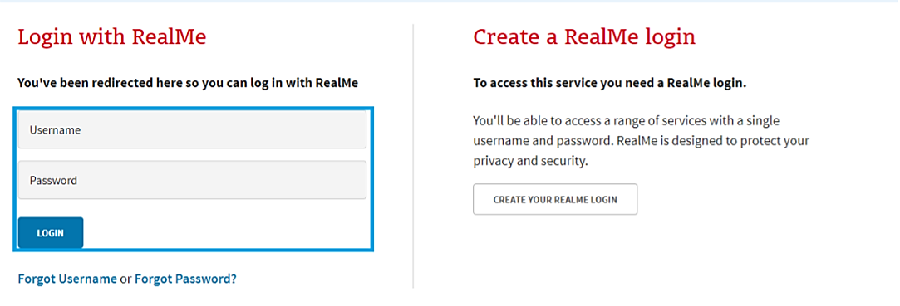

Complete the User Registration
Once you have logged in using RealMe, you will need to register with Enquire by completing and submitting the User Registration Form.

Note: Make sure to enter the contact details that you want the Department to use.

Complete the User Profile.
You will then be directed to your user profile which asks for a few extra details, such as your title and address.

All mandatory fields must be filled in before you Save.

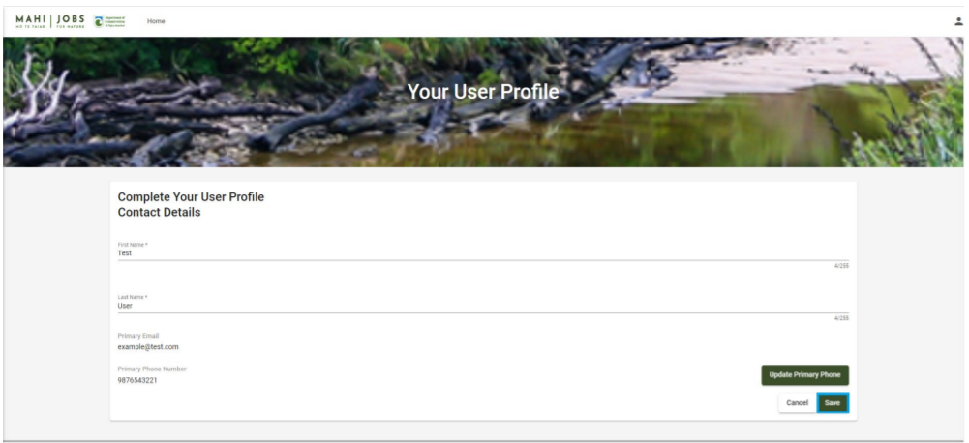

Complete and Submit Reporting in the Client Portal of Enquire
The key contact for the Project’s account will receive an email notification when a report request is waiting for them in Enquire.
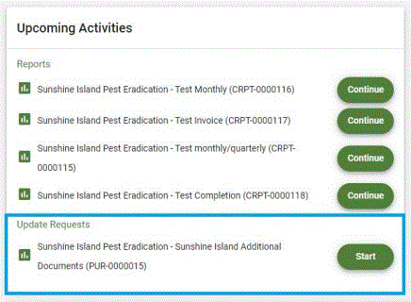

How to start your report
When you receive an email notification about a report:

- Login to Enquire using your RealMe username and password.
  - The report will be displayed on the homepage for your Project’s account.
- Select Start.

How to Navigate the report
Navigate the report using the forward and back arrows.
The Submit button sends the report back to DOC.
The Save button saves the report for additional work later.

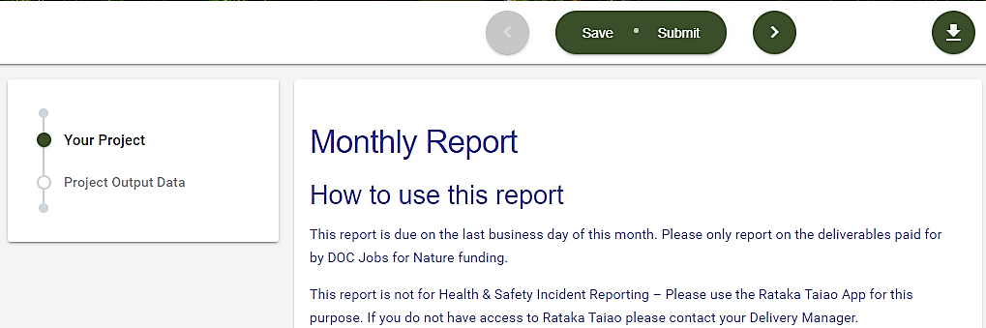

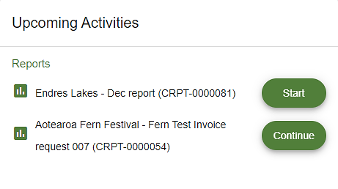

How to resume a saved report
To resume a saved report, from your Project’s homepage, select Continue.

Provide Invoices from the Client Portal of Enquire
Invoicing through Enquire is very similar to reporting. The key contact for the Project’s account will receive an email notification when an invoice request is waiting for them in Enquire.

Once the key contact clicks Start on the invoice request, there are instructions in what needs to be included in the invoice.
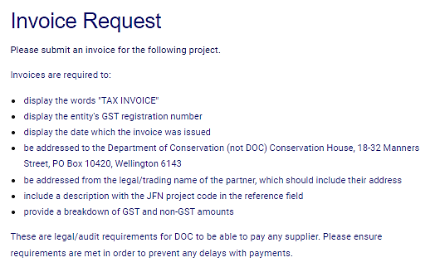

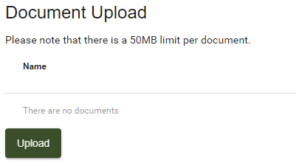

How to upload documents
You may want to provide documents to support reports, expense claims and invoices.

At the Document Upload step. Select Upload.

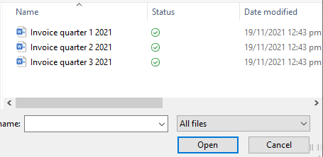
Browse and select the document, then Open.

The document will now be uploaded to the report. If the wrong file has been uploaded, select the trash can icon to delete it from the report.

Frequently Asked Questions for Enquire
Step-by-step detail can be found in the Enquire Client Portal User Guide.

Who do I contact for help?
For assistance with Jobs for Nature, contact your Delivery Manager.
For technical assistance with the Client Portal, contact Enquire Support at: enquiresupport@tactiv.net.

What if I forget my username or password?
To reset your password, go to the Login tab and select Forgotten Your Username or Password? This will redirect you to the RealMe service where you will follow the RealMe process for resetting your password.

If I update my contact details in RealMe, will they updated in Enquire?
No. RealMe does not pass any of your personal details to Enquire.

If I have an NZBN number, will my organisation’s account be automatically updated when I update my NZBN details?
No. The NZBN database does not pass any organisation details to Enquire.

How do I clear my browser cache?
You may need to clear your browser’s cache to fix unexpected issues on the Client Portal. Please make sure that you save all work before clearing your browser cache. ensure any work is saved before proceeding with the steps below as you will need to close the browser down to finish the process.
Microsoft Edge
- Open the Delete Browsing History window by selecting Ctrl+Shift+Delete shortcut.
- Check that the following options have been selected:
- Browsing history
- Download history
- Cookies and other site and plug-in data
- Cached images and files

- Select Clear Now. Now close all Edge browser windows to complete the clear cache process.

Alternatively, go to Settings, select Privacy, search, and services. Then select Choose what to clear.

Google Chrome
- Bring up the Clear Browsing Data window.
- Use the Ctrl+Shift+Delete shortcut to bring up the Clear Browsing Data window. Or at the top right of your Chrome select More tools, then Clear browsing data.
- On the Advanced tab from the Time range drop down menu, select All time.
- Check that the following options have been selected.
- Browsing history
- Download history
- Cookies and other site and plug-in data
- Cached images and files

- Select Clear Data. Now close all Chrome browser windows to complete the clear cache process.

Alternatively, go to Settings and select Privacy and Security. Then select Clear browsing history.

Undertake reporting
Jobs for Nature requires regular reporting on several aspects associated with your Project. DOC uses Enquire to create a format to make this process as easy as possible.
NOTE: Your Delivery Manager will be required to verify the data submitted in your reports as part of DOC’s assurance process.
ALSO NOTE: There is an expectation that Projects keep adequate records and that that DOC may request to see these as part of its assurance role.
Reporting is through quarterly
reports

We continue to refine all reporting. Any changes will be communicated to keep you informed.

Quarterly report
Quarterly reporting is critical for tracking project performance and forms part of the milestone payment process. When you use quarterly reports to inform us of Project progress, success, and risk, it gives confidence about the release of further funds.
The quarterly report is delivered through the Client Portal of Enquire. This report is focused primarily on:
- employment metrics,
- training,
- conservation outputs and
- project spending.

Breakdown of the quarterly report
Please note that the report questions change slightly depending on the specific project.

Project identification basics

  - Including the project name and code, region, etc.

People measures
    - Employment starts,
    - Total work hours,
    - Total people employed

Training outputs - including formal and informal
  - Formal training is defined as training provided by a recognised institution where industry-recognised certificates/credits can be obtained.

Conservation outputs
    - Hectares treated for predators,
    - Hectares planted,
    - Hectares treated for weeds, and
    - Other outputs dependent on the specific project.

Additional deliverables or outputs

- For example, preparation work for future phases of the project

A story to celebrate project mahi
- What difference has your Project made for you and the community you live in?
- Can we share your story through DOC’s communication channels?

Once all questions in the survey have been answered, click ‘Submit’.
This sends the survey to Jobs for Nature. You can also save a copy of your answers for later review.

Financial reporting
Financial reporting is required to demonstrate our fiscal responsibility. Additionally, it is important for us to understand your funding arrangements, including whether your project is also funded by other parties (called co-funding).
The financial reporting allows Jobs for Nature to assess the release of funds to each project. DOC also uses this information in Jobs for Nature reports that we submit to Treasury and other stakeholders.

We provide a link to the spreadsheet for you to fill in and return to Jobs for Nature, to capture Project financial performance. The template can be downloaded from the DOC website here: https://www.doc.govt.nz/our-work/jobs-for-nature--mahi-mo-te-taiao/reporting-for-jobs-for-nature/how-to-report/.

NOTE: This will need to be returned to Jobs for Nature in the Document Upload section of the Quarterly report as a functional spreadsheet.

Where we have asked for year-to-date (YTD) and this-quarter financial information, we’re referring to the financial year associated with Jobs for Nature funding, which is 1 July to 30 June.
The financial report is broken into two parts, Operating Expenditure and Capital Expenditure.

Salaries & personnel allowances
Training, personnel protective equipment, uniform
Other personnel costs (E.g. recruitment costs, provided accommodation)
Field Personnel related costs:

Field operation supplies
Vehicle and travel costs
Contractors
Other field operations costs
Field Operations related costs:

Salaries (I.e., office based)
Professional fees
Other (E.g. recruitment costs, provided accommodation)
Project administration related costs:
Listing purchases over
$5,000
Capital Expenditure

Figure 2 The contents of the financial report

Help with the calculating the employment metrics can be found at the back of this document in Appendix 2: Calculating Jobs for Nature employment metrics.

There is a column labelled Guidance in the report to prompt the appropriate information to be added to each field.
Once all the reporting (financial and non-financial) is submitted through the Client Portal of Enquire, DOC Delivery Managers will view and verify the information.

Helpful definitions:
Formal training is defined as training provided by an established/recognised institution and/or where industry-recognised certificates/credits can be obtained.
Pest control - The reported area can include where treatment and trigger monitoring are completed. Trigger monitoring is searching for a pest with the intent to act when a threshold limit is reached.

Weed control –
- If the treatment removes wilding conifers as a by-product (when it is not a target weed), then only report it under area treated for weeds.
- If the area of weed control is targeting both wilding conifers and other weeds, this can be reported under both outputs:
  - area treated for weeds
and
  - area treated for wilding conifer.
- If the area was cleared of weeds in preparation for planting, or if the plants were released from weeds, report this under area treated for weeds.
Riparian strip refers to land close to water that serves to protect riparian waterways.
Other helpful definitions can be found in the back of this kete in Appendix 1: Jobs for Nature reporting definitions.

Deadlines for the quarterly report
Partners must provide quarterly reports before the last business day of the month following the reporting period. This supersedes any reporting due dates in funding agreements.

Capital Assets

Most Jobs for Nature Funding Agreements have a Capital Assets clause worded as below:

31. If you use any part of the Funding to purchase or develop any capital asset valued at more than $20,000 (plus GST, if any) and, at any point during the Term of this Agreement or during the 5 years after the End Date, either:
a) you sell, dispose or transfer that capital asset, without DOC’s prior written consent; or
b) the capital asset will no longer be used for the purpose intended by DOC at the time this Agreement was entered into (or as otherwise later agreed with DOC),
then you must immediately repay to DOC an amount equal to the current market value of that capital asset up to the amount of the Funding used by you in the purchase or development of that capital asset, as determined by DOC.

DOC therefore needs to work with you on ensuring we have a joint understanding of the use, sale, disposal, or transfer of these assets. This clause is valid for five years after the project completion date, so it is worth having these conversations early if the final intent of the asset is known.

What is a capital asset?

For Jobs for Nature Funding Agreements a capital asset is an item that is purchased or built with a useful life of more than one year and costs over $20,000 (plus GST, if any). Examples are vehicles, trailers, boats, shade houses, tracks and sheds.

If building an asset, the cost would include the total costs of the components such as design, materials and labour costs, in some instances this can include major maintenance that extends the life of that asset e.g. a new roof. A temporary track built for short term surveillance will not be considered an asset if used for less than a year.

Please ensure that you separate all the funding to be used to purchase or build capital assets into the capital expenditure section of the finance report and then list the items in the section provided. All purchased and developed assets must be used for the project as outlined in the Funding Agreement.

If you purchased or built an asset that is over $20,000 (plus GST) with Jobs for Nature funding and the item is then sold, written off, or lent out, DOC permission is required or the funds need to be returned. Please contact us early to ensure we administer this clause to give best effect to the project. This clause remains valid for five years after the funding stops.
If you have any questions, please contact your Delivery Manager, or email JobsforNature@doc.govt.nz

Reaching your Milestones
As part of your Project’s Funding Agreement, you set up a work plan of milestones / deliverables that you agree to meet by certain dates. This keeps your Project on track. Your funding payments are also attached to these milestones.
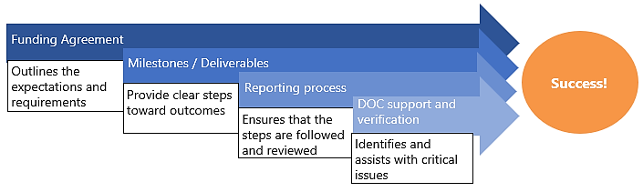
Figure 3 How milestones, reporting and verification contribute to your Project

Provide invoice
To prompt the release of Jobs for Nature funding instalments, the Project must submit an invoice.

Submitting Invoices
Invoices are required to include the following:
- a GST no.
- if an entity is GST registered, 'tax invoice', not just 'invoice' must be stated
NOTE: an invoice cannot be paid without this.
- the JFN project code in the reference field
- addressed to: The Department of Conservation, Conservation House, 18-32 Manners Street, PO Box 10420, Wellington 6143
Your initial invoice can be sent through to the Delivery Manager once the Project is set up in DOC’s Accounts Payable system. Invoices for subsequent milestone payments should only be sent once requested, through the Enquire Client Portal.

If you need any additional help, you can contact Accounts Payable (ap@doc.govt.nz or 0800 677 800).

Employment – Employer obligations
If you are new to employing staff, you may not be aware of your obligations. Inland Revenue (IRD) have some helpful videos that cover:
- Who needs to register as an employer
- New employees and filing returns
- Further obligations

These videos can be found on the IRD website at www.ird.govt.nz.

Employment - Ministry of Social Development (MSD)

MSD has access to its JobSeeker database and can access a big-picture view of need across the region.
As Jobs for Nature Projects end, workers will have an interest in transitioning to other employment. MSD can support projects in the same region to collaborate across the recruitment process. They can also support Projects to fill gaps when people leave. Staff will have gained skills and will be seen as "work ready." MSD can help workers shift from one Project (winding down) to another (growing) or to other roles that call for similar skills.

MSD can provide the following services:
- Provide public employment services to recruit for MSD clients and New Zealanders at risk of being made redundant.
- Advertise job opportunities on the Work and Income Find a Job website linked to the all-of-government Connected website.

Other examples of how MSD can assist:

- Onboarding whānau to projects
- Tailor job training for specific projects
o Training needs could include Site safe, Growsafe, driver's license, chainsaw, etc.
- Provide pastoral care support
- Connect employees to other work opportunities as the Project ends
- Clothing to enter employment can be applied for.
o This does not include safety equipment. That is an employer's responsibility.
- Equipment can be applied for, if not normally supplied by the employer.
There are some government service websites led by MSD that can assist:

- Connected.govt.nz – Focused on connecting people to employment, education, and training. It includes a job search function.

We suggest that you get in touch with your regional MSD contact to discuss the projects and recruitment opportunities in your area through Jobs for Nature.

Regional Ministry of Social Development contacts
Region | Labour Market Manager | Email | Mobile
Northland | Darrell Lambert | Darrell.Lambert008@msd.govt.nz | 027 379 0985
Auckland | Flo Samuels | Flo.Samuels005@msd.govt.nz | 029 200 4129
Waikato | Tristian Te Nana | Kristian.TeNana001@msd.govt.nz | 029 200 1103
Bay of Plenty | Brent MacDonald | Brent.MacDonald001@msd.govt.nz | 029 200 9127
East Coast | Robyn Leake | Robyn.Leake001@msd.govt.nz | 029 200 6228
Taranaki | Lu Scanlon | Lu.Scanlon001@msd.govt.nz | 029 244 5604
Central | Toni Seanoa | Toni.Seanoa001@msd.govt.nz | 029 200 6229
Wellington | Jane Fanselow-Price | Jane.Fanselow-Price005@msd.govt.nz | 029 257 6061
Nelson | Michelle Martin | Michelle.Martin029@msd.govt.nz | 029 201 4601
Canterbury | Regan Jackson | Regan.Jackson002@msd.govt.nz | 029 278 3740
Southern | Deb Sutton | Deb.Sutton003@msd.govt.nz | 029 221 4750

Train staff – build skills
While the main purpose of Jobs for Nature is to provide jobs, it is expected that some of the funding will also be used to train workers. Only properly trained staff have the skills to work both safely and effectively.
Training catalogues on the DOC website:
- Administration skills (PDF, 373K)
- Maintenance skills (PDF, 482K)
- Biodiversity skills (PDF, 697K)
- Communication skills (PDF, 505K)
- Health and safety skills (PDF, 355K)
- Outdoor skills (PDF, 494K)
- Project management (PDF, 246K)
- Technical data skills (PDF, 378K)
- Pest control (PDF, 483K)
- Riparian wetland (PDF, 523K)
The added skills that staff gain in working on your project can improve their future career prospects. Training is not only a necessity of Project work, but also a contribution toward the future employment development of your workers.
DOC has a series of training catalogues on our website that help employers to assess the training needed by staff and point to where training exists in New Zealand.

Raise critical issues
Critical issues are defined as anything that prevents the successful delivery of a Project milestone. Your DOC Delivery Manager is there to provide guidance and support in solving critical issues. They are also the person that will be verifying your Project reports.
Talk to your Delivery Manager about any concerns early - as soon as you become aware of any issues. Failure to meet milestones can temporarily stop payment on future invoices. Repeated failure to meet milestones could result in termination of the Deed of Grant.
While most day-to-day problems resolve in time, do not let critical issues sort themselves out!

Project Delivery

Communication – working with your Delivery Manager
Inform them of Health & Safety incidents
Inform them of significant cultural sites
Raise critical issues
Keep them up to date with the Project
DOC
Delivery Manager
Share success stories to help them celebrate your mahi
The DOC Delivery Manager role actively supports partners to successfully deliver projects and build their capability to grow conservation. Although there is an important contract monitoring and reporting aspect to the work, the Delivery Manager is the primary liaison between you and the Jobs for Nature team.
It is important that you keep them informed.

Figure 4 What to communicate to your Delivery Manager

Health and Safety

Your Health and Safety role includes:
Ensuring everyone on site follows the Safety Plan
Establishing a site-specific Safety Plan

Reporting all Health and Safety incidents

As a Jobs for Nature Project, you have agreed to work to DOC’s aim to ensure that workers go home safe and healthy every day. This also includes making sure that all duties are fulfilled under the Health and Safety at Work Act 2015.
DOC is happy to provide support to you in your Health and Safety responsibilities.

Developing a Safety Plan
Before any work begins, a site-specific Safety Plan must be in place.

Your Safety Plan should include:
Helpful Health and Safety documents that you can get from your Delivery Manager:
- Community Group Safety Plan Template
- Delivery Manager Safety Plan Checklist
- Identification of risks with controls
- Explanations on how you will assess competence of workers
- Emergency procedures

How will you effectively manage the Health and Safety risks associated with your Project's work?

Questions to ask when considering how you will manage Health and Safety
How will you ensure that all involved PCBUs (landowners, other government agencies, etc.):
- have agreed on the Health and Safety risks and mitigations?
- understand their roles and responsibility in managing Health and Safety?

How will you communicate information on the Health and Safety risks / controls to all parties?

How will you communicate the roles and responsibilities for managing Health and Safety in the work to all parties and workers?

How will you monitor the Health and Safety performance of people working on your site for the duration of the project?

Please note: Your DOC Delivery Manager will need to ensure that a Safety Plan is in place before any work begins. They will also work with you to set up a monitoring schedule. (You can see what they will be looking for in terms of Health and Safety in the Delivery Manager Safety Plan Checklist – Ask for a copy!)

Reporting Health and Safety

Reporting notifiable events or critical risk incidents

Your project should report all notifiable events and/or critical risk incidents to us through an online form.

Your project should inform DOC, using the online form, within one business day for notifiable events and as soon as practicable for critical risk incidents.

Complete the health and safety incident form (external site).

A notifiable event is classed as a:
- death
- serious illness or injury
- serious incident.

More about notifiable events from WorkSafe (external site).

A critical risk incident means any health and safety incident involving any critical risk identified and agreed by the Organisation/Trust, DOC and/or other Jobs for Nature PCBU’s that has a potential for serious harm. Critical risks will be identified and agreed in individual health and safety management plans before work begins at site.

Reporting all other health and safety incidents

Your project should report all other health and safety incidents though your quarterly Enquire report, as set out in part C of your agreement.

Identifying Project warning signs
There are some common Project warning signs that could result in future critical issues. Sorting out these problems early on prevents them from becoming a critical issue that stops the delivery process.
NOTE: If the warning sign has become a critical issue, it is important to let your DOC Delivery Manager know.

Process warning signs

People concerns

Milestones were too difficult (not being achieved)
Poor budgeting, funds are getting diverted
The team doesn't understand the risks

Lack of skills or resource capacity
Inconsistent or ineffective leadership
Regular absences of staff
Conflict within the team
Communication issues

Try to resolve any concerns early - while the issues are still small. Your team can only fix a problem if they know about it. Ignoring problems could result in several little things building up to become critical issues.
Tips on talking about Project concerns:
Talk to the Project team immediately for any health, safety, and wellbeing concerns.
Choose the appropriate way to communicate (e.g. phone call, e-mail, face-to-face meeting)
The bigger or trickier the problem, the better it will be handled with a face-to-face conversation.
Record the problem as part of tracking progress.
Act in good faith to negotiate a mutually acceptable solution.
Use problem-solving approaches that are practical, clear, achievable, and effective.

Comms and media
Telling stories about the fantastic work JFN projects are doing helps demonstrate the positive impacts the programme is having on conservation and communities.
The key aim is to showcase the "Boots on the Ground" work and highlight the long-term conservation impacts that are being made.
As the people working directly on the projects, we would appreciate your help in identifying these story-telling opportunities. DOC will ensure you are included in all steps of identifying, developing, and scheduling any media stories.
We are also happy to help you with developing stories and pitching to media if you want to put a story in your own words. However, we request that you give us advanced notice if you are planning any media stories (by contacting your Delivery Manager). This will ensure that our messaging is aligned with yours, and our Comms Team can help you frame up a story to media.
You are welcome to share any stories about your work which are posted on DOC’s social media channels.
What makes a good story?
The aim is to tell stories about how JFN is making a difference. For example, stories could include:
- The impact JFN is having on people and communities
- The long-term conservation impacts projects are having
- Key milestones achieved by a project, for example 100,000 trees planted in 3 months. These kind of facts and figures can really help to strengthen a story.
- People stories are very powerful and go down well in the media and on social media.
A great photo can also really bolster a story.

Jobs for Nature branding
You are welcome to use the JFN logo on any JFN related material. However, we’d appreciate if you could let your Delivery Manager know in advance.

Roles & responsibilities of others

Department of Conservation
- analyse and verify reports
- identify, resolve, and escalate critical issues
- recommend decision on releasing milestone payments

Jobs for Nature Advisor
Relationship Manager

Delivery Manager

- Accountable for the health of your relationship with DOC
- Sometimes the Delivery Manager also performs this role

- Help to set-up reporting requirements and expectations
- Receive and review reports
- Process documents for audits and payments

Contact information
If you require assistance with your project, contact your DOC Delivery Manager in the first instance. For other enquires:
  - Reporting enquiries: JFNReporting@doc.govt.nz
  - Health and safety enquiries: JFNReportingHS@doc.govt.nz
  - General enquiries: jobsfornature@doc.govt.nz

Appendix 1: Jobs for Nature reporting definitions
 | Term | Definition
Employment | Employment starts | Number of new people employed over a given period.
 | People currently employed | Number of people employed at a given point in time.
 | Total hours | Total paid hours of all employed people
 | Part-time employment | Number of people who have worked part-time (less than 30 hours per week) at a given point in time.
 | Full-time employment | Number of people who have worked full-time (30 or more hours per week) at a given point in time.
 | Casual employment | Number of casual contracts at a given point in time.
Conservation outputs | Animal pest control | Total hectares (ha) treated for:  - possums  - rats and/or mustelids  - goats  - deer  - wallaby  - other animal pests (specify).
 |  | Reported area can include where treatment and trigger monitoring is completed.
 |  | Trigger monitoring is searching for pest with the intent to take action when a threshold limit is reached.
 | New fencing | Total length (m) of new fencing constructed to standard over project period to manage pests, stock, riparian sites.
 | Maintained existing fencing | Total length (m) of current fencing maintained to standard over project period to manage pests, stock, riparian sites.
 | Weed pest control | - Weeds – excluding wilding conifers  - Wilding conifers – excluding other weeds
 | Weeds | - Includes aquatic weeds, such as algae and invasive seaweeds.  - Includes activities such as tree releasing or removing weeds in preparation for planting.
 |  | If the treatment would remove wilding conifers as a by- product when it is not a target weed, then only report under "area treated for weeds."

If the area of weed control is targeting both wilding conifers and other weeds, this can be reported under both outputs:
- "area treated for weeds,” and
- "area treated for wilding conifer."
 | Wilding conifers | If the treatment would remove other weeds as a by- product when wilding conifer is the only target, then only report under "area treated for wilding conifers."  If the area of weed control is targeting both wilding conifers and other weeds, this can be reported under both outputs  - "area treated for weeds," and  - "area treated for wilding conifer."
 | Planting restoration | Total hectares (ha) restored and number of indigenous plants planted for:  - freshwater areas – riparian, lakes or wetlands  - other areas – not riparian, lakes or wetlands.  If the area was cleared of weeds in preparation for planting, or if the plants were released from weeds, report this under "area treated for weeds."
 | Recreation | Total hectares (ha) treated for:  - Total number of huts to standard over period of project  - Total kilometres of tracks to a standard over period of project.
 | Historic heritage assets receiving remedial work | Total number of assets maintained over period of project.
 | Plant nursery work | - Number of indigenous plants prepared and ready for restoration (count).  - Excludes exotic plants.  - Stock must be suitable for the area that it is supplying (for example, is complementary to the inherent local biodiversity of the area).  - Stock must be appropriately sourced. For example:  - sourcing method is not destructive to the ecology of the area.  - sourcing method has appropriate consents in place.
Biodiversity | Number of actively managed  ecosystem management units (EMUs) | Increase in priority EMUs and species management units (SMUs) fully managed.
 | Ecosystem representation in managed sites | More ecosystem types are represented in managed EMUs.
 | Ecosystem condition in managed sites | Higher estimated integrity of managed ecosystems.

 | Species representation in managed sites | Threatened species have populations greater than 1 in a managed site.
 | Species persistence in managed sites | Increase of threatened or at-risk species have enough populations adequately managed for persistence.
Freshwater | Number of rivers under management | River catchments protected and restored for long-term resilience and progress to conservation of a representative range of freshwater catchments.
 | Improved stakeholder satisfaction | Stakeholders actively involved.
 | Migratory freshwater fish management and security | Assured long-term persistence of migratory fish species across their range.
 | Invasive aquatic pest management | Increased number of pest control programmes.
Marine | Improved security of marine species | Number of fishing methods where impact is reduced and number of fishing methods where liaison is undertaken.
Pest control and biodiversity | Tahr distribution and density | Tahr numbers and distribution comply with statutory plan.
 | No new pest establishments | Early detection and effective responses for island biosecurity.
Employee training | formal training | Number of people in formal training.
 | formal training completion | Number of people who have completed formal training.
 | NZQA credits | Number of NZQA credits earned.
 | Formal training is training provided | - by an established or recognised training institution, or  - where industry-recognised certificates or credits can be obtained.

Appendix 2: Calculating Jobs for Nature employment metrics
For Jobs for Nature projects, there are three employment metrics.

Jobs for Nature funded projects need to provide number of:
- employment starts
- people currently employed
- total hours – DOC uses this data to calculate full time equivalent (FTE)

Definitions

Employment starts
The number of people who have been employed since the previous indicated date.
For casual employees, count when the employment relationship begins, and not each time the person completes work.

Example 1
An employed person was re-directed to support a Jobs for Nature project. Their wages are now paid by the Jobs for Nature project. Upon starting this employment relationship, count as one employment start.
Example 2
A self-employed contractor was hired by a project made up of two smaller projects (sub-projects):
- one for weed control, and
- one for riparian planting.
If the contractor was hired under one employment agreement for both sub-projects, count as one employment start.
If the contractor was hired under two employment agreements, one for each sub-project, this may be counted as two employment starts. However, if it’s identifiable that this is the same person, effort should be taken to prevent double counting for this overall project.

People currently employed
The number of people employed at a specific point in time. This reflects the number of people employed at any given time.

Total hours
The combined total number of paid hours from all employed people, including part-time, casual, and full- time hours. This includes all hours worked and leave such as annual and sick leave.

DOC will calculate FTE
DOC will use the total hours number to calculate the FTE. Your project does not have to provide calculated FTE values.
One FTE is 30 hours per week for 52 weeks, totalling 1560 hours per year. This is consistent with the Statistics New Zealand definition of full-time work being 30 hours or more per week. The FTE is calculated as total hours divided by 1560.

Projects may determine FTE differently, for example, using 40 hours instead of 30 hours per week. For our metrics, we use total hours divided by 1560 to prevent variability of FTE between projects.

Estimating total hours example
You estimate that an activity will need:

three people working 40 hours per week over 4 weeks

one person working 20 hours per week over 4 weeks
You would estimate the total hours:

For the three people, you do 40 hours × 4 weeks × 3 people = 480 total hours.

For the one person, you do 20 hours × 4 weeks × 1 person = 80 total hours.

For the total hours, you add 480 and 80 to get
560 total hours.

You then calculate the estimated FTE as 560 total hours ÷ 1560 = 0.36 FTE estimate.

Actual total hours
If the actual timesheet was different to the estimate, report the actual total hours.

For the total hours: 480 + 80 + 15 =
575 total hours.
Example timesheet:
Two employees who
each worked 10 hours per week over 4 weeks
40 hours × 4
weeks × 3 people
= 480 total
hours

Three employees who
each worked 40 hours per week over 4 weeks
10 hours × 4
weeks × 2 people
= 80 total
hours

One contractor who
worked 15 hours total during the 4 weeks
15 hours × 1
person
= 15 total
hours

DOC will use the actual total hours to calculate the actual FTE. This would be 575 total hours ÷ 1560 =

0.37 FTE.
This means that over four weeks, this project provided work equivalent to 0.37 FTE, with a total number of 6 people employed.
If all employment ended following this reporting period, the people currently employed for next month would be zero.

Helpful links

DOC website – Jobs for Nature –  Mahi mō te Taiao section | https://www.doc.govt.nz/our-work/jobs-for-nature--mahi-mo-te- taiao/for-projects/skill-assessments-for-jobs-for-nature-projects/
Reporting for Jobs for Nature | https://www.doc.govt.nz/our-work/jobs-for-nature--mahi-mo-te- taiao/reporting-for-jobs-for-nature/rataka-taiao-natures- diary/guide/incident-notification/
Roles and responsibilities for Jobs for Nature | https://www.doc.govt.nz/our-work/jobs-for-nature--mahi-mo-te- taiao/reporting-for-jobs-for-nature/roles-and-responsibilities/
Skill assessments for staff – including where you can access training. | https://www.doc.govt.nz/our-work/jobs-for-nature--mahi-mo-te- taiao/for-projects/skill-assessments-for-jobs-for-nature-projects/
How projects are assessed | https://www.doc.govt.nz/our-work/jobs-for-nature--mahi-mo-te- taiao/how-projects-are-assessed/
Enquire help - written | https://www.doc.govt.nz/contentassets/c6cff688867c45309e808f6d9721ba29/enquire-guide-jfn.pdf
Enquire help - video | https://youtu.be/rqVqwq_yup4
How to complete the incident notification | https://www.doc.govt.nz/our-work/jobs-for-nature--mahi-mo-te- taiao/reporting-for-jobs-for-nature/rataka-taiao-natures- diary/guide/incident-notification/
IRD - Employer obligations help | https://www.ird.govt.nz/about-us/videos/webinars/employers- workshop

