
11

Translocation Outline
Application form 11
This application form is to be completed by the applicant. Once it has been deemed complete by the Department of Conservation, a Case Manager will be assigned to the Translocation, and will work with the applicant to complete Application Form 11a – Full Translocation Proposal.
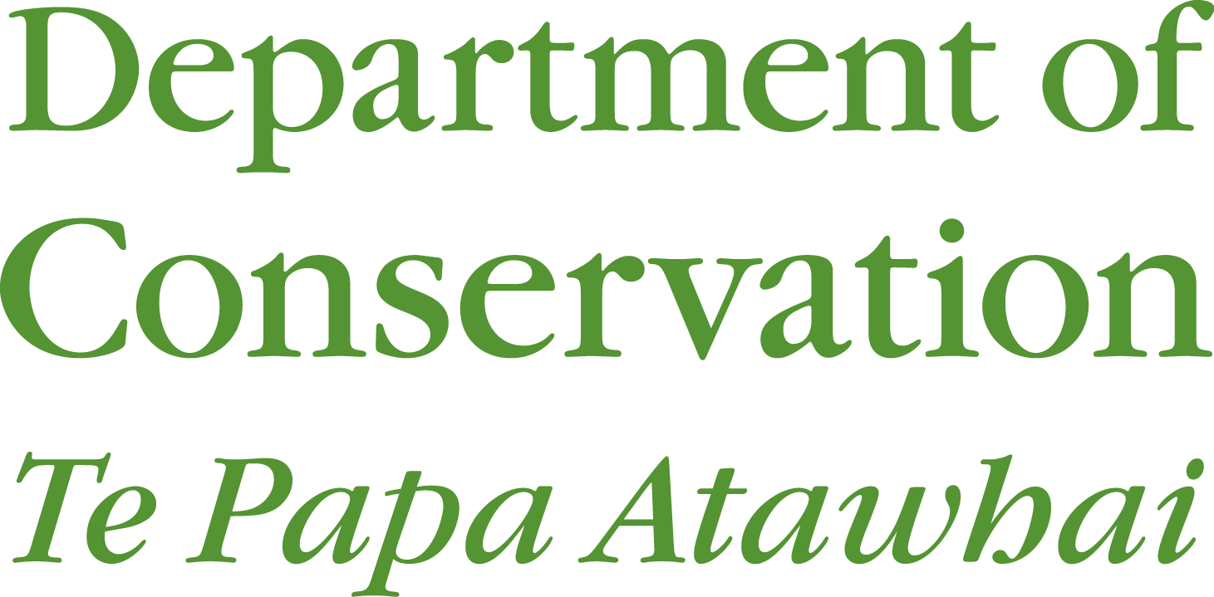


Using this application form |   Application checklist  Have you included labelled attachments as required for your activities (including maps, testimonials, and consultations)?  Have you read the section regarding liability of the applicant for payment of fees?  Have you checked if your application requires a CITES permit or EPA application and included these as applicable?  Have you signed your application (digitally or manually)?
Completing the application
Save – You can save this application form to your digital device and edit or fill it in your own time.
Fill – You can fill this application digitally using Microsoft word.
Print – You can print this application form and fill it manually, or you can fill it digitally, then print it.
Submit – This application form can be submitted by email or by post.
Email – Email your application and all the required labelled attachments to: permissions@doc.govt.nz
Post – Post your application and all the required labelled attachments to:
Permissions Team
Private Bag 3072
Hamilton 3240
Navigation
Hints – Use the links through the hints column on the right hand side of the application form
Scroll – Simply use your mouse or keyboard arrows to scroll through the document page-by-page.

Before you start  You are strongly advised to contact your local Department of Conservation office while completing this application form; you will be assigned a Conservation Translocation Case Manager who can provide advice and assistance throughout the application process. |  | Please take the timeframes below into consideration when submitting your application.
Process:  - After DOC has provided feedback and consulted on your ‘Translocation Summary’ your Case-Manager will work with you and the other affected parties to develop a specific proposal form for your project based on a selection of the relevant sections in this document. |  | An application is deemed complete when all information requested has been received.  Any amendments requested after lodgement may require a Form 9a variation application to be completed resulting in a delay of processing of your application.  Please see also the fees section.
Consultation:  Consultation is required on most applications. In general, iwi have 20 working days to respond to DOC once we make a formal request. If there are considerable iwi values to consider they may request a further 20 working days to respond. If no response is received from iwi within the specified period DOC will continue to process your application, as we may be able to locate relevant information about their interests from other sources. |  | For more information please see the iwi consultation section.
Contact  Permissions Team  Private Bag 3072  Hamilton 3240 | +64 27 308 8958  permissionshamilton@doc.govt.nz

Section A | Applicant details
Full name (registered company, institute, organisation, or individual)  Legal status of applicant: |  |  |  |  |  |  |  |  | Enter your details in the grey fields.
Individual  Research institute |  | Trust |  |  |  |  |  | Registered company | Please attach a copy of Trust Deed
 |  | Other (specify)
Registration number (if company, trust or incorporated society)
Trading name (if different from applicant name)
Any previous Authorisations held? Yes No
If yes, please provide Authority number
Postal address |  |  |  | Street address (if different from postal) |  |  |  |  | You must provide a New Zealand address for service.
Registered office of company or incorporated society (if applicable)
Phone |  |  |  |  |  | Website
Contact person and role
Phone |  |  |  |  |  | Mobile |  |  | Please fill these three fields for your company contact person or if you are applying as an individual.
Email

Section B | Activities – Initial Information
- This Conservation Translocation is:  A Supplementation; A re-introduction; An introduction  - Species Name and Threat Classification  - Please list both the common and scientific name/s as well as the threat classification of all protected wildlife species for which authorisation is sought. Threat classifications can be found on the DOC website - New Zealand Threat Classification System Lists.  - Have you had contact with the relevant Technical Advisory Group (e.g. a species Recovery Group) and if so who has been your key contact? Write ‘Not Applicable’ if there is no Technical Advisory Group for the species being translocated. | If you have complied information in another format or it does not fit in the space provided please label any attachments with the relevant question number  A New Zealand classification system guide can be found here on the DOC website.
  Common Name | Scientific Name | Threat Classification
Section B (continued) | Activities
- Purpose
Briefly explain why you want to do the translocation. If applicable explain the need for the translocation (e.g. the conservation problem you are trying to fix).
- Explain what alternatives to translocation have been attempted or considered. If this is a threatened species explain why in-situ management is not feasible instead of translocation.
- What are the main outcomes you expect to achieve through undertaking this conservation translocation? e.g. conservation outcomes (benefits to the site or species), advocacy, research.

- Release Site
- Briefly describe the release site and its location and size.
- How does the release site meet the needs of the species being moved (e.g. food, habitat, breeding requirements, predator control)? You may append and refer to existing management and restoration plans.
- Is the species to be translocated already present at the site? Was this species ever at this site before? If so, why did it die out (for example, predators, forest clearing, and competition)?

Section B (continued) | Activities
For wild sites only:
- Does this site have a restoration plan or site management plan?
- Are the animals likely to disperse from the release site?
- Is the habitat at the release site secure for the term the released population is to reside at the site? e.g. what is the land tenure of the site; do you permission/support for the project if privately owned? and how access for management and monitoring will be provided if the land is privately owned.

For captive sites only:
- Does this site have an existing Captive Management Plan and Captive Coordinator? If not, what is planned for a captive population of this species in the long term?
- Does the facility receiving the species have authority (a permit) to hold the species? Please provide the permit number.

- Source Population/s
- Do you have any knowledge regarding possible source populations for this conservation translocation? If you do please provide the names of the location/s.
- Will there be enough plants or animals within the source population/s to harvest sustainably for this proposed conservation translocation? Do you have any evidence to support your opinion?

Section C | Consultation
- Engagement with Tangata Whenua  During the application process consultation will be required with tangata whenua (local Māori), and may be required with other interested parties.  If you have already begun consultation, including with tangata whenua, please attach any additional written expert views, advice or opinions you have obtained concerning your proposal to support the application and label them Attachment C-1.  - General Stakeholder Engagement  Are there additional stakeholders known to the applicant with an interest in this proposal? Who are they and what engagement, if any, has been undertaken with individuals/ groups as part of this proposal? State any concerns that were raised and how they were addressed.  Attach a record of consultation with key stakeholders and label it Attachment C-2. Include name and contact details for all key stakeholders consulted, the date/s, topics covered, and any decisions reached. Include relevant letters/emails. | If you are unsure of any consultation requirements for your proposal, please see the iwi consultation section or contact your local DOC office to discuss what is required.

Section D | Fees
Please note  This section only applies to applications with a commercial focus – which will include applications from registered companies. The Department does not charge fees for non-commercial Wildlife Act authorisations. The Department will advise if fees will be charged, and if so, provide an estimate of these fees. |  |  |  |  | If you are making an application for non-commercial activity, proceed to declaration.
Processing fees  Section 60B of the Conservation Act contains the statutory provisions regarding processing fees.  The Department recovers all direct and indirect costs to process an application from applicants regardless of whether the application id approved or declined. If at any stage an application is withdrawn, the Department will invoice the applicant for the costs incurred by the Department up to that point. |  |  |  |  | Applicants are required to pay the processing fees within 28 days of receiving an invoice. The Director-General is entitled to recover any unpaid fees as a debt.
Fee waivers and reductions
The Director-General has discretion to reduce or waive processing fees. You may apply for a fee waiver or reduction if you can provide information to the permissions team about how your application meets the criteria of the activity making a direct contribution to management.
Terms and conditions: Account with the Department of Conservation
Have you held an account with  the Department before? | Yes |  | No
If yes, under what name?

Terms and conditions: Account with the Department of Conservation
- I/We agree that the Department of Conservation can provide my details to the Department’s Credit Checking Agency to enable it to conduct a full credit check.
- I/We agree that any change which affects the trading address, legal entity, structure of management or control of the applicant’s company (as detailed in this application) will be notified in writing to the Department of Conservation within 7 days of that change becoming effective.
- I/We agree to notify the Department of Conservation of any disputed charges within 14 days of the date of the invoice.
- I/We agree to fully pay the Department of Conservation for any invoice received on or before the due date.
- I/We agree to pay all costs incurred (including interest, legal costs and debt recovery fees) to recover any money owing on this account.
- I/We agree that the credit account provided by the Department of Conservation may be withdrawn by the Department of Conservation, if any terms and conditions of the credit account are not met.
- I/We agree that the Department of Conservation can provide my details to the Department’s Debt Collection Agency in the event of non-payment of payable fees.
Section D (continued) | Fees
Reduction in fees for exceeding processing timeframe
If the Department fails to meet its own processing timeframes the estimate of fees will be reduced at a rate of 1% per day late, up to a maximum of 50% of the total processing fee. The reduction will not apply if the Applicant’s actions have delayed the process.
Additional Fees  You may also be required to pay additional fees. These may include:  - Annual management fee to cover administration time; and/or  - Monitoring fee to cover the cost of monitoring the effects of your activity. |  |  |  |  |  | Please contact the Permissions team to discuss whether these fees apply.
Section E | Declaration
I certify that the information provided on this application form and all attached additional forms and information is to the best of my knowledge true and correct. |  |  |  |  |  |  | An Authorisation may be varied or revoked if the information given in this application contains inaccuracies.
Signature (applicant) |  | Date (dd/mm/yyyy)
This application is made pursuant to Section/s 41(1)(g), 53; 54; 55; and/or 56 of the Wildlife Act 1953 [and (where applicable) Section/s 22; 49; 50; 51; 57; and/or 59 of the Reserves Act 1977; and/or Section/s 5; 13; 14(3) of the National Parks Act 1980; and/or 38 of the Conservation Act].
Applicants should familiarise themselves with the relevant provisions of the Wildlife Act 1953, the Conservation Act 1987, the Reserves Act 1977 and the National Parks Act 1980 relating to authorisations.
The purpose of collecting this information is to enable the Department to process your application. The Department will not use this information for any reason not related to that purpose.
Applicants should be aware that provisions of the Official Information Act may require that some or all information in this application be publicly released.

