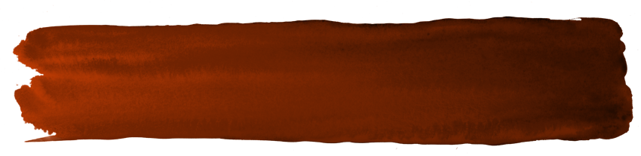

\
COMMENT SUBMISSION FORM
Publicly notified application for leases, licences, permits, or easements.

This form is to be used to provide submissions concerning publicly notified applications for leases, licences, permits, or easements under section Sections 17SC and 49 of the Conservation Act 1987.
Notes to Submitter:
Please download and complete this form, scan and send to permissionshamilton@doc.govt.nz. You may also mail your submission to: Director-General, c/o Department of Conservation, Private Bag 3072, Hamilton, 3240.
Closing Date: The closing date and time for serving submissions to the Director-General on this matter is 5:00pm on 3 July 2025 (Thursday).
Please note that submissions are public documents. Your name and submission will be included in documents that are available to the media and the public. You may request that your contact details be kept confidential, but your name, organisation and your submission itself will become a public document.
Privacy:
The Department will deal with any personal information you supply in your submission in accordance with the Privacy Act 1993. The Department will only use your contact details for the purposes of processing the notified permissions application that it relates to (or in exceptional circumstances for other reasons permitted under the Privacy Act 1993).
Where your submission is made publicly available, your contact details will be removed only if you have indicated this as your preference in the tick box on page two.
Under the Privacy Act 1993, you may request the right of access to, and correction of, personal information provided in this submission.
The Department is likely to post your submission on its website at www.doc.govt.nz. Once submitted, submitters' information is subject to the Official Information Act 1982 and may be released under that Act.
Do not send page one of this document with your submission. If you require additional space for providing your submission, please attach extra pages as needed and label according to the relevant section.

COMMENT SUBMISSION FORM
Publicly notified application for leases, licences, permits, or easements.

Note: Include pages two and three of this form with your response to DOC. Do not include page one.

A. Permission Application Number and Name of Applicant
Russell Boating Club Incorporated, 119504-OTH

B. Name of Proposed Activity and Location(s)
The Applicant (Russell Boating Club Incorporated) has applied for an application submitted by for a lease for a lease for various existing structures on the Matauwhi Bay Recreation Reserve, Bay of Islands.

C. Submitter Information-
Full Name (also list organisational name if submitting on behalf of a business, community group, etc.): ___________________________________________________________________________________
Address for Service (Postal Address): ____________________________________________________
_____________________________________________________ Post Code: ____________________
Telephone: _____________________________ Email Address: _______________________________
Note: Communication from DOC will be via e-mail unless alternate contact is requested below.
I wish to be contacted alternately by: ______________________________________________
I wish to keep my contact details confidential

D. Statement of Support/Opposition

I (circle one) Support / Neutral / Oppose this Application.

E. Hearing Request

I (circle one): Do / Do Not wish to be heard in support of this submission at a hearing.
Permissions Application Number 119504-OTH

F. Submission
The specific parts of the application that this submission relates to are:
My submission is [include the reasons for your views]:

What outcomes would you like to address with your submission? [give precise details, including the parts of the application you wish to have amended and the general nature of any conditions sought]:

G. Your Signature

_____________________________________________________________
Signature of submitter or person authorised to sign on behalf of submitter

_____________________________________________________________
Printed name of submitter or person authorised to sign on behalf of submitter

__________________________
Date

Please complete this form and send to permissionshamilton@doc.govt.nz (Marked for the attention of J Methorst). You may also post your submission to: Director-General, c/o Department of Conservation, Private Bay 3072, Hamilton, 3240 (Marked for the attention of J Methorst).

