Prosecution Policy 2026
CONTENTS

Purpose 2
Conflicts of interest 3
Alternatives to Prosecution 3
Prosecutions 4
Test for Prosecution 5
Public Interest considerations 5
Prosecution decision-making process 6
Diversion 10
Disputed Infringement Notices 10
Responsibilities of Prosecutors 11
Investigator / Officer in Charge Responsibilities 12
Appeals 12
Review Procedure 12
Related documents 13
Prosecution decision making process flow diagram 14
Disputed Infringement decision making process flow diagram 15

VERSION: 1
DATE: 1 January 2026

Purpose

- The purpose of the Prosecution Policy 2026 (“Policy”) is to explain the objectives of the Department of Conservation’s (“DOC”) prosecution activities, and set out principles and guidelines which DOC will follow when:

- Deciding whether or not to initiate a prosecution;

- Considering alternative enforcement options, such as formal warnings or infringement notices, when an investigation is referred for prosecution; and

- Deciding whether to appeal a court decisions arising from DOC’s prosecutions.
Scope

- This Policy applies to enforcement actions arising from an investigation by DOC under:

- Any legislation, regulations, or bylaws administered by DOC; and

- Any other legislation or regulations relevant to DOC’s role.

- DOC has a compliance and law enforcement function under various Acts and Regulations. These include:

- Conservation Act 1987
- Dog Control Act 1994
- Freedom Camping Act 2011
- Hauraki Gulf/Tikapa Moana Protection Act 2025
- Marine Mammals Protection Act 1978
- Marine Mammals Protection Regulations 1992
- Marine Reserves Act 1971
- National Parks Act 1980
- Reserves Act 1977
- Resource Management Act 1991
- Trade in Endangered Species Act 1989
- Whitebait Fishing Regulations 2021
- Wildlife Act 1953
- Wild Animal Control Act 1977

Solicitor-General’s Prosecution Guidelines

- All Government agencies with prosecution function are required to have a prosecution policy in accordance with the Solicitor-General’s Prosecution Guidelines. This Policy adopts the Solicitor-General’s Prosecution Guidelines.

Definitions

Term | Definition
Warranted Officer | Means:  A DOC staff member, or honorary officer, warranted under s 59 of the Conservation Act 1987.  Warranted Officers may include District Office staff, Investigation Officers, and Compliance Officers.
Manager | Means:  National Compliance Manager, or the manager they report to  Border and Species Trade Manager, or the manager they report to

Conflicts of interest

- Staff with responsibilities under this Policy must act without any actual, potential or perceived conflict of interest, and in accordance with this Policy and the law. This is in recognition of the significant impact prosecution-related decisions may have on the public.

- Any person involved in an investigation, or the preparation, or conduct of a prosecution, who may have, or may be aware of, any actual, potential or perceived conflict of interest whatsoever must disclose the potential conflict immediately to the Chief Legal Adviser.

- Where a person has disclosed a conflict of interest (including disclosing a prior relationship with a person or an organisation that is the subject of an investigation or possible prosecution), that person must, unless approved by the Chief Legal Adviser, cease further involvement in the process.

Alternatives to Prosecution

- DOC uses alternatives to prosecution to respond to non-compliance in way that is fair, proportionate and encourages future compliance. Each option, listed from least to most severe, has a clear purpose and is applied in line with DOC’s Enforcement Policy, supported by internal guidance and processes, including access to legal advice, to ensure consistency and appropriateness:

- Taking no action. Used for trivial matters or where evidential sufficiency may not be met. If evidential sufficiency is met, this option is appropriate only when enforcement action would be disproportionate or unnecessary. Decisions to take no action must still be recorded, with reasons, to ensure transparency and consistency;

- Education/advocacy letter. Used for very minor or low-risk non-compliance where informing and educating the person is most likely to achieve future compliance. These letters explain the rules and why they exist, and may include supporting resources (such as pamphlets). They do not assert or imply that an offence has been committed.

- Formal warning. A letter identifying the relevant law, potential penalties, and expected compliance, without stating or implying guilt (although evidential sufficiency must be met). Formal warnings are used for minor offending where remediation may be possible, and prosecution would be disproportionate. The offender is advised that formal warnings are recorded for future reference, and may influence DOC’s response to repeat offending.

- Infringement notice. A formal notice alleging an offence and requiring payment of a fee set by law. Infringement notices are used for lower-level offending that is too serious for a formal warning but not serious enough for prosecution. Evidential sufficiency must be met, and an infringement notice must be proportionate to the offending. Infringement notices do not result in a criminal record but are recorded and considered in future enforcement decisions.

- The circumstances and criteria for using each alternative, and who makes the decisions, are set out in DOC’s Enforcement Policy (doc-6077326).

Prosecutions

- The objectives of DOC prosecutions are:

- Holding offenders accountable who cause significant actual or potential harm to conservation values;

- Promoting public awareness of conservation values, whether natural, historic, or cultural, and the legislation which protects them;

- Protecting and promoting wāhi tapu, taonga, and other cultural values, in accordance with section 4 of the Conservation Act 1987;

- Upholding the integrity of DOC’s function as a regulator, and ensuring regulated resources, such as recreational fisheries, are enforced fairly so that all participants operate under the same conditions and compliance expectations;

- Deterring repeat offending, or offending by others, in order to protect conservation values in future;

- Recognising the rights of victims, which can include DOC rangers who experience obstruction, intimidation, or threats in the course of carrying out their duties.

Test for Prosecution

- A prosecution will be initiated only if:

- There is sufficient evidence to prove the charge beyond reasonable doubt (the evidential sufficiency test); and

- The public interest requires a prosecution to be brought rather than an alternative enforcement option (the public interest test).

Public Interest considerations

- The Solicitor-General’s Prosecution Guidelines provide a non-exhaustive list of relevant public interest factors that may be considered. There are four broad issues to consider for this part of the prosecution test:

- How does the seriousness of the offending weigh for or against prosecution?

- How do the characteristics of the suspect weigh for or against prosecution?

- How do the interests of any victim weigh for or against prosecution?

- Are there alternative tools for appropriately resolving the alleged offending, other than a prosecution?

- DOC prosecutions rarely involve a human victim. However, damage or harm to natural, historic or cultural resources will frequently offend or upset communities, particularly the kaitiakitanga interests of tangata whenua.
DOC specific public interest factors

- In addition to the factors referred to in the Solicitor-General’s Guidelines, DOC may also consider:

- The purposes of the legislation/regulations DOC seeks to enforce;

- The principles of the Treaty of Waitangi, as referred to in section 4 of the Conservation Act 1987;

- The inherent difficulty in detecting breaches of conservation laws, and the importance of deterring future offending by bringing a prosecution;

- The prevalence of the alleged offending;

- The desirability of consistent enforcement outcomes with similar previous cases or investigations;

- The rarity, importance, or protected status of species, and other conservation values, potentially impacted by alleged offending;

- The resources available to DOC relative to the seriousness of the alleged offending;

- Whether another agency has or will bring a prosecution for the same matter or alleged activity.

Prosecution decision-making process

- DOC uses different processes for determining the evidential sufficiency test and the public interest test. Because evidential sufficiency is primarily a legal issue, this test is determined by legal staff. The public interest test, however, involves much wider considerations. To ensure the public interest test is made as independently as possible, DOC uses a prosecution review panel for this part of the prosecution test. A flow diagram depicting DOC’s prosecution decision making process is attached at the end of the Policy. The process is described in more detail below.

Recommendation to prosecute / not prosecute

- When Warranted Officers investigate alleged offending that may lead to prosecution, they must create an investigation file containing all relevant information. Warranted Officers must ensure their file contains all available evidence, including exculpatory evidence.

- All investigation files must include:

- An investigation report, or in simple cases an offence report, setting out the relevant circumstances, summary of the investigation, potential witnesses, and all relevant evidence;

- Formal statements from all key witnesses, unless impractical to obtain;

- A recommendation setting out why prosecution is considered appropriate, rather than an alternative enforcement option;

- The name of the Officer in Charge of the file, who is responsible for any further enquiries, managing criminal disclosure, and preparing witnesses for court, if required.

- If a Warranted Officer who is outside the National Compliance Team or Border and Species Trade Team, recommends a prosecution, the file must first be reviewed by either the National Compliance Team or Border and Species Trade Team, for quality assurance. If the file meets the required standard for referral for prosecution, the appropriate Team Leader will send the file to Legal Services for review.

- If a Warranted Officer within the National Compliance Team or Border and Species Trade Team recommends a prosecution, the file may be sent directly to Legal Services for review.

Legal review of recommendation to prosecute

- Legal Services will review the file in accordance with the Solicitor-General’s Prosecution Guidelines, and this Policy. Legal Services will provide advice on whether the evidential sufficiency test is met, and identify public interest factors relevant to the potential prosecution.

- Legal review will be carried out by:

- Solicitor (Compliance and Law Enforcement);

- Any other DOC solicitor who is classified as a prosecutor under the Solicitor-General’s in-house prosecution framework; or

- With the prior consent of the Chief Legal Adviser, a Crown Prosecutor.

- The solicitor reviewing the file will:

- Ensure the evidence founding a potential prosecution is available, admissible, credible, and reliable, as set out in paragraphs 9-18 of the Solicitor-General’s Prosecution Guidelines;

- Provide written advice on whether there is sufficient evidence to prosecute, any potential defences, and legal risks posed by a prosecution;

- If the evidential sufficiency test is met, identify relevant public interest factors, and whether an alternative enforcement option may be more appropriate;

- If the evidential sufficiency test is met, recommend the most appropriate charge or charges, and note applicable limitation periods;

- Identify any weaknesses in the evidence and suggest any further enquiries or additional information required to satisfy the evidential sufficiency test;

- Advise the Officer in Charge if any further investigation, enquiries, or information is needed, or the reasons why the file does not meet the required standard for prosecution.

Evidential Sufficiency Test

- If legal review confirms the evidential sufficiency test is met, then the file is referred to DOC’s Prosecution Review Panel to assess the public interest component of the test for prosecution.

- If the evidential sufficiency test is not met, the file is returned to the Warranted Officer, who may then:

- Deal with alleged offending by way of an education/advocacy letter;

- Discuss any evidential issues with the solicitor to try and reach agreement around evidential sufficiency;

- Gather additional evidence, and resubmit the file for legal review;

- Seek review of the legal advice through DOC’s escalation process.

Escalation Process

- If a Warranted Officer wishes to review legal advice on the evidential sufficiency , they may escalate the file.

- To escalate a file, the Warranted Officer must first obtain approval from a Manager. If approved, an escalation memo must be prepared by or on behalf of the Manager setting out the reasons for disagreeing with the legal advice.

- The escalation memo will be sent to the Chief Legal Adviser for review and decision. The Chief Legal Adviser may consult any persons they consider appropriate about the file and the reasons for escalation. The Chief Legal Adviser may also refer the escalation decision to an external Crown Prosecutor. The decision of the Chief Legal Adviser, or of the Crown Prosecutor, on whether the evidential test is satisfied, is final.
Public Interest Test

- To ensure independence of prosecution decisions, DOC uses a Prosecution Review Panel, of at least three staff, to determine whether the public interest requires a prosecution. Proposed panel members must complete a conflict of interest declaration prior to being involved with the panel.

- The Prosecution Decision-Making Panel comprises:

- A Manager who was not involved in the investigation;

- A DOC solicitor who did not provide the formal legal review ;

- Either an Operations Manager/Director , or other senior staff member with knowledge of expertise – e.g. expertise in science of technical matters, or in tikanga and Treaty relationships.

- The Panel will consider the circumstances of each file, and the legal advice provided, to determine if the public interest test is met in accordance with the Solicitor-General’s Prosecution Guidelines and this Policy.

- The Panel must consider the cost-effectiveness of bringing a prosecution in terms of financial and staff resources required, and whether there are more appropriate alternatives to prosecution available, such as providing a formal warning or issuing an infringement notice. The Panel will aim to make decisions by consensus, but where consensus is not possible, a majority decision may be made.

- The Panel must keep a record of the reasons for their decision. If the Panel recommends prosecution, the file is referred to Legal Services to prepare the charging document(s) and other court documents.

- Charging documents must be signed by an appropriate Manager, except where legislation requires a specific authorised person (e.g. under section 67 of the National Parks Act 1980 and section 101 of the Reserves Act 1977.

- In rare cases of particularly serious conservation offences, such as under the Wildlife Act or Trade in Endangered Species Act, a person may be arrested and charged immediately, without following the procedures set out above. In serious cases which result in an arrest, DOC will also not consider alternatives to prosecution. In these serious cases the public interest test for prosecution will be satisfied by virtue of the arrest, but legal review of the evidential sufficiency of the charge or charges will still occur as soon as possible thereafter. Escalation procedures also apply if legal review advises that there is insufficient evidence to continue the prosecution.

- The test for prosecution will be periodically reviewed by the prosecutor during the course of a prosecution, to account for any changes in availability or reliability of evidence, or in regard to the public interest.

Diversion

- DOC operates a diversion scheme aimed at keeping defendants with no previous criminal history out of the court system. Diversion is generally available for minor offences, and for defendants with no, or only historic, previous convictions. DOC’s Diversion Policy can be accessed here: Diversion Policy doc-1404680

Disputed Infringement Notices
Infringement notices – request for Court hearing

- A Notice of Hearing for a disputed infringement notice must be filed in court within 6 months of the alleged offence. Although infringement offences can’t result in a criminal conviction, Filing a Notice of Hearing has similar implications to a prosecution for the parties, as it leads to a judge-alone trial, requiring significant time and resources.

- The test for prosecution, as set out in paragraph 5 of this Policy, must be satisfied, but in a modified form, before a Notice of Hearing is filed in court. The public interest part of the test is modified to recognise that the required public interest in filing a notice of hearing for a minor infringement offence is less than that required to bring a prosecution. The importance of maintaining the integrity of the infringement notice system means that when an infringement notice has been correctly issued, the public interest will usually support filing a notice of hearing. When assessing the public interest required for filing a notice of hearing, DOC will also balance the resources required to prove an alleged infringement offence in court, compared to the relative seriousness of the offence.

- If an obvious error was made when issuing an infringement notice, the Warranted Officer who issued the notice may cancel it, without following the process steps that follow. A flow diagram depicting the decision-making process for filing a Notice of Hearing in court is attached at the end of the Policy. The steps are:

- If the infringement notice is not cancelled due to obvious error, the request for a hearing is referred to Legal Services for legal advice as to whether there is sufficient evidence to prove the alleged infringement offence(s), and it is in the public interest to file a notice of hearing.

- If the Legal recommendation is that the test for filing a notice of hearing are met, then a Notice of Hearing will be filed in the relevant District Court;

- If the Legal recommendation is that the test for prosecution is not met, then the advice will be provided to the Warranted Officer;

- If the Warranted Officer agrees with the legal advice, then the infringement notice will be cancelled;

- If the Warranted Officer does not agree with it, then the Warranted Officer may escalate the matter with approval from a Manager;

- If a Senior Manager approves escalation, a memo must be prepared for the Chief Legal Adviser in accordance with paragraph 26-27 above. The Chief Legal Adviser’s decision on any escalation request is final.

- The Criminal Disclosure Act applies once a notice of hearing has been filed in court, and the Warranted Officer who issued the infringement notice must ensure compliance with that Act.

Responsibilities of Prosecutors

- Once a decision to prosecute, or file a Notice of Hearing, is made, accountability for the legal process passes to the Solicitor (Compliance and Law Enforcement), and the prosecutor allocated the file. Their responsibilities include:

- Determining the correct nature, number and wording of charges;

- Complying with the Criminal Procedure Act 2011;

- Working with the Officer in Charge to ensure DOC complies with the Criminal Disclosure Act 2008;

- Representing DOC competently and to the ethical standards expected of prosecutors by the New Zealand Law Society and the Solicitor-General;

- Ensuring prosecutors are supervised by, and allocated to, solicitors appropriately classified under the Solicitor-General’s “Prosecutor Classification of In-House Lawyers” framework;

- Ensuring decisions on significant procedural steps that affect the conduct of the prosecution, such as plea arrangements, offers of diversion, and withdrawal of charges, are made by a L3 classified prosecutor, and, where practicable, in consultation with the Solicitor (Compliance and Law Enforcement);

- Consulting with the Officer in Charge, where practicable, before any significant procedural steps that affect the conduct of the prosecution;

- Responding to requests for diversion or offers of diversion in accordance with DOC’s Diversion Policy;

- Advising relevant staff on resourcing, or progress issues;

- Providing regular progress reports on the prosecution.

Investigator / Officer in Charge Responsibilities

- Investigators and prosecutors must cooperate and consult on key decisions affecting prosecutions, including disputed infringement offence hearings. Ultimately, however, prosecutors must make prosecution decisions independently of investigators.

- The Officer in Charge of the file has responsibility for ensuring compliance with the Criminal Disclosure Act 2008. Criminal disclosure is a co-operative exercise between the Officer in Charge and the prosecutor, and requires:

- The Officer in Charge to keep accurate records of all evidence and relevant information obtained; and

- Consultation with the prosecutor about any relevant information proposed to be withheld from disclosure.

Appeals

- No appeal may be brought from any DOC prosecution unless:

- The relevant Manager, and any other relevant staff, have been consulted;

- The Chief Legal Adviser has agreed to refer the proposed appeal to the Solicitor-General for consideration; and

- The Solicitor-General approves the appeal in accordance with the Criminal Procedure Act 2011.

Review Procedure

- Any person affected by a decision under this Policy, including a decision to take no action, may seek a review via DOC’s Complaints System: How to make a complaint - www.doc.govt.nz

Related documents

- Conflict of Interest Policy doc-863986

- Enforcement Policy doc-6077326

- Diversion Policy doc-1404680

- Formal Warning Process doc-7108602

Prosecution decision process

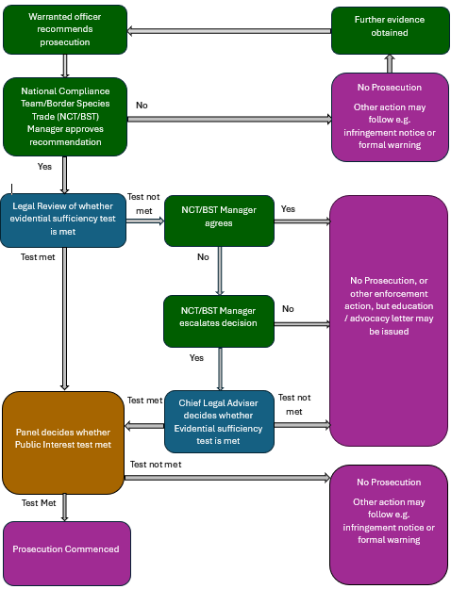

Disputed Infringement Notice decision process

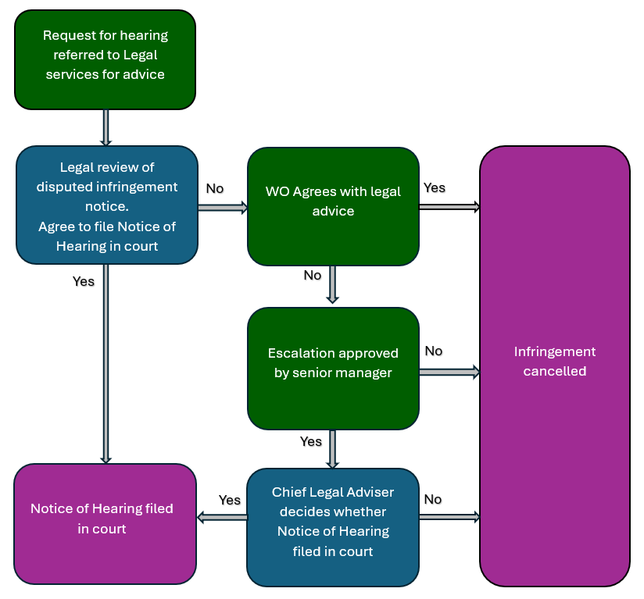

Exculpatory evidence is evidence which may tend to show the alleged offender is innocent.

