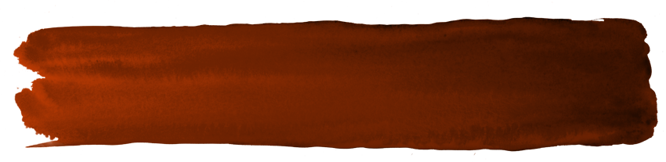

\
COMMENT SUBMISSION FORM
Publicly notified application for leases, licences, permits, or easements.

This form is to be used to provide submissions concerning publicly notified applications for leases, licences, permits, or easements under section Sections 17SC and 49 of the Conservation Act 1987.
Notes to Submitter:
Please download and complete this form, scan and send to permissionshamilton@doc.govt.nz. You may also mail your submission to: Director-General, c/o Department of Conservation, Private Bag 3072, Hamilton 3240, Attention: Darcy Liddell.
Closing Date: The closing date and time for serving submissions to the Director-General on this matter is Friday the 27th of July 2018 at 5:00pm.
Privacy: Please note that submissions are public. Your name and submission will be included in papers that are available to the media and the public. Your submission will only be used for the purpose of the notified permissions application process. Once submitted, submitters' information is subject to the Official Information Act 1982 and may be released under that Act. If you wish to keep any part of your submission confidential, you need to state this in writing when making your submission. Under the Privacy Act 1993, you may request the right of access to, and correction of, personal information provided in this submission.

Do not send page one of this document with your submission. If you require additional space for providing your submission, please attach extra pages as needed and label according to the relevant section.

COMMENT SUBMISSION FORM
Publicly notified application for leases, licences, permits, or easements.

Note: Include pages two and three of this form with your response to DOC. Do not include page one.

A. Permission Application Number and Name of Applicant
66693-OTH Imlig Family Trust

B. Name of Proposed Activity and Location(s)
Operation of an avocado orchard on part of Hidden Gorge Scenic Reserve, Bay of Plenty.

C. Submitter Information-
Full Name (also list organisational name if submitting on behalf of a business, community group, etc.): ___________________________________________________________________________________
Address for Service (Postal Address): ____________________________________________________
_____________________________________________________ Post Code: ____________________
Telephone: _____________________________ Email Address: _______________________________
Note: Communication from DOC will be via e-mail unless alternate contact is requested below.
I wish to be contacted alternately by: __________________________________________________

D. Statement of Support/Opposition

I (circle one) Support / Neutral / Oppose this Application.

E. Hearing Request

I (circle one): Do / Do Not wish to be heard in support of this submission at a hearing.

F. Submission
The specific parts of the application that this submission relates to are:
My submission is [include the reasons for your views]:

What outcomes would you like to address with your submission? [give precise details, including the parts of the application you wish to have amended and the general nature of any conditions sought]:

G. Your Signature

_____________________________________________________________
Signature of submitter or person authorised to sign on behalf of submitter

_____________________________________________________________
Printed name of submitter or person authorised to sign on behalf of submitter

__________________________
Date

Please complete this form and send to permissionshamilton@doc.govt.nz. You may also mail your submission to: Director-General, c/o Department of Conservation, Private Bag 3072, Hamilton 3240, Attention: Darcy Liddell.

